LAB1 0416225賴威仁

架構圖: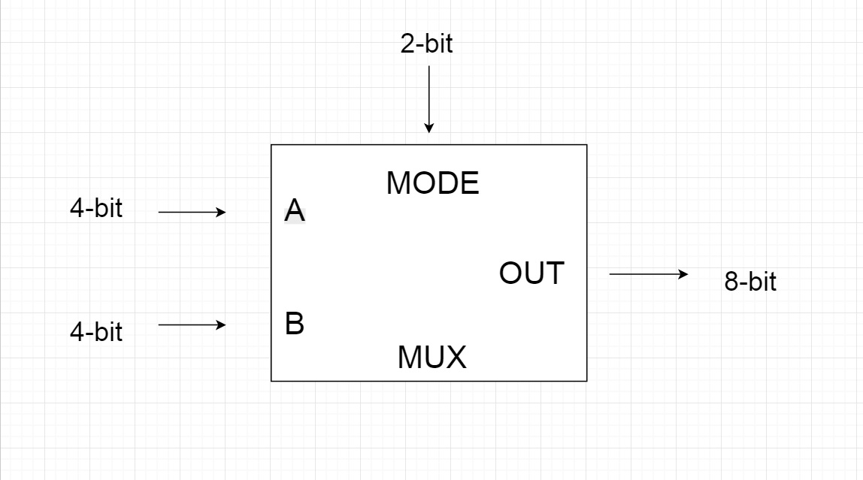

流程圖(continuous assignment):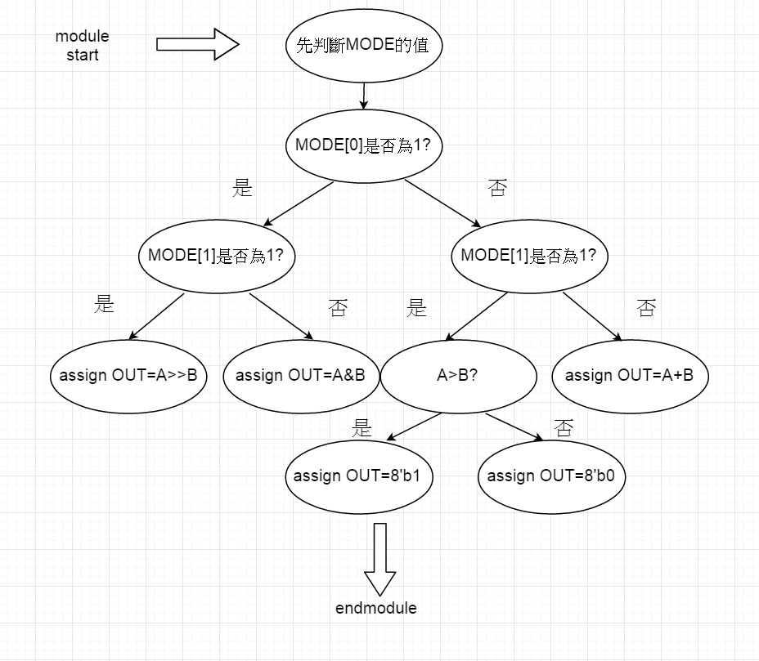

流程圖(procedural assignment):