Part 3 — Graph Recommender Architectures: From LightGCN to a Custom Hybrid
Turning a featured graph into "where will they go next" — a survey of graph-neural-network recommenders, six recent papers reimplemented, and a hybrid that fuses knowledge-graph attention with contrastive learning.
Series: Building a restaurant recommender from 2.5M Google reviews — graphs, local LLMs, and geography. Part 3 of 4. (Part 1 · Part 2)

The prediction task: ranking, not rating
A common misconception about recommenders is that they predict a star rating. Ours doesn't. The job is to rank — out of ~19,000 restaurants, surface the handful a particular diner will actually visit next. We treat each review as implicit positive feedback (they showed up, so they were interested) and train every model with a ranking objective: score a place the diner visited above one they didn't. At evaluation we ask the blunt question from Part 1 — was the restaurant they actually visited next in our top 10?
The features from Part 2 don't sit on the sidelines: each model starts from those user and restaurant feature vectors and refines them as it learns. The interesting question this part answers is what architecture does the refining — and whether the fancy ones are worth it.
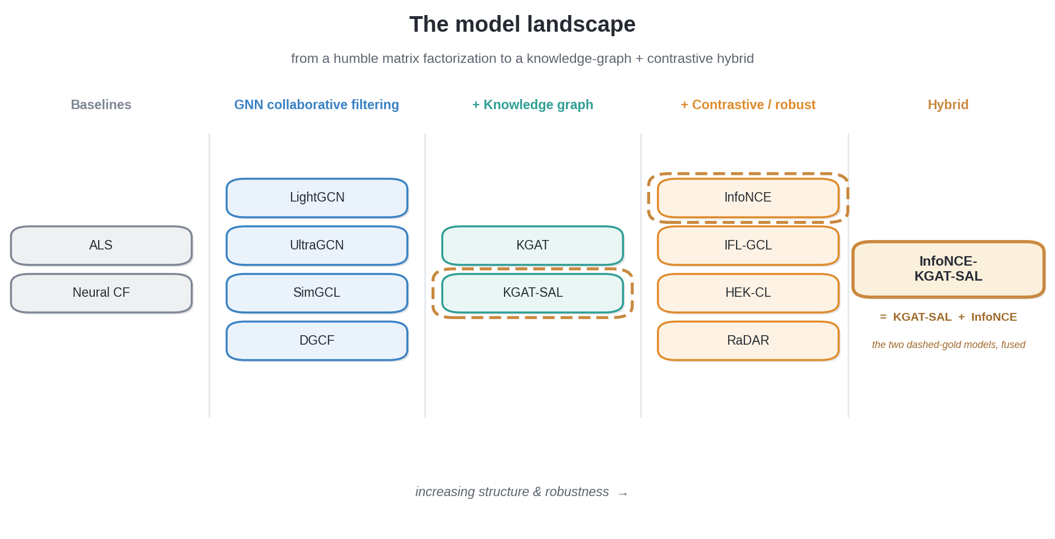

Baselines: non-graph models
Before reaching for graph neural networks, you need a yardstick.
- Matrix factorization (ALS) is the classic move: arrange every diner-visited-restaurant pair into a giant sparse matrix and factor it into compact "taste" vectors for users and restaurants. No graph, no review text — just who-visited-what. If a GNN can't beat this, the complexity isn't earning its keep.
- Neural collaborative filtering swaps the dot-product for a small neural network over the same embeddings — a little more flexible, still no graph.
These set the bar. Everything that follows is an argument for why structure helps.

Graph-based collaborative filtering
The core idea of a graph recommender is almost folk wisdom: a diner's taste is defined by the places they go, and a place's character by who goes there. A graph neural network makes that literal. Information flows along the review edges in rounds ("message passing"): after one round, your embedding has absorbed the restaurants you've visited; after two, the other diners who visit those restaurants; after three, their favorites. Stack a few rounds and a diner who loves three ramen shops drifts, in embedding space, toward the broader ramen-loving crowd — and toward ramen places they haven't tried yet.
- LightGCN is the workhorse. Its insight was subtractive: throw away the heavy transformations earlier graph models inherited from other domains and keep only neighbor averaging. Simpler, faster, and a stronger recommender. It's our reference point.
- UltraGCN notices that stacking message-passing rounds is expensive and instead approximates "infinitely many rounds" with a clever training constraint — much faster, similar spirit.
- SimGCL adds a contrastive twist (more on that below): nudge the graph with a little random noise twice, and train the model to recognize the two noisy versions as the same place. It spreads embeddings out and resists over-popular items dominating.
- DGCF disentangles intent: you might visit one restaurant for a quick weekday lunch and another for a date, so it splits each embedding into separate intent channels.

Adding a knowledge graph: KGAT
LightGCN only knows the review edges — it's blind to why two restaurants are similar. But Part 1 handed us a knowledge graph: restaurants link to the dishes they serve, the cuisine they belong to, and the neighborhood they sit in. KGAT (Knowledge Graph Attention Network) propagates over the review edges and those knowledge edges together, using attention to learn which connections matter.
The payoff is concrete. Suppose you've loved several pad-thai-and-drunken-noodle spots. A pure collaborative model can only recommend a new Thai place once enough other people have linked it to your crowd. KGAT can route through the shared dish and cuisine nodes and surface it immediately — even with almost no reviews. That's a direct attack on the cold-start problem.
- KGAT-SAL goes further with "self-augmented learning" (borrowed from the Self-GNN paper): it splits each diner's history into time periods and learns to denoise them — recognizing that tastes drift and that a one-off airport-McDonald's visit shouldn't define you. A stability weighting quietly down-weights the noisy, out-of-character visits.

Contrastive and robustness models from the literature
Recent recommender research is full of self-supervised and robustness ideas, and we reimplemented six recent papers to see whether they'd transfer to messy, real-world review data:
Paper (idea) | What it does | Our model
INFONCE-GCL — Wang et al., 2025 [1] | Reframes contrastive learning as a positive-unlabeled problem, mining true positive pairs instead of trusting random ones | IFL-GCL (and a KG-aware variant)
RaDAR — Huang et al., 2026 [2] | Diffusion-style denoising plus asymmetric negative sampling for sparse, noisy graphs | RaDAR
HEK-CL — Yuan et al., 2024 [3] | Embeds nodes in hyperbolic (curved) space — a natural fit for hierarchy — with denoising and a robust contrastive loss | HEK-CL (and a hyperbolic-loss SimGCL)
Self-GNN — Liu et al., 2024 [4] | Combines short-term and long-term behavior with self-augmented denoising | the SAL component of KGAT-SAL
HGNN-AR — Lin et al., 2025 [5] | Adaptively rebuilds missing graph edges to fix connection gaps | KG edge refinement in the hybrid
LIT-GRAPH GCN — Gelal et al., 2025 [6] | Shows deep relational embeddings beat shallow ones on knowledge graphs | the relational rationale behind KGAT
Contrastive learning, in one sentence: make two slightly-perturbed views of the graph and train the model to recognize that a given diner (or restaurant) is "the same" across both views. It pulls meaningful things together, pushes unrelated things apart, and — crucially for a long-tail dataset — stops a handful of mega-popular restaurants from swallowing the embedding space.

The custom hybrid: combining the knowledge graph with contrastive learning
Each family above has a different strength: KGAT-SAL brings the knowledge graph and temporal denoising; contrastive methods bring robustness and well-spread embeddings. So we built a hybrid — InfoNCE-KGAT-SAL — that runs a contrastive objective on top of the KGAT-SAL knowledge-graph backbone, getting both at once.
The figure below sketches the three ideas the hybrid combines — KGAT's knowledge-graph attention, SAL's temporal denoising, and InfoNCE's contrastive learning — and how they roll up into a single training objective.
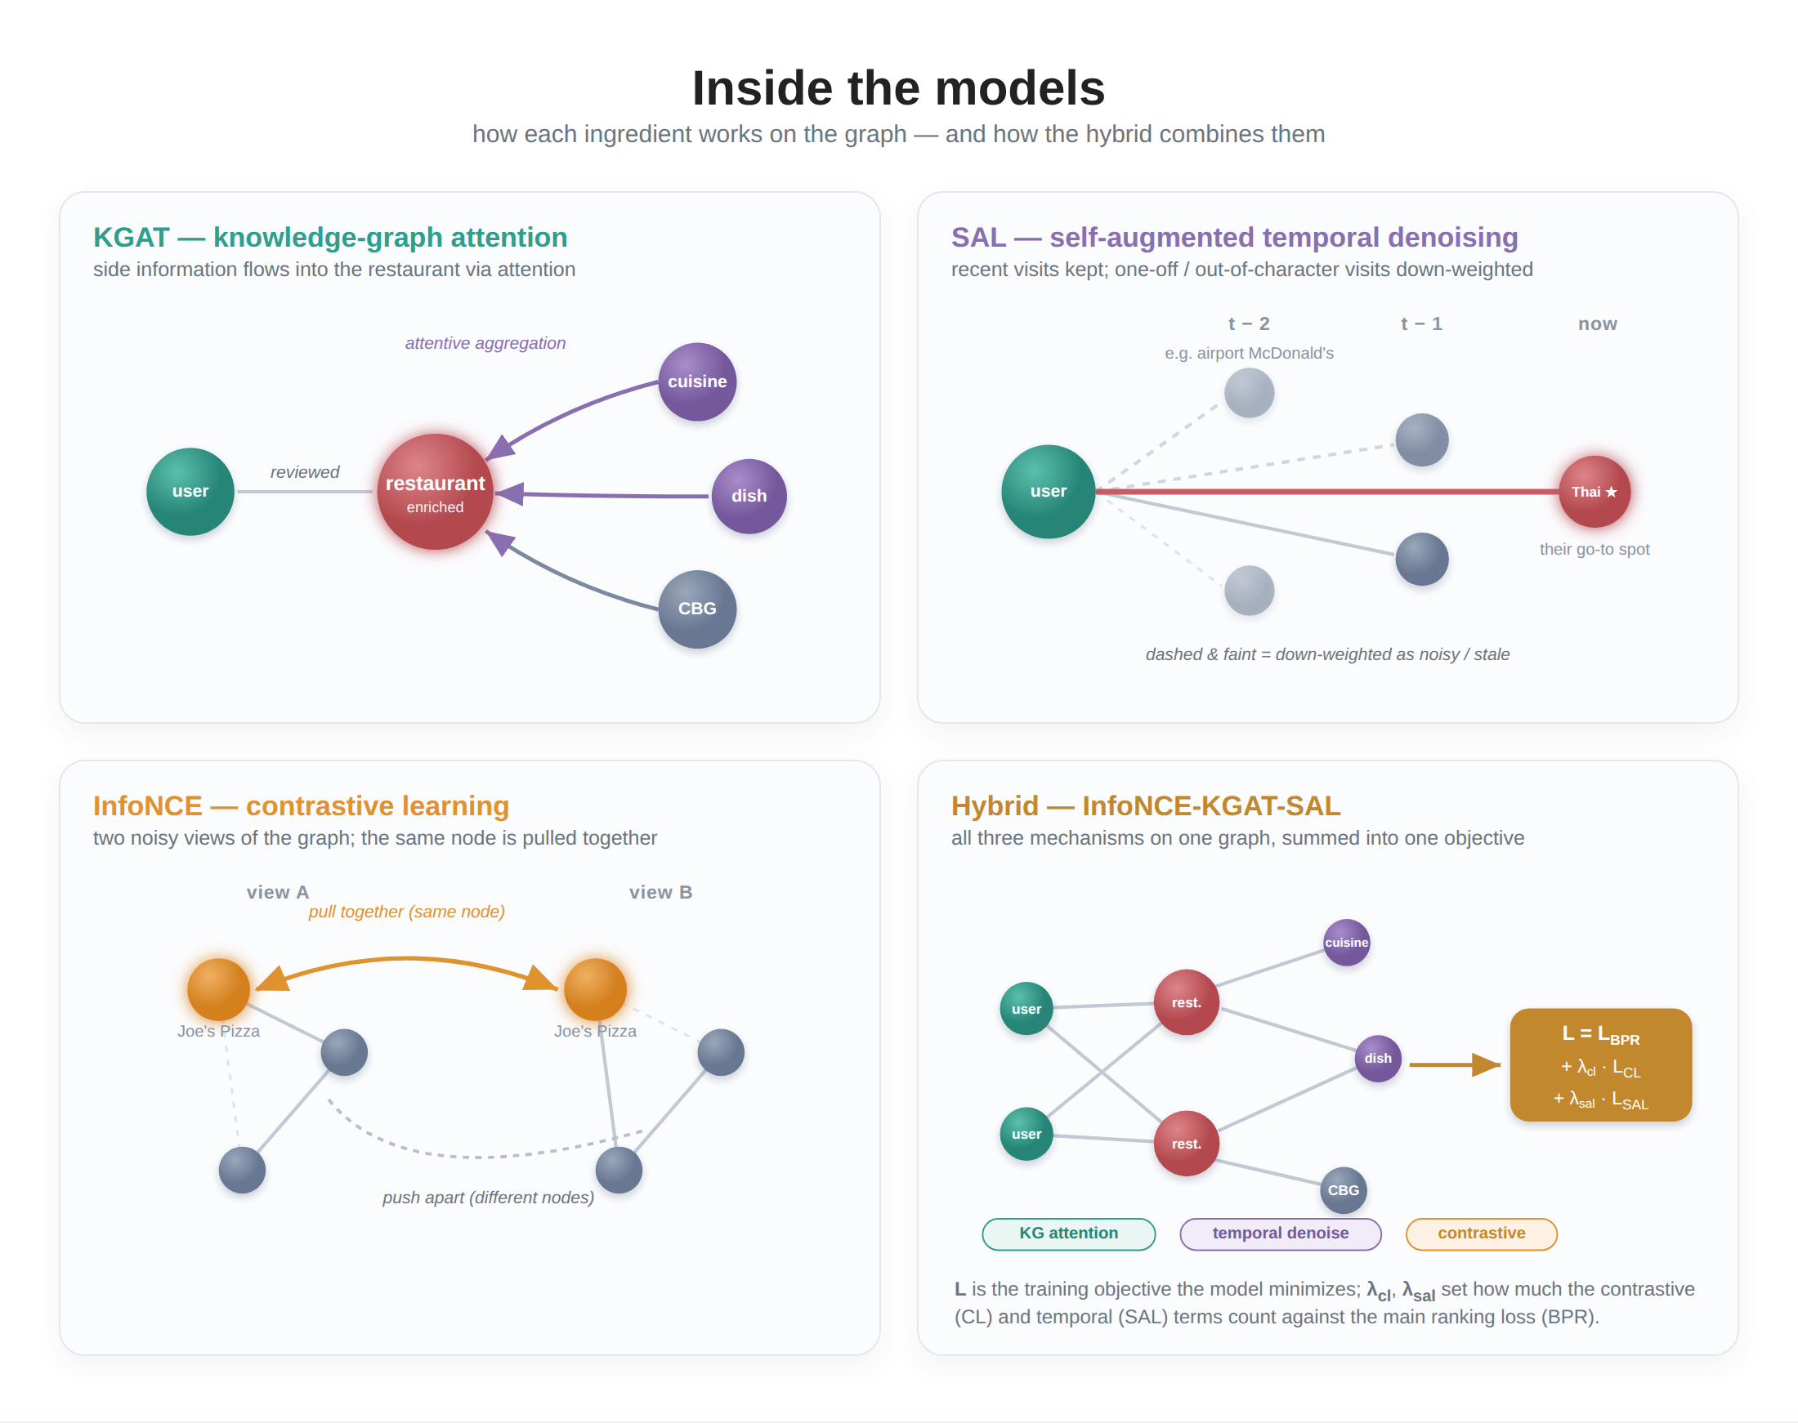
Getting it to train well took one nice debugging story. A pure contrastive objective plateaued: once it had pulled every matching diner-restaurant pair together, the remaining negatives were all easy, produced almost no gradient, and learning stalled. Three changes fixed it: keep a ranking objective running alongside the contrastive one so there's always a useful signal; mine hard negatives (restaurants that look similar to a diner's favorites but that they didn't choose — the genuinely informative mistakes); and gradually sharpen the contrastive objective over training rather than starting it at full strength.
Whether all this machinery actually paid off is Part 4's subject — and the answer is sobering: the gaps between these models turned out to be small, and a simple geographic re-ranking outperformed every one of them.

Which architectures fit this problem?
Benchmarks aside, it's worth asking why some families suit restaurant recommendation and others don't — because this scenario has a particular shape. The signal is extremely sparse (2.5M reviews spread over ~2M diners and ~19K restaurants, with a long tail of one-or-two-review users and restaurants), the feedback is implicit and noisy (a visit isn't an endorsement; some visits are one-off or occasion-driven), and — the theme of Part 4 — behavior is intensely local.
- Matrix factorization and neural CF are honest baselines but structurally limited here: with no side information and no message passing, they have nothing to fall back on for a restaurant with five reviews. They drown in the sparsity.
- LightGCN / UltraGCN help precisely because propagation lets a sparse node borrow signal from its neighbors — a real fit for this data. But pure collaborative filtering still can't speak to a brand-new restaurant, and it tends to amplify popularity bias (a problem we measure in Part 4).
- Contrastive methods (SimGCL, InfoNCE, IFL-GCL) are, in principle, well-suited to a long-tail catalog: spreading embeddings out counters the pull of mega-popular items. In practice they were finicky — pure InfoNCE plateaued and some variants collapsed — so the benefit came only with careful tuning.
- Hyperbolic embeddings (HEK-CL) are theoretically appealing for hierarchical structure (cuisines contain sub-cuisines contain dishes), but were the hardest to train and underperformed on our messy real-world data — an elegant idea that didn't pay off here.
- Disentangled intent (DGCF) captures something true — a diner has a lunch self and a date-night self — but separating those intents from sparse implicit signals proved hard, and the payoff was modest.
- Knowledge-graph models (KGAT) are the best conceptual fit, and the leaderboard agreed. The dish/cuisine/neighborhood side information directly attacks the cold-start problem: a new ramen shop can be recommended through the dishes it serves, before anyone has reviewed it. That's the one thing pure CF cannot do, and it's exactly what this long-tail, high-turnover domain needs. KGAT-SAL's temporal denoising further targets the noisy, occasion-driven visits.
The meta-lesson sets up Part 4: the architectures that helped most were the ones that injected structure the interactions alone couldn't provide (the knowledge graph). And even the best of them was about to be outdone by something none of them modeled — where the diner actually is.

Next steps
We have more than a dozen trained models, from a humble matrix factorization to a knowledge-graph-plus-contrastive hybrid. Part 4 puts numbers on all of them and develops the central finding of the series: geography beats architecture. A single spatial re-ranking step lifts precision sharply across every model, outweighing the differences between them. We'll also look at where the recommender works, who it works for, and the popularity bias in its recommendations.

References
- Z. Wang, B. Xu, Y. Yuan, et al. InfoNCE is a Free Lunch for Semantically Guided Graph Contrastive Learning. arXiv:2505.06282, 2025. arxiv.org/abs/2505.06282
- Y. Huang, J. Chen, S. Zhang, Z. Cao. RaDAR: Relation-aware Diffusion-Asymmetric Graph Contrastive Learning for Recommendation. arXiv:2603.16800, 2026. arxiv.org/abs/2603.16800
- M. Yuan, Z. Zhang, W. Chen, C. Zhao, T. Cai, D. Wang, R. Liu, F. Zhuang. HEK-CL: Hierarchical Enhanced Knowledge-Aware Contrastive Learning for Recommendation. Beihang University, 2024.
- Y. Liu, L. Xia, C. Huang. SelfGNN: Self-Supervised Graph Neural Networks for Sequential Recommendation. SIGIR, 2024.
- W. Lin, Z. Chen, Y. Chen, S. Wang. Heterogeneous Graph Neural Network with Adaptive Relation Reconstruction. Neural Networks 187:107313, 2025.
- N. Gelal, C. Snow, K. M. Jagodnik, A. Rios, H. Küçük McGinty. LIT-GRAPH: Evaluating Deep vs. Shallow Graph Embeddings for High-Quality Text Recommendation in Domain-Specific Knowledge Graphs. Kansas State University, 2025.

Appendix: the canonical-data note
All model numbers in this series come from the unextended dataset (the graph from Part 1, embedding dimension 2048). See RECONCILIATION.md for provenance.

