Geographic sampling and composition of the restaurant-review dataset

Abstract
Recommendation quality is constrained by the catalogue and interaction data available to the model. We assembled a US restaurant dataset by searching Census block groups (CBGs) selected for high foot traffic, high population density, and surrounding geographic coverage. Restaurant metadata came from Google Places API (New); public review pages were collected separately and processed into a canonical analytical table. The resulting dataset contains 75,203 restaurants and 5,544,947 reviews. This article documents the sampling frame, collection safeguards, cuisine normalization, demographic diagnostics, and the chronological evaluation population used by the subsequent recommendation experiments.

Geographic sampling and restaurant discovery
A CBG is a small Census statistical geography. We used CBGs because they provide a more precise unit of coverage than states or cities and can be linked to population and spatial-neighborhood information. The discovery frame combined three signals:
Coverage component | Purpose
High-foot-traffic CBGs | Represent active commercial and dining areas
Top 10,000 population-density CBGs | Avoid omitting dense residential and mixed-use areas
Surrounding CBGs and H3 search cells | Cover restaurants near CBG boundaries and local neighborhoods

Every selected polygon was covered with H3 resolution-9 search cells. Google Places API (New) Nearby Search supplied place identity and metadata, and Google Place ID served as the restaurant deduplication key. Terminal markers were written for successful searches and confirmed empty searches. This distinction prevents a large CBG with no returned restaurants from being searched again merely because its result set is empty.
The static map below shows 11,992 terminally searched CBG identifiers that map directly to 2024 boundaries. Another 1,343 terminal identifiers come from an earlier Census boundary vintage and are omitted from the static geometry rather than assigned to an incorrect polygon. The map is a search-footprint visualization, not a restaurant-density map.
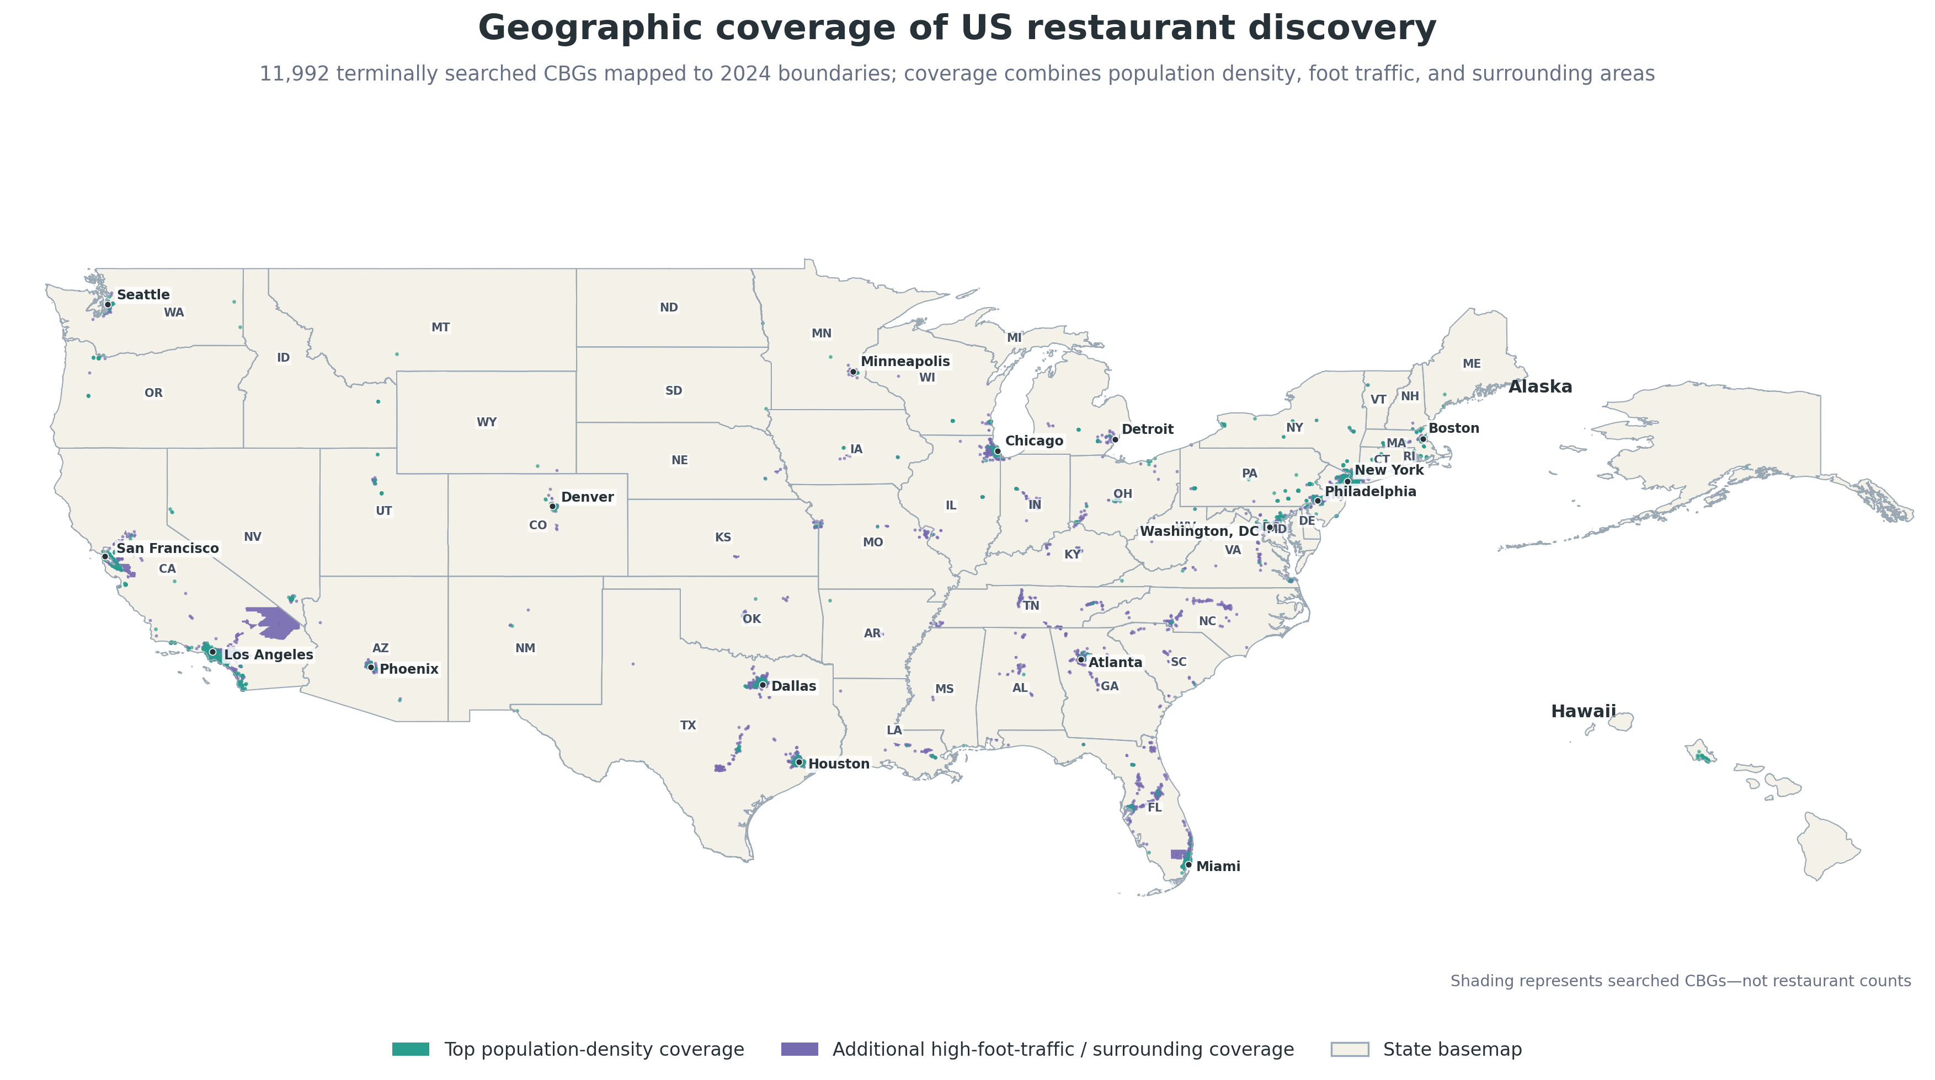
Figure 1. Terminally searched Census block groups. Teal marks top population-density coverage; purple marks additional high-foot-traffic and surrounding coverage. Alaska and Hawaii are shown as insets.

Final analytical corpus
The restaurant catalogue spans 49 state/DC jurisdictions; Alaska and Montana have no retained restaurant record. Coverage is therefore broad but not a probability sample of US restaurants. Google visibility, the selected CBGs, and the query geometry all influence inclusion.
Dataset quantity | Count
Unique restaurants | 75,203
Raw review objects | 5,545,260
Canonical analytical reviews | 5,544,947
Identified reviewers | 3,930,034
Restaurants with at least one analytical review | 70,625
Reviewers eligible for modeling (4+ restaurants) | 156,261

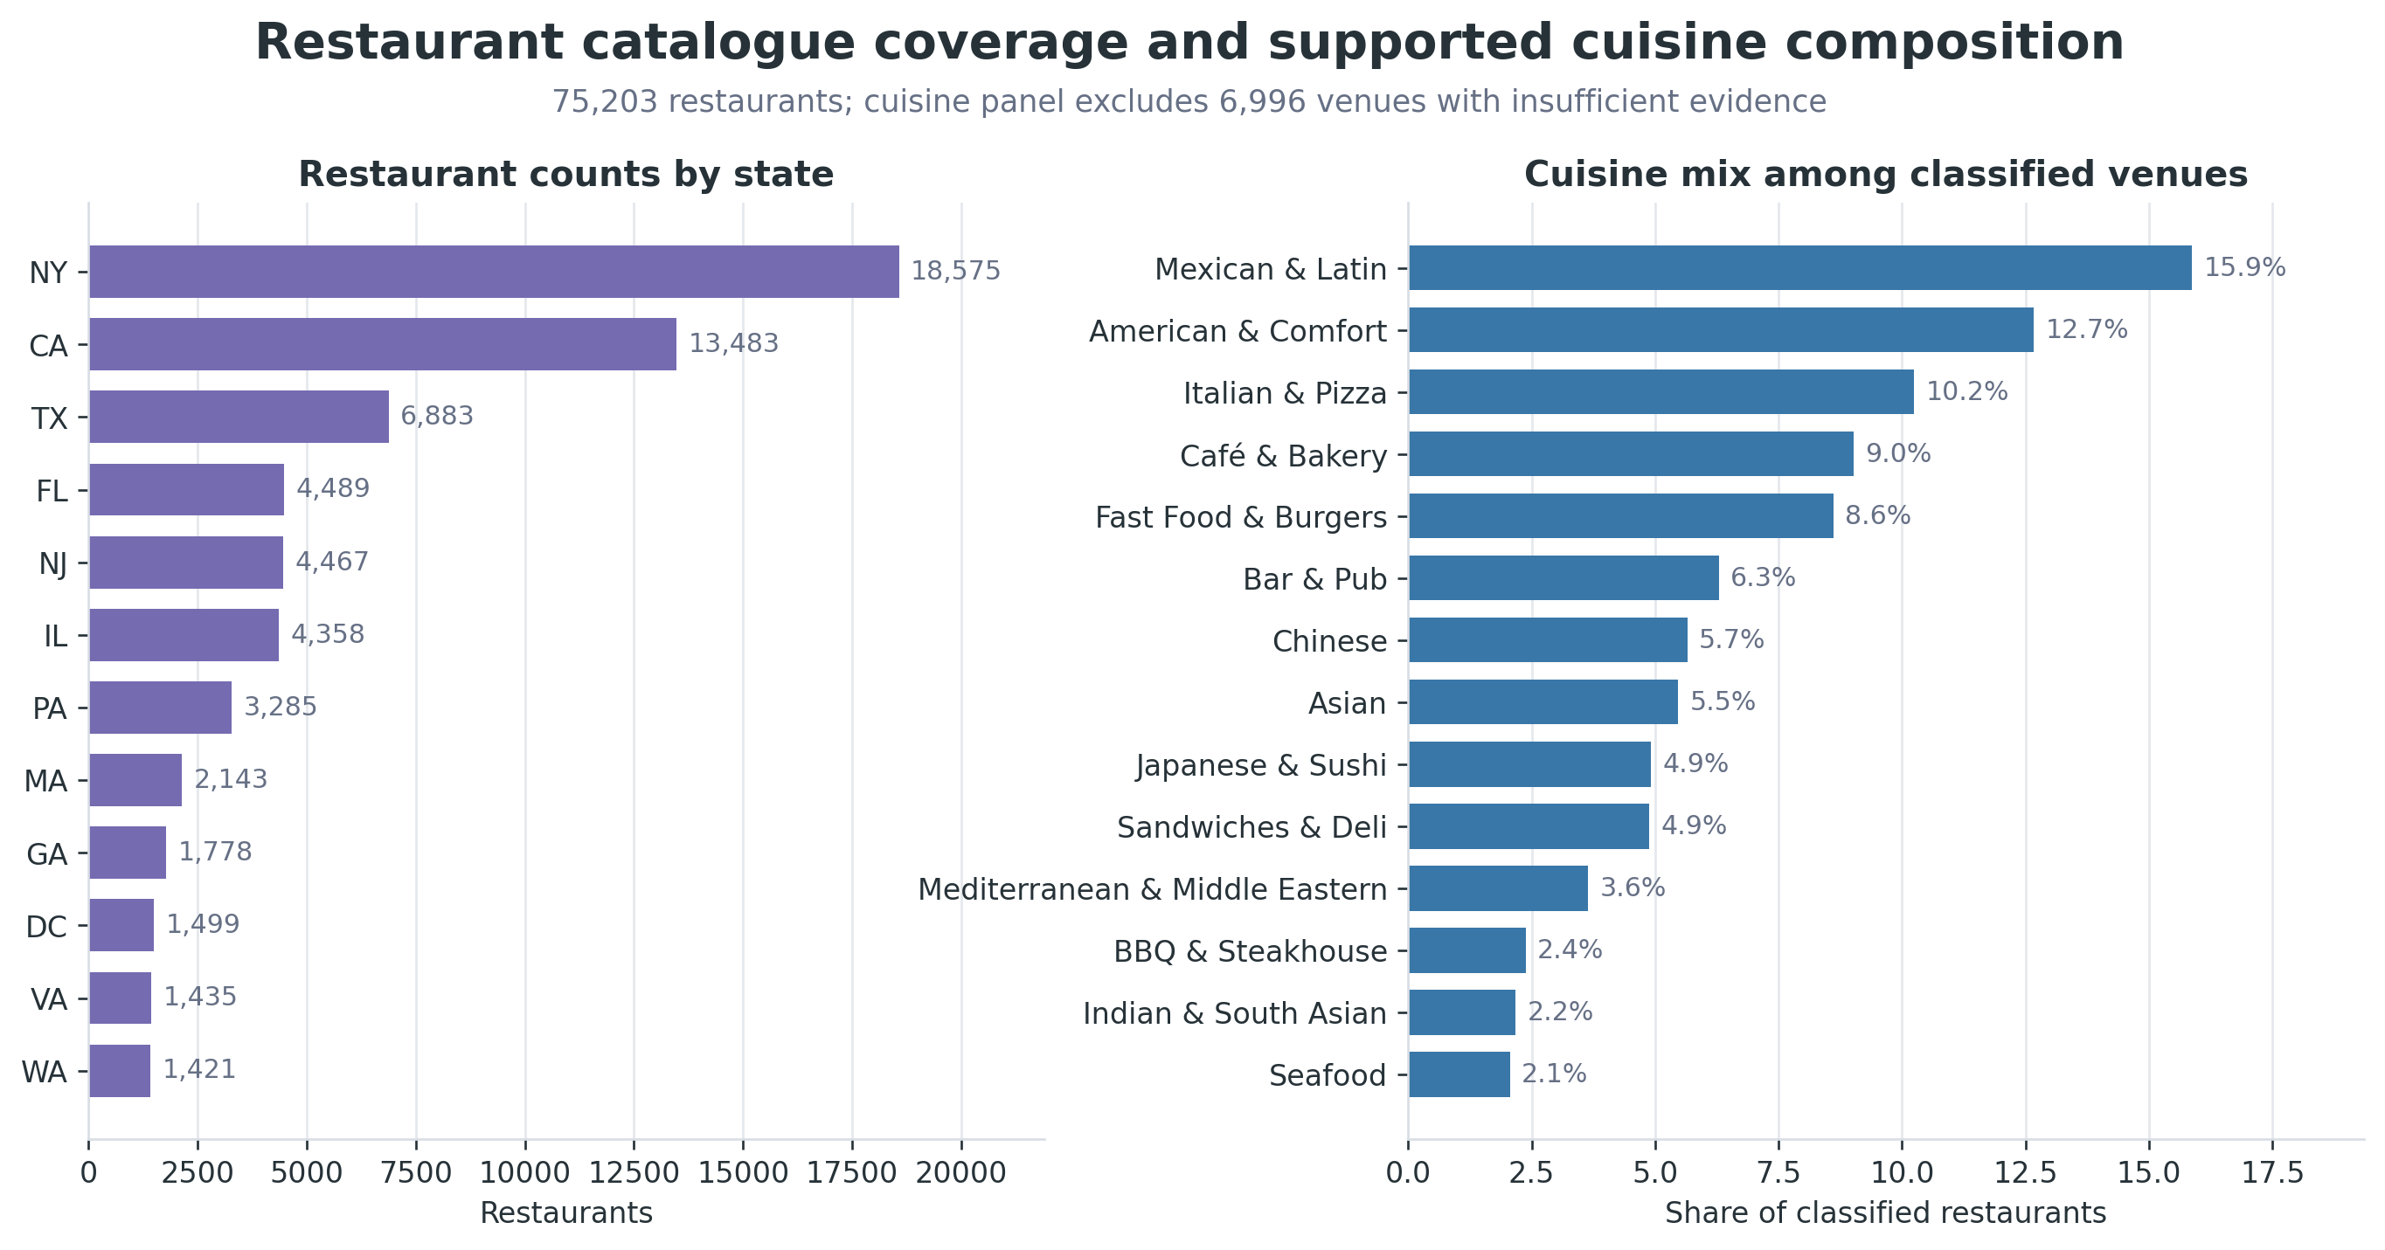
Figure 2. State coverage and cuisine distribution. Cuisine shares exclude venues without a supported cuisine label, but those venues remain in the analytical and modeling tables.
Review collection used Camoufox with reusable browser contexts and a fresh page per restaurant. Starts were staggered and rate-limited, and scrolling was paced to allow dynamically rendered review panels to load. A known-positive probe distinguished a genuine absence of reviews from connectivity failures, delayed rendering, and automated-traffic challenges. Retryable failures were retained as retryable states rather than converted into false “no review” outcomes.

Review-rating and reviewer-activity distributions
The corpus is strongly positive: 63.2% of reviews have five stars and 12.5% have four stars. Reviewer activity is highly skewed in the opposite direction: 82.0% of identified reviewers occur at only one restaurant. The model population therefore represents a denser behavioral subset, not a miniature copy of all reviewers.
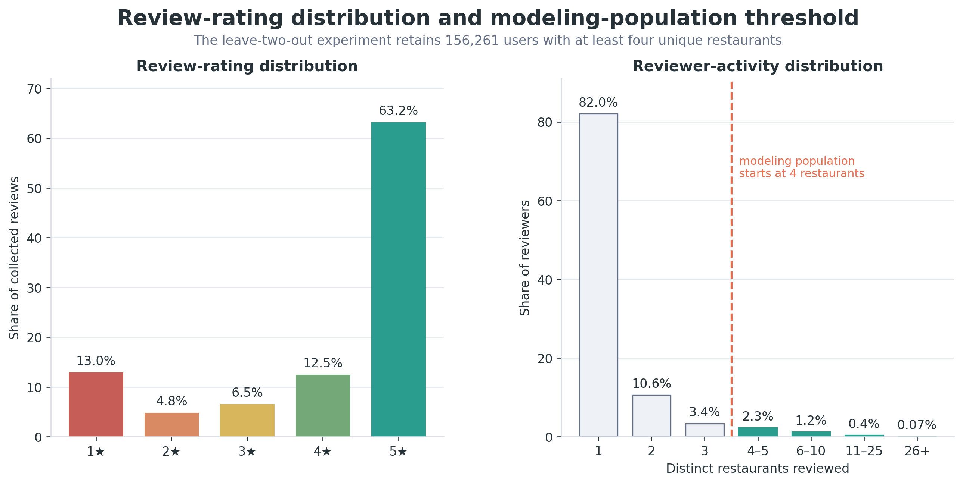
Figure 3. Rating distribution and reviewer-activity funnel. The modeling threshold begins at four distinct restaurants because each user must retain training history after validation and test interactions are held out.
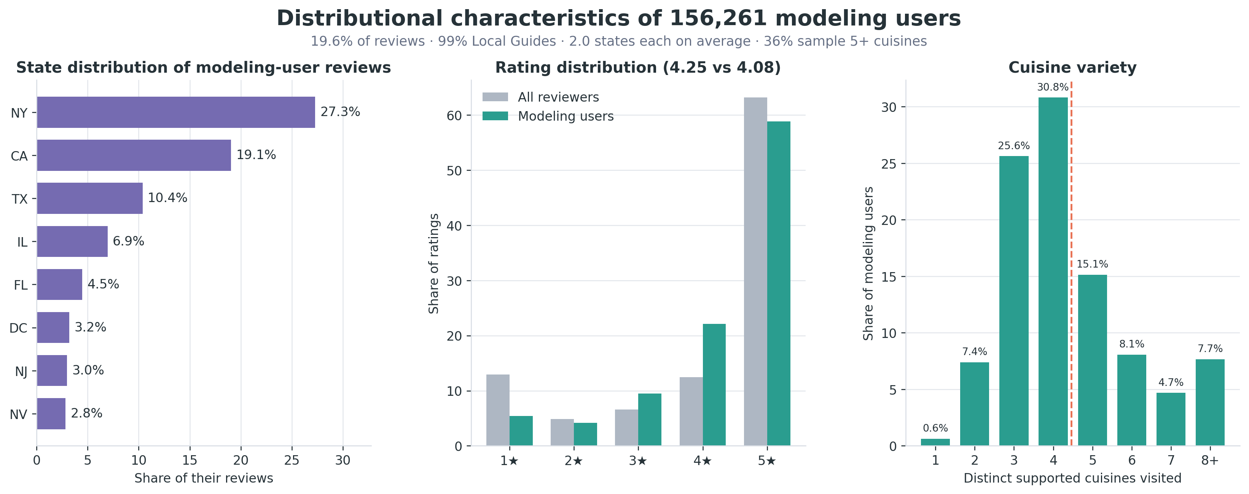
Figure 4. Geography, rating behavior, and cuisine breadth among the 156,261 modeling users.
Review content varies with sentiment. Critical reviews contain more text, while attached photos are more common in positive reviews. These differences matter for semantic feature extraction: negative reviews provide detailed failure descriptions, whereas positive reviews more often add visual evidence.
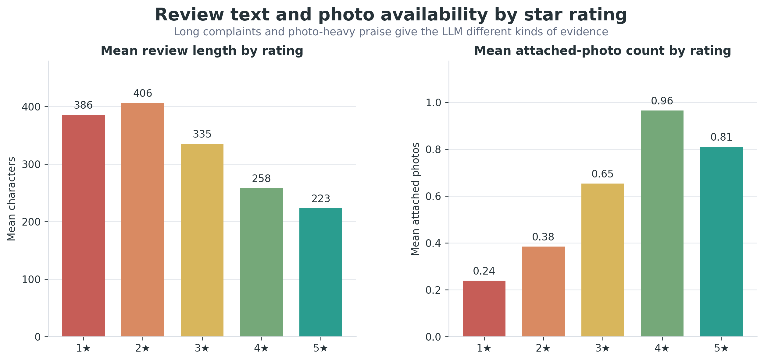
Figure 5. Mean review length and attached-photo count by star rating.

Cuisine normalization
Google’s broad type mapping assigned 15,747 restaurants to a generic category. A targeted local 27B model re-examined only those records using names, place types, summaries, and available review evidence. It assigned 8,751 supported specific labels; 6,996 restaurants retained an insufficient-evidence state. Cuisine figures omit the latter group rather than forcing a label. The restaurants themselves remain in the dataset and model candidate universe.
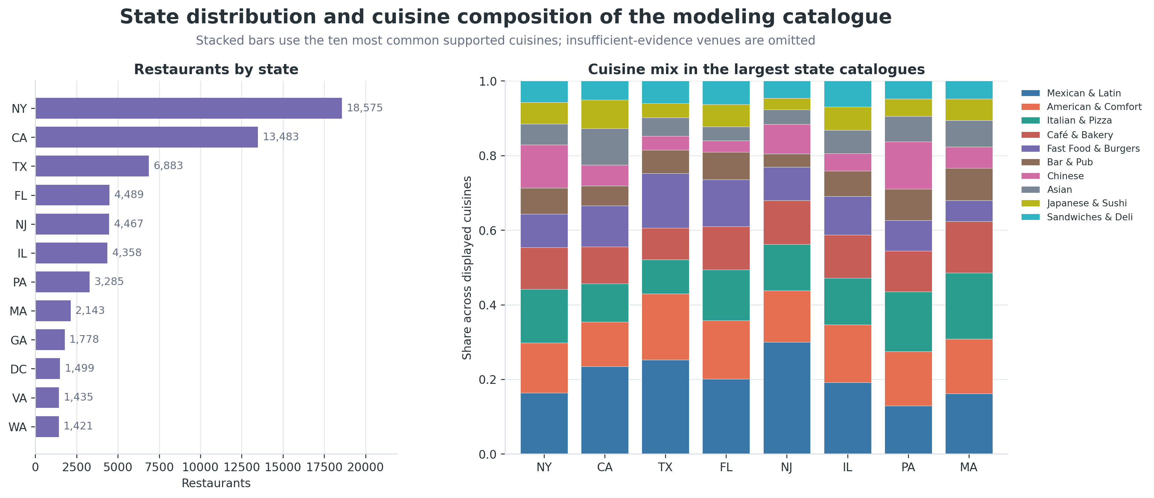
Figure 6. Restaurant counts and cuisine composition in the largest state catalogues. The stacked panel uses supported cuisine labels only.

Demographic rating analysis
Gender and race/ethnicity labels are probabilistic name-inference outputs, not self-reported identity. They are used only for descriptive diagnostics and subgroup evaluation. They should not be interpreted as population estimates or used for sensitive targeting.
Across classified review rows, female-coded reviewers average 4.1359 stars and male-coded reviewers average 4.0974; both medians are 5 stars. Repeated reviews from one person violate the independence assumption of an ordinary review-level test, so the primary significance analysis uses one mean rating per reviewer. At that level, the means are 4.0969 and 4.0461, respectively, and both medians remain 5.
Analysis level | Female mean | Male mean | Female median | Male median | Difference
Review rows | 4.1359 | 4.0974 | 5.0 | 5.0 | +0.0385
One mean per reviewer | 4.0969 | 4.0461 | 5.0 | 5.0 | +0.0508

The reviewer-level Welch test gives t=30.09, p=8.0×10^-199, with a 95% confidence interval of [0.0475, 0.0541] stars for the mean difference. The effect is statistically detectable because the sample contains nearly 2.92 million classified reviewers, but it is substantively negligible: Cohen’s d=0.035. Statistical significance should not be confused with practical importance.
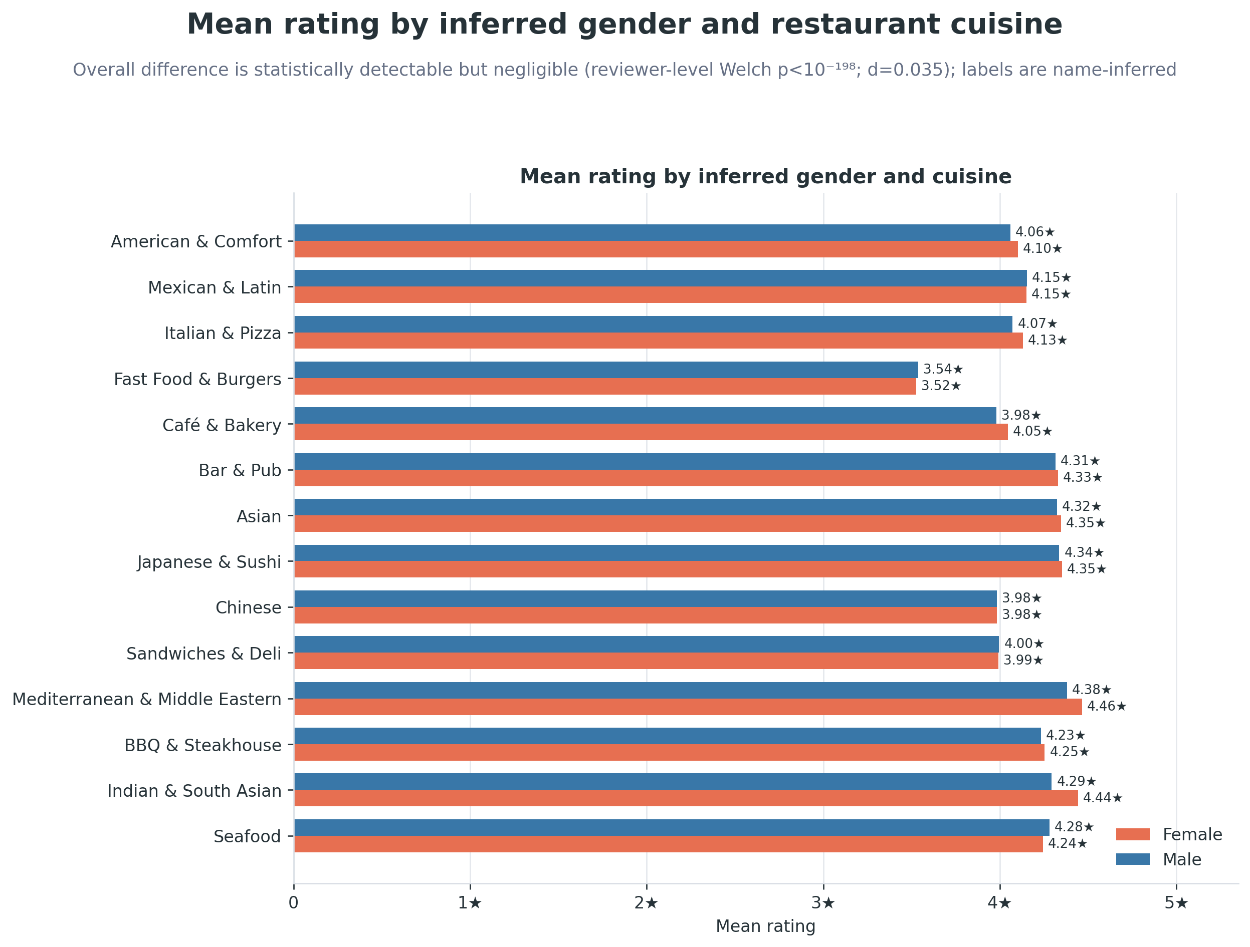
Figure 7. Mean rating by cuisine and inferred gender. Bars use the full zero-to-five-star scale.
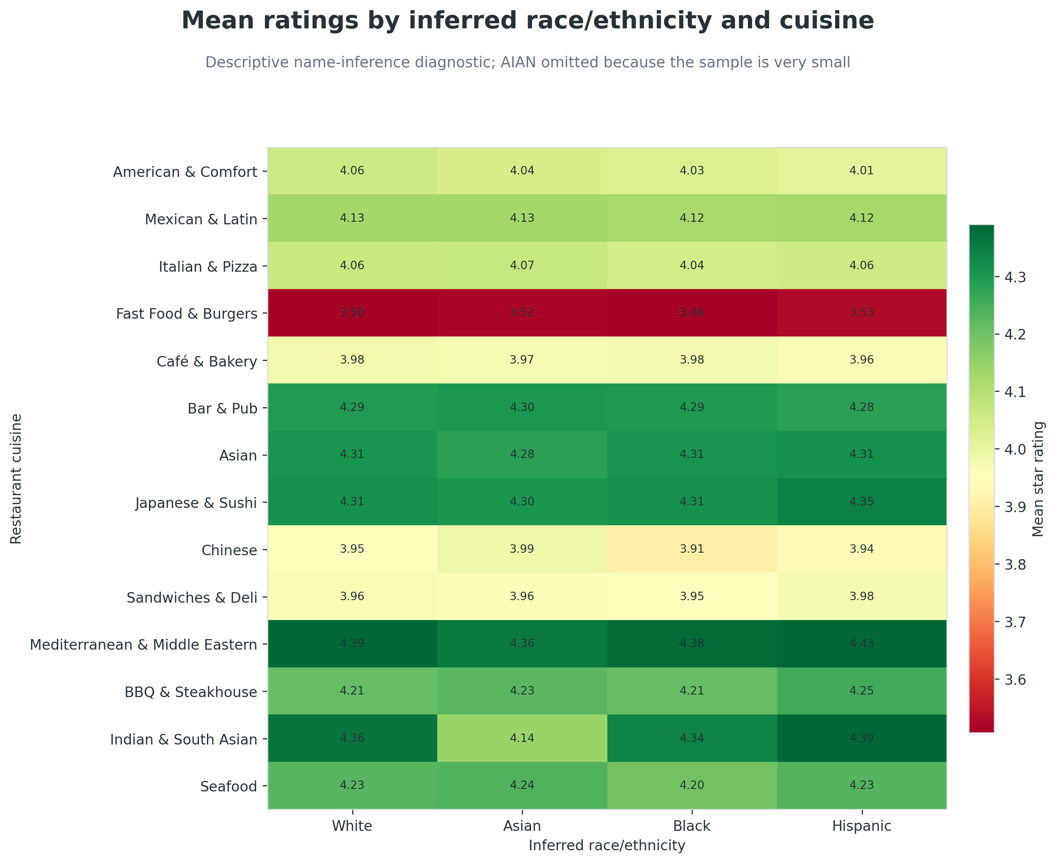
Figure 8. Cuisine-conditioned mean ratings for sufficiently represented inferred race/ethnicity groups.
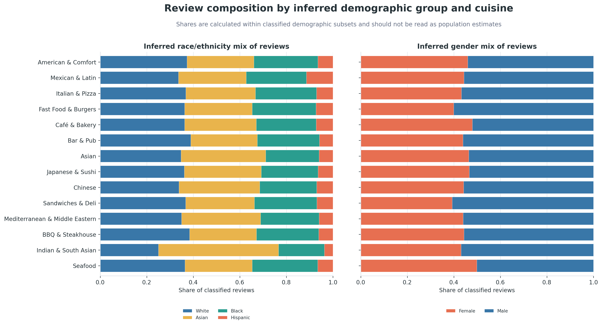
Figure 9. Demographic composition within the classified subsets. Shares are conditional on a classified name-inference output and are not estimates of customer populations.

Modeling population and chronological split
The recommendation experiment deduplicates user–restaurant pairs and retains reviewers with at least four distinct restaurants. For each eligible user, the newest interaction is test, the second-newest is validation, and all older interactions form training.
Split | Interactions
Training | 772,170
Validation | 156,261
Test | 156,261

This chronological boundary also governs behavioral aggregates, LLM corpora, graph edges, model selection, and GraphRAG evidence. The next article examines how semantic features are constructed without allowing validation or test review text to cross that boundary.

