Graph-structured recommendation with locally generated semantic features

Abstract
Restaurant recommendation is both relational and semantic. Interaction histories identify which users visited which restaurants, but review text contains the conditions under which those visits were valued: cuisine, dishes, dietary accommodation, atmosphere, service, occasion, and sensory preferences. We represent these sources jointly. A typed graph propagates evidence through user, restaurant, cuisine, price, dish, geographic, and temporal relations; a local large language model (LLM) converts heterogeneous review language into a shared feature schema and dense semantic representations. The LLM is therefore a feature-construction component rather than the ranker. This article specifies the graph, the frozen feature taxonomy, evidence-aware missingness, and the chronological controls used to prevent held-out review text from entering model inputs.

Relational structure of the recommendation problem
A feature-only model scores a user vector against a restaurant vector. That formulation can encode attributes but treats each user–restaurant pair largely in isolation. A graph exposes additional statistical structure. Two restaurants may be related through cuisine, commonly mentioned dishes, price tier, or neighboring Census block groups (CBGs); two users may become comparable because their interaction histories connect to overlapping restaurant neighborhoods even when they never reviewed the same venue.
The modeling graph contains 156,261 eligible user nodes and 61,204 restaurant nodes observed in eligible interactions. Its collaborative backbone consists of 772,170 chronological training edges. Restaurant nodes connect to 17 cuisine entities, four price tiers, 6,637 CBG entities, and the 200 most frequent training-derived dish entities. Each CBG also connects to its five nearest CBGs. KGAT-SAL first enriches restaurant representations by attention over these typed relations, then propagates collaborative information over the user–restaurant graph. Three temporal interaction subgraphs provide short-term user views that are combined through the stability-aware learning component.
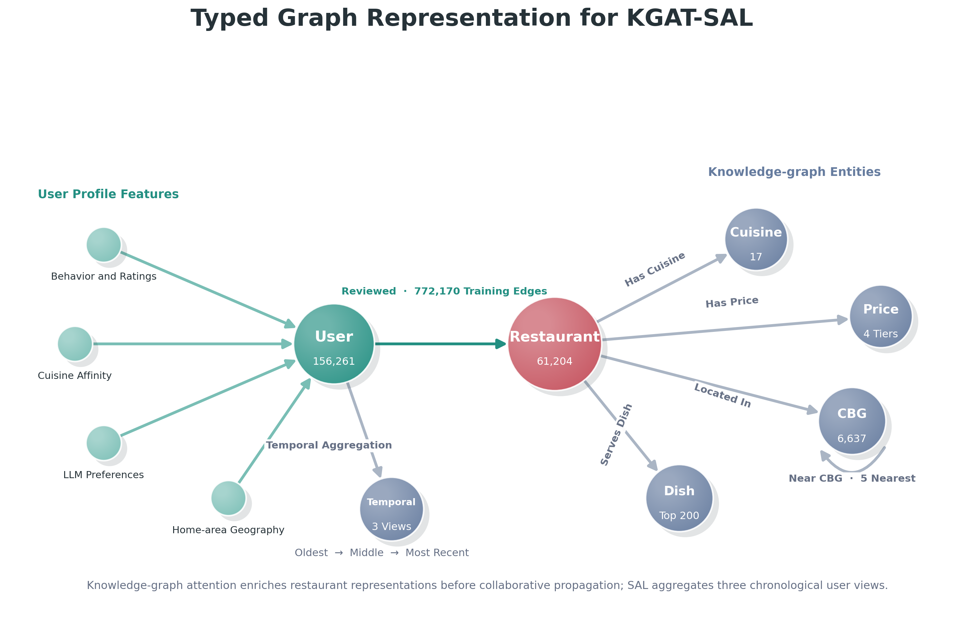
Figure 1. Typed entities and relations used by KGAT-SAL. User and restaurant feature vectors are attached to graph nodes; validation and test interactions are excluded from the displayed training graph.

Complementary roles of graph structure and LLM semantics
The graph contributes an inductive bias that a flat feature comparison does not provide. It permits multi-hop propagation, parameter sharing across sparse entities, and relation-specific aggregation. For example, evidence about a dish can update several restaurants that serve it, while a cuisine preference can influence restaurants connected to the corresponding cuisine entity. Spatial CBG edges allow geographically adjacent restaurant neighborhoods to exchange information, and temporal views distinguish persistent preferences from period-specific behavior.
The LLM contributes information that is weakly represented by interaction topology or conventional metadata. Reviews express concepts such as noise tolerance, desired formality, plant-based needs, portion preferences, service expectations, and occasion suitability in many linguistic forms. A conventional implementation could approximate these signals using multiple classifiers, lexicons, topic models, and aggregation rules. The local LLM provides one structured extraction interface across these heterogeneous concepts while retaining evidence strength and provenance.
These roles are complementary. LLM-derived attributes make user and restaurant nodes more informative; graph propagation determines how those attributes can influence related entities. Dish mentions also become typed restaurant–dish relations rather than remaining only values in a flat matrix. The central experimental hypothesis is consequently an architecture–feature interaction: the value of semantic features should increase when an architecture can propagate them over meaningful relations.

Frozen feature taxonomy
The frozen matrices contain 205 feature dimensions for each eligible user and 262 for each catalog restaurant. The conventional condition removes the structured LLM, LLM embedding, and dish-derived groups. The full-LLM condition retains all groups and enables training-only restaurant–dish graph relations. Both conditions retain the same interaction split and spatial CBG relations.
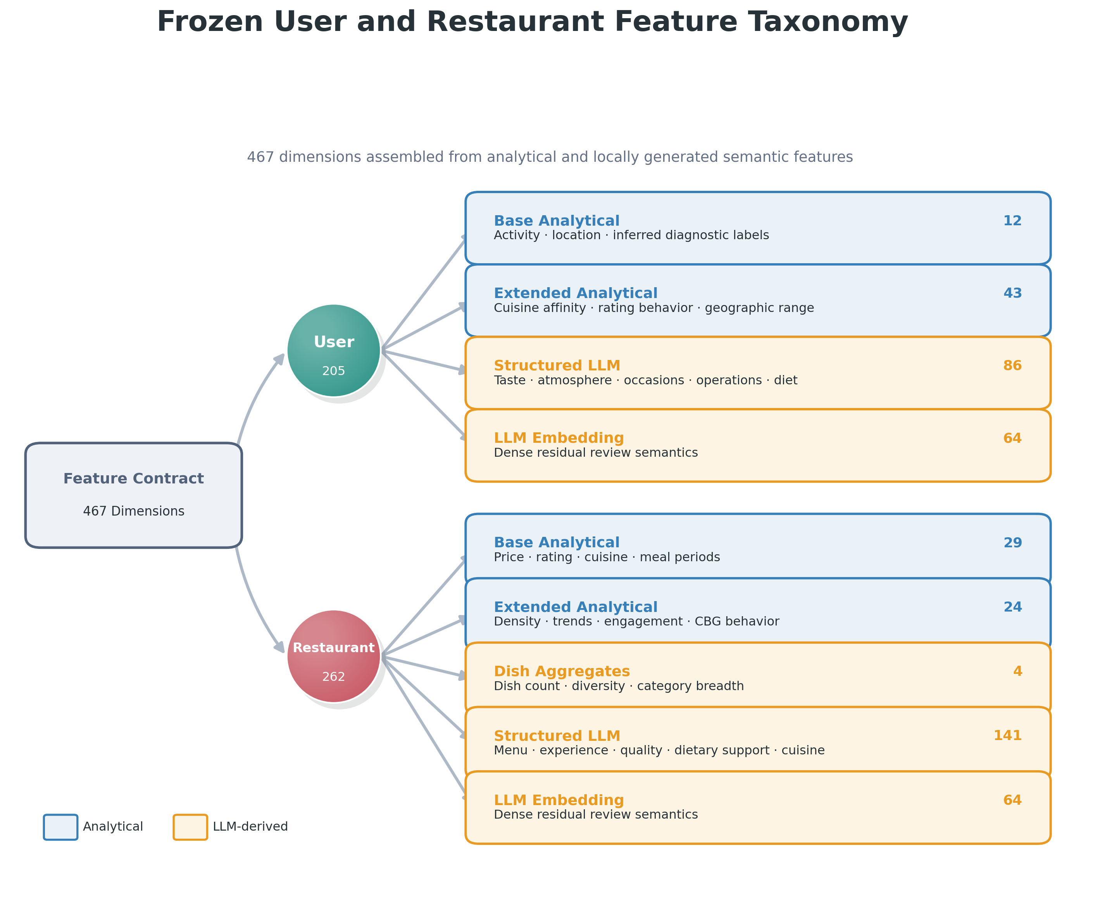
Figure 2. Exact feature-group sizes in the frozen modeling contract. Blue groups are computed analytically; gold groups are derived from the local-LLM pipeline or its dish extraction.
Family | Representative fields | Representation
Behavioral and geographic | activity, rating history, cuisine affinity, meal periods, spatial range | normalized analytical fields
User review semantics | taste, texture, atmosphere, occasions, operations, dietary restrictions | value plus known mask
Restaurant review semantics | menu, experience, service, quality, dietary support, cuisine | evidence-aware scores and typed relations
Residual and menu semantics | 64-dimensional review embedding and training-only dish mentions | dense vectors, aggregates, and dish edges

User-side semantic fields summarize preferences and restrictions inferred from that user’s training history. Restaurant-side fields summarize place metadata and training-safe review evidence. The full-LLM condition is therefore not an embedding-only condition: it combines structured attributes, dense semantic representations, corrected cuisine fields, dish aggregates, and dish relations.

Chronological feature-construction contract
The chronological split is applied before either analytical aggregation or LLM extraction. For each eligible user, the newest unique restaurant is assigned to test, the second-newest to validation, and all older restaurants to training. User profiles use only training interactions. Restaurant review corpora exclude every validation and test review identifier even if the same restaurant has other training reviews. Validation data select model checkpoints and proximity parameters; test data are reserved for final evaluation.
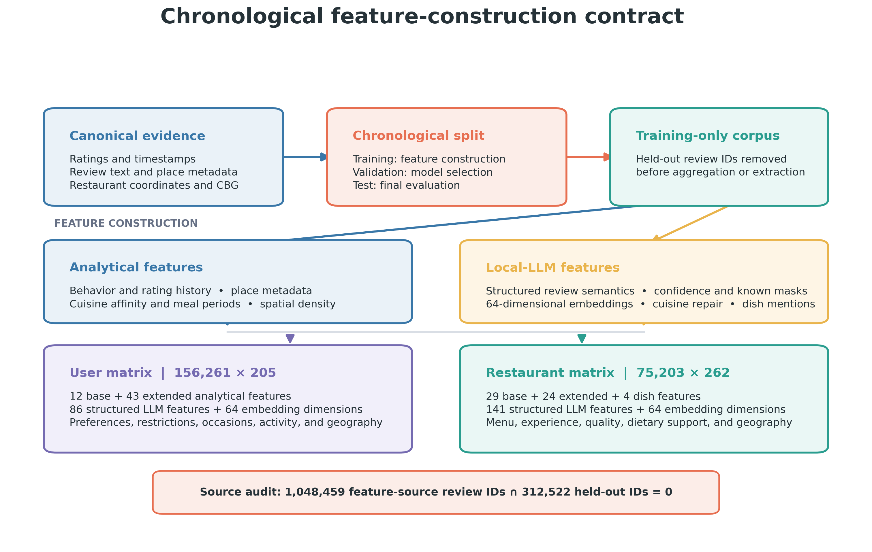
Figure 3. Analytical and LLM-derived features share a training-only source boundary before they are assembled into the frozen user and restaurant matrices.

Evidence-aware treatment of sparse attributes
A missing textual mention is not negative evidence. A review corpus that never discusses outdoor seating does not establish that a restaurant lacks it, and the absence of an observed gluten-free request does not imply that a user rejects gluten-free food. Each sparse semantic value is paired with a known indicator or evidence-strength field. Unknown values are initialized neutrally; the associated mask tells the model that the value reflects insufficient evidence rather than a confirmed negative attribute.
This distinction is especially important for sweetness, outdoor suitability, accessibility, dietary accommodation, and other properties that reviewers mention selectively. Without an explicit missingness representation, review volume and topic prevalence can be mistaken for the underlying attribute.

Source-level leakage audit
Features derived from a held-out review could reveal the target restaurant, sentiment, menu items, and preference language. Leakage control therefore operates at the source-review level rather than only at the final matrix-row level.
Leakage audit quantity | Count
Review IDs used as structured-feature evidence | 1,048,459
Validation and test review IDs | 312,522
IDs in both sets | 0

The zero intersection verifies that the aggregated feature sources and the held-out evaluation sources are disjoint. It does not establish extraction accuracy; that question requires a separate feature audit. It does establish that semantic information from the held-out reviews did not enter the training features through restaurant-level aggregation.

Architecture–feature hypothesis
The controlled evaluation compares a feature-aware Two-Tower reference, LightGCN, and KGAT-SAL under the conventional and full-LLM contracts. Two-Tower tests direct user–restaurant feature matching without graph propagation. LightGCN adds collaborative propagation over the interaction graph. KGAT-SAL adds typed knowledge-graph relations and temporal user views. Holding the split, optimization budget, and random seeds constant allows the next article to test whether semantic augmentation produces progressively larger gains as the model gains mechanisms for relational propagation.

