Evaluation of LLM-augmented graph recommendation and proximity reranking

Abstract
We compare a feature-aware Two-Tower reference, LightGCN, and KGAT-SAL under conventional and LLM-augmented feature conditions. The experiment uses a chronological validation/test protocol, three seeds, and full-catalog ranking over 61,204 interacted restaurants. LLM-derived semantics provide their largest relative gain to KGAT-SAL, the architecture with the richest typed graph. A separately tuned proximity reranker produces a still larger improvement. Segment and rating-aware diagnostics identify where those aggregate metrics do and do not translate into uniform behavior.

Experimental design and controlled comparison
Every model uses the same 772,170 training interactions, 156,261 validation targets, and 156,261 test targets. Models train for 300 epochs with 1,024-dimensional embeddings under seeds 42, 43, and 44. LightGCN uses three propagation layers. KGAT-SAL uses four collaborative-filtering layers, two knowledge-graph layers, three temporal periods, training-only dish edges, and spatial edges between each CBG and its five nearest CBGs. Validation NDCG@10 selects checkpoints.
Model | Features | Hit@10 | NDCG@10 | Relative NDCG gain
Two-Tower | Conventional | 0.01634 ± 0.00015 | 0.00785 ± 0.00010 | —
Two-Tower | + LLM | 0.01649 ± 0.00015 | 0.00796 ± 0.00007 | +1.4%
LightGCN | Conventional | 0.02556 ± 0.00035 | 0.01274 ± 0.00007 | —
LightGCN | + LLM | 0.02677 ± 0.00005 | 0.01338 ± 0.00008 | +5.0%
KGAT-SAL | Conventional | 0.02862 ± 0.00026 | 0.01437 ± 0.00018 | —
KGAT-SAL | + LLM | 0.03200 ± 0.00059 | 0.01614 ± 0.00029 | +12.3%

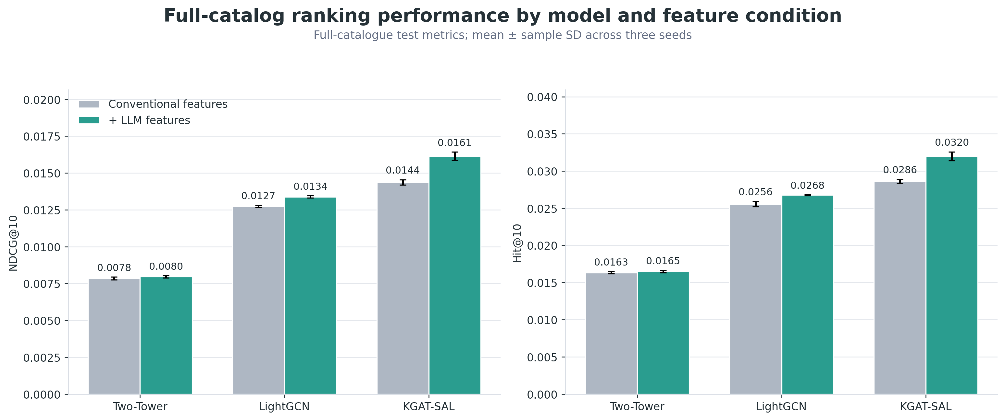
Figure 1. LLM features improve KGAT-SAL more than LightGCN or the Two-Tower reference. Values are means over three seeds; uncertainty is sample standard deviation.
The result establishes an architecture–feature interaction, not a causal account of a particular message-passing path. The same augmented contract changes Two-Tower NDCG@10 by 1.4%, LightGCN by 5.0%, and KGAT-SAL by 12.3%. A focused structured-only versus embedding-only ablation would be required to attribute the gain to one LLM-derived component.

Proximity reranking
Spatial CBG edges allow KGAT-SAL to propagate information among neighboring areas, but they do not force the final top ten to remain near a diner’s observed activity. We therefore compute the median coordinate of each user’s training history and blend a distance-decay term into the model’s top 100 candidates. Alpha, bandwidth, and candidate depth are selected using validation predictions only.
Proximity setting | Value
Distance weight | 0.7
Exponential bandwidth | 5 km
Candidate depth | 100

Evaluation stage | Hit@10 | NDCG@10
KGAT-SAL + LLM | 0.03200 ± 0.00059 | 0.01614 ± 0.00029
+ proximity reranking | 0.04803 ± 0.00038 | 0.02378 ± 0.00018
Relative change | +50.1% | +47.3%

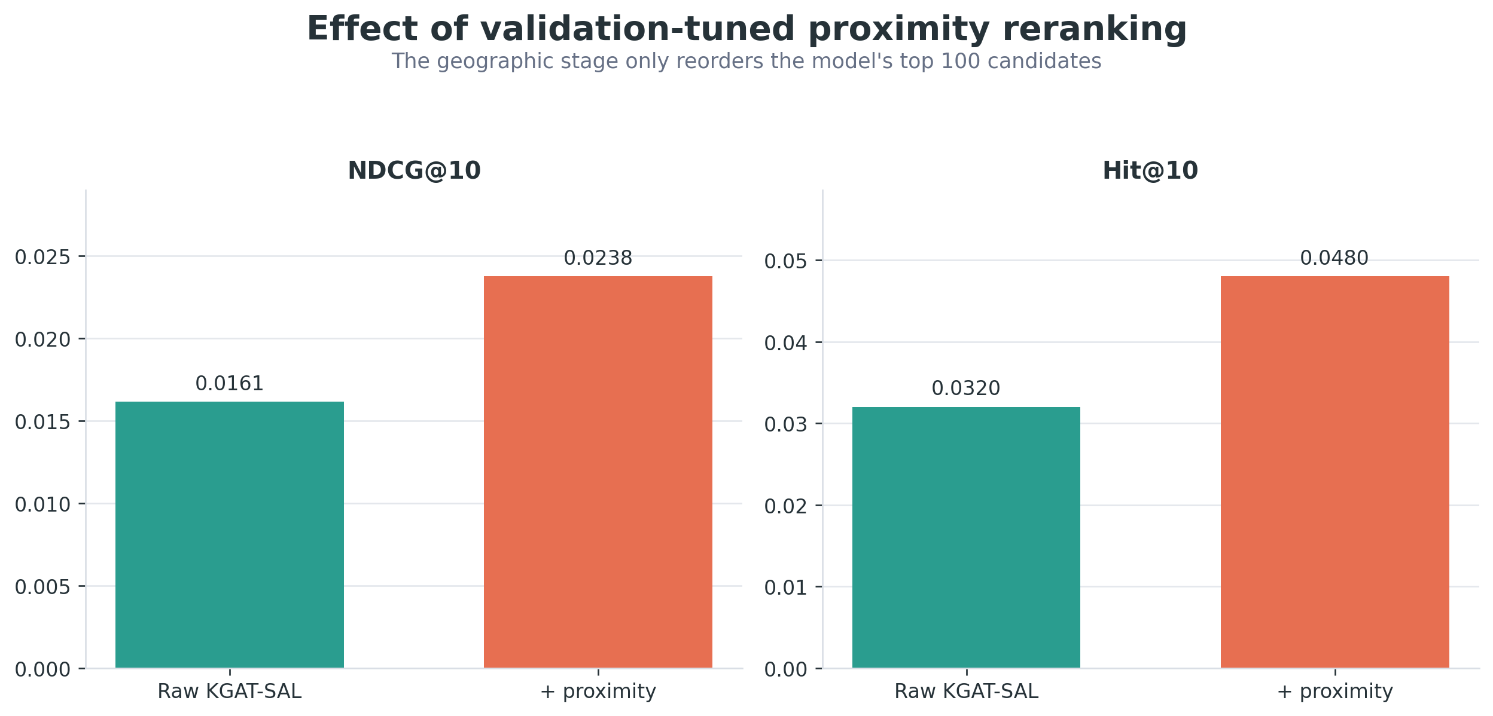
Figure 2. Explicit distance improves both ranking metrics after graph-based candidate generation.

Subgroup performance analysis
The final pipeline is similar across the displayed inferred demographic groups. Female and male Hit@10 values are 0.04859 and 0.04954; corresponding NDCG@10 values are 0.02385 and 0.02456. Across the four reported inferred race/ethnicity groups, Hit@10 ranges from 0.04663 to 0.04874. Because these labels are probabilistic name-inference outputs, this is a descriptive diagnostic rather than a fairness certification.
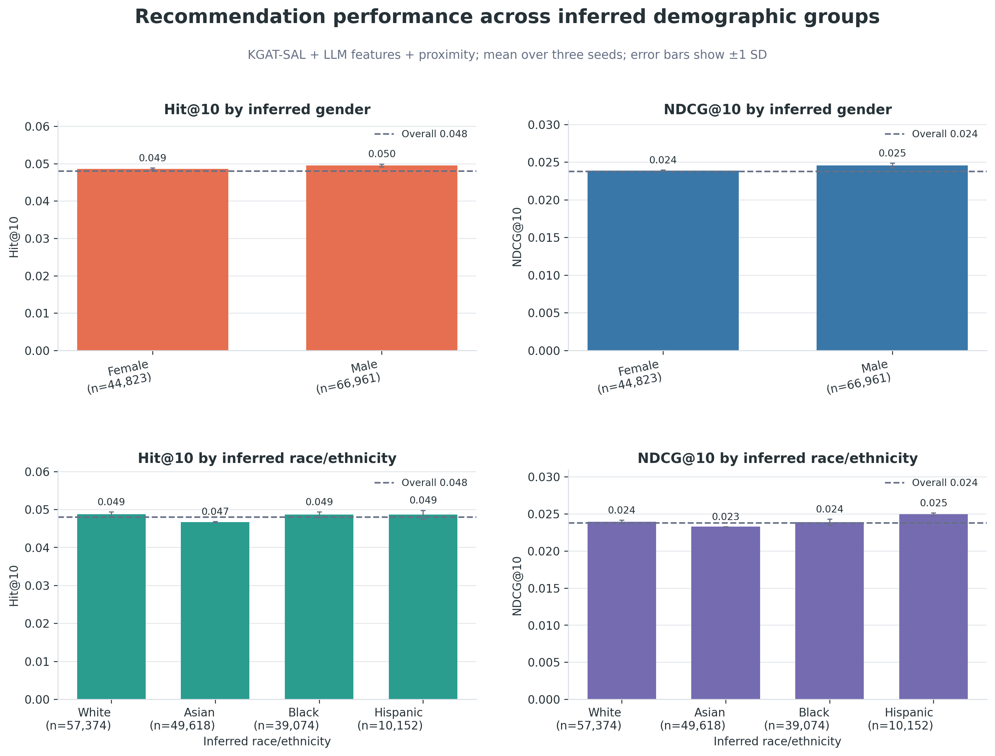
Figure 3. Hit@10 and NDCG@10 by inferred demographic group. Unknown labels are omitted; error bars show variation over three seeds.
Cuisine differences are larger. Among the fourteen most frequent supported target cuisines, Hit@10 ranges from 0.02896 for Mediterranean & Middle Eastern restaurants to 0.07220 for Fast Food & Burgers. Catalogue frequency, chain repetition, interaction density, geographic concentration, and taxonomy breadth are plausible contributors, but the segmented metric alone cannot separate them.
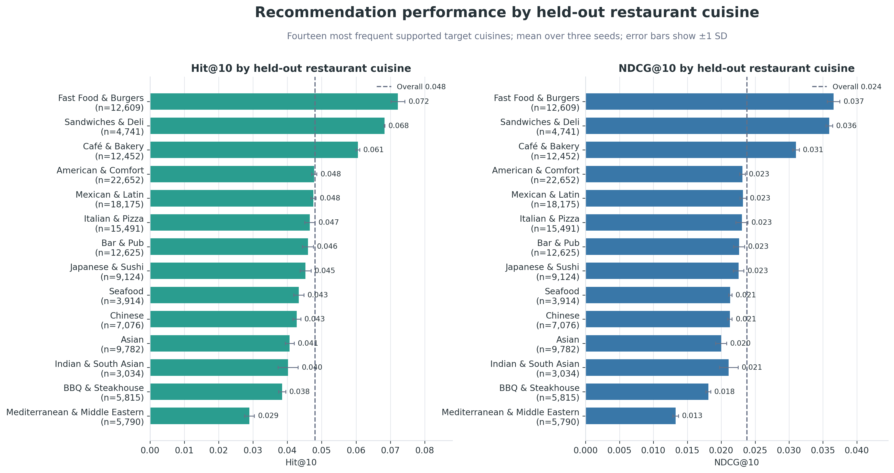
Figure 4. Metrics grouped by the corrected cuisine of the held-out restaurant.

Rating-aware evaluation of retrieved targets
The primary objective treats a visit as relevant regardless of its star rating. A rating-aware diagnostic therefore classifies four- and five-star targets as liked, three-star targets as neutral, and one- and two-star targets as disliked.
Diagnostic after proximity | Value
Positive Hit@10 | 0.03764
Neutral Hit@10 | 0.00439
Disliked-target Hit@10 | 0.00600
Liked share among hits | 78.4%
Liked share among all targets | 80.1%
Disliked share among hits | 12.5%
Disliked share among all targets | 11.4%
Rating-signed discounted utility@10 | 0.01553

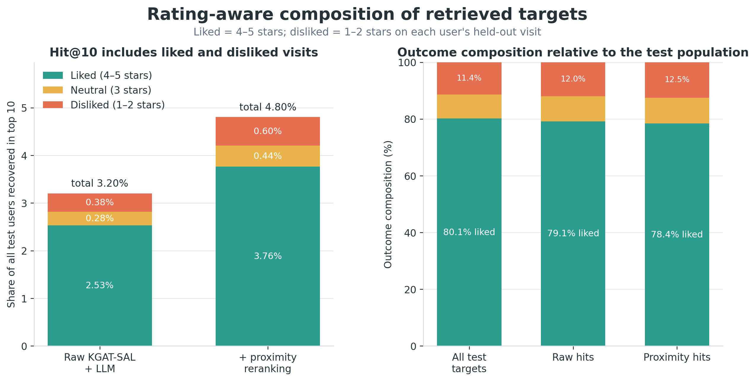
Figure 5. Recovered visits are decomposed by held-out rating. The final model improves visit retrieval but does not preferentially recover more positive experiences than the test population.
The architecture comparison remains valid because all conditions share the same implicit objective. Product interpretation is narrower: if the target is satisfaction rather than revisitation, future work should threshold relevance, weight interactions by sentiment, or train against a utility-aware ranking loss.

