Evaluation of a post-ranking GraphRAG explanation layer

Abstract
The final recommender separates selection from explanation. KGAT-SAL scores the restaurant catalogue, a frozen proximity function reranks the top 100 candidates, and GraphRAG operates only after a restaurant has been selected. It retrieves a compact, training-safe evidence subgraph and asks a local LLM to produce a cited explanation. This design provides traceability without claiming that generated prose is a causal account of the GNN’s internal computation.

Post-ranking explanation architecture
The retrieved subgraph may include:
- restaurants in the diner’s training history and their observed ratings;
- user attributes inferred exclusively from training reviews;
- metadata and supported structured attributes for the selected restaurant;
- cuisine, dish, temporal, and CBG relations; and
- short restaurant-review evidence whose review IDs do not occur in validation or test.
The generator must cite every factual claim using an evidence-node identifier. It cannot access private profile fields, held-out review text, or restaurants outside the already ranked result. The explanation is therefore a grounded rationale for a fixed recommendation, not another ranking step.

GraphRAG recommendation case study
For one activity-stratified audit case, KGAT-SAL and proximity select Elizabeth’s, a fine-dining restaurant in Washington, DC. The diner has 18 training interactions. Four displayed five-star reviews contain direct vegan-related evidence: The Modern was “accommodating to vegan,” Family Meal at Blue Hill was a “good option for vegans,” Stretch Pizza was “vegan with no cheese,” and a Sushi Yasu Tanaka review states “I’m vegan.” The structured user profile summarizes this evidence as a plant-based preference score of 0.9. Elizabeth’s has a supported plant-based offering score of 1.0 and a Google rating of 4.7 from 362 ratings. Training-safe restaurant reviews describe a fully vegan tasting menu, atmosphere, prompt service, and an alcohol-free pairing option.
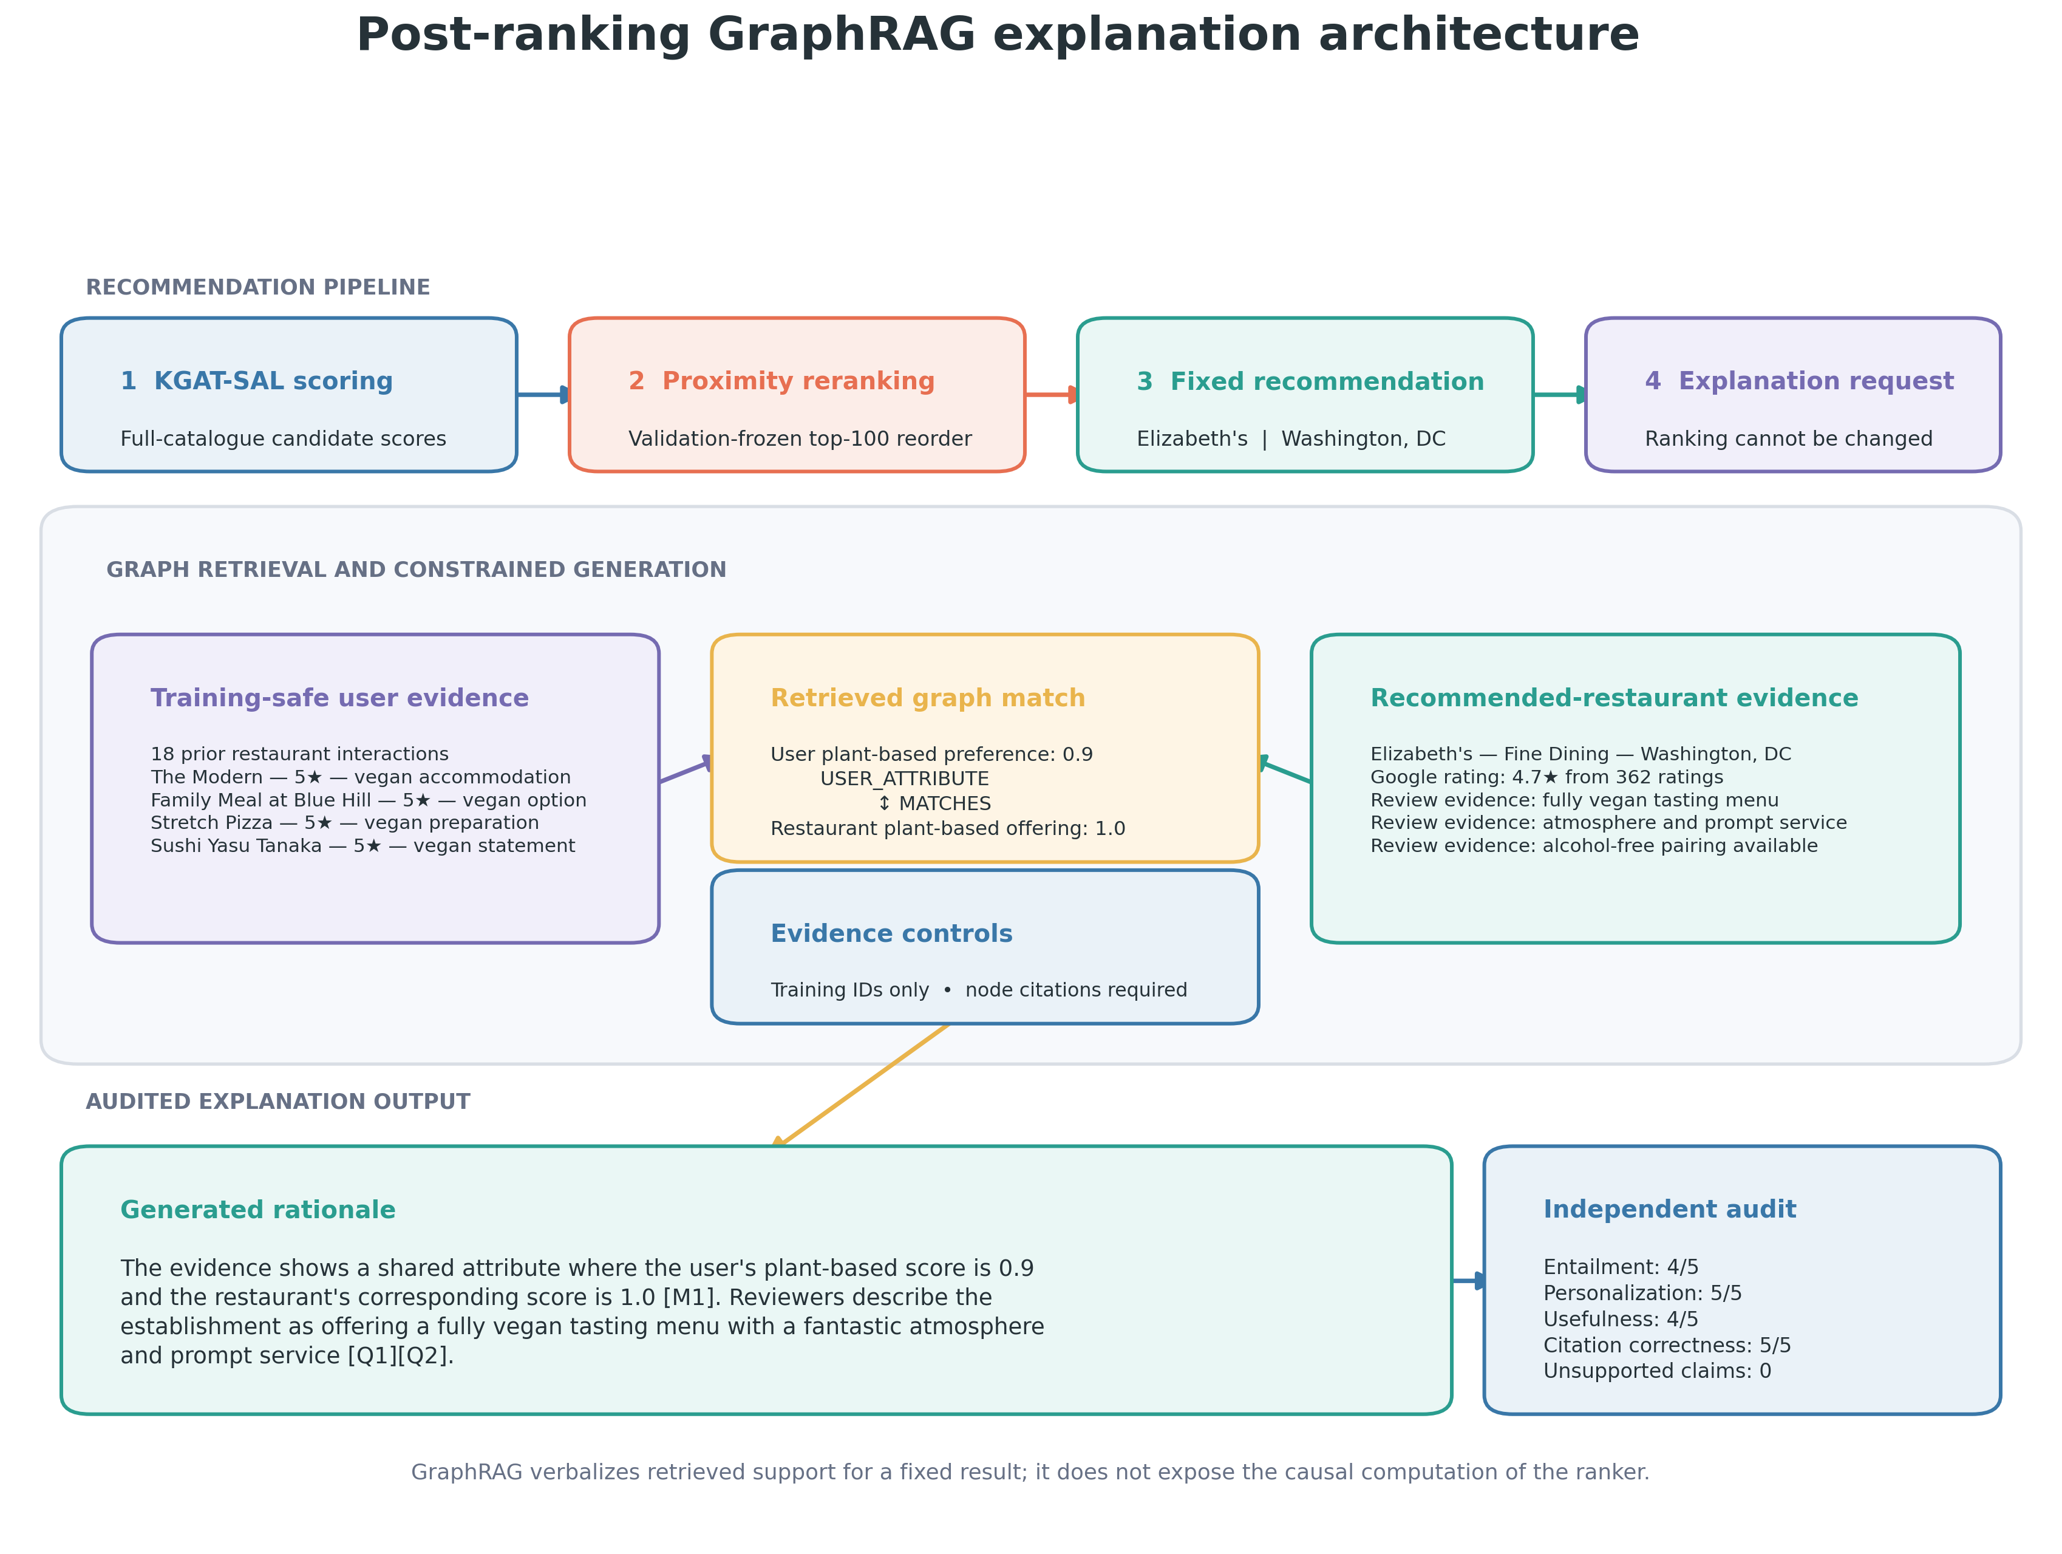
Figure 1. The graph exposes user-side and restaurant-side evidence separately. Node M1 supports the personalized attribute match; Q1 and Q2 support the restaurant description.
The constrained generator produced:
The evidence shows a shared attribute where the user's plant-based score is 0.9 and the restaurant's corresponding score is 1.0 [M1]. Reviewers describe the establishment as offering a fully vegan tasting menu with a fantastic atmosphere and prompt service [Q1][Q2].
The user-facing rationale and restaurant description have different provenance:
Explanation component | Supporting evidence | What it establishes
Why it may fit the diner | H2/H3/H5/H6 → U1; A1; M1 | Multiple training reviews support the user profile, which aligns with the restaurant attribute
What the restaurant offers | Q1 and Q2 | Reviewers explicitly describe a vegan tasting menu, atmosphere, and prompt service
Restaurant identity/context | R1 | Name, category, location, Google rating, and rating count

The independent local judge gave this example 4/5 entailment, 5/5 personalization, 4/5 usefulness, and 5/5 citation correctness, with zero unsupported claims.

Automated explanation audit
The audit uses 100 deterministic top-1 recommendations, with 25 users sampled from each activity quartile. The audit separates deterministic provenance checks from local-LLM quality judgments.
Audit dimension | Result
Supported personalization match available | 79%
Available match cited | 100%
Valid inline evidence identifiers | 100%
Restaurant evidence cited | 100%
Evidence bundles free of held-out review IDs | 100%
Exact short-quote fidelity | 95%
Mean entailment | 3.39 / 5
Mean personalization | 2.34 / 5
Mean usefulness | 2.71 / 5
Mean citation correctness | 3.75 / 5
Unsupported claims per explanation | 0.81

The former “passing checks” plot is intentionally not included in the main article. Binary-looking pass rates combine rule compliance, evidence availability, and generation quality, which can be misread as a single certification. The table preserves the distinctions and makes the central limitation visible: a citation identifier can be valid even when nearby prose overgeneralizes its evidence. The plot remains available as an appendix asset if required.

Scope and limitations
The experiment demonstrates a leakage-safe and auditable explanation architecture. It does not show that GraphRAG reveals the causal mechanism behind KGAT-SAL’s score, and the average automated quality scores do not justify deployment claims. A blinded human audit should evaluate factual support, usefulness, calibration, and whether the personalized relation is meaningful to a user.
The modular division remains useful. The GNN handles relational candidate scoring; explicit distance handles geographic utility; GraphRAG retrieves the evidence needed to verbalize a fixed result. Each component is evaluated against a criterion suited to its role rather than asking one LLM to perform ranking, retrieval, and explanation simultaneously.

