**Assignment given**

1.Feign Client -- done

a) used application.properties instead of application.yml

2. Input Validation - done

3. Call endpoints programmatically in spring -- done

4. GlobalExceptionHandler use ResponseEntity --done

5. Pass Proper paramenter type in map method – done

**Details about Projects**

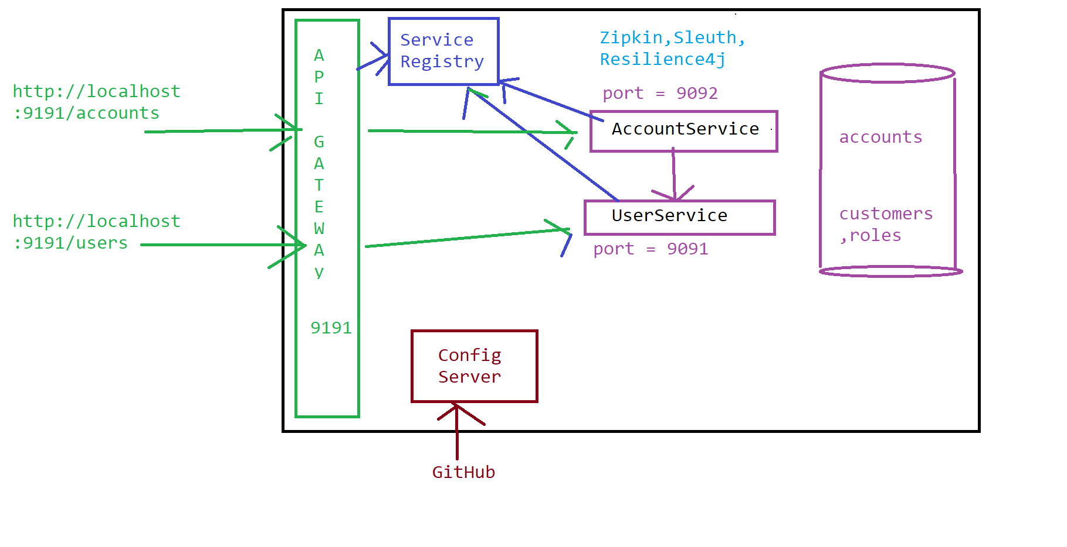

Above workspace has following projects

1. Eureka_service_registry -> Eureka server
2. ConfigServerProject -> fetches eureka client configuration from github and provide to other services
3. CloudAPIGetway -> Common API Gateway to access USER-SERVICE and ACCOUNT-SERVICE by port 9191
4. UserServiceProject -> USER-SERVICE project
5. AccountServiceProject -> ACCOUNT-SERVICE project
6. RestClientWithRestTemplate -> Rest Client project accesses USER-SERVICE and ACCOUNT-SERVICE through API Gateway using RestTemplate

Run Projects in above sequence . In “RestClientWithRestTemplate” project uncomment one by one code to access rest endpoints

In above projects “AccountServiceProject” is calling USER-SERVICE using Feign Client to access user by email.

There are two more projects of assignment

1. LambdaMappingProject -> This project has Mapping.java which has a code for Stream map method
2. SpringBoot3WithJWT -> In this project , spring security with jwt is implemented.