Solution Submission Template

CT/DT Number: CT20172267832
Contestant Name: Swaminathan G
College Name: K.Ramakrishnan College of Engineering

Background
Forecast the electricity consumption of top 3 households with highest number of samples on an hourly basis based on the previous usage pattern. The major features for analysis includes household id, the plans used (standard or dynamic time of use), date, time, meter readings in Kwh and acorn groups

Your Understanding
To Forecast The Energy Usage Of The Persons Who Are Using Large Amount Of Electricity And To Stop The Large Consumption Of Electricity.

Scope
Electricity metering, Demand, Energy consumption, Load factor – Demand/Energy relationship, Power factor.

Assumptions
General Assumptions:
Load forecasting techniques are one of the widely studied aspects using various time series techniques and regression algorithms including ARMA and Neural Networks. Most of the studies in this direction use statistical techniques or Artificial Intelligence (AI) algorithms such as regression, neural networks, fuzzy logic and expert systems.
Consider The Top Three Households Which Consumes Large Number (or) Amount Of Electricity. First Take The Probability Of The Households. The Probability Can Be Measured By The Formula.
P = Number Of ON Events In Hour In i
Total Number Of ON Events
Then Take The Readings Of The Energy Consumed By The Households. For Example Consider The Diagram To Be The Readings Of the Households.
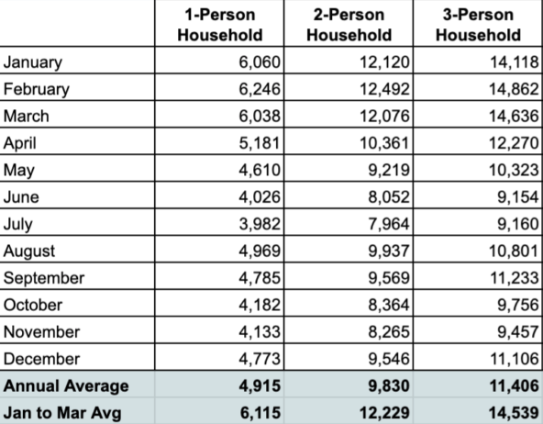
Consider The Average Consumption Of Energy.We Have To Control The Usage (or) Consumption of Electricity To a Normal Consumption.
The modelling exercise for the electricity consumption forecasting for smart meter data was done using Boosted Decision Tree Regression algorithm with Random Grid Search. The Random Grid Search was chosen to make sure that the best parameter applied to the model. A total of five iterations were done during the training phase. Mean Absolute Error was used to select the best model from the Grid Search results. The training and test data split was done using year wise separator. Data from 2010 to 2013 was used as the training set and data from year 2014 was kept as test set. As the current problem is a time-series forecasting, splitting the data by random 70- 30 split or stratified split will corrupt the seasonal phenomena captured though various feature engineering techniques.
Root Mean Square Error (RMSE) and 𝑅^2
are selected as error metric. 𝑅^2 is calculated as the square of correlation between the observed y values and the predicted 𝑦̂ values.
𝑅^2 =∑(𝑦𝑖̂ − 𝑦̅)^2
∑(𝑦𝑖 − 𝑦̅)^2
Otherwise it can be referred as the proportion of variation in the forecast variable that is accounted for by the regression model. If the predictions are close to the actual values,𝑅^2
𝑠ℎ𝑜𝑢𝑙𝑑 to be close to 1. On the other hand, if the predictions are unrelated to the actual values,
then 𝑅^2= 0. In all cases, 𝑅^2 lies between 0 and 1. The use of RMSE is very common error metric
for numerical predictions. Compared to the similar Mean Absolute Error, RMSE amplifies and
severely punishes large errors.
𝑅𝑀𝑆𝐸 = √1/(𝑦𝑖 − 𝑦̂𝑖)^ 2

Solution Approach
The final data set used for modelling exercise consisted of following attributes: day hour index, is the day holiday, name of the day (such as Monday), whether the day is weekend or not,Maximum consumption of the day, minimum consumption of the day, demand in hour minus one And demand in hour minus two. Three iterations of the training with BDTR has performed and Evaluated the model with test data using the NRMSE score. The first iteration was done using Five parameters combination to the BDTR and then 10, 15, 20 and finally 30 combinations. The Combinations and results from the combinations in the training set is provided in the Appendix A. The parameter combination 10, 15 and 20 model reported NRMSE of 1.20, the 30-parameter Combination yielded NRMSE of 1.21 and 5 parameter combination yielded NRMSE of 1.24.
Parameter Combinations | NRMSE in Test Data
5 | 1.24
10 | 1.2
15 | 1.2
20 | 1.2
25 | 1.21

Implementation Framework
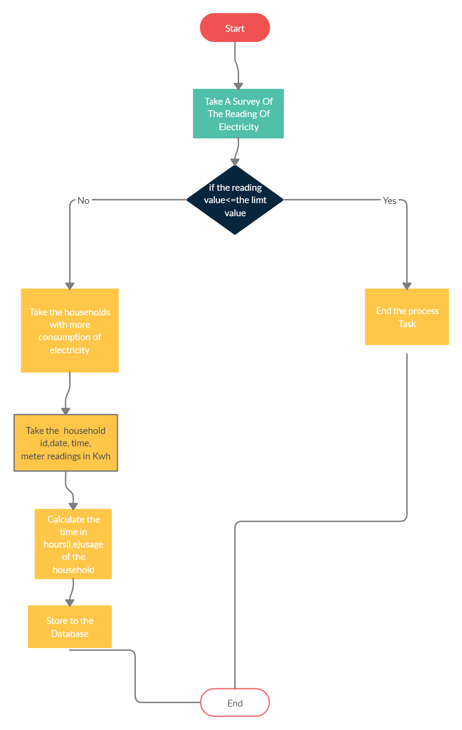
Solution Submission

