Project Name: Bookstore Management Using MySQL
Student Name: Swamini Dangat.
Guide: Mr. Prasad Deshmukh.
GitHub Link: https://github.com/swaminidangat/Book_Store_Managment_System

- Introduction:
This project focuses on designing and implementing a MySQL-based database system for a retail bookstore. The project uses a books table as the core dataset and enhances it to support better data management, analytics, and reporting.
The books table consists of 998 distinct records.
The Schema of books table is:

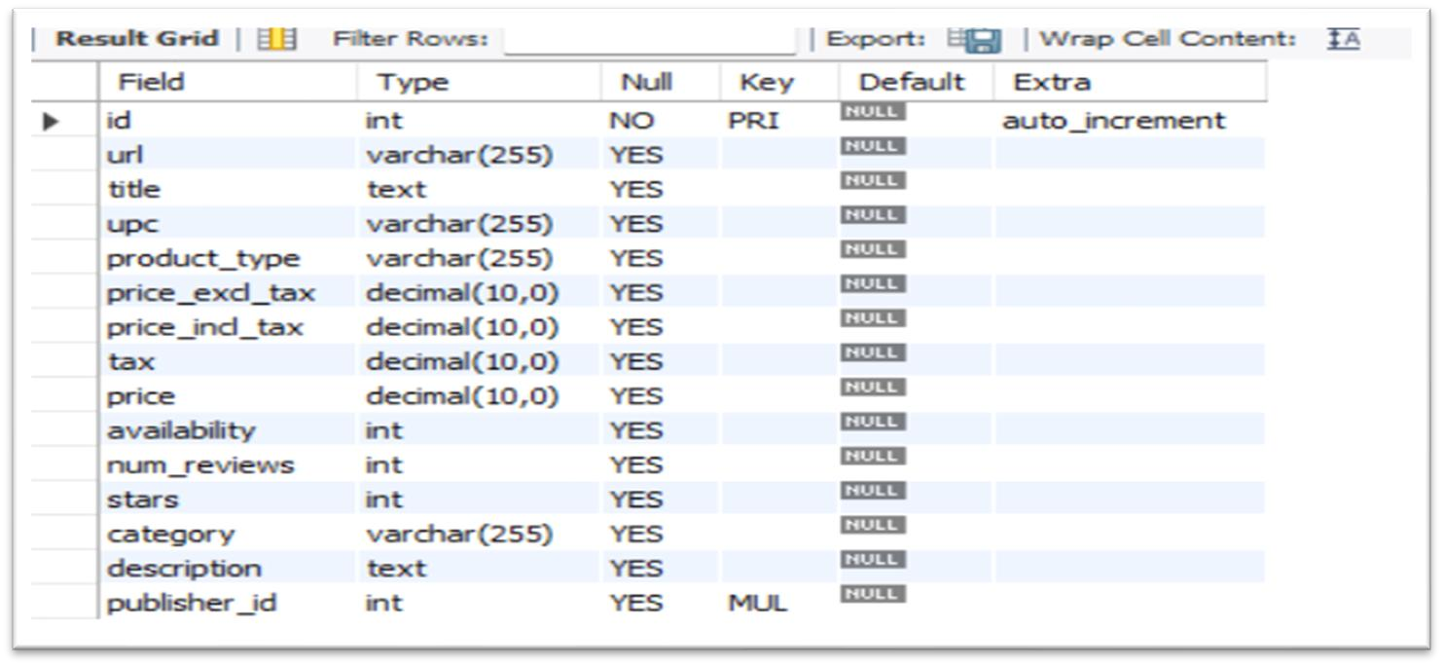
A secondary table, publishers, is added to normalize the schema and improve database structure.
The publishers table contain 10 records and the schema is:

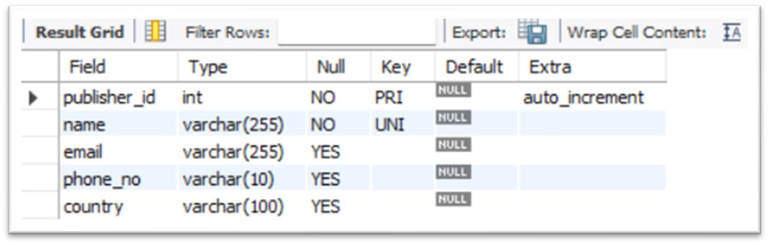
2.Objective:
The main objective of this project is to transform raw book data into meaningful insights.
This project demonstrates skills in data retrieval, aggregation, subqueries, CASE expressions, JOINs, updates, deletes, and schema normalization.

Queries:
1.Data retrieval and filtering:
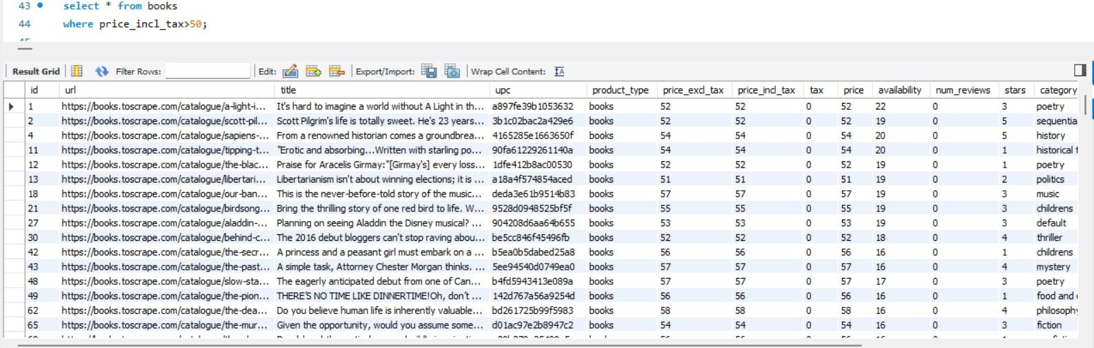

1.

Books price
_incl
_
tax

above $ 50

Interpretation:
Out of 998 total books in the inventory, 189 books have a price_incl_tax greater than $50. 2. Book sorting by price_excl_tax
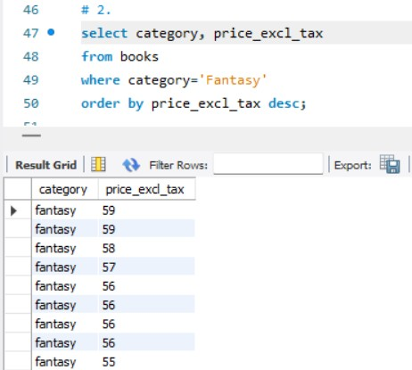

3. Books with 4 or more stars and an availability of 10 or less
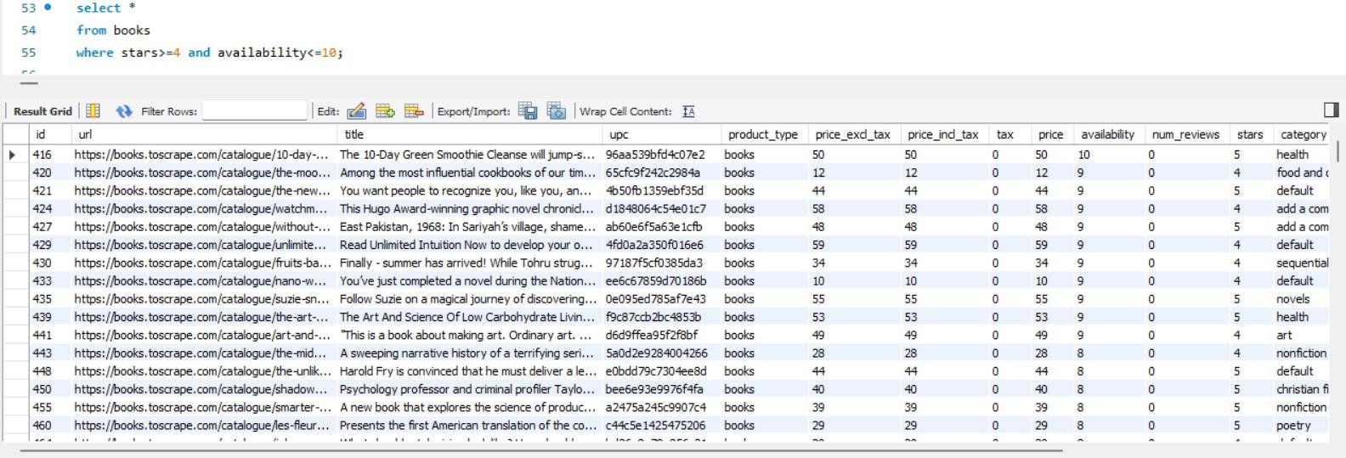
Interpretation:

There are 217 books with a star rating of 4 or higher and availability of 10 or fewer copies. These books are both highly rated and low in stock, indicating strong customer demand. This group of books may require prioritized restocking and plays an important role in inventory planning and sales strategy.

2.Data Aggregation and Analysis

- No. of books and average price for each category
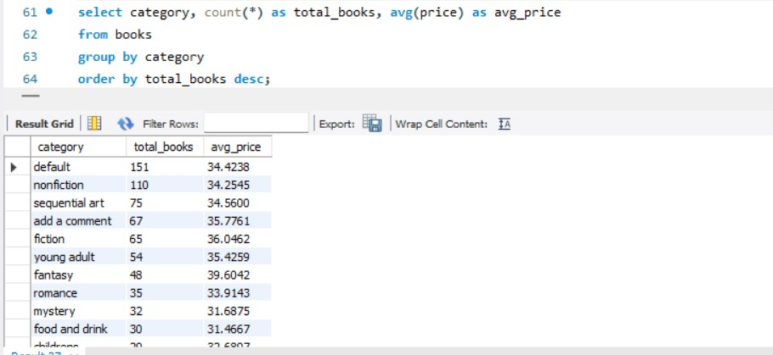

Interpretation:

Default category have maximum number of books (i.e. 151) in the inventory followed by non- fiction having total books 110. But the suspense, novels categories have the maximum avg(price)
(i.e. 58 and 55 respectively).

- Top 5 most reviewed books
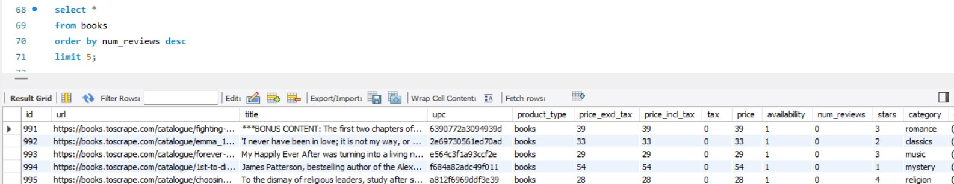
Interpretation:
Above are top 5 most reviewed books. So, inventory management system should add the stock of these books.
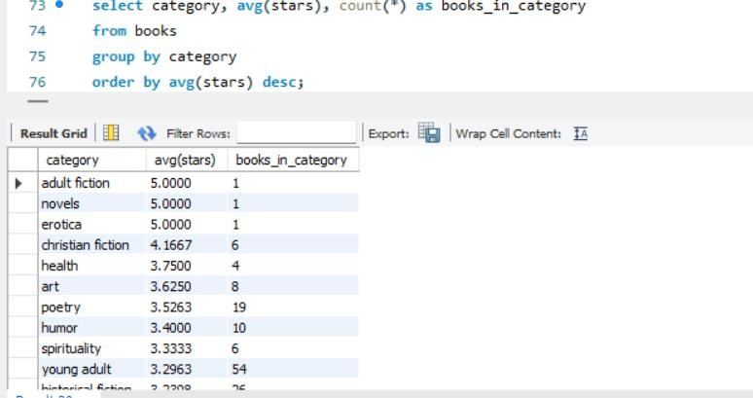
3.

Average star rating for each category

Interpretation:
Adult fiction, novels and erotica categories have maximum rating (i.e. 5). But the number of books is very low. These books should be added.

3.Complex Queries and Reporting

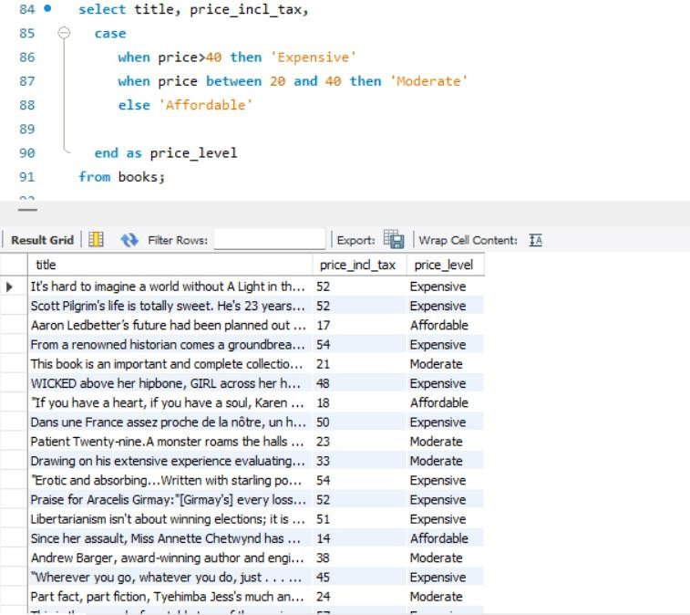

1.

Price levels of every book

Interpretation:
The books are classified in expensive, affordable and moderate based on the price.
- highest price within each category
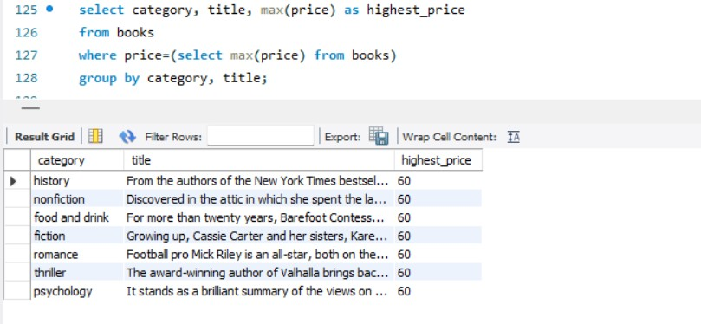

- percentage of books in each category

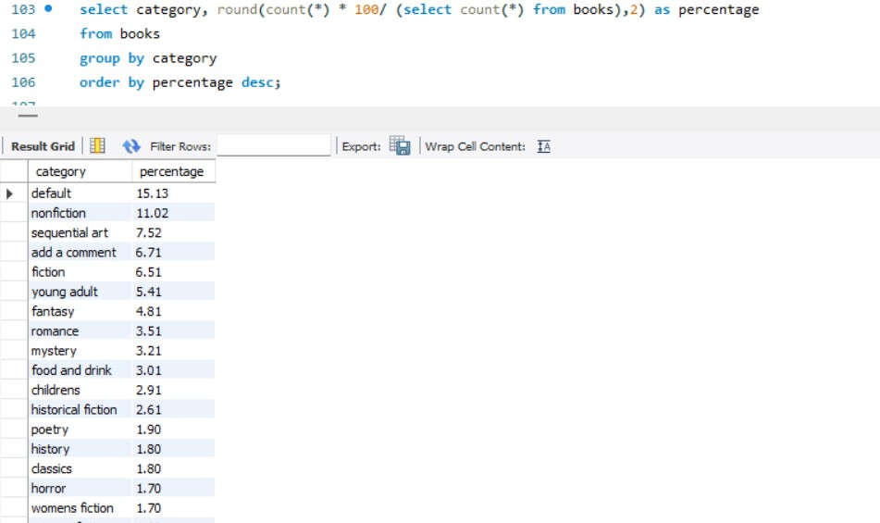

Interpretation:
Default, nonfiction have maximum number of books in inventory.

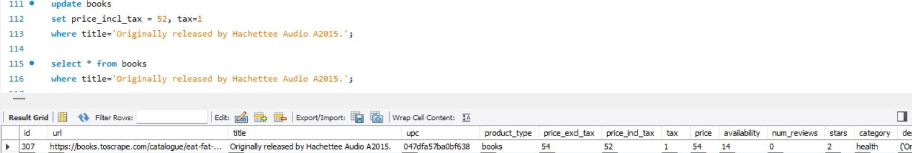
Data Maint
e
n
a
nce and Update
:

1.
4
Update
tax and price_incl_
tax of
one recor
d

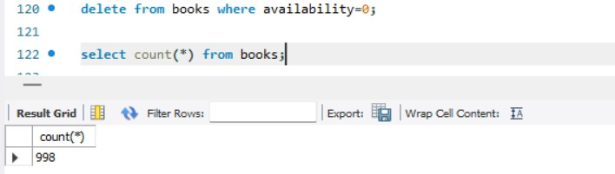
2.

Delete

records

having no
availability of book
s

There is no any book which is not available now. Hence, out of 998 books, all books have availability>0.
▪ Database Design and Schema Improvements
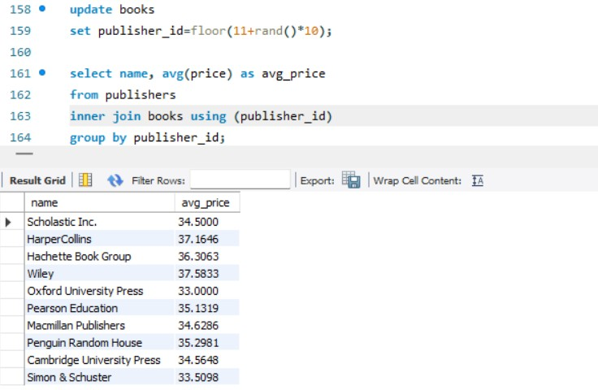

Here, Publishers table is created to calculate the average price of book of each publisher using publisher_id. By using joins, we get the result.

Conclusion:
This MySQL Bookstore Project effectively analyzes the bookstore’s inventory using SQL queries to extract meaningful insights. The results show that while the Default and Non-Fiction categories have the most books, Suspense and Novels contain the highest-priced titles, indicating strong revenue potential. The project also highlights inventory risks, such as many highly rated books having low availability. Schema improvements like adding a Publishers table enhance data integrity and normalization.
Overall, the project demonstrates strong database management skills and provides valuable insights for better inventory and business decision-making.

