American College of Veterinary Anesthesiologists
End of Year Financial report
December 31, 2009

Assets: | 2008 | 2009
Checking Account: Jan. 1 | $196,579.69 | $225,327.33
Dec. 31 | $225,327.33 | $213,075.99
Income:
Dues | $44,550.00 | $47,230.00
Exam Fees | $ 7,080.00 | $ 7,080.00
VAA Royalties | $25,313.73 | $16,575.01
IVECCS registration | $ 5,987.00 | received in ‘10
Sponsorships | $ 3,000.00 | $ 2,875.00
ACVS Symposium | $13,725.00  (‘07 & ‘08) | $6,900.00
Regions Bank CDs & MM closure | $ 13,156.67 | $ 0.00
Interest | $ 361.97 | $2,426.66
Total: | $113,174.37 | 83,086.67
Expenses:
Exam written  oral  total: | $ 7,096.49  $14,031.52  $21,128.01 | $ 8,004.12  $16,172.31  $24,176.43
Meeting scientific  business  total: | $ 2,824.01  $15,079.73  $17,903.74 | $ 1,947.68  $ 7,624.18  $ 9,571.86
Undergraduate Award | $ 196.71* | $ 2,092.24
Job/Task Analysis or NOCA documents | $ 38.35 | $ 285.00
VAA subscriptions | $10,400.00 | $11,881.00
ACVS Speaker Expenses | $ 4,576.52  (’06, ’07, ’08) | $ 3,774.75
Websites: acva.org  acva.org2 | $ 3,377.50  $ 0.00 | $ 2,915.00  $ 2,648.89
Credit Card service | $ 1,041.14 | $ 1,011.69
Teleconferencing Service | $ 789.21 | $ 585.08
Corporate Registration Fees (TN & VA) | $ 20.00 | $ 70.00
Insurance (E & O, D & O) | $ 5,112.77 | $ 5,114.81
Legal Fees (Logo, Foundation) | $ 1,267.65 | $ 2,830.90
Skinner Advertising (plaques) | $ 1,881.04 | $ 1,353.98
Office supplies/postage etc§ | $ 686.80 | $ 867.61
Tax Preparation | $ 780.00 | $ 690.00
Bank Charges | $ 93.10 | $ 58.10
Executive Secretary | $15,000.00 | $19,583.31
Contributions – NAVMEC, WCVA | 0.00 | $ 6,000.00
Total Expenses: | $ 84,292.54 | 95,510.65
Net Profit/Loss: | $28,881.83 | -$12,423.98
Respectfully submitted,
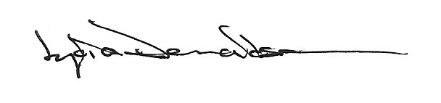

2/28/2010
* cost of VAA subscriptions for 2008 Award recipients billed in 2009
§ general office supplies other than those specifically for award or exam

