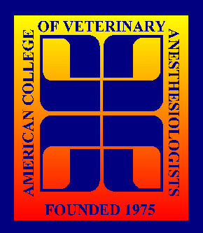
®
American College of Veterinary Anesthesiologists
P.O. Box 1100, Middleburg, VA, 20118 www.acva.org

CAPT Valerie Jensen, R.Ph.
Associate Director
CDER Drug Shortage Program,
FDA Building #22/Room 6202 10903
New Hampshire Avenue
Silver Spring, MD 20993

March 24, 2011
Officers:
President:
Dr. Robert Meyer

President elect:
Dr. Bruno Pypendop

Executive Secretary:
Dr. Lydia Donaldson

Past President:
Dr. David Martin

Board of Directors:

Region 1 & Chair:
Dr. Sophie Cuvelliez

Region 2:
Dr. Stephanie Berry

Region 3:
Dr. Nora Matthews

Region 4:
Dr. Lesley Smith

Region 5:
Dr. Craig Mosley

At-Large:
Dr. Thomas Doherty Dr. Frank Golder
Dr. Eugene Steffey

Dear Captain Jensen:

It has come to the attention of the American College of Veterinary Anesthesiologists (ACVA) that the manufacturer of thiopental has chosen to discontinue manufacture of this drug in the United States. The ACVA, as the American Veterinary Medical Association-recognized certifying body for the specialty of veterinary anesthesiology, provides practice guidelines and recommendations relative to the practice of veterinary anesthesia.

On behalf of our diplomates and our veterinary colleagues in the United States, it is our belief the Food and Drug Administration (FDA) needs to take action to see that this important drug is again made available for veterinary use in the United States. Although other drugs, such as propofol, are currently available, recent production shortages have led to reduced availability of anesthetic induction medications; these shortages can contribute to reduced applicability and safety for animals under our care.

We understand that it is possible to import thiopental from FDA-approved foreign production sites. The ACVA urges FDA to exercise its authority and work collaboratively with foreign governments to import thiopental from foreign manufacturing sites to alleviate the critical veterinary shortage within the United States, and to ensure that animals under our care also have access to this important medication when it is indicated. If intervention or authority beyond the FDA is necessary to secure supplies of thiopental within the United States, we urge the Agency to request such assistance from the Administration.

Thank you in advance for your assistance in this important matter. Please know that you have the full support of the ACVA and its members in this endeavor.

Sincerely,
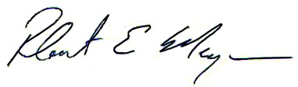
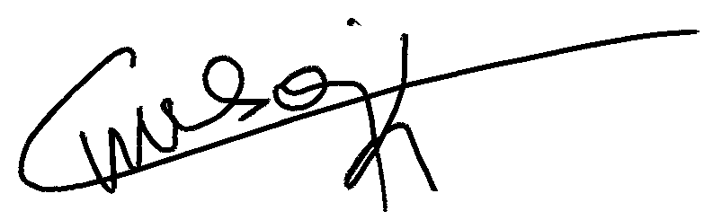

Robert E. Meyer DVM, Dipl. ACVA Sophie Cuvelliez DMV, MS,
President, ACVA Dipl. ACVA, Dipl. ECVAA
Chair, ACVA Board of Directors

Cc: Dr. Bernadette Dunham
Dr. Larry M. Kornegay

