American College of Veterinary Anesthesiologists
End of Year Financial report
December 31, 2010

Assets: | 2009 | 2010
Checking Account: Jan. 1 | $225,327.33 | $212,248.08
Dec. 31 | $212,248.08 | $226,926.89
Income:
Dues | $47,230.00 | $73,241.42
Exam Fees | $ 7,080.00 | $ 8,300.00
Foundation Contributions |  | $ 3,560.38
VAA Royalties | $16,575.01 | $ 5,567.00
IVECCS registration | received in ‘10 | $ 9,510.00
Sponsorships | $ 2,875.00 | $13,980.00
ACVS Symposium | $6,900.00 | $ 6,900.00
Interest | $2,426.66 | $ 2,957.98
Total: | $83,086.67 | $124,016.78
Expenses:
Exam written  oral  total: | $ 8,004.12  $16,172.31  $24,176.43 | $20,385.33  $ 7,949.09  $28,334.42
Meeting scientific  business  35th Anniversary  total: | $ 1,947.68  $ 7,624.18  $ 9,571.86 | $ 7,230.15  $ 8,004.24  $ 7,018.81  $22,253.20
Undergraduate Award | $ 2,092.24 | $ 2,393.53
Job/Task Analysis or NOCA documents | $ 285.00 | 0.0
VAA subscriptions | $11,881.00 | $11,899.00
ACVS Speaker Expenses | $ 3,774.75 | $ 2,697.63
Websites: old acva.org  new acva.org | $ 2,915.00  $ 2,648.89 | $ 2,890.00  $ 3,182.51
Credit Card service | $ 1,011.69 | $ 1,161.49
Teleconferencing Service | $ 585.08 | $ 843.76
Corporate Registration Fees (TN &/or VA) | $ 70.00 | $ 20.00
Insurance (E & O, D & O) | $ 5,114.81 | $ 5,114.81
Legal Fees (Logo, Foundation) | $ 2,830.90 | $ 779.75
Skinner Advertising (plaques) | $ 1,353.98 | $ 1,268.12
Office supplies/postage etc* | $ 867.61 | $ 518.82
Tax Preparation | $ 690.00 | $ 685.00
Bank Fees | $ 58.10 | $ 30.00
Executive Secretary | $19,583.31 | $24,999.96
Financial Support (NAVMEC, WCVA, ABVS) | $ 6,000.00 | $ 895.90
Total Expenses: | $ 95,510.65 | $109,967.90
Net Profit/Loss: | -$12,423.98 | $14,048.88
Respectfully submitted,
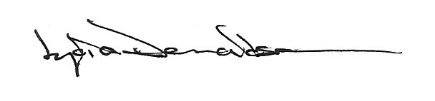

2/3//2011
* general office supplies other than those specifically for award or exam

