**GitHub Link:** [**https://github.com/swamy1199/Assignment8**](https://github.com/swamy1199/Assignment8)

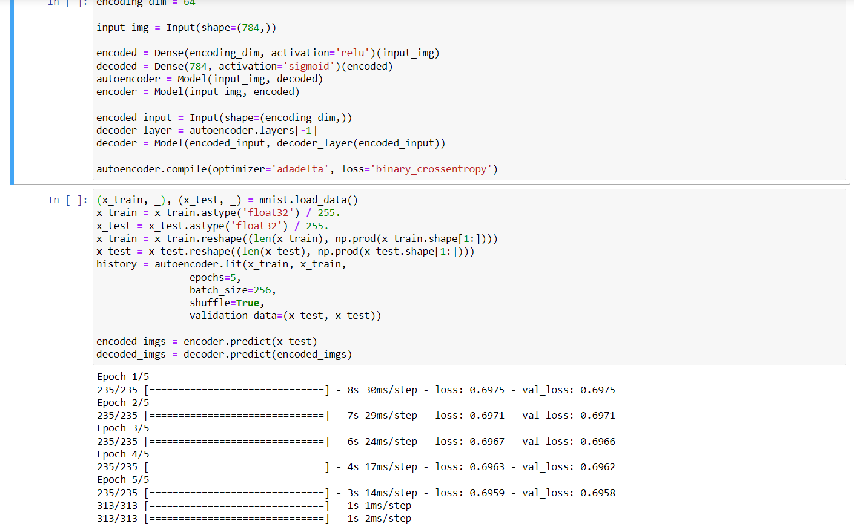

Autoencoder without hidden layer.

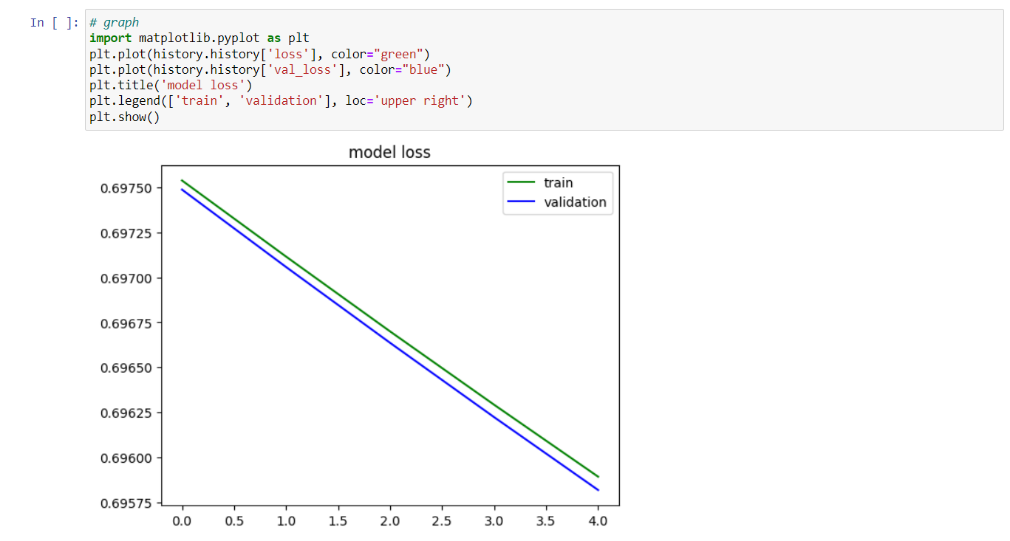

Graph for validation and training.

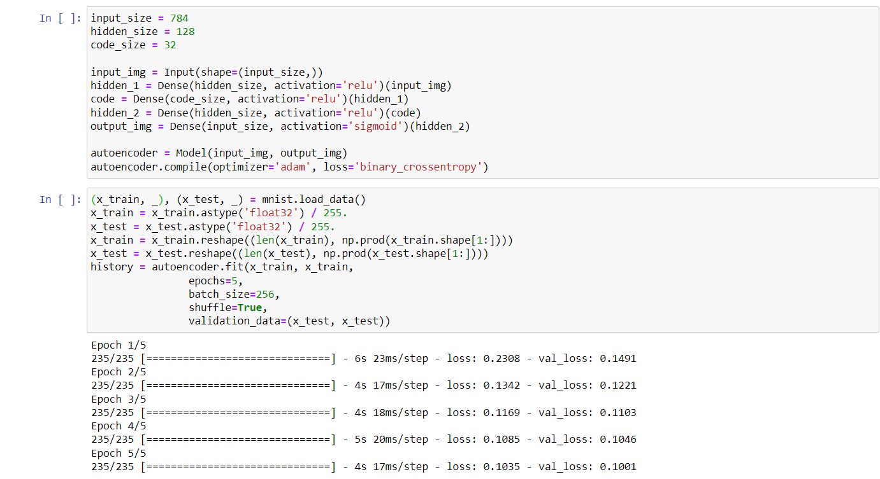

Autoencoder with hidden layer. Here the validation loss is 0.1001.

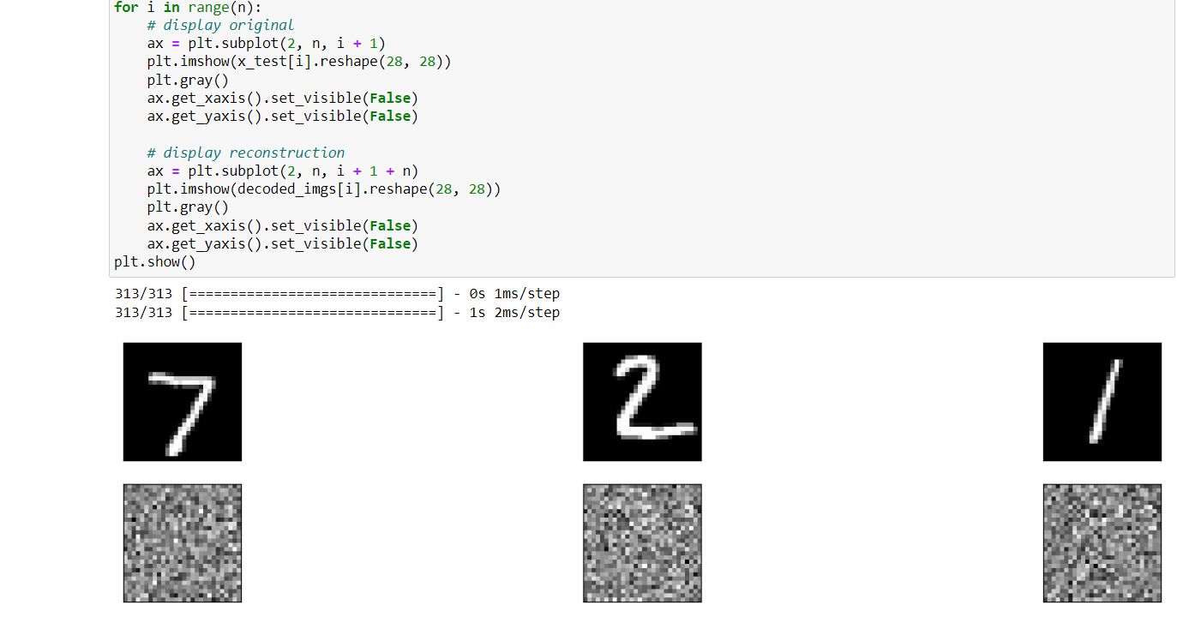

Printing original and reconstructed images

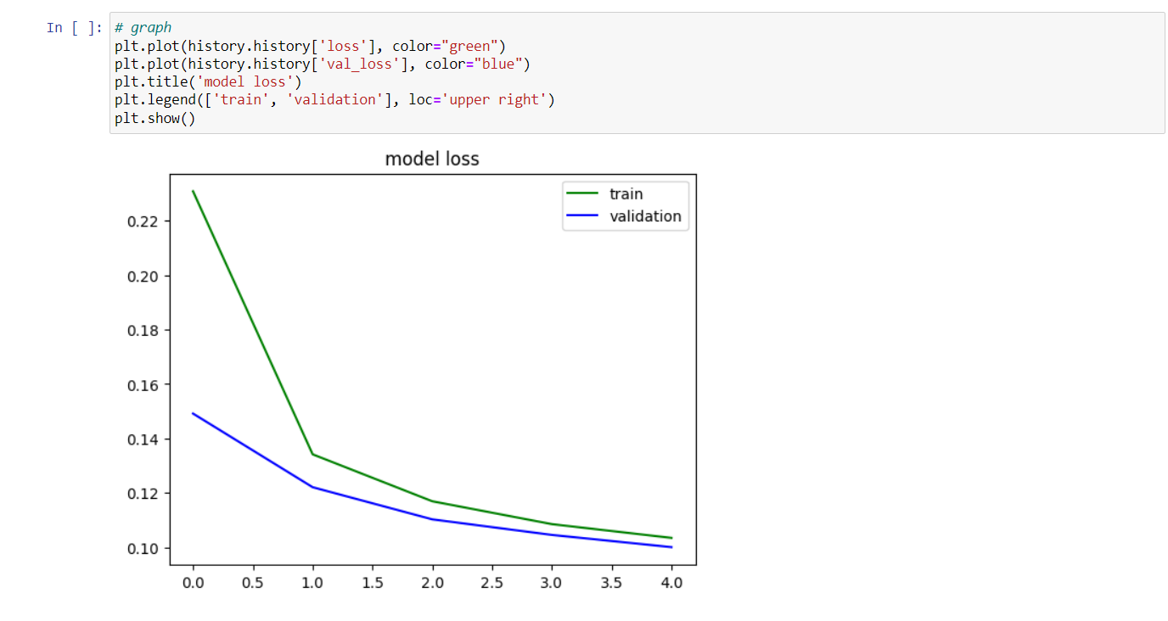

Printing model loss after adding hidden layer.

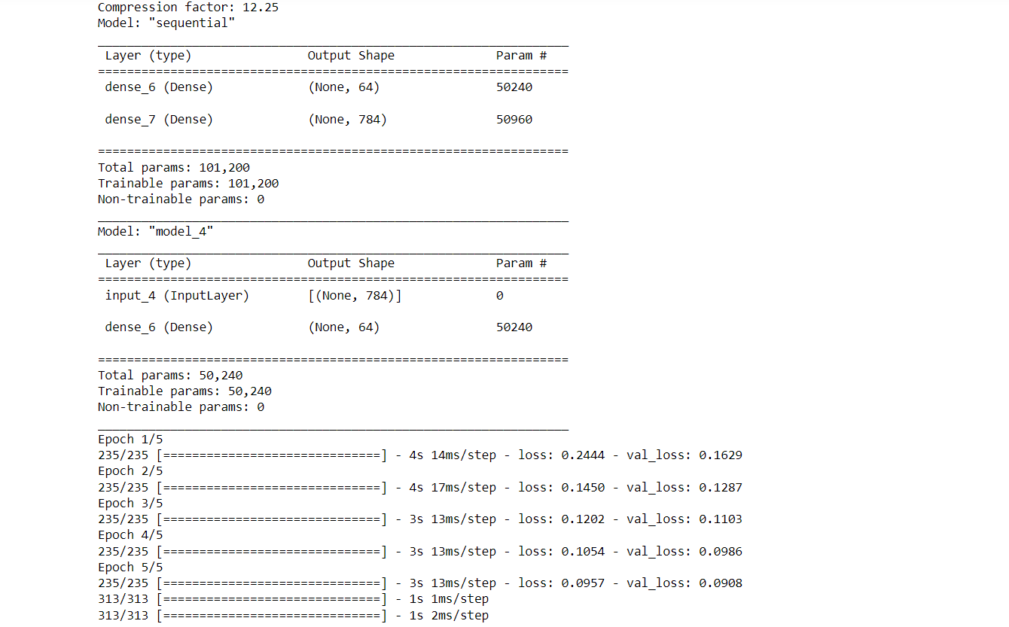

Computing and printing compression factor, and validation loss.