Sign in into the git hub

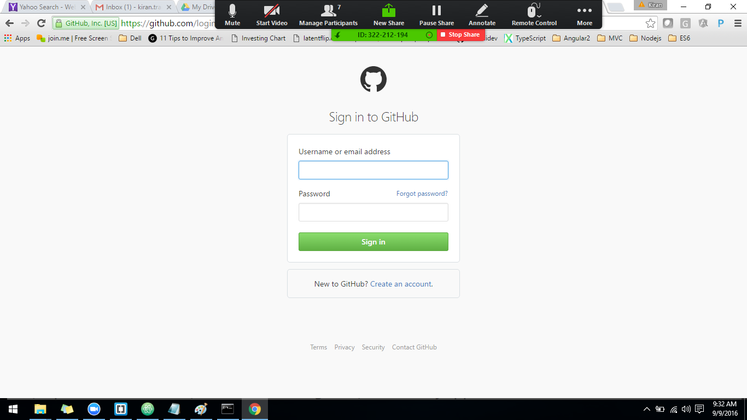

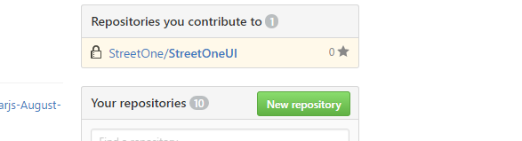

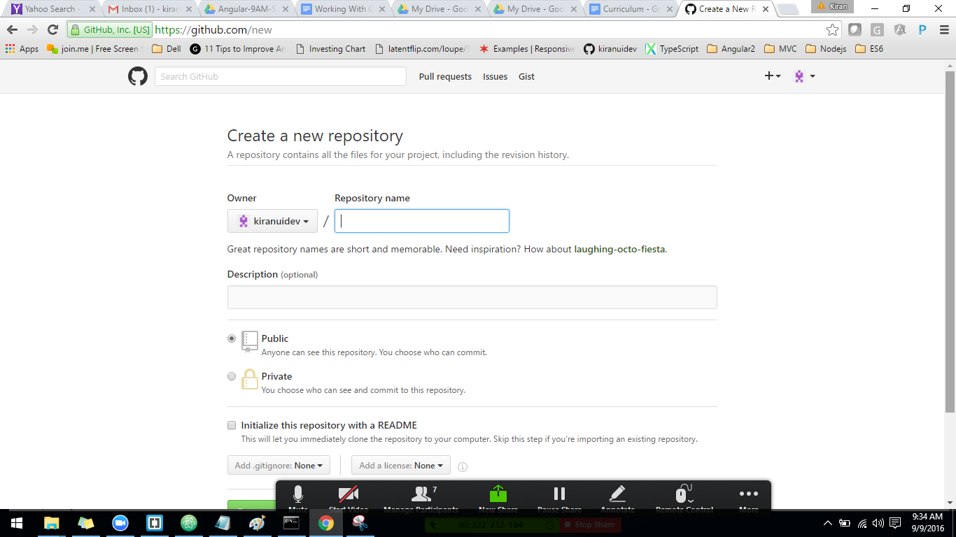

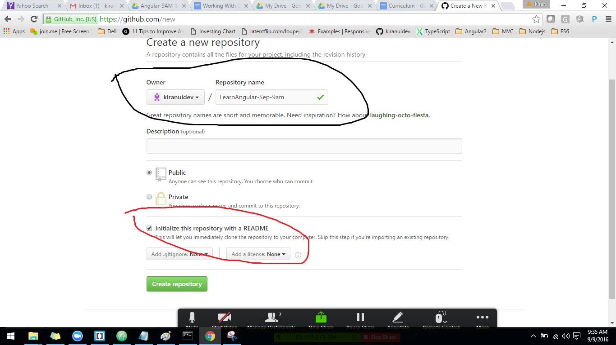

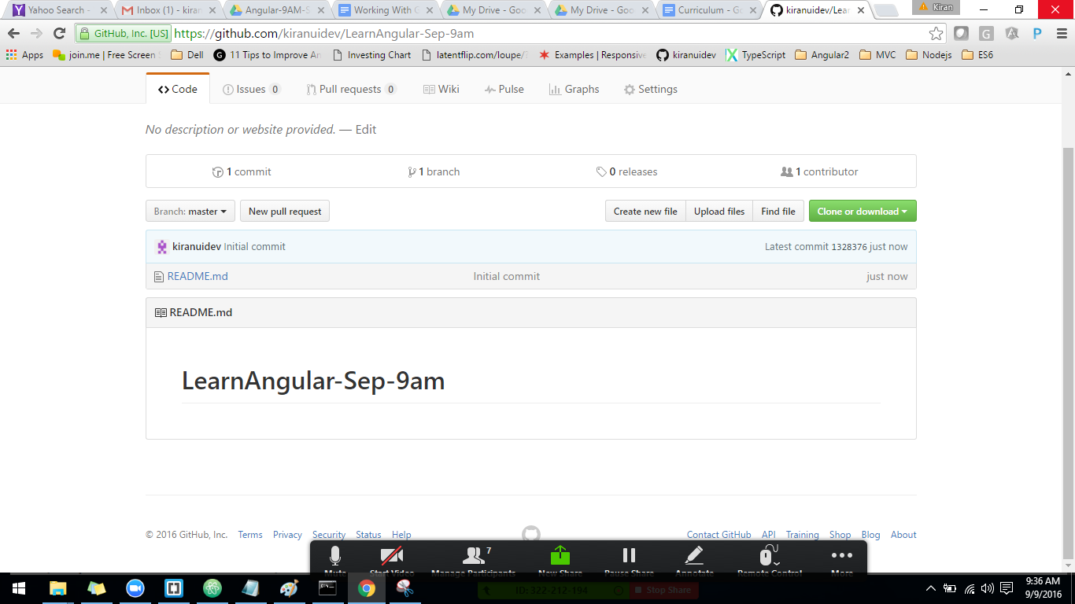

\

Cloning a repository:

Create a working folder in you system drive

Navigate through the command prompt that folder.

git clone <https://github.com/kiranuidev/LearnAngular-Sep-9am.git>

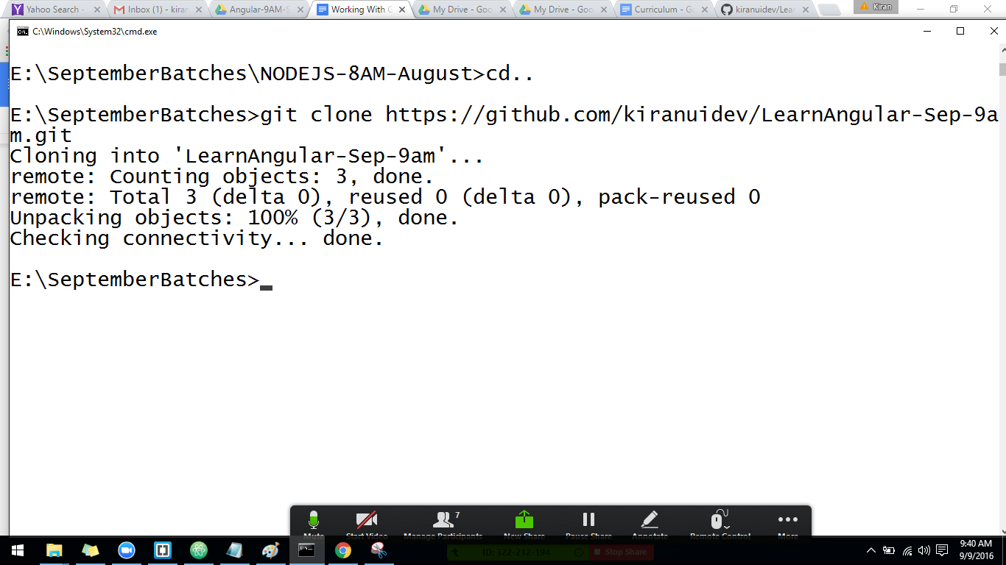

Creating branch

-- git checkout -b <branchname>

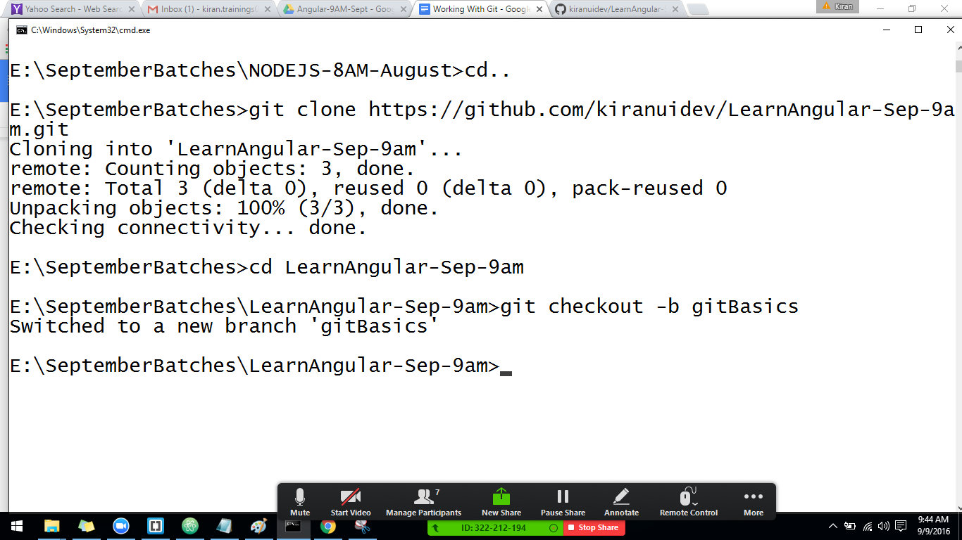

Git branch will give you the list of branches avaialble.

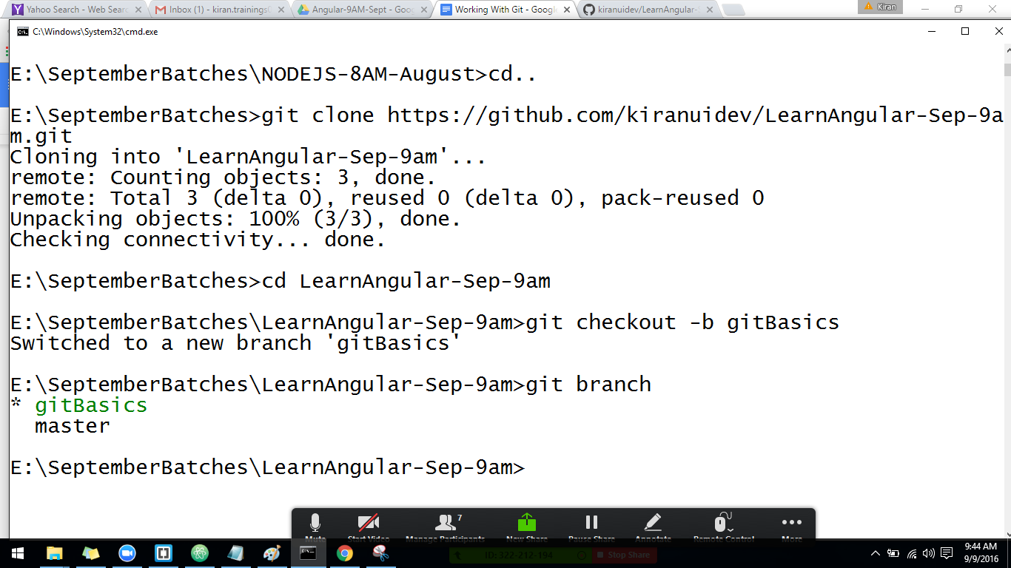

Switching between branches.

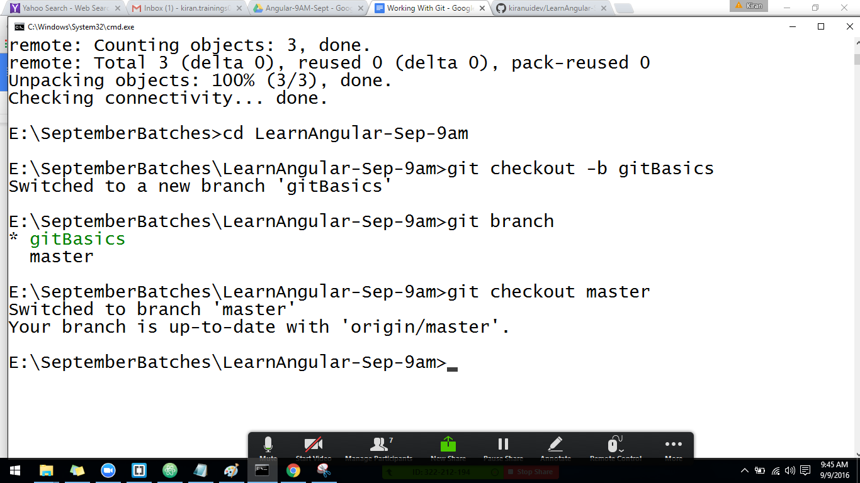

Add a modified file locally to the git

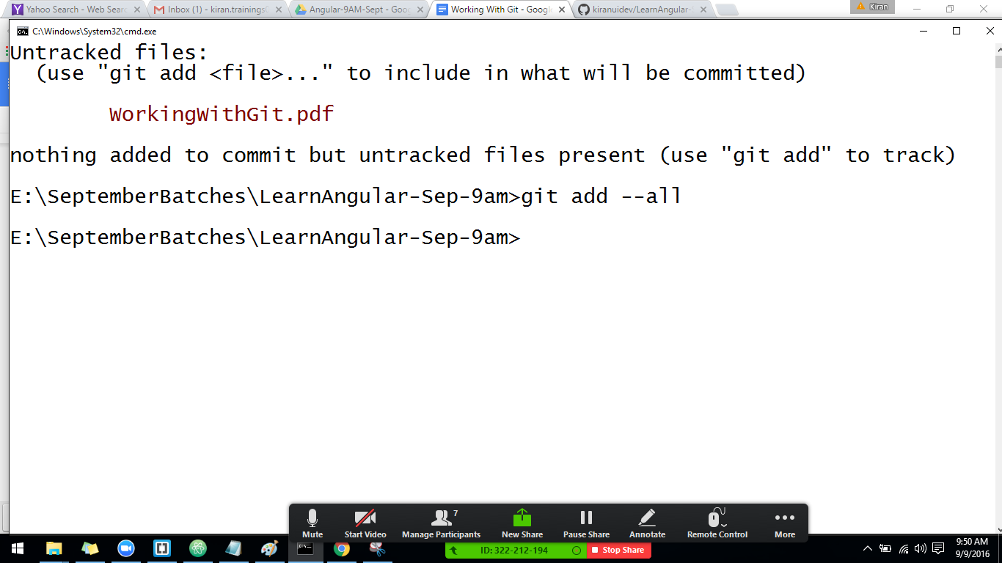

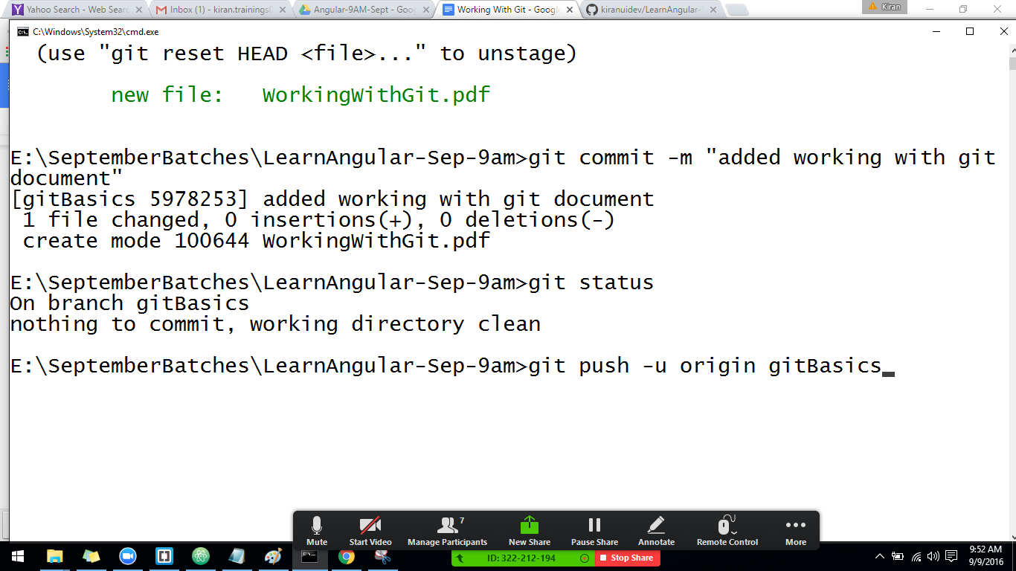

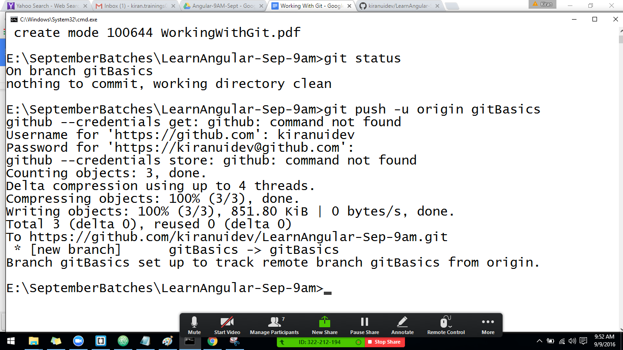

To take the latest code

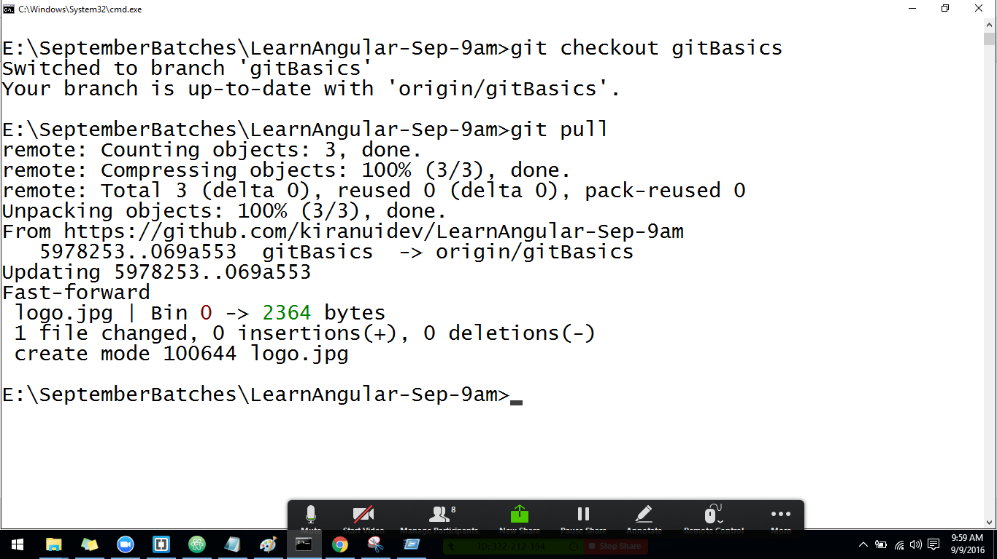

To clone the repo--

git clone <url>

Once we make the changes to the code

git add --all

To commi the changes.

git commit -m

to push the changes.

git push -u origin branchname

to the latest code

git pull