**USE-CASES OF IoT**

**Introduction:**

Internet of Things is a technology that has slowly gained momentum and is now silently shaping our future. IoT is such a result of humankind’s curiosity and intention to lead a convenient and connected lifestyle, reducing labour and eliminating the chances of human errors. That is why we decided to make devices smart and take care of things that will draw out efficiency.

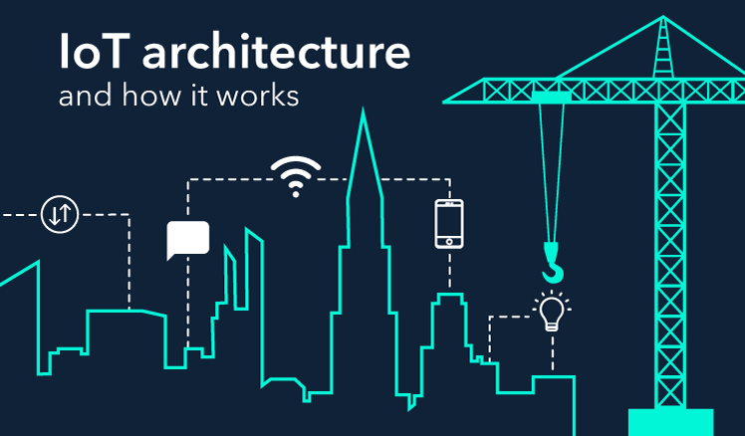

Let us see some of the use cases of IoT in our day to day lives and know how it has changed our lives smarter and convenient.

The following are the some of the use cases of IoT:

**Smart Parking:**

In cities parking is a big problem. With IoT sensors, parking problems ina a city can be minimized.

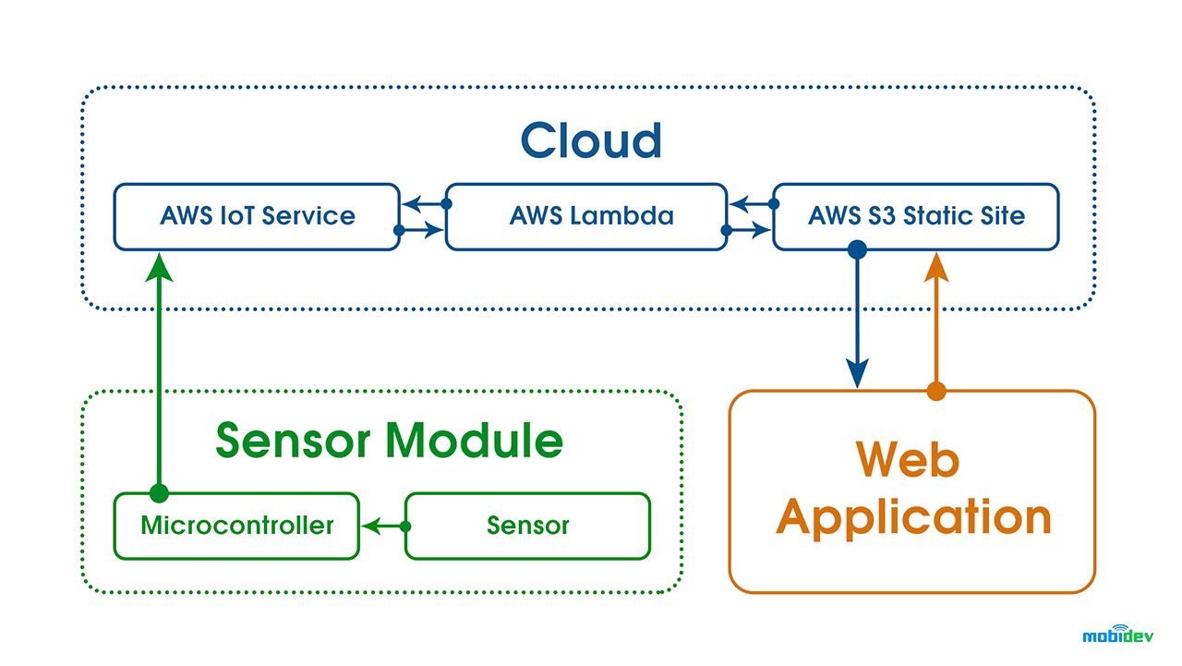

The IoT device consists of an ESP8266 microcontroller and an HC-SR04 distance measurement sensor. The sensor periodically measures the distance and transmits this data to the microcontroller, which is connected to AWS IoT service via the MQTT protocol.

**Smart Lighting:**

Smart lighting aims to optimize the energy management.

Smart lighting is made up of street lighting with the IoT sensors. Sensors collect data about the condition of traffic and pedestrians. With that data, streetlights provide optimum lighting so that street lighting systems can save up to 80% of the energy.

Smart lighting can also be applied to factories or homes.

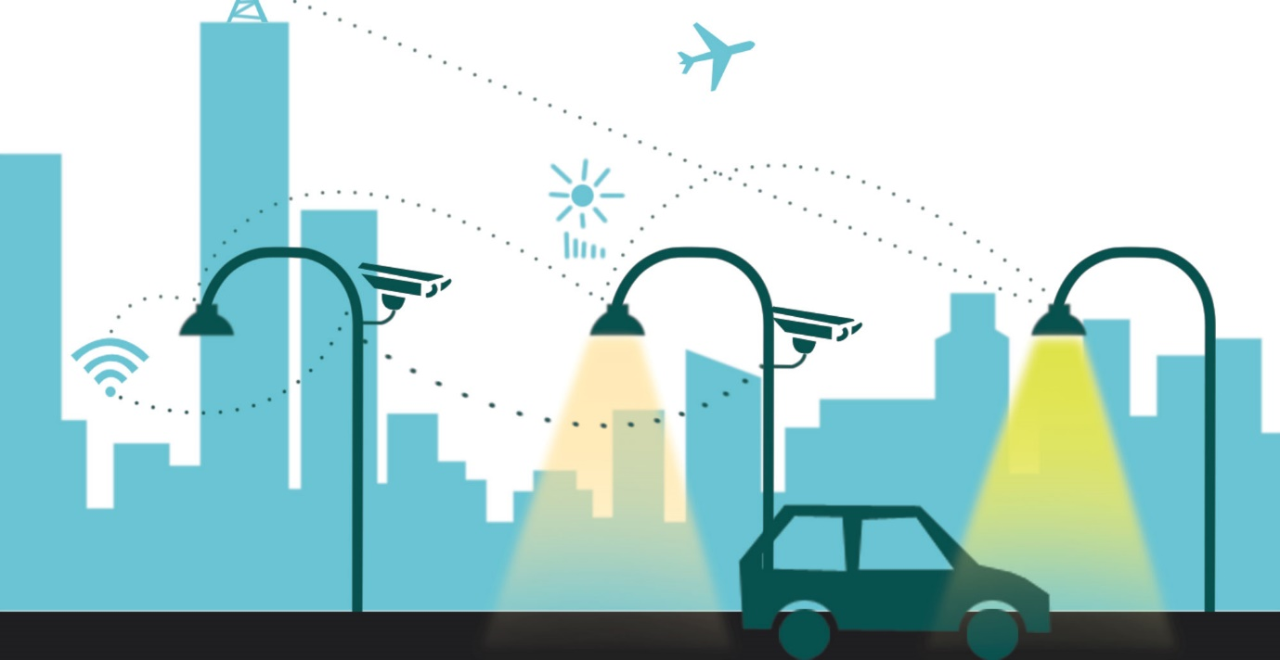

**Noise Monitoring:**

Internet of Things (IoT) technology is one of the best choices to monitor the noise or sound intensity in the environment for the safety of human being. In smart cities, sound monitoring systems can monitor noise levels and warn companies that violate limits and help manage noise levels.

**Outdoor Surveillance:**

When IoT CCTV cameras combined with AI and machine vision, governments can automate surveillance of streets through cameras. As the IoT enables the connectivity of machines, they are able to record and analyse video data in real time, and they can provide police officers with insights instead of single pieces of images.

However, outdoor surveillance processes personal information and there is potential for abuse in use of such technologies. Therefore, appropriate checks and balances need to be implemented in such systems to ensure that personal information is not abused while risk of crime is minimized.

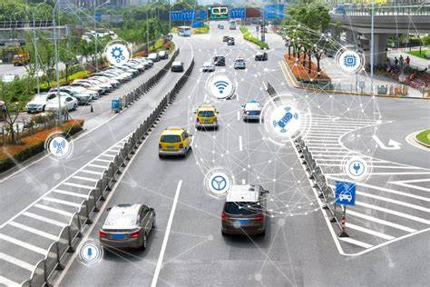

**Water Conservation:**

A smart water management system ensures protection from water damage, flooding, and unpleasant surprises in your water bill. The digital system identifies unusual water consumption, both, in open and concealed areas. The system alerts you immediately about water leaks and closes the main water supply itself, even when you are not at home. IoT sets a new standard for water technology worldwide. IoT offers full control by syncing the system with mobile devices through mobile and web app for simple and precise management of water consumption in the home. You determine how, how much, and when all over click of a button. Using the mobile app, you receive real-time alerts about abnormal and unexpected situations, and you can manage and control them remotely, saving lots of money yearly.

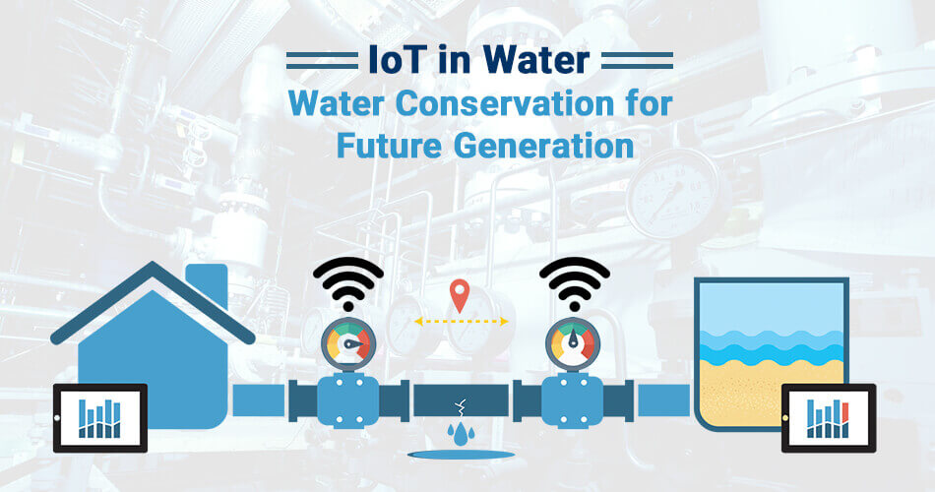

**Water Quality management:**

IoT sensors determine the what kind of chemicals are in the water.They also identify metrics such as total dissolved solids(TDS), bacteria, chlorine, electrical conductivity, etc.This will assist in accessing the real-time, precise quantification of results and will also offer the capability to pinpoint the difficult areas.

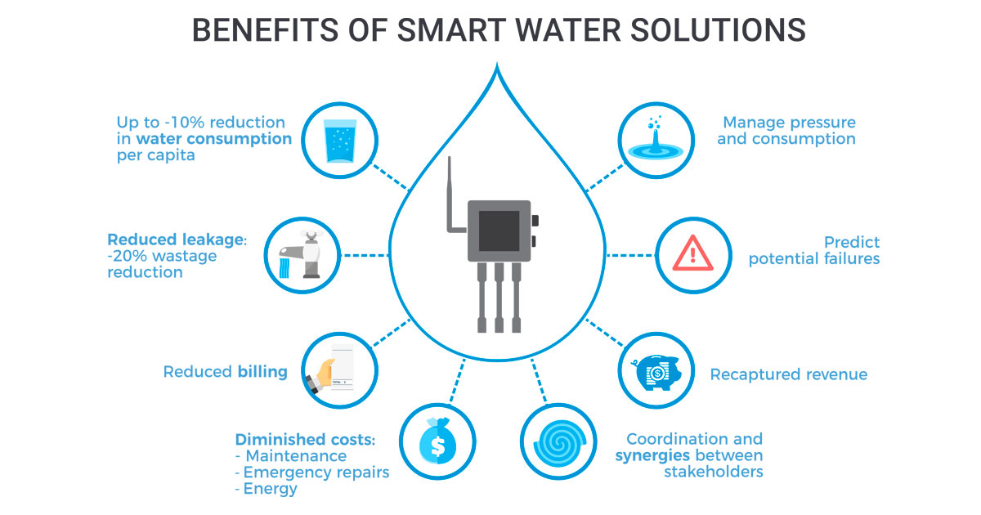

**Smart Irrigation:**

Smart irrigation technologies help people precisely schedule when lawns and crops need to be watered and **how much water** these plants require. Using IoT/M2M sensors, growers can monitor the soil moisture levels around their plants, as well as monitor weather conditions, so they can use water more efficiently and effectively.

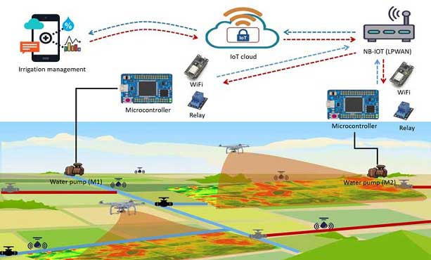

**Waste Management:**

Traditional waste collections are complicated and costly since a fleet of trucks drives along the busy streets using inefficient routes. Fill levels of garbage containers differ for each container: ranging from overflowing, partially filled and empty. IoT sensors can monitor fill levels for conventional bins and send the data to the relevant department of the city hall. With that information, the garbage truck routes can be optimized for trash collection.

Machine learning methods can also be implemented in IoT sensors (i.e. edge analytics) so that sensors can predict the fill levels of containers by learning from historical data.

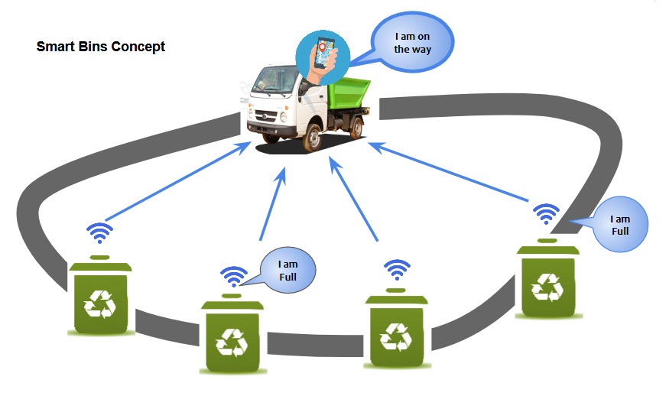

**Smart Homes**

Remote Control Appliances:

IoT powered home appliances let residents remotely switch on and off devices using smartphone apps to avoid incidents and save energy. Additionally, these devices can make autonomous decisions based on sensor inputs such as preparing fresh coffee when a resident is identified to wake up. Other examples of autonomous or remote-controlled actions include:

* turning on lights,
* starting the coffee maker,
* setting temperature,
* open up a music playlist,
* locking doors.

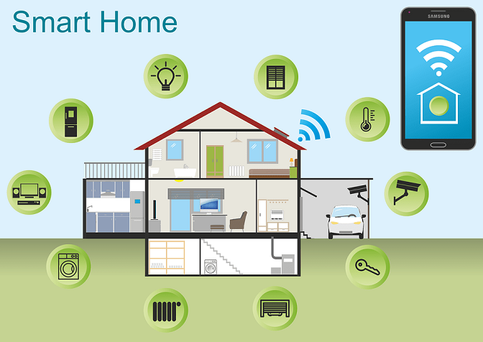

**Medical Fridges:**

Medical fridges monitor the temperature of vaccines, medicines and organic elements for clinics and health centres. Medical fridges provide an opportunity to follow all safety standards and national regulations of the pharmaceutical market using IoT sensors. They prevent medicines and vaccines from spoiling.

Efento is an IoT sensor an IoT platform vendor that has a variety of temperature measurement products along with wireless monitoring of temperature in medical refrigerators.

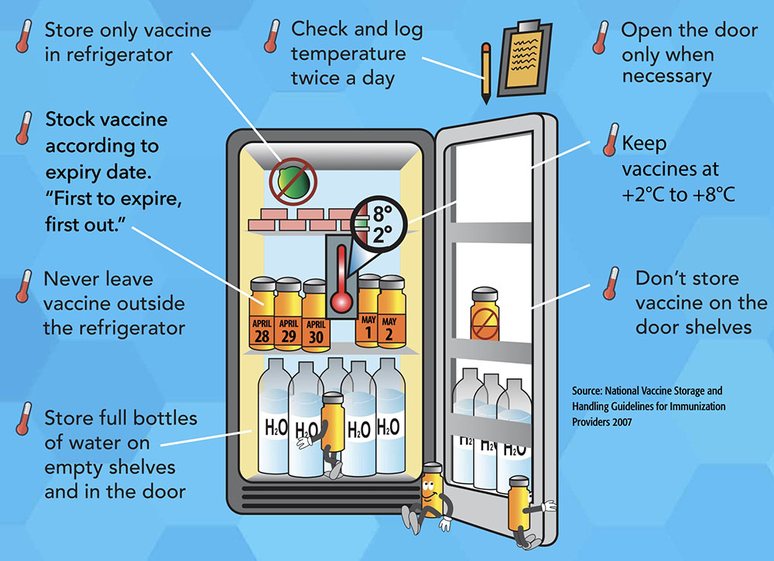

**Patient Surveillance/Remote Patient Monitoring:**

[20%](https://www.iotforall.com/iot-tackling-data-access-remote-patient-monitoring/) of patients who had surgery are readmitted to the hospital within just 30 days. Remote patient monitoring (RPM) systems use wearables to monitor the condition of patients who are resting at home after surgery. RPM enables real-time data collection about patients’ body temperature which is the main indicator of infections. With RPM, doctors can observe patients’ data and provide early diagnoses without requiring patients to be physically present at the hospital.

Telit is an IoT solution vendor and offers its customers a remote patient monitoring (RPM) solution that enhances patient monitoring capabilities and patient satisfaction. Telit’s offering can reduce:

* patients hospital stay duration thanks to early diagnosis of complications
* hospital readmissions

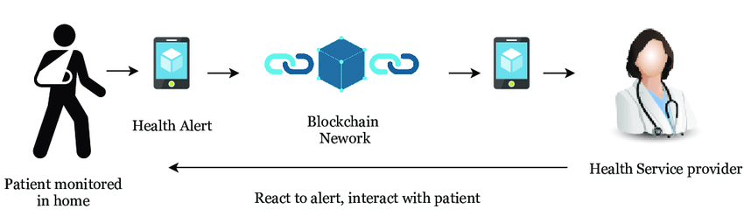

**Ultraviolet Radiation Monitoring:**

Sunlight consists of three major components:

* Visible light: Wavelengths between 0.4 and 0.8 micrometres,
* Ultraviolet light: Wavelengths shorter than 0.4 micrometres,
* Infrared light: Wavelengths longer than 0.8 micrometres.

Ultraviolet (UV) rays are electromagnetic waves that account for about 10% of solar light. When overexposed, UV rays have harmful effects such as skin cancer, premature aging, cataracts, and immune system suppression. IoT sensors measure UV sun rays to warn people not to be exposed in certain hours.

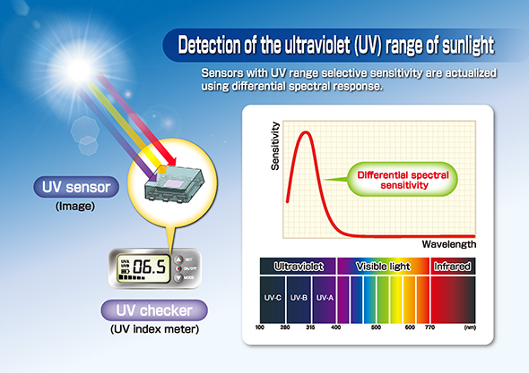

**Smart Logistics:**

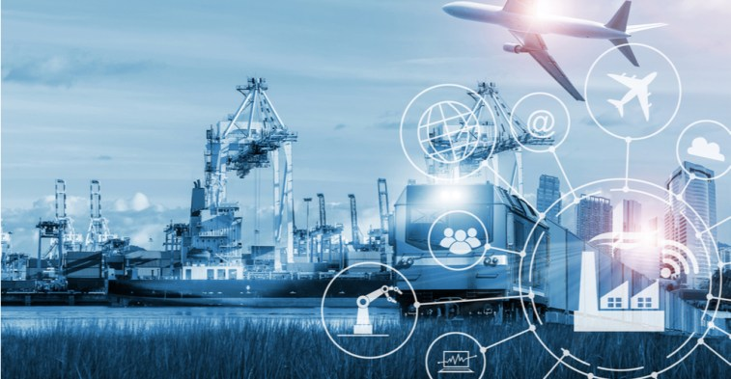

**Fleet Tracking**

IoT fleet tracking systems improve security and provide precise and complete reports that give the fleet managers full transparency towards the fleet’s activities. Through GPS monitoring and geo-location tools, companies can track the location of their trucks, optimize routes and monitor their fleet utilization in detail.

For instance, Canadian delivery service Sure Track Courier [saved](https://business.bell.ca/web/Shop/resources/pdf/Voice/Sure_Track_Mobility_Case_Study_EN.PDF) 6-10% per month on fuel costs by optimizing routes using IoT data from trucks.

**Platooning**

Platooning involves a group of self-driving trucks that follow a lead truck at high speed safely and efficiently. Trucks use IoT sensors so that each truck communicates with the other trucks to adapt its speed and braking accordingly.

**Connected Vehicles**

Sensors are enhancing vehicles along with AI and analytical capabilities. These sensors provide communication with the driver to supply useful information about other cars on the road and roadside infrastructure to the driver to help the driver make safer or more informed decisions. For example, these vehicles provide GPS enabled location detection feature that helps them detect traffic congestions.

**Energy Management:**

Energy can be a costly input for industrial businesses. With fluctuating energy costs and strict government requirements of efficiency, managing energy distribution becomes important.

IoT devices can help manufacturers manage energy consumption based on real-time data collected from devices. Intelligent energy management systems reduce energy bills, operational expenditures and carbon footprint of the factory while increasing energy efficiency. WebNMS is an IoT platform that provides IoT applications including energy management to optimize the energy consumption of businesses.

**Industrial process automation:**

Organizations can keep a real-time record of the metrics of all the machines inside a plant using IoT and IP networks. Manufacturers can use this data to automate workflows and to optimize production systems. Automation and optimization support industrial companies to reduce costs and increase the quality and volume of output.

**Smart Factories:**

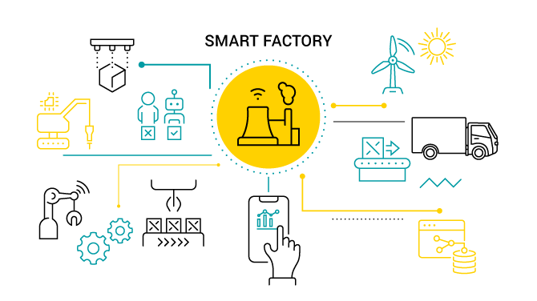

**Enterprise Asset management**

Enterprise asset management involves : work management, asset maintenance, planning and scheduling, supply chain management and environmental, health and safety (EHS) initiatives. Businesses collect real-time data from an asset with IoT sensors.

Businesses are rapidly adopting smart asset management systems into their businesses. Due to their asset-intensive environments, we mostly encounter with IoT asset monitoring in industries such as logistics, retail, and manufacturing.

IoT-powered asset management increases real-time visibility of assets and helps businesses optimize their resource while providing benefits such as:

* Increased operational efficiency
* Better control over the sales lifecycle
* More efficient safety and compliance checks

**Digital Twins:**

On an IoT platform, a digital twin is a virtual representation of a physical asset, a machine, a vehicle, or a device. It digitally represents the data, processes, operation states, and lifecycle of the asset.Implementing IoT with digital twin capabilities in a factory, an airport, or a machine plant enables:

**Better visibility:**You can continually view the operations of the machines or devices, and the status of their interconnected systems.

**Accurate prediction:** You can retrieve the future state of the machines from the digital twin model by using modeling.

**What-if analysis:** You can easily interact with the model to simulate unique machine conditions and perform what-if analysis using well-designed interfaces.

**Documentation and communication:** You can use the digital twin model to help you understand, document, and explain the behavior of a specific machine or a collection of machines.

**Integration of disparate systems:**You can connect with back-end applications related to supply chain operations such as manufacturing, procurement, warehousing, transportation, or logistics.

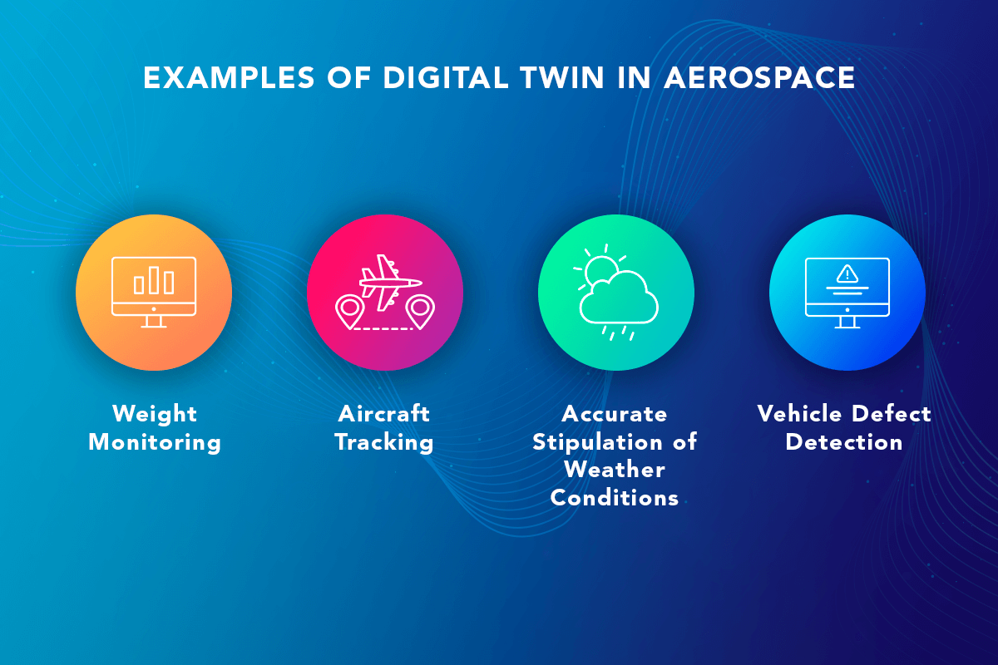

**Smart Boards:**

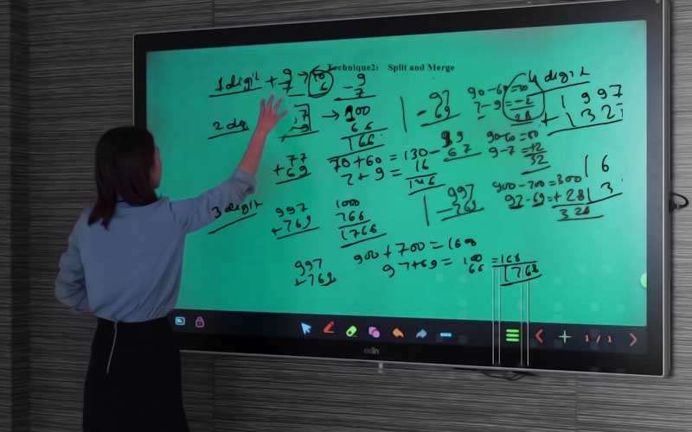

The times have changed. The current day students enjoy smart boards way more than black boards. Smart boards are interactive white boards that projects subject images. It enables the teachers and students to interact with it. How? By simply writing on it or moving it around the class. It is much more fun and exciting than it is seems at the moment. Here, applications of IoT in education have managed to make education and the exchange of information simple, interesting and interactive. With smart boards, a teacher can take a sigh of relief. Info graphics, tutorial videos and complex formulae, be it for any subject and especially of mathematics, could be solved in shorter time frames.

**Conclusion:**

In conclusion, Internet of Things is the concept in which the virtual world of information technology connected to the real world of things.

