Capstone Project

Machine Learning Engineer Nanodegree

Title: Evaluation of Nursery School Applications

Alphonso Jo Stephen
February 9th, 2019

I. Definition

Domain Background:

Nursery school, pre-primary school, playschool or kindergarten, is an educational establishment or learning space offering early childhood education to children before they begin compulsory education at primary school. It may be publicly or privately operated, and may be subsidized from public funds.

In an age when school was restricted to children who had already learned to read and write at home, there were many attempts to make school accessible to orphans or to the children of women who worked in factories.

With development of science and technology and with improved civilization, the need for basic education has increased which in turn lead to high number of schools and colleges. But here we are only discussing about Nursery school which is the first door towards education

Here I am finding out whether a child is accepted into a nursery school or not by evaluating the accuracy and acceptance

Database reference: https://archive.ics.uci.edu/ml/machine-learning-databases/nursery/nursery.names

Problem Statement:

The main objective of this project is to evaluate all the applications that are enrolled into a nursery school and identify the children who are capable of getting an admission based on some factors. Classification technique like Decision Tree classifier will be implemented and compared upon standard metric like accuracy. Pipeline is also used to avoid any data leakage.

There are several factors which are based upon to accept the application form like parents, social status, health checkup, housing status, financial stability. Nursery School prediction predicts the acceptance of children into the kindergarten.

Metrics:

Accuracy:

It is the number of correct predictions made by the model over all kinds of predictions made

Accuracy= (TP+TN) / (TP+FP+FN+TN)

Accuracy is a good measure when the target variable classes in the data are nearly balanced. Here I am predicting the accuracy score for selected models and the best score model is selected.
II. Analysis

Data Exploration:

Dataset Link: https://archive.ics.uci.edu/ml/datasets/Nursery’

In this project I have used 9 attributes and around 1200 trained and test data to evaluate the accuracy score. And this accuracy of classifiers is found out by 5-fold cross validation. The attributes used are shown in the below table
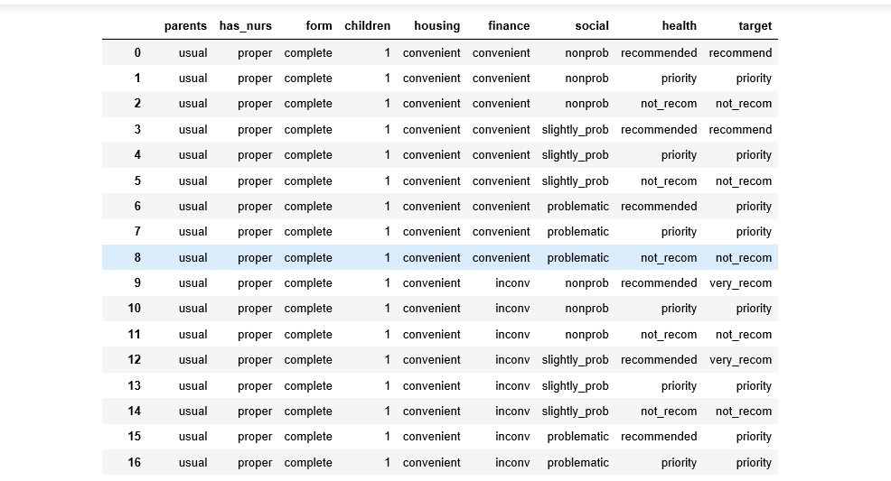

Data Set Information:

Nursery Database was derived from a hierarchical decision model originally developed to rank applications for nursery schools. It was used during several years in 1980's when there was excessive enrollment to these schools in Ljubljana, Slovenia, and the rejected applications frequently needed an objective explanation. The final decision depended on three sub problems: occupation of parents and child's nursery, family structure and financial standing, and social and health picture of the family. The model was developed within expert system shell for decision making DEX (M. Bohanec, V. Rajkovic: Expert system for decision making. Sistemica 1(1), pp. 145-157, 1990.).

Features Information:

- parents - usual or pretentious (real or adapted parents)
- has_nurs – has proper nursing or not
- form – application form complete or incomplete
- children – number of children
- housing – status of house (convenient or inconvenient)
- finance – financial stability(convenient or not)
- social - problematic or not
- health – health status

- target – final decision (recommended or not)
Description of data
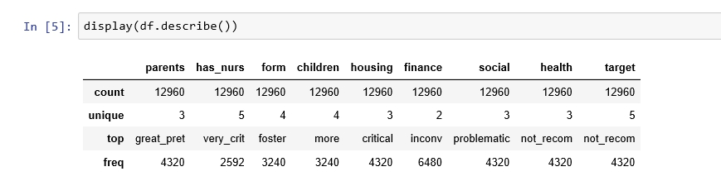

Information of Data set:
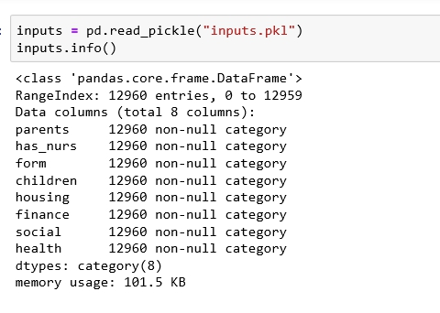

There are no missing values existing in the data set, so we don’t need to modify any data
Data Visualization:
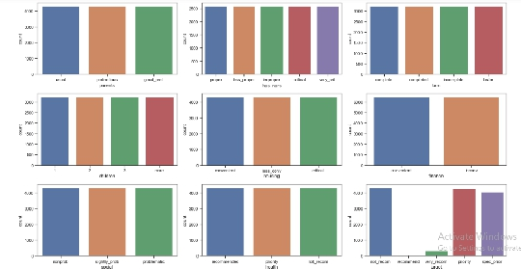

Each of our features is perfectly balanced with respect to the values they can take. That is not what real life datasets would look like, but oh well. We see however that the target class is interesting: almost no observations are labelled as recommended, very few are much recommended; most of them are not recommended, recommended with priority or recommended with special priority.
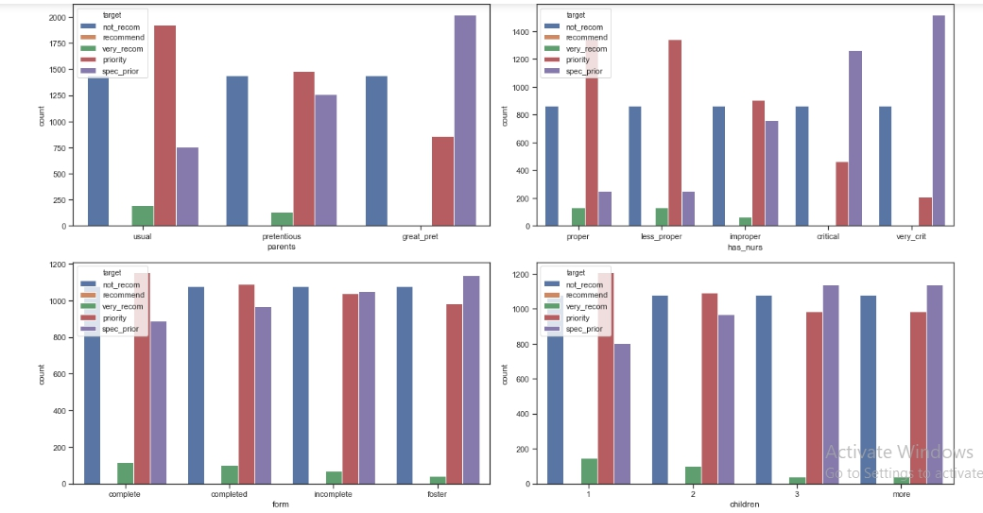
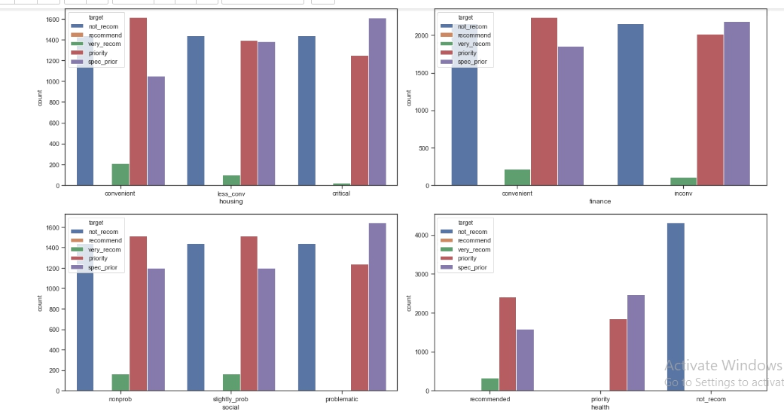

There seems to be some correlation between the family's health status and the acceptance outcome. In particular, in the last plot, we clearly see that if the health status of the family does not recommend final acceptance, the final decision will be to not recommend the child. To visualize this, and some other useful relations in the data, we will resort to use the correlation matrix between each values the features (and the target) can take.

Heat Map:

The heat map is a 2-D representation of data in which values are represented by colors. A simple heat map provides the immediate visual summary of information. More elaborate heat maps allow the user to understand complex data.

