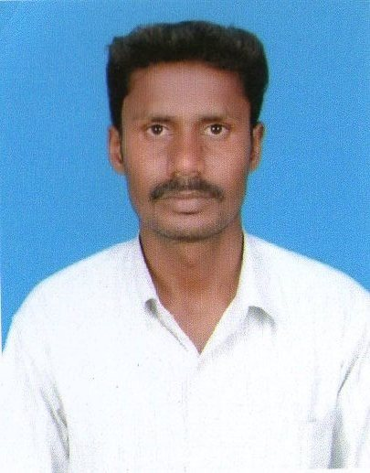
D. PRABAKARAN

Email: id: kpraba65@gmail.com
Mobile: +91 9629996494.

Summary:
I have 5 + years of total expertise in the areas of System & Network Administration. Handling the Servers, PC’s, Routers and Switches, Working as Admin – System & Network in Tech-up Engineering Pvt Ltd, Tiruchirappalli.

Work History:

- Working as Engineer – System & Network Admin @ Tech-up Engineering Pvt Ltd, Tiruchirappalli.

Organization Tech-up Engineering Pvt Ltd, Tiruchirappalli.
Period From December 2010 – till date.
Designation Engineer – System & Network Admin.

Objective as Engineer – System & Network: Effective execution of System & Network Administration
Responsibilities:
- Expertise hands in troubleshooting of Computer hardware related problems such like UPS, SMPS, Printer and Drivers.
- Managing and Maintaining the Servers, PC’s, Routers and Switches.
- Configuring, Managing and Maintaining Networking Equipments.
- Network processing, centralized and distributive network connection
- Installing, configuring and administering network technologies
- Installed and configured workstations for IP/IPX based LAN
- Installed and configured DHCP Client/Server
- Implemented HP-Open view for network management
- Backup Management, Reporting and Recovery
- Disaster Recovery
- Virus Protection and Eradication
- Maintenance of MS Exchange Environment
- Configuring and troubleshooting Microsoft Outlook and Outlook express.
- Provision of Internet Access and Management of Web marshal
- Analysis of Security Alerts and Implementation of Recommendations Third-party middleware and database software
- Implementing and troubleshooting Cluster and SAN
- Providing Training for Cisco Certifications such as CCNA, MCP, MCSA and ADCHN.
- Installing configuring administrating software applications.
- Providing training about Microsoft Server 2003 and Client OS Windows XP.
- Providing Training of Basic Skills of Linux.
- Providing Training of troubleshooting of Computer Hardware Devices
- Security administration port security on switch and IP security on Router via Access list
- Familiar with web technology HTML CSS
- Functional knowledge of Data base management SQL Server on windows
- Created and deployed desktop images using Symantec Ghost 10
- Documentation of all the work done using Visio, Excel and MS word.
- Preparing monthly work status report and updating technology specific documents
- Responsible for designing and implementation of customers network infrastructure
- Help negotiate hardware, software, and circuit contracts for customers
- Redesign customers office copper and fiber cable plant for scalability
- Online vendor registration current company
- Attending E-auction on behalf of the company

- Worked as an Engineer – Systems & Service in Alpha Computers and Communication, Tiruchi.

Organization Alpha Computers and Communication, Tiruchi.
Period From December 2009 – November 2010.
Designation Engineer – Systems & Service.

Objective as Engineer – Systems & Service. Effective execution of Systems & Service to customers.
Responsibilities:

- Computer assembling and maintenance.
- Troubleshooting hardware and software problems.
- Installing and configuring the peripherals, components and drivers
- Installing software and application to user standards
- Wide knowledge of motherboard and circuit designs of monitor
- Deep knowledge of printer and cartage refilling.
- Familiarity with Analog Circuit, Digital Circuit, PCB design, schematic capture, board layout, vendor interface analysis and simulation
- Solid understanding of all phases of SMPS and UPS
- Configuring and troubleshooting desktops, laptops and servers
- Familiar with hardware tools like servers, printers, VoIP, networking and telecommunications devices
- Excellent troubleshooting skills in complex software and hardware problems
- Installed Hard disks, Floppy drives, CD Drives, Sound Blaster cards, CPU, Memory, Power supply unit, Network card, Video graphics card, Hard disk controller card on PC systems
- Troubleshooting of personal computers. On line Support to customers concerning their computer problems.

Education:

Diploma (DCE), Sri Adhisankarar Polytechnic, Errungalur. 69%
H.S.C, Boiler Plant Boys Hr. Sec School, Tiruchirappalli. 50%
S.S.L.C, St.Mary’s Higher Secondary School, Pathalapettai. 75%

Personnel details:

Father Name : E.Devadass
Date of birth and Age : 06-04-1986
Sex & Marital status : Male, Single.
Nationality : Indian.
Languages Known : English & Tamil.
Contact Details:

Present address : 3\137,Mathakovil Street, Chettiyarpettai, Pathalapettai (PO),
Tiruchirappalli – 620013.

E-mail id : kpraba65@gmail.com

Mobile no : +91 96299 96494.

Notice Period : One week from the date of appointment order.

Current Location : Tiruchirappalli.

Date : 21.08.2014 Yours Truly,
Place : Tiruchirappalli. (D. PRABHAKARAN)

