CURRICULUM VITAE
K.Ramasubramanian
47/23 Tailors Estate 2nd Street Email:kramji70@gmail.com
Kodambakkam Date of Birth:19.07.1970
Chennai 600 024. ph: 9677011818
EDUCATIONAL QUALIFICATION: -
COURSE NAME | BOARD/UNIVERSITY  NAME | YEAR OF PASSING | %
B.SC MATHS | MADRAS UNIVERSITY | 1992 | 52
B.SC IT | ALAGAPPA UNIVERSITY | 2003 | 54

Master of Financial  Management | ANNAMALAI UNIVERSITY | 2007 | 55.2
MBA Finance | ALAGAPPA UNIVERSITY | 2010 | 55.6
M.PHIL  (MANAGEMENT) | VINAYAKA MISSIONS UNIVERSITY | 2008 | 70.5

FULL TIME IT COURSES-
COURSE | UNIVERSITY/INSTITITE | YEAR OF COMPLETION | %
PGDCS | BDPS | 1994 | 59
CIC | IGNOU | 1997 | 69.5
D2K | BENCHMARK | 1997 | 55
MAINFRAME | NAVO | 2005 | 62

RANKSHEET IT EXAMS:-
S.No. | Exam Name | Level | Appear Date | Score
1 | HTML | Level 2 | 09-Jul-2009 | Score: 60/100
2 | PHP | Level 2 | 31-Jul-2011 | Score: 60/100
3 | Red Hat Linux | Level 1 | 04-Apr-2013 | Score: 50/100
4 | XML | Level 1 | 25-Feb-2014 | Score: 80/100
5 | CSS | Level 1 | 28-Feb-2014 | Score: 50/100
6 | SharePoint Power User | Level 1 | 01-Mar-2014 | Score: 50/100
7 | Selenium IDE | Level 1 | 01-Mar-2014 | Score: 50/100
8 | Spring | Level 1 | 28-Feb-2014 | Score: 60/100
9 | VSTS Load Testing | Level 1 | 01-Mar-2014 | Score: 50/100
10 | MySQL | Level 1 | 01-Mar-2014 | Score: 50/100
11 | CSS3 | Level 1 | 13-sep-2014 | Score : 50\100
NCFM EXAMS (NSE EXAMS SKILLS)
EXMA NAME | MODULE | EXAM DATE | %
NCFM | CAPITAL MARKET DELAERS MODULE | 17- JUNE -2010, | 51%

TestsWorld.com etests:-
MS-office | MS-Powerpoint | 15 - September - 2006 | 80
ASP.NET Exam | ASP. Net Exam | 10 - August - 2007 | 70
JAVA Exam | Java Exam | 16 - June - 2009 | 100
Microsoft | Exam 70-210 | 17 - June - 2009 | 83
Microsoft | Exam 70-100 | 17 - June - 2009 | 80
Microsoft | Exam 70-230 | 19 - June - 2009 | 92
Microsoft | Exam 70-305 | 19 - June - 2009 | 80
Microsoft | Exam 70-315 | 19 - June - 2009 | 90
Microsoft | Exam 70-316 | 19 - June - 2009 | 85
Microsoft | Exam 70-028 | 21 - June - 2009 | 85
Microsoft | Exam 70-215 | 21 - June - 2009 | 83
Microsoft | Exam 70-229 | 21 - June - 2009 | 80
Microsoft | Exam 70-310 | 21 - June - 2009 | 75
Microsoft | Exam 70-216 | 21 - June - 2009 | 70
Oracle | 1Z0-031 Exam | 21 - June - 2009 | 82
IBM | IBM 000-355 Exam | 21 - June - 2009 | 100
IBM | IBM 000-512 Exam | 21 - June - 2009 | 85
IBM | IBM 000-513 Exam | 21 - June - 2009 | 100
IBM | IBM 000-516 Exam | 21 - June - 2009 | 100
IBM | IBM 000-285 Exam | 21 - June - 2009 | 93

WORK EXPERIENCE:-

COMPANY NAME | DESIGNATION | WORK  DETAILS | DURATION
BUSINESS/SELF EMPLOYED AS  SUB BROKER | BUSINESS/  Software developer  (freelancer on contract) | Jeyamjobs,sakthidata.  Com,shrishrishaadi.com | 2009-TillDate
DHANUS LTD | SOFTWARE  ENGINEER | SOFTWARE DEVELOEMENT | 2007-2008
DUALSOFT  SOLUTIONS | SOFTWARE PROGRAMMER | SOFTWARE DEVELOPMENT | 2005-2007
COMPCARE | SOFTWARE TRAINEE | SOFTWARE DEVELOPMENT | 2003-2004
Fuller K.C.P LTD | IT (EDP)  Executive | Software developement | 1995-1997

Projects :-
PROJECT jeyamjobs.in,srisrishaadi.com ,sakthidatastore.com(asp.net4,mysql 5.5)
CLIENT JEYAM FINANCIAL ADVISORS
DURATION 2009-tilldate
ENVIRONMENT PHP,MYSQL,ZENCART,JAVASCRIPT,HTML,CUTEFTP,WAMP,XAMPP
TEAMSIZE 8
ROLE SOFTWARE WEB DEVELOPMENT AND PROGRAMMING

DESCRIPTION This application is aimed for Manpower gaints and industries for searching
Candidates,Companies and recruiters in India.The websites is designed and developed for the best
Needs of today .The employee login is designed for the recruiters and candidates to login
And have their requirements matching their needs.It known by interaction for further cpanel,etc
For the admin access.
PROJECT FLEETRAC
CLIENT DHANUS BPO LTD
DURATION 2007-2008
ENVIRONMENT ASP.NET,ADO.NET,C#,VB6,SQLSERVER 2005.
TEAMSIZE 8
ROLE SOFTWARE DEVELOPMENT AND PROGRAMMING

DESCRIPTION This application is aimed for automobile gaints and industries for route
Tracking and communication.It is an ERP application aimed to track
The route of the 4 wheeler such as taxi,bus,etc.The tracking is made by
Self developed route maps for various countries and states of India.

PROJECT DUALSOFT REAL ESTATE MANGEMENT SYSTEM
CLIENT DUALSOFT INTERNATIONAL,SIGNGAPORE
DURATION 2003-2004
ENVIRONMENT VB6,SERVER 2000.
TEAMSIZE 6
ROLE Involve in planning and creating database design,programming for
document Management and stored procedure.

DESCRIPTION This application is aimed for Real Estate Mangement Services and for the
Materials management.The Structure of DRESMS is Inventory
Management,Materials Management,Client Database,Sales Management,
Sales order management,etc.The is mainly aimed to do services to Motels,
Hotels,etc.It competes with various ERP products and better utilized if
Know through interaction.The user of the product is one user one license.

PROJECT DUALSOFT RESTAURANT MANAGEMENT SYSTEM
CLIENT DUALSOFT INTERNATIONAL,SIGNGAPORE
DURATION 2003-2004
ENVIRONMENT VB6,SQL SERVER 2000.
TEAMSIZE 6
ROLE Involve in planning and creating database design,programming for
document Management.

DESCRIPTION This application is aimed for Restaurants Mangement Services and for the
reciepe management.The Structure of DRESTMS is Inventory
Management,Reciepe Management,Client Database,Sales Management,
Sales order management,etc.The is mainly aimed to do services to Motels,
Hotels,etc.It competes with various ERP products and better utilized if
Know through interaction.The user of the product is one user one license.

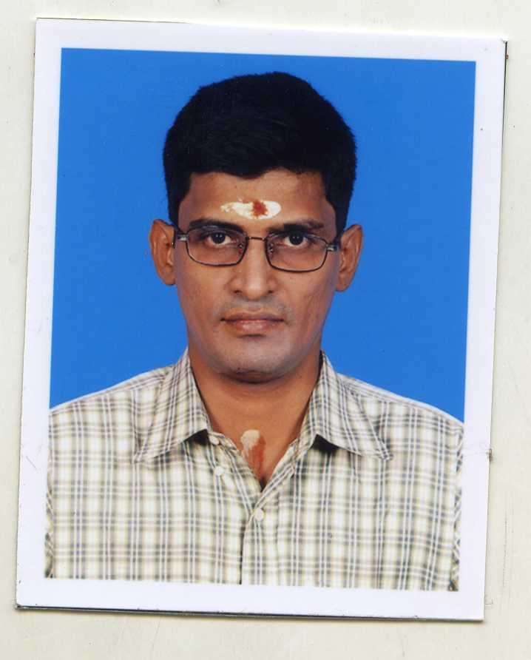
PERSONAL DETAILS

FATHER’S NAME :R.KRISHNAMOORTHY(LATE)

MOTHER’S NAME :V.R.JEYAM

SEX : MALE

MARTIAL STATUS : SINGLE

LANGUAGES KNOWN :TAMIL,ENGLISH

K.RAMASUBRAMANIAN

