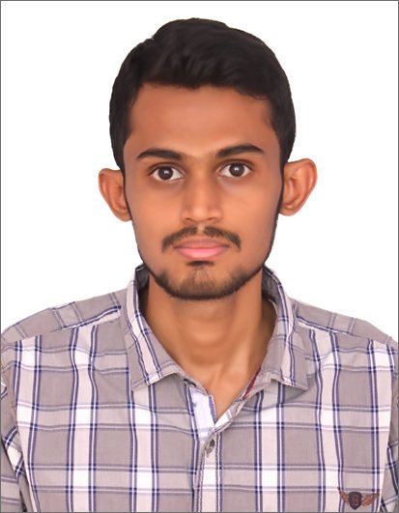

**MOHAMMED MUSADDIQ.KN**

#35/83, 2ND STREET VINAYAGAPURAM,

ARUMBAKKAM, CHENNAI-600 106

**E-Mail:** [**knmdmusaddiq@gmail.com**](mailto:knmdmusaddiq@gmail.com)

**Mobile: +91 9840027008/ 8939629789**

**OBJECTIVE**

Seeking a challenging position in a leading organization in the Areas of Market Research, Business analytics, client servicing, forecasting, Brand management, Product Management and International Marketing.

**PROFESSIONAL SYNOPSIS**

**AIOCD Pharmasoftech AWACS Pvt. Ltd.** **Since Sep’14** **FIELD COORDINATOR**

**Roles and Responsibilities**

* Handling a project with more than 2000 stockists, 3000 retailers and 200 software vendors throughout India.
* Coordinating with field managers, Clients and vendors.
* Monthly performance report to be submitted and analysed with Managing Director of the company.
* Identifying problems and doing root cause analysis for the same
* Providing new process improvements in the existing system
* Preparing Whitepaper and SOP’s for internal use.
* Leading a team with five members.

**Centrum Direct Limited.**  **Oct’13 – Sep’14 MANAGEMENT TRAINEE**

**Roles and Responsibilities**

* Inside Sales
* Client Relationship
* Branch Operations
* Maintaining Best Relationships with corporate, Banks and other FFMC's.
* Internal auditing and compliances as per RBI regulations.
* Management Information System

**KEY ACHIEVEMENTS**

* Secured First Prize in the BUSINESS QUIZ Competition (a national level management symposium) held at S.C.S.V.M University, Kanchipuram in March 2012.
* Won three consecutive prizes at the VARIOUS EVENTS in Marketrix’12, A National Level Management Symposium conducted by SRM B-School, Chennai.
* Won first prize at the STOCK WAR EVENT in FOSTRA’12, A National Level Management Symposium conducted by Karpaga Vinayaga College of Engineering and Technology, Chennai.
* Participated in WALK-A global social awareness campaign about Diabetes conducted by United Nations World Diabetes Foundation on November 2007.
* Active participant of student conference conducted by Madras Management Association.

**INTERNSHIP**

**Post-Graduation:**

**Final Project:**

**Title: An Analysis towards website effectiveness for Sterling Holidays and Resorts.**

**Description:** To analyse the detail study and overall performance, design and layout of the website and

for ascertaining the effectiveness of online payment mode is safe and secure.

**Summer Internship:**

**Title: An Analysis to identify target market for Polaris Financial Technology Ltd.**

**Description:**  To identify and analyse the target market, untapped international market and presence

of its competitors in that market for its financial services.

**CO- CURRICULAR ACHIEVEMENTS and STRENGHTS**

* Good communication skills
* Well Acquainted with the use of Microsoft Office and technical skills like C++,Java and SQL.
* Worked as a part of many events where I have shown my qualities of working in a Team
* Leadership Skills- As a Business Operations Executive

**ACADEMICS QUALIFICATION**

|  |  |  |  |
| --- | --- | --- | --- |
| Degree/Certificate | Institution | Year of Passing | Board/University |
| MBA(Marketing & Systems) | Sri Sairam Institute of Management Studies | 2011-2013 | Anna University |
| B.Sc (Computer Science) | The New College | 2008-2011 | Madras University |
| 12th | MES Razeena Matriculation Higher Sec School | 2006-2008 | State Board |

**Personal Details**

Father’s Name **:** KN.MOHAMMED HIFZUR RAHMAN

Nationality               **:**Indian

Date of Birth           **:** 15th October 1990

Marital Status **:** Single/Unmarried

Hobbies   **:** Reading digest, magazine & business mandates, playing cricket, gadget geek etc.

Languages Known **:**  **English, Hindi, Tamil, Urdu & Arabic**

Passport Number **:** L1042041

Preferred Location **:** Chennai, Bengaluru & Abroad

I hereby declare that the above written particulars are true to the best of my knowledge and belief.

**Date: Signature**

**Place: Chennai**

**(MOHAMMED MUSADDIQ.KN)**