**CC-2**

**CODE:**

package com.Test.CC2;

import org.openqa.selenium.By;

import org.openqa.selenium.WebDriver;

import org.openqa.selenium.chrome.ChromeDriver;

import org.openqa.selenium.chrome.ChromeOptions;

import org.testng.Assert;

import org.testng.annotations.Test;

import io.github.bonigarcia.wdm.WebDriverManager;

public class CC_2 {

*@Test*

public void f() throws InterruptedException {

ChromeOptions co=new ChromeOptions();

co.addArguments("--remote-allow-origins=*");

WebDriverManager.*chromedriver*().setup();

WebDriver driver=new ChromeDriver(co);

driver.get("https://www.yatra.com/hotels");

driver.manage().window().maximize();

Thread.*sleep*(3000);

driver.findElement(By.*xpath*("//*[@id=\"booking_engine_flights\"]")).click();

Thread.*sleep*(3000);

driver.findElement(By.*xpath*("//*[@id=\"BE_flight_form_wrapper\"]/div[1]/div[1]/ul[1]/li[2]/a")).click();

Thread.*sleep*(3000);

driver.findElement(By.*xpath*("//*[@id=\"BE_flight_origin_city\"]")).click();

Thread.*sleep*(3000);

driver.findElement(By.*xpath*("//*[@id=\"BE_flight_form_wrapper\"]/div[1]/div[2]/ul/li[1]/ul/li[1]/div/div/ul/div/div/div/li[4]/div[1]/p[1]")).click();

Thread.*sleep*(3000);

driver.findElement(By.*xpath*("//*[@id=\"BE_flight_arrival_city\"]")).click();

Thread.*sleep*(3000);

driver.findElement(By.*xpath*("//*[@id=\"BE_flight_form_wrapper\"]/div[1]/div[2]/ul/li[1]/ul/li[3]/div/div/ul/div/div/div/li[6]/div[1]/p[1]")).click();

Thread.*sleep*(3000);

driver.findElement(By.*xpath*("//*[@id=\"BE_flight_origin_date\"]")).click();

Thread.*sleep*(3000);

driver.findElement(By.*xpath*("//*[@id=\"27/04/2023\"]")).click();

Thread.*sleep*(3000);

driver.findElement(By.*xpath*("//*[@id=\"03/05/2023\"]")).click();

Thread.*sleep*(3000);

Thread.*sleep*(3000);

driver.findElement(By.*xpath*("//*[@id=\"BE_flight_paxInfoBox\"]/span")).click();

Thread.*sleep*(3000);

driver.findElement(By.*xpath*("//*[@id=\"BE_flight_passengerBox\"]/div[1]/div[2]/div/div/span[2]")).click();

Thread.*sleep*(3000);

driver.findElement(By.*xpath*("//*[@id=\"armedforces_offer\"]/a/i")).click();

Thread.*sleep*(3000);

driver.findElement(By.*xpath*("//*[@id=\"BE_flight_flsearch_btn\"]")).click();

String actual=driver.findElement(By.*xpath*("/html/body/h1")).getText();

String expected="Access Denied";

Assert.*assertEquals*(actual,expected);

}

}

**CONSOLE:**

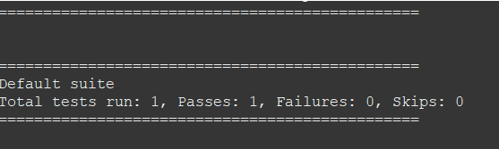

**TESTNG REPORT**

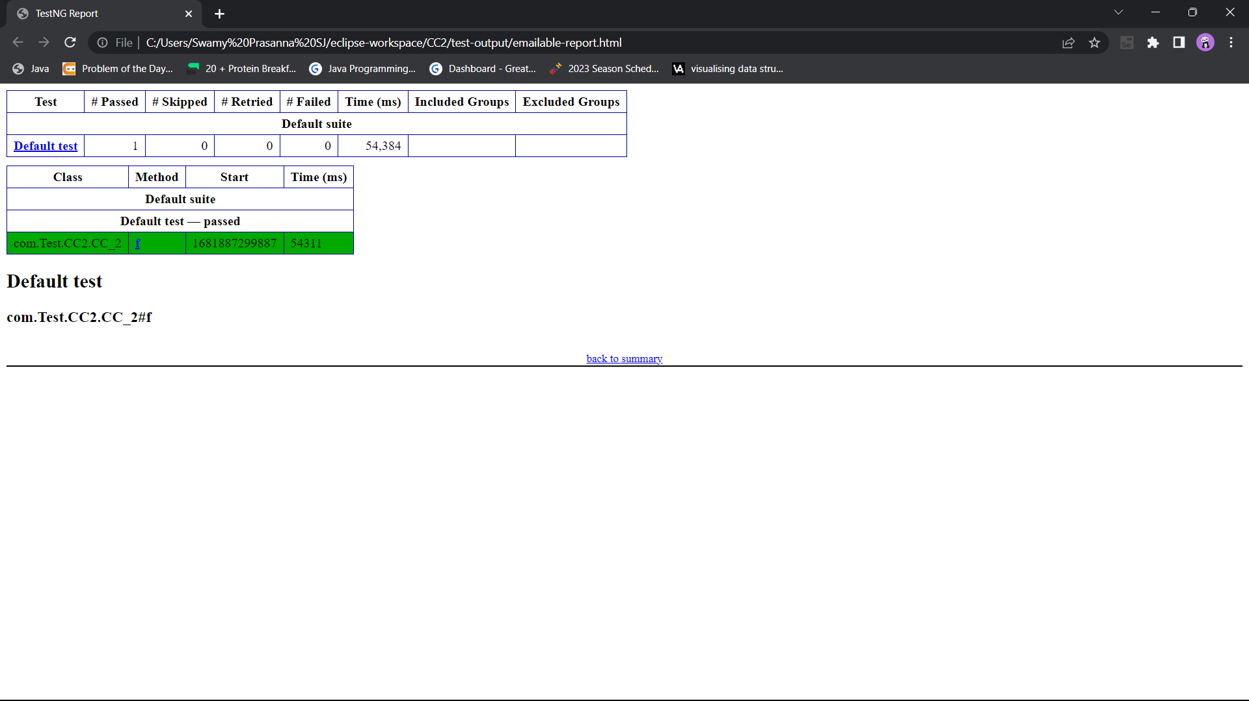

**ACCESS DENIED**

