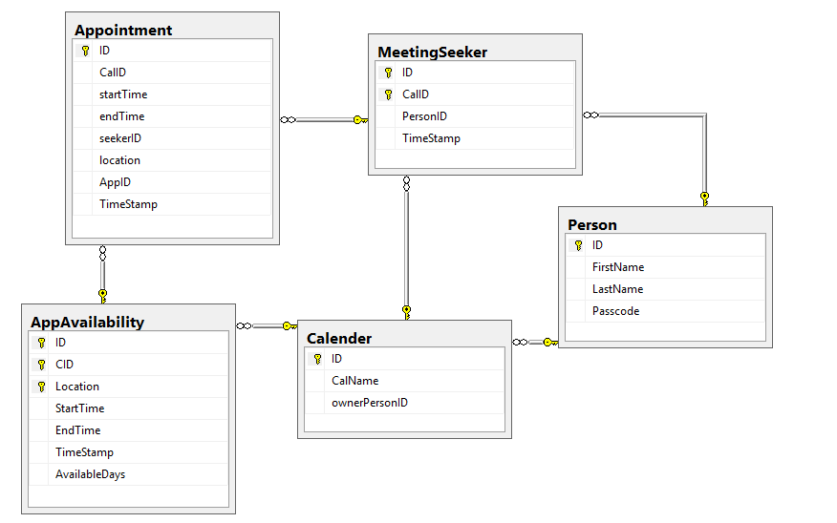

use FMIS555ssn6259DB;

drop table Appointment;

drop table MeetingSeeker;

drop table AppAvailability;

drop table Calender;

drop table Person;

Create table Person(

ID int not null Identity(-2000,1),

FirstName varchar(20) not null,

CHECK( FirstName like'[a-z][a-z]%'),

LastName varchar(20) not null,

CHECK( LastName like'[a-z][a-z]%'),

Passcode varchar(50),

Primary Key (ID)

);

insert into Person (FirstName, LastName, Passcode)

Values( 'max', 'jones', 'batmanrocks'),

( 'Dhaval', 'Chauhan', 'ironmansuxx'),

( 'james', 'bond', 'fortknoxxx'),

( 'james1', 'bond1', 'fortknoxxx1'),

( 'james2', 'bond2', 'fortknoxxx2'),

( 'james3', 'bond3', 'fortknoxxx3');

--select \* from Person;

Create table Calender(

ID int not null Identity(-2000,1),

CalName varchar(120) not null,

CHECK( CalName like'[a-z][a-z]%'),

ownerPersonID int not null

Primary Key(ID),

Foreign Key (ownerPersonID) references Person(ID)

);

insert into Calender (CalName,ownerPersonID)

Values ('MaxCal', -2000),

('DhavalCal', -1999),

('JamesCal', -1998),

('JamesCal1', -1998);

create table AppAvailability(

ID int not null Identity(-2000,1),

CID int,

Location varchar(120),

StartTime Time,

EndTime Time,

[TimeStamp] timestamp,

AvailableDays varchar(10),

Primary Key (ID, CID, location),

Foreign Key (CID) references Calender(ID),

);

--Select \* from AppAvailability;

insert into AppAvailability (CID, Location, StartTime, EndTime, AvailableDays)

Values (-2000, 'CISLAB', convert(time,'10:00:00 AM'), convert(time,'2:00:00 PM'), 'MWR' ),

(-1999, 'CISLAB', convert(time,'10:00:00 AM'), convert(time,'11:00:00 AM'), 'MWR' ),

(-1999, 'CISLAB2', convert(time,'12:30:00 PM'), convert(time,'2:00:00 PM'), 'TF' ),

(-1999, 'CISLAB3', convert(time,'2:00:00 PM'), convert(time,'3:00:00 PM'), 'MWR' ),

(-1998, 'CISLAB', convert(time,'10:00:00 AM'), convert(time,'2:00:00 PM'), 'MWR' );

create table MeetingSeeker(

ID int not null Identity(-2000,1),

CalID int,

PersonID int,

[TimeStamp] timestamp,

Primary Key (CalID,ID),

Foreign Key (CalID) references Calender(ID),

Foreign Key (PersonID) references Person(ID)

);

--select \* from Person;

insert into MeetingSeeker (CalID, PersonID)

Values (-2000, -1995),

(-2000, -1998),

(-2000, -1997),

(-1998, -1995),

(-1999, -1995);

create table Appointment(

ID bigint not null Identity(-2000,1),

CalID int,

startTime DateTime,

endTime DateTime,

seekerID int,

location varchar(120),

AppID int,

[TimeStamp] timestamp

Primary Key (ID),

Foreign Key (AppID, CalID, location) references AppAvailability(ID, CID, location),

Foreign Key (CalID,seekerID) references meetingSeeker(CalID,ID)

--Foreign Key (location) references AppAvailability(location)

);

--select \* from AppAvailability;

--select \* from meetingseeker;

insert into Appointment (CalID, startTime, endTime, seekerID,location,AppID)

values(-2000, convert(time,'10:00:00 AM'), convert(time,'11:00:00 AM'), -1998, 'CISLAB', -2000),

(-1999, convert(time,'1:00:00 PM'), convert(time,'2:00:00 PM'), -1996, 'CISLAB2', -1998);

--select \* from Appointment