Abstract

One of the most important tasks in advertising is planning on implementing advertisement material and reaching the audience. The American Marketing Association’s (AMA) definition of marketing research [which is related to advertising planning] emphasizes its role in linking marketing managers to information about their customers: “Marketing research is the function which links the consumer, customer, and public to the marketer through information – information used to identify and define marketing opportunities and problems; generate, refine and evaluate marketing actions; monitor marketing performance; and improve our understanding of marketing as a process.”

Advertising research uncovers the information needed for making advertising decisions. It is the systematic gathering and analysis of information to help develop and evaluate advertising strategies, ads, and entire campaigns. Advertising strategy consists of creative strategy, media strategy, product concept, target audience, media alternative and possible message elements. Advertisers need to be creative in order to attract consumers; therefore, their ads need to be composed to appeal consumers. Creative strategy is a written statement that is creative team’s guidance for writing and producing ad. In terms of the media strategy, advertisers need to be aware of where do their consumers usually go to check the information. Is it television, or internet or newspaper? Then, they need to decide where they will publish the ads. Product concept is important because consumers want to know the qualities of their brands, so they can develop (potentially) a brand loyalty.

Advertisers also need to know what the target audience for a specific brand is. The major purpose is to develop a rich profile of the brand’s target audience. So when it comes to doing a research, usually what companies tend to do is pretesting. Pretesting is the testing the effectiveness of an advertisement for gaps or flaws in message content before recommending it to clients often conducted through focus groups. After pretesting, usually what advertisers do is posttesting. Posttesting is the testing of the effectiveness of the advertisement after it has been run.

There are five basic steps in the research process:

1) Situation analysis and problem definition
2) Informal research
3) Construction of research objectives
4) Formal research
5) Interpretation and reporting of findings

Introduction

Advertising is a form of communicating information, in persuasive purposes for products (goods, services and ideas) by acknowledged sponsors through numerous media. Albert Lakert, also known as the father of advertising, defined advertising as “salesmanship in print, driven by a reason why.” Advertising is directly related to the groups of people, rather than to individuals and therefore, it is a non-personal or mass communication. Those individuals could be consumers, people who buy products or business people who would buy large quantities of products for resale in their stores. Mass communication in advertising is very important, because the whole purpose of advertising would be getting the message across to those who will purchase goods, to consumers. Advertising also helps in promoting services and ideas. In terms of the channel of communication, its purpose is to be a medium.

An advertising medium is any non-personal means used to present an ad to its target audience. For example, we have radio advertising, television advertising, newspaper ads, and more. Advertising is just one type of marketing communications. Marketing communications are the various efforts and tools used to communicate with customers and prospects, including solicitation letters, newspaper ads, event sponsorship, publicity, telemarketing and many more. Marketing is one of the important aspects of advertising. Marketing is an organizational function, a set of processes in which the value is created, communicated and delivered to customers, and for handling customer relationships in ways that benefit the organization and its shareholders.

Marketing communications are various efforts and tools used to communicate with customers. They are very important for maintaining the relationship with the customers. What connects advertising and marketing are 4Ps of marketing mix: Products, Pricing, Places and Promotion. The final goal of marketing is to earn a profit for the firm by consummating the exchange of products or services with those customers who need or want them. Moreover, the role of advertising is to promote - to inform, persuade, and remind groups of customers, or markets, about the need-satisfying value of the company’s goods and services.

The advertising system our project provides is one of a kind and suffices the clients need in one point portal where the client needs to provide only the product details after selection of and has to carry out payment for the same. Our system takes care of everything else and the client need not worry about the advertisement any more as the complete care has been taken by our system.

Scope

Advertising is often regarded as the most important means of marketing a company’s services and tools. The scope of advertising is to communicate a message to current customers or potentially target new customers. It helps a company get a message or a piece of information across to their customer base regarding a new product or special deal.

1) Scope of advertising by budget

There is always a budget allocated for advertising and promotion within the marketing budget. The budget allocated should be in coordination with the type of advertisement the organization wants. The resources and other requirements are to be kept in mind for the budget allocation.

2) Scope of advertising by deliverables

Once the budget is decided, the marketing plan can be projected further. A detailed scope of work that deliverables require can be outlined. Agencies can now develop a proposed resource plan.

3) Scope of advertising by allocating deliverables

For creative work, allocating the type of deliverables (​TV​, online, mobile, press, magazine​,​ etc) based on the previous campaign requirements can be more insightful after the previous plan.

4) Scope of advertising by strategy

Once the deliverables are allocated, advertising agencies can define the strategic requirements by brand or category and develop a scope of work based on past requirements and remuneration for similar strategic deliverables.

Requirements

1) XAMPP Control Panel v3.2.2
2) QT designer v 5.2.0
3) phpMyAdmin
4) JetBrains PyCharm Community Edition 2018 2.2*64

System Screenshots


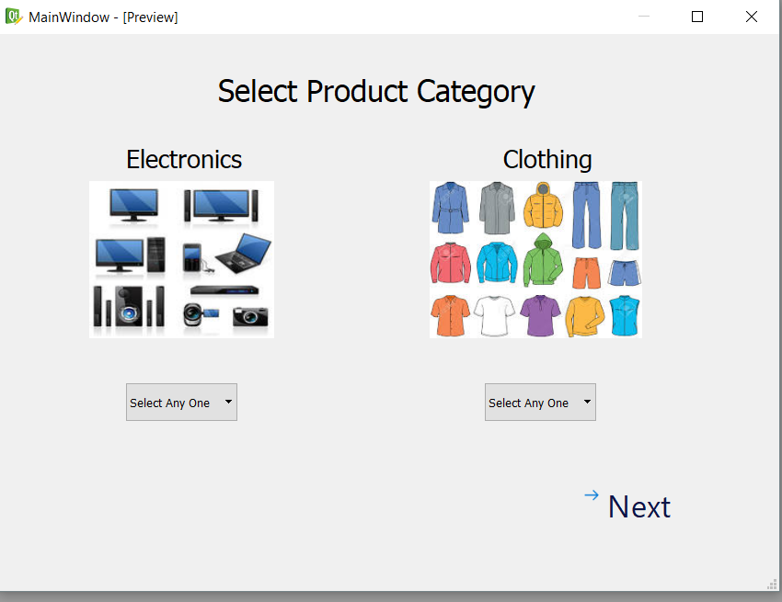

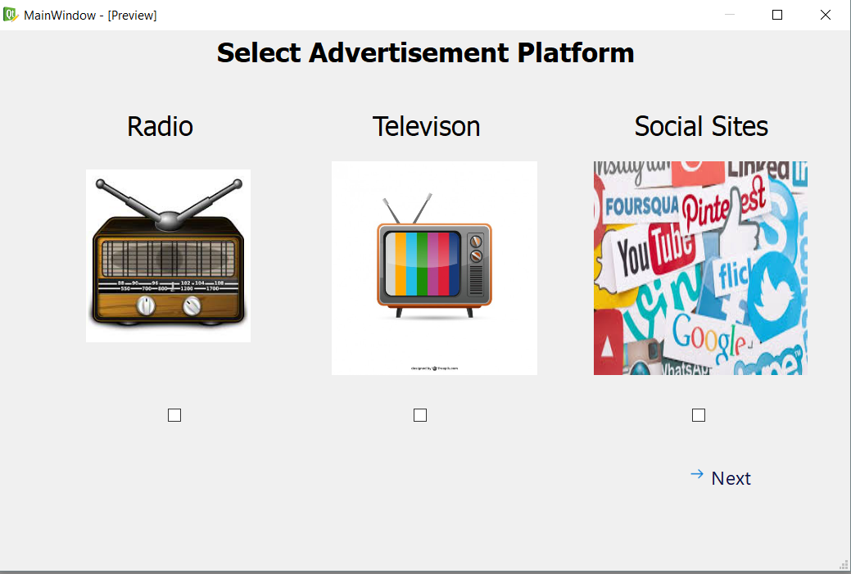












Conclusion

Advertising is a huge industry. It has created opportunities for various domains. ​The​ benefits of advertising ​include:

Launch of a new product:

Advertising plays very significant role in the introduction of a new product in the market. It stimulates the people to buy or know about a product.

Increases markets:

It helps the manufacturers to expand their markets. It opens the horizons for new markets for the product or service.

Mass sales:

Advertising facilitates mass production to goods that ultimately results in a raised volume of sales. Keeps the competitive spirit alive:
Advertising helps in keeping the competition and the competitors at bay. It keeps a regular check on the performance of your brand or product.

Creates goodwill:

Advertising builds goodwill of a brand. Advertising is a crucial source through which the audience gets to know about a brand or product. If a company is spending on advertisement, it means they care to make their consumers aware. This increases the goodwill of a brand.

Creative minds:

Every place has a rich pool of strategic and creative minds, media and professionals. And every advertising organization possesses such talents.

Consumer awareness:

Advertising is educational and dynamic in nature. It educates the customers about the new products and their diversifications.

Direct link:

Advertising aims at establishing a direct link between the manufacturer and the consumer. This rules out the possibility for a middlemen to be involved in between.

Creates employment:

Advertising provides and creates more employment opportunities for many talented people in the industry.

References

1)localhost/phpmyadmin/sql.php?server
2)www.tutorialspoint.com
2)www.wikihow.com
3)www.youtube.com

