# EMTF track address format for uGMT output

A. Madorsky, University of Florida/Physics

Reference document:

**Interface between the Muon Track Finders and the micro-Global Muon Trigger in the Upgraded CMS Trigger for 2016**

Table 1 in the document listed above shows data format for transmission from regional track finders to uGMT. This document details “track addresses” field implemented in Endcap Muon Track Finder.

Each EMTF receives data from several chambers in the neighboring sector. This is done to provide better track detection on the sector’s edges. The neighboring sector number is calculated as shown below:

NB = (N > 1) ? N-1 : 6

N is the number of sector that EMTF belongs to, NB is neighboring sector. All sector numbers range from 1 to 6.

The tracks that are located in the sector overlap areas may be detected by both sectors. uGMT should cancel one of such double tracks if they share at least one track segment. An example algorithm is shown below:

If the following is true:

(

(ME1_ch_ID_N != 0) AND

(ME1_ch_ID_NB != 0) AND

(ME1_ch_ID_N == ME1_ch_ID_NB + 3) AND

(ME1_seg_ID_N == ME1_seg_ID_NB)

) OR

(

(ME2_ch_ID_N != 0) AND

(ME2_ch_ID_NB != 0) AND

(ME2_ch_ID_N == ME2_ch_ID_NB + 2) AND

(ME2_seg_ID_N == ME2_seg_ID_NB)

) OR

(

(ME3_ch_ID_N != 0) AND

(ME3_ch_ID_NB != 0) AND

(ME3_ch_ID_N == ME3_ch_ID_NB + 2) AND

(ME3_seg_ID_N == ME3_seg_ID_NB)

) OR

(

(ME3_ch_ID_N != 0) AND

(ME3_ch_ID_NB != 0) AND

(ME3_ch_ID_N == ME3_ch_ID_NB + 2) AND

(ME3_seg_ID_N == ME3_seg_ID_NB)

)

then cancel the track with lower rank. Pt or quality may be used as rank. If the ranks match, cancel any one of the tracks, but make sure not to cancel both.

Here:

MEX_ch_ID_N is chamber ID from a track from certain sector N, MEX_ch_ID_NB is chamber ID from N’s neighbor sector (NB). MEX_seg_ID_N and MEX_seg_ID_NB are segment IDs from sectors N and NB respectively.

|  |  |  |
| --- | --- | --- |
| **Name** | **Bits** | **Description** |
| BX counter | 28:18 | Local BX counter (occupying spare bits at this time) |
| Best track number | 17:16 | Best track number: 0,1,2. 0 is the best track, 1 is second best, etc. |
| ME4_ch_ID | 15:13 | Chamber ID from station ME4, see Figure 2 |
| ME4_seg_ID | 12 | Segment ID from station ME4 (0 or 1) |
| ME3_ch_ID | 11:9 | Chamber ID from station ME3, see Figure 2 |
| ME3_seg_ID | 8 | Segment ID from station ME3 (0 or 1) |
| ME2_ch_ID | 7:5 | Chamber ID from station ME2, see Figure 2 |
| ME2_seg_ID | 4 | Segment ID from station ME2 (0 or 1) |
| ME1_ch_ID | 3:1 | Chamber ID from station ME1, see Figure 1 |
| ME1_seg_ID | 0 | Segment ID from station ME1 (0 or 1) |

Table 1. Track addresses fild format

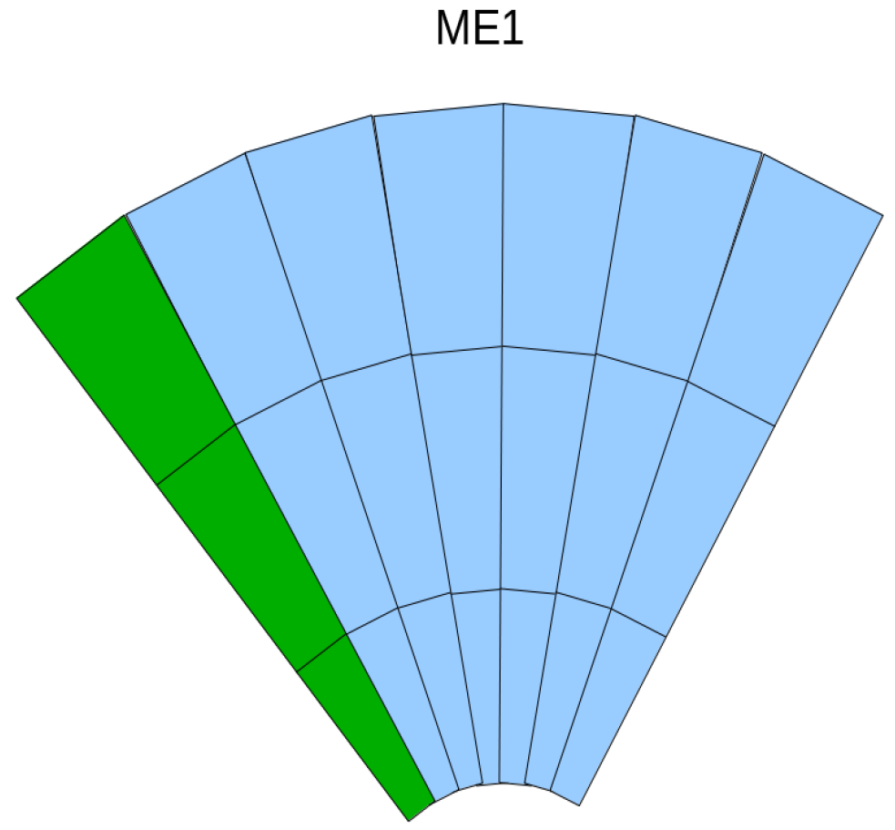

6

5

4

1

2

3

Figure 1. ME1 chamber IDs. ID = 0 means no segment from this station. Green chambers belong to neighbor sector.

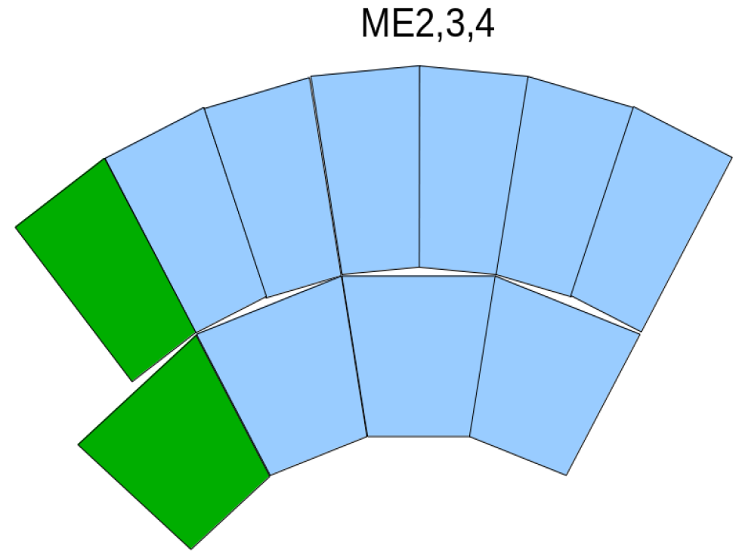

2

1

4

3

Figure 2. ME2,3,4 chamber IDs. ID = 0 means no segment from this station. Green chambers belong to neighbor sector.