Leader: Stanley Wang  
Project Name: Blackjack game

Description: This is a blackjack game we created in CSS and HTML to demonstrate the concepts of how a blackjack game would work.

Stan Code conditions:

BlackJack  
Lose

Michael Code conditions:  
Bust  
Win (normal)  
  
Both:  
Deal cards  
Flip cards over transition  
Move cards to discard pile

Code Snippets:

Card dealing function

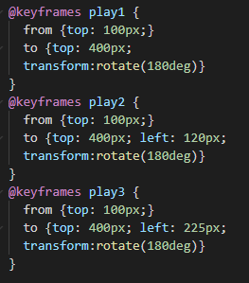

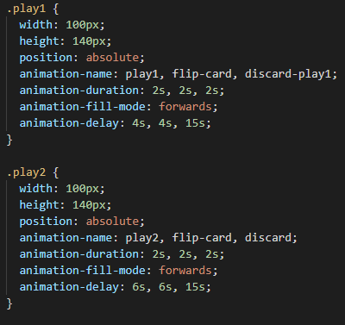

Betting Functions

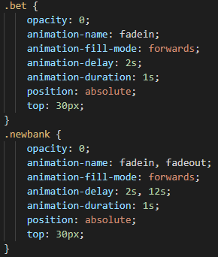

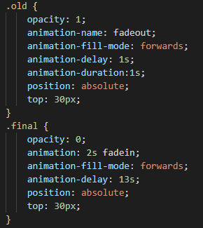

Choosing a deck background

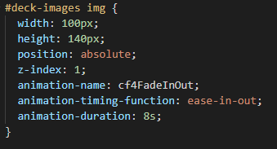

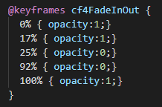

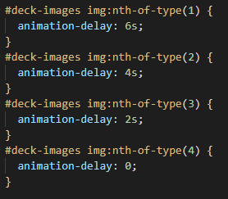

Discard Function

