Alan. D. Martin(Vol. 39 (2008) ACTA PHYSICA POLONICA B No 9)

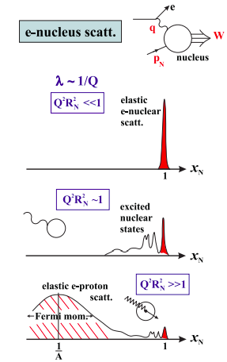

So the invariant mass W of the outgoing system in Fig. 1 satisfies
W² = (p_{N} + q)² = M²_{N} + 2p_{N}· q + q² ,

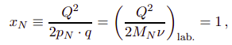
Small Q

DIS
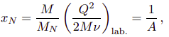

The reduction of the eN elastic peak, with increasing Q2 , reflects the small chance of the A−1 spectator nucleons all happening to be moving in the direction of the outgoing struck proton and reforming the original nucleus.

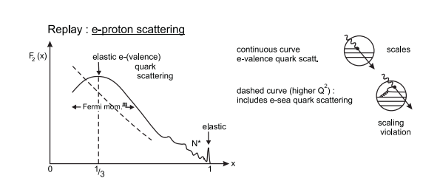

If there were no further substructure, this curve would persist as Q² increases. We would have (Bjorken) scaling; the scattering depends only on the ratio x = Q²/2p · q, and not on the two variables, Q² and p · q, individually. x is known as the Bjorken scaling variable.

Forte and Watt(https://arxiv.org/pdf/1301.6754)

At the current stage of knowledge of strong interactions, parton distributions cannot be computed from first principles. They are instead determined by comparing the PDF dependent prediction for one or more physical processes with its actual measured value: in this sense, their determination is akin to the problem of the measurement of fundamental constants, with the important complication that one has to determine a set of functions, rather than a set of numbers.

These sets of PDFs, while differing in many technical details, shared the basic underlying approach: a functional form for PDFs is assumed, parametrized by a relatively small number of parameters, that are determined by optimizing the fit of the computed observables to the experimental data.

(Perez and Rizvi)(https://arxiv.org/pdf/1208.1178)

