Lab 3: One-Way ANOVA (Jamovi)

Plots
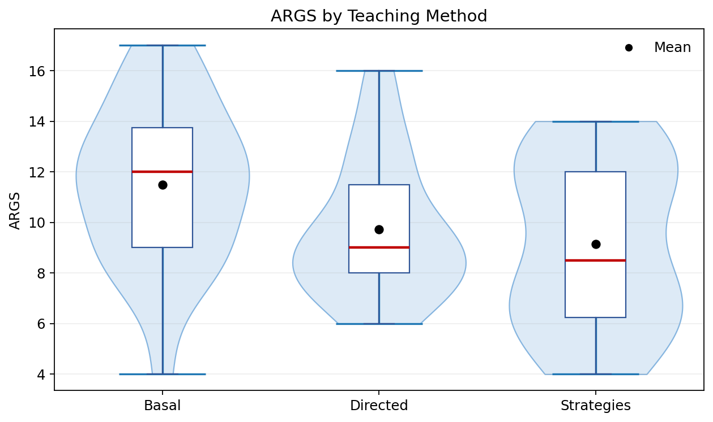
Box/violin plot by teaching method.
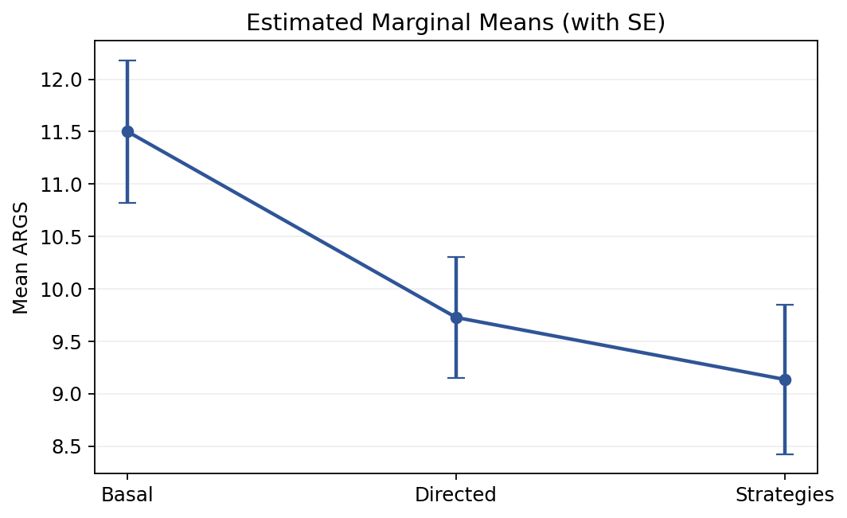
Estimated marginal means plot.

Descriptives
Method | n | Mean | SD | Median | Min | Max
Basal | 22 | 11.50 | 3.19 | 12.00 | 4 | 17
Directed | 22 | 9.73 | 2.69 | 9.00 | 6 | 16
Strategies | 22 | 9.14 | 3.34 | 8.50 | 4 | 14

Short Answers
- Medians differ a little
- The spreads look similar. Largest SD / smallest SD = 1.24 (< 2), so the spread check is acceptable.
- H0: all three teaching methods have the same mean ARGS score. Ha: at least one mean differs.
- Levene's test was not significant, F(2, 63) = 1.43, p = .246, so homogeneity was met.
- Normality was mostly acceptable, but Directed was a little low on Shapiro-Wilk (p = 0.039).
- The one-way ANOVA was significant, F(2, 63) = 3.49, p = .036, eta squared = 0.10.
- Basal had the highest mean ARGS score. After Bonferroni correction, no pair was significant at .05; Basal vs. Strategies was the closest.

Post-Hoc (Bonferroni)
Comparison | Mean Diff. | Adj. p
Basal vs. Directed | 1.77 | .159
Basal vs. Strategies | 2.36 | .063
Directed vs. Strategies | 0.59 | 1.000

There was a significant effect of teaching method on ARGS scores, F(2, 63) = 3.49, p = .036, eta squared = 0.10. Levene's test was not significant, F(2, 63) = 1.43, p = .246, so homogeneity of variance was there. Basal produced the highest mean score, Directed and Strategies were lower. Bonferroni post-hoc tests did not show any pairwise difference at the .05 level.

