**\* What is the DOM?**

-> The DOM (Document Object Model) in JavaScript is a programming interface provided by browsers that represents an HTML or XML document as a tree-like structure made up of nodes. Each node is an object that corresponds to a part of the document, such as an element (like <div> or <p>), attribute, or piece of text.



You can access DOM elements directly from the browser's JavaScript console using standard DOM methods. Some of the most common ways are:

* + By ID:

document.getElementById('myId')

* + By class name:

document.getElementsByClassName('myClass')

* + By tag name:

document.getElementsByTagName('div')

* + With a CSS selector:

document.querySelector('.myClass') *// Returns the first element matching the selector*

document.querySelectorAll('.myClass') *// Returns all elements matching the selector*

*\* Example : Get Element by ID*

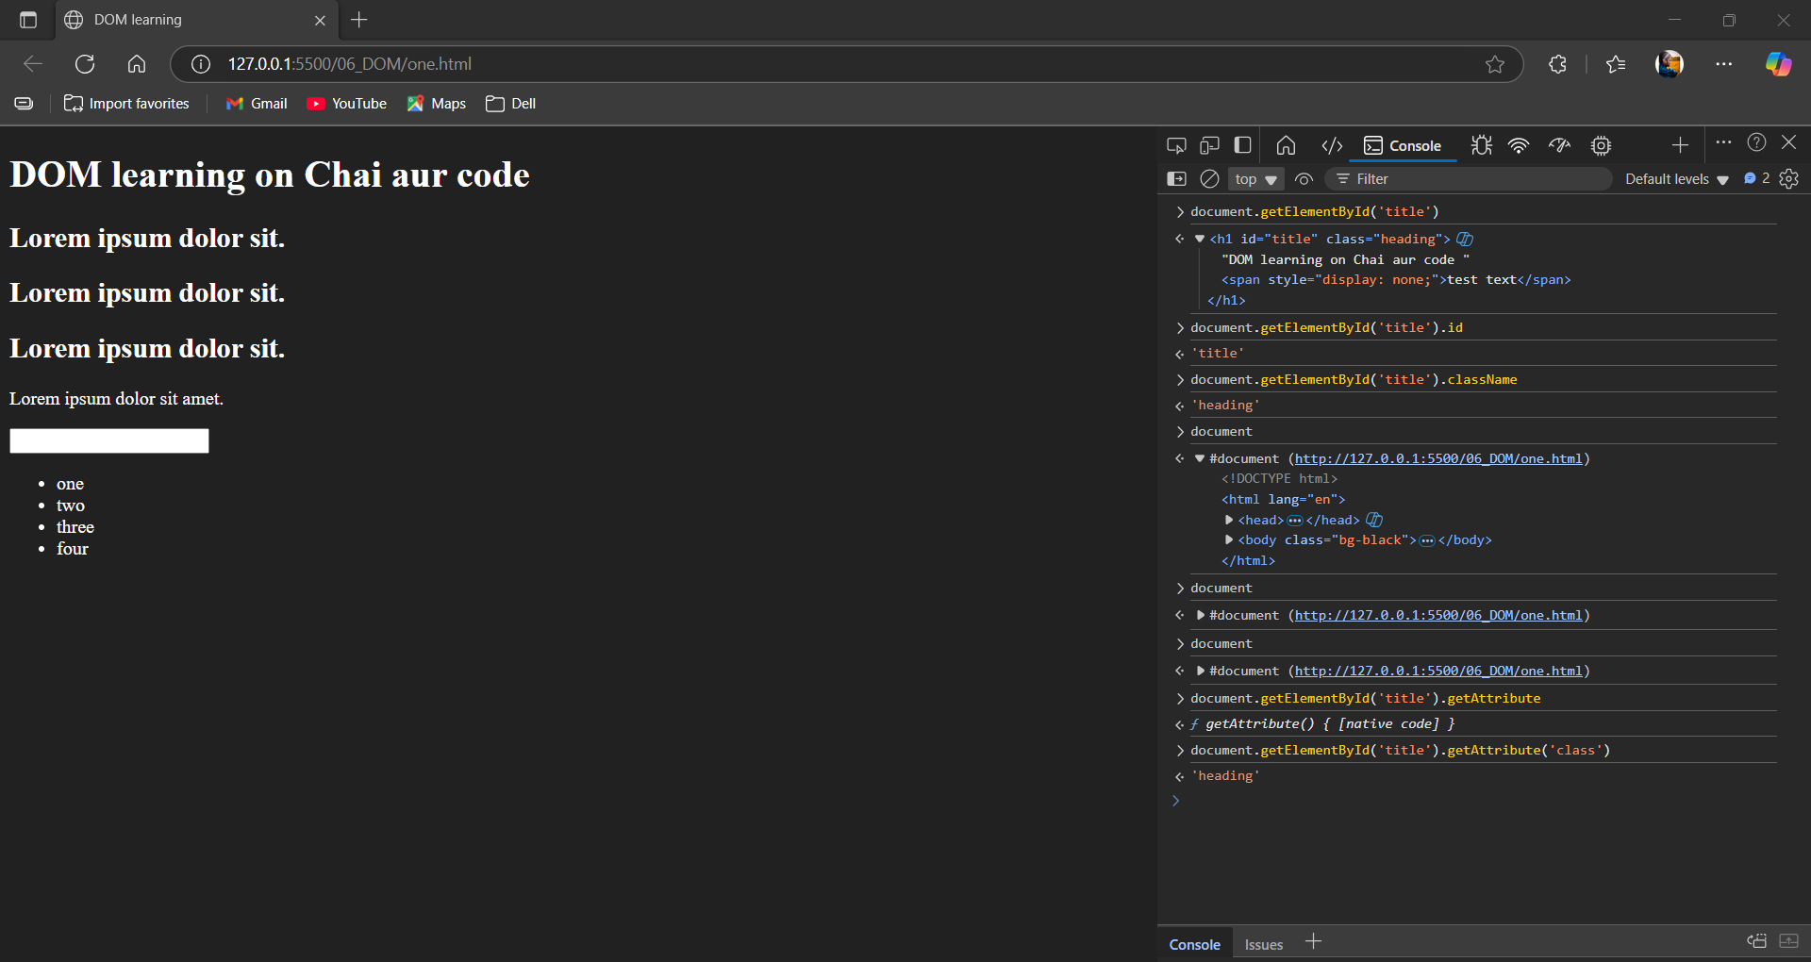

\* Example : Query selector and Query all selector

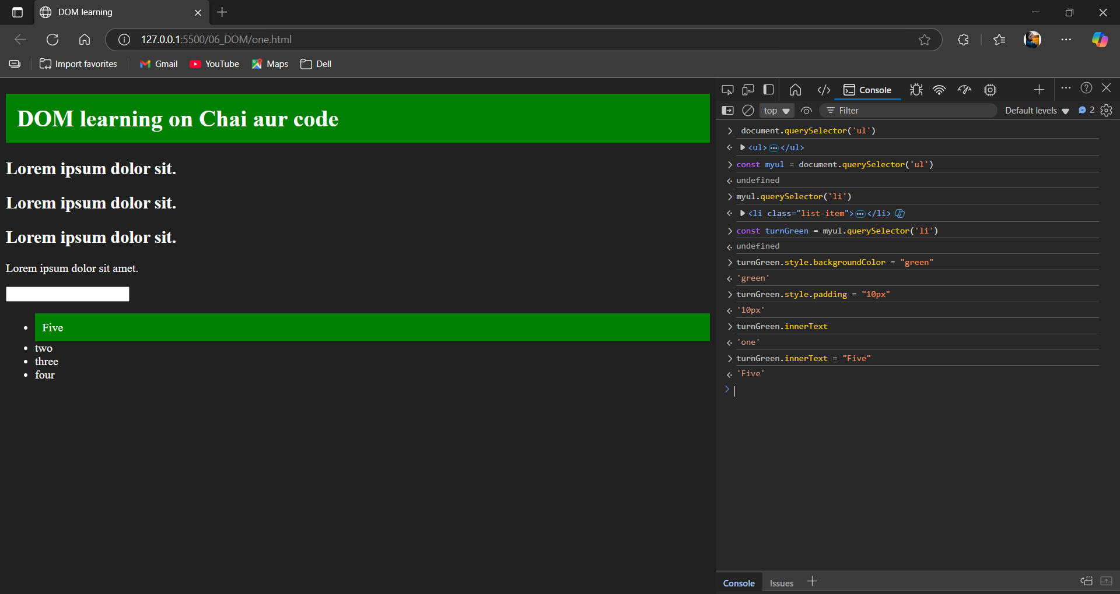

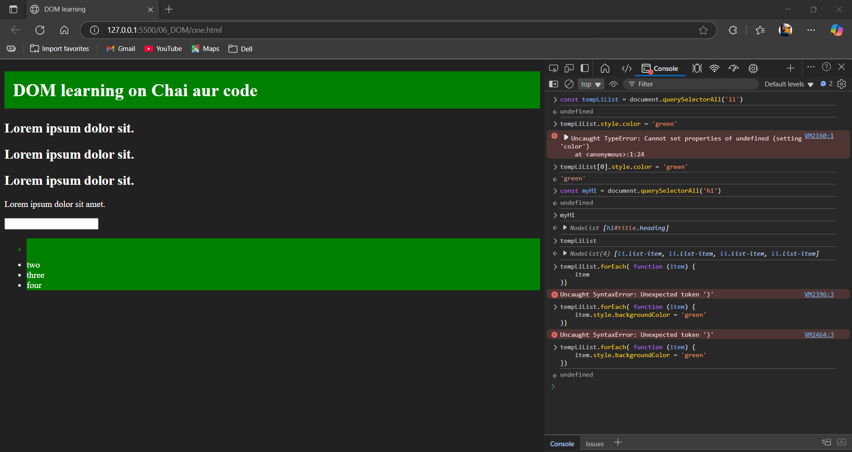

What is node List and HTML collection?

A NodeList is an array-like collection of nodes returned by DOM methods such as querySelectorAll() or childNodes. It can include element nodes, text nodes, and comment nodes, not just HTML elements. NodeLists support access by index and have a length property. Some NodeLists are "live" (e.g., childNodes) and update as the DOM changes, while others are "static" (e.g., querySelectorAll()).

An HTMLCollection is an array-like collection that contains only HTML element nodes (not text nodes or comments), usually returned by methods like getElementsByClassName() or getElementsByTagName(). HTMLCollections are always "live," so changes in the DOM automatically update the collection. Elements in an HTMLCollection can be accessed by index, and sometimes by name or id if available

How to Loop over both of this?

* For the Node List method foreach is use to loop.
* For the HTMLCollection we have to convert it into the array.  
  following screen shot has been added for how to do this.

