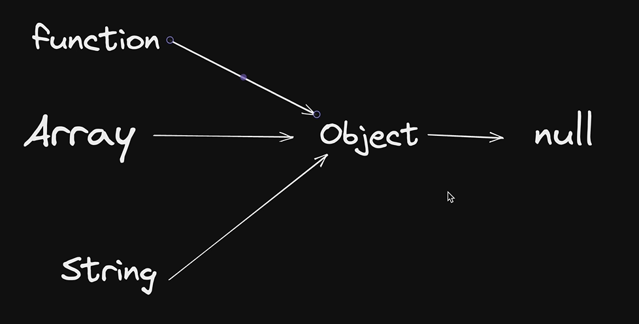

1. In JavaScript, **every object has a prototype**, which is another object it inherits properties and methods from.
2. The **prototype chain** allows an object to access properties defined on its prototype or further up the chain until reaching Object.prototype.
3. When you add a method to Object.prototype, like .swanand(), it becomes available on **all objects**, including arrays and functions.
4. Adding a method to Array.prototype, like .heySwanand(), makes it available only on **array objects**, not on plain objects.
5. This chain of inheritance means **all JavaScript attributes and methods come from objects**, enabling shared behavior and extending built-in types.