Brandon Swanson CS 325 Project 3 11/15/15
Problem 1:

A) Lindo code used to generate solution
min 10 p1w1 + 15 p1w2 +
11 p2w1 + 8 p2w2 +
13 p3w1 + 8 p3w2 + 9 p3w3 +
14 p4w2 + 8 p4w3 +

5 w1r1 + 6 w1r2 + 7 w1r3 + 10 w1r4 +
12 w2r3 + 8 w2r4 + 10 w2r5 + 14 w2r6 +
14 w3r4 + 12 w3r5 + 12 w3r6 + 6 w3r7

st
!supply constraints
p1w1 + p1w2 <=150
p2w1 + p2w2 <=450
p3w1 + p3w2 + p3w3 <=250
p4w2 + p4w3 <=150

!warehouse input = output constraint
w1r1 + w1r2 + w1r3 + w1r4 - p1w1 - p2w1 - p3w1 = 0
w2r3 + w2r4 + w2r5 + w2r6 - p1w2 - p2w2 - p3w2 - p4w2 = 0
w3r4 + w3r5 + w3r6 + w3r7 - p3w3 - p4w3 = 0

!demand constraints
w1r1 >= 100
w1r2 >= 150
w1r3 + w2r3 >= 100
w1r4 + w2r4 + w3r4 >= 200
w2r5 + w3r5 >= 200
w2r6 + w3r6 >= 150
w3r7 >= 100

!nonegativity constraint
p1w1 >0
p1w2 >0
p2w1 >0
p2w2 >0
p3w1 >0
p3w2 >0
p3w3 >0
p4w2 >0
p4w3 >0
w1r1 >0
w1r2 >0
w1r3 >0
w1r4 >0
w2r3 >0
w2r4 >0
w2r5 >0
w2r6 >0
w3r4 >0
w3r5 >0
w3r6 >0
w3r7 >0

end

Minimum Costs: $17100
Routes:
P1 to W1 :150
P2 to W1 :200 P2 to W2 :250
P3 to W2 :150 P3 to W3 :100
P4 to W3 :150
W1 to R1 :100 W1 to R2 :150 W1 to R3 :100
W2 to R4 :200 W2 to R5 :200
W3 to R6 :150 W3 to R7 :100
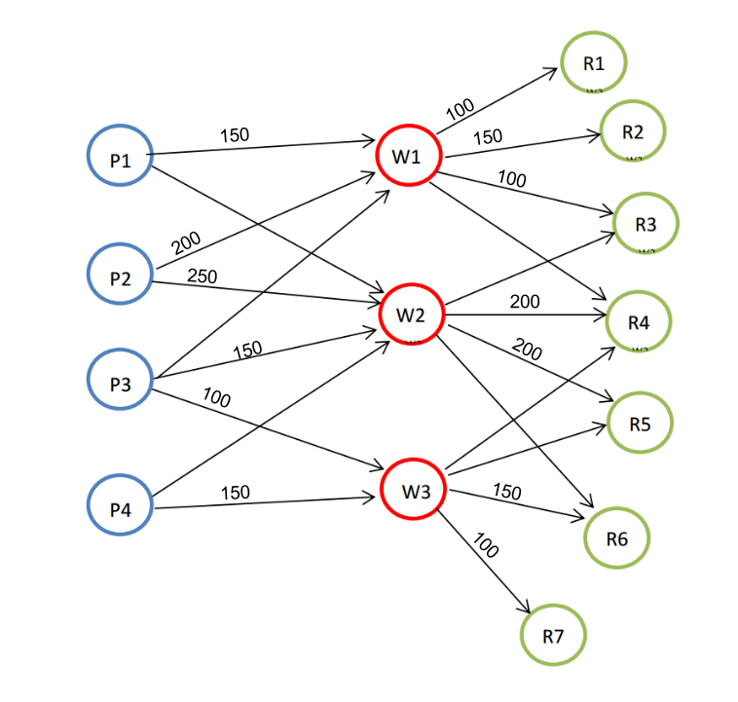
B) It is infeasible without warehouse 2, there is no way to meet all the demands of the retailers.
R4 is 50 units short.

Lindo code used to verify:
min 10 p1w1 + 11 p2w1 + 13 p3w1 + 9 p3w3 + 8 p4w3 +

5 w1r1 + 6 w1r2 + 7 w1r3 + 10 w1r4 +
14 w3r4 + 12 w3r5 + 12 w3r6 + 6 w3r7

st
!supply constraints
p1w1 <=150
p2w1 <=450
p3w1 + p3w3 <=250
p4w3 <=150

!warehouse input = output constraint
w1r1 + w1r2 + w1r3 + w1r4 - p1w1 - p2w1 - p3w1 = 0
w3r4 + w3r5 + w3r6 + w3r7 - p3w3 - p4w3 = 0

!demand constraints
w1r1 >= 100
w1r2 >= 150
w1r3 >= 100
w1r4 + w3r4 >= 200
w3r5 >= 200
w3r6 >= 150
w3r7 >= 100

!nonegativity constraint
p1w1 >0
p2w1 >0
p3w1 >0
p3w3 >0
p4w3 >0
w1r1 >0
w1r2 >0
w1r3 >0
w1r4 >0
w3r4 >0
w3r5 >0
w3r6 >0
w3r7 >0

end

To verify the solution I also added just this single constraint to the original problem 1 lindo file:
w2r3 + w2r4 + w2r5 + w2r6 + p1w2 + p2w2 + p3w2 + p4w2 = 0
C) It is feasible to meet all the demands with the reduced capacity of warehouse 2 with an increased cost of $18,300
to get this solution the the following constraint was added
p1w2 + p2w2 + p3w2 + p4w2 = 100
It was only necessary to constrain the routes from production to warehouse because there are already constraints in place to ensure input and output of the warehouses are equal.

Minimum Cost: $18,300
Routes:
P1 to W1: 150 P2 to W1: 350 P2 to W2: 100 P3 to W3: 250
P4 to W3: 150 W1 to R1: 100 W1 to R2: 150 W1 to R3: 100
W1 to R4: 150 W2 to R4: 50 W2 to R5: 50 W3 to R5: 150
W3 to R6: 150 W3 to R7: 100

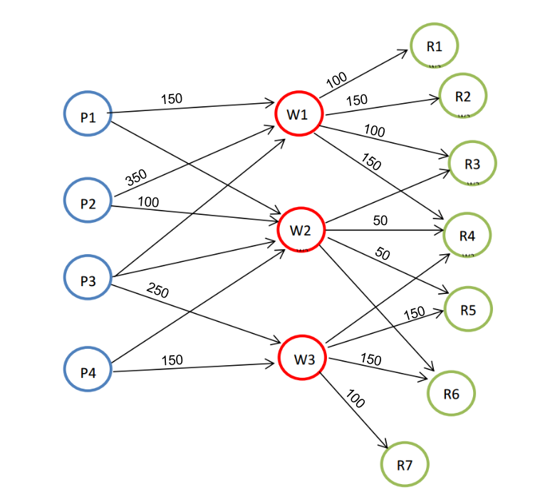
D)

Problem 2:
A)
LINDO CODE
min 21t + 16l + 40s + 41c + 585ss + 120st + 164cp + 884o
st
PROTIEN).85t + 1.62l + 2.86s + .93c + 23.4ss + 16st + 9cp >= 15

MT2GRAMFAT).33t + .2l + .39s + .24c + 48.7ss + 5st + 2.6cp + 100o >=2
LT8GRAMFAT).33t + .2l + .39s + .24c + 48.7ss + 5st + 2.6cp + 100o <=8

CARBOHYDRAYTES)4.64t + 2.37l + 3.63s + 9.58c + 15ss + 3st + 27cp >=4

SODIUM)9t + 28l + 65s + 69c + 3.8ss + 120st + 78cp <=200

PERCENTLEAFY).6s + .6l - .4t - .4c - .4ss - .4st - .4cp - .4o >= 0

t >= 0
l >= 0
s >= 0
c >= 0
ss >= 0
st >= 0
cp >= 0
o >= 0

end

The minimum calorie salad that meets all of the requirements has 114.7541 calories and contains
58.54801 grams of Lettuce
87.82201 grams of Smoked Tofu
and costs 2.33$

B)
LINDO CODE
min t + .75l + .5s + .5c + .45ss + 2.15st + .95cp + 2o
st
PROTIEN).85t + 1.62l + 2.86s + .93c + 23.4ss + 16st + 9cp >= 15

MT2GRAMFAT).33t + .2l + .39s + .24c + 48.7ss + 5st + 2.6cp + 100o >=2
LT8GRAMFAT).33t + .2l + .39s + .24c + 48.7ss + 5st + 2.6cp + 100o <=8

CARBOHYDRAYTES)4.64t + 2.37l + 3.63s + 9.58c + 15ss + 3st + 27cp >=4

SODIUM)9t + 28l + 65s + 69c + 3.8ss + 120st + 78cp <=200

PERCENTLEAFY).6s + .6l - .4t - .4c - .4ss - .4st - .4cp - .4o >= 0

t >= 0
l >= 0
s >= 0
c >= 0
ss >= 0
st >= 0
cp >= 0
o >= 0

end

The low-cost salad has a cost of 1.55$ and has 278.4884 calories

C)
It seems that the tools for solving multiple optimization problems like this one are usually interactive with the a person being presented with iterative solutions an then inputing information about tradeoffs or pairwise comparisons. Through this negotiation improved solutions are presented until the most preferred solution is found.

Barring access to such interactive tools for linear programming Veronica can add upper bound constraints on calories and cost and then minimize cost and calories in turn to discover the minumum calories if the cost is allowed to be equal to the upper bound and vice versa for the minimum cost. From here she can use this information to tighten the upper bound on the constraints of cost and calorie to some value between her original upper bound and their absolute minimum, checking if such a solution is feasible.

I would suggest a salad that contains
Ingredient | Grams
Tomato | 0
Lettuce | 0
Spinach | 59.28
Carrot | 0
Sunflower Seeds | 8.84
Smoked Tofu | 57.52
Chickpeas | 22.56
Oil | 0

With a cost of: $1.78 (and profit of $3.22 if sold at 5$)
and total calories: 181.47

I arrived at this combination of ingredients through a system of binary searching for a feasible and nearly optimal solution.
I first added the constraints for the upper bounds of calories and cost as such
COST) t + .75l + .5s + .5c + .45ss + 2.15st + .95cp + 2o <=2
CALORIE) 21t + 16l + 40s + 41c + 585ss + 120st + 164cp + 884o <= 249
and then solved with the objective function minimizing cost and then calories in turn

If the cost was allowed to be 2 dollars then the optimum salad had only 134.76 calories.
If the calories were allowed to be 249 then the optimum salad cost only $1.62

I then solved once again for both minimizing cost and calorie in turn updating the cost and calorie constraints to be the mid point between their optimum (min) values and the upper bound for each
COST) t + .75l + .5s + .5c + .45ss + 2.15st + .95cp + 2o <=1.8125
CALORIE) 21t + 16l + 40s + 41c + 585ss + 120st + 164cp + 884o <= 191.88

With these new constraints an optimum calorie salad cost $1.81 and has 171.074 calories
and an optimum cost salad cost $1.76 and 191.88 calories.

Again the constraints were updated to be the midpoint between these new optimums
cost constraint = (1.81 + 1.76) /2 calories constrain = ( 171.074 + 191.88 ) / 2

COST) t + .75l + .5s + .5c + .45ss + 2.15st + .95cp + 2o <=1.7874775
CALORIE) 21t + 16l + 40s + 41c + 585ss + 120st + 164cp + 884o <= 181.477

This was the final iteration because a feasible solution with these constraints was found and the cost and calories objective function caused negligible variation in in the cost and calories and ingredients variables. The two optimizations differed in cost by less than a penny and by a thousandth of a calorie and hundredth of a gram for each ingredient. So this seems like a good middle ground of optimizing both calorie and cost.

