Course End Project Report
Slack Integration with Jenkins for Automated CI/CD Deployment

Submitted By
Name: Swapnil Sonawane
Project Title: Slack Integration with Jenkins for Automated Build, Deployment and Notification System
Tools Used:
- GitHub
- Jenkins
- Maven
- Apache Tomcat 10
- Slack
- ngrok
- Ubuntu WSL
- Java 21

1. Introduction
Problem Statement
La' Market recently adopted a microservices-based architecture for its flagship application. Different development teams manage different functionalities of the application.
To improve deployment efficiency and collaboration, the organization wants developers to trigger Jenkins jobs directly from Slack channels and receive build notifications in real time.
The objective of this project is to integrate Slack with Jenkins, enabling:
- Build notifications in Slack
- Remote Jenkins job invocation from Slack
- Automated deployment workflow
- Real-time collaboration and visibility

2. Industry Relevance
Jenkins
Jenkins is an open-source automation server used for:
- Continuous Integration (CI)
- Continuous Delivery (CD)
- Automated Build Management
- Automated Deployment
Benefits:
- Faster software delivery
- Reduced manual effort
- Early defect detection
- Improved release management
Slack
Slack is a collaboration platform used for:
- Team communication
- Notifications
- Workflow automation
- Third-party integrations
Benefits:
- Real-time communication
- Faster incident response
- Centralized collaboration

3. Project Architecture
The following architecture was implemented:
GitHub Repository
↓
Jenkins Build Trigger
↓
Maven Build
↓
WAR Artifact Generation
↓
Tomcat Deployment
↓
Application Validation
↓
Slack Notification

4. Environment Details
Component | Details
Operating System | Ubuntu WSL
Jenkins Version | 2.555.2
Maven Version | 3.8.7
Java Version | OpenJDK 21
Application Server | Apache Tomcat 10
Slack Workspace | TestSlackWorkspace
Slack Channel | #la_market_build_team_slack
Git Repository | La_Market_Deployment_Pipeline
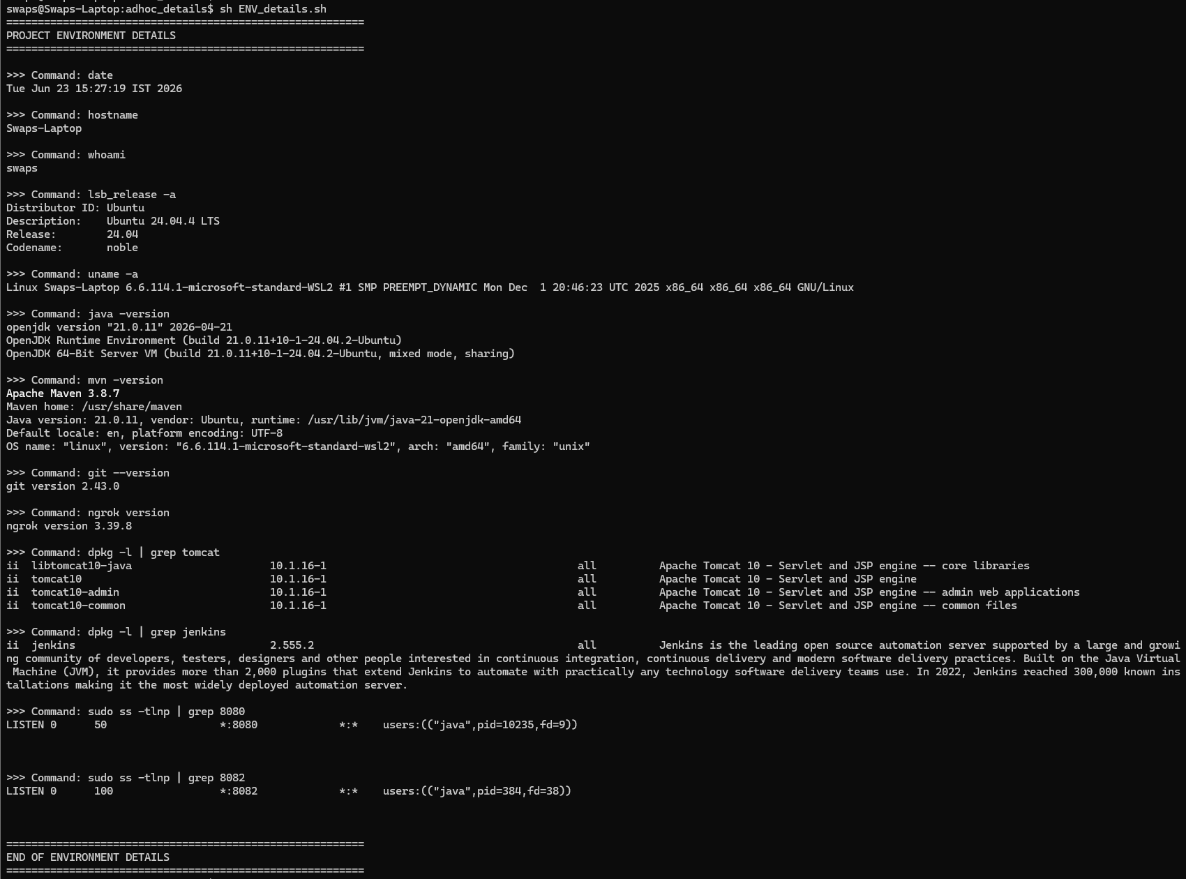

5. Implementation Steps
Step 1: Create Slack Channel
Created a Slack workspace and a dedicated channel:
Channel Name:
#la_market_build_team_slack
Purpose:
- Build notifications
- Deployment notifications
- Team collaboration

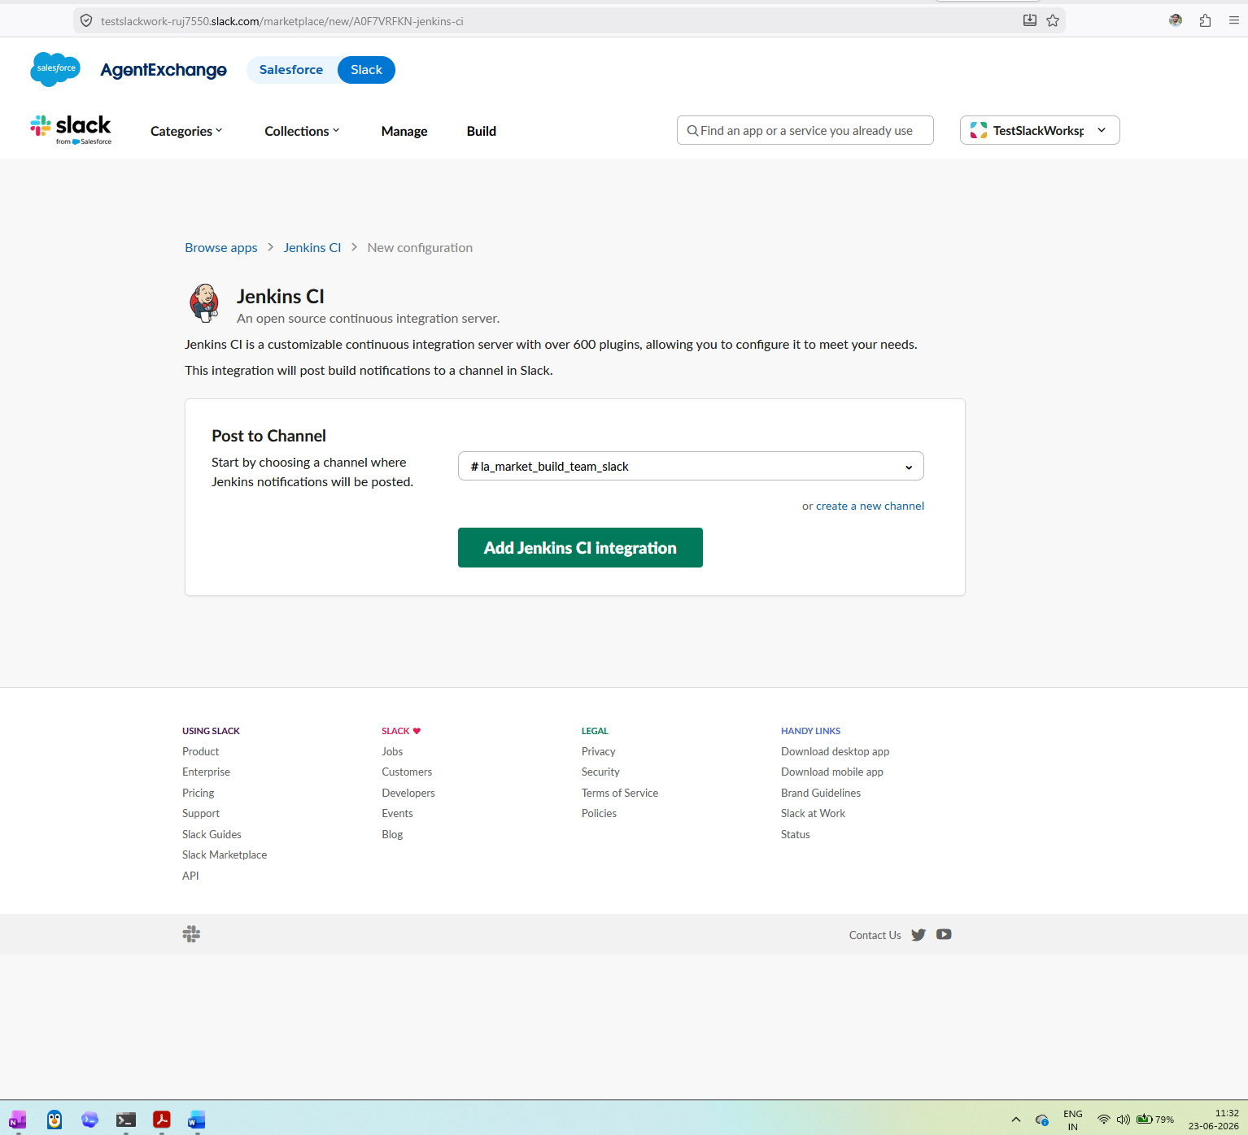
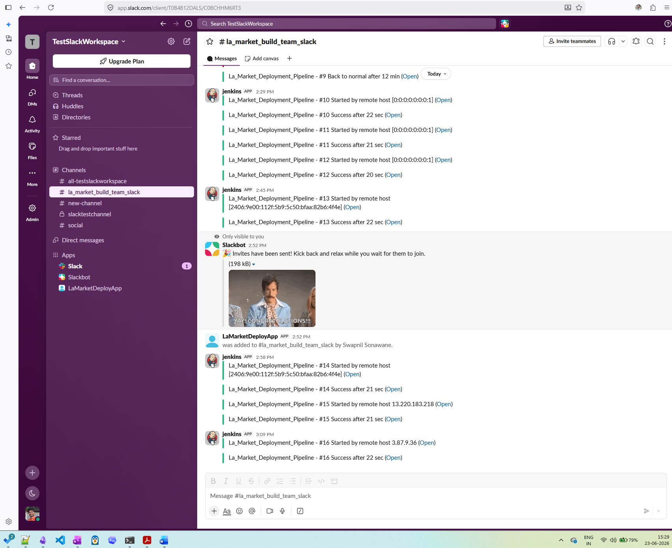

Step 2: Install Slack Notification Plugin
Jenkins Plugin Installed:
Slack Notification Plugin
Navigation:
Manage Jenkins
→ Plugins
→ Available Plugins
→ Slack Notification Plugin
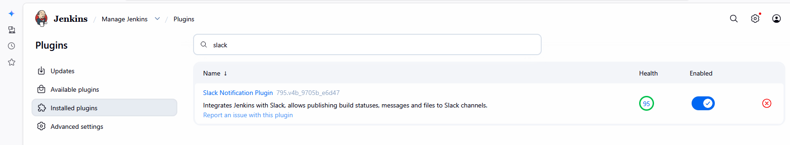

Step 3: Configure Slack Integration
Slack Jenkins CI application was integrated with the Slack workspace.
Configured:
- Team Subdomain
- Integration Token
- Channel Configuration
Navigation:
Manage Jenkins
→ System
→ Slack Settings

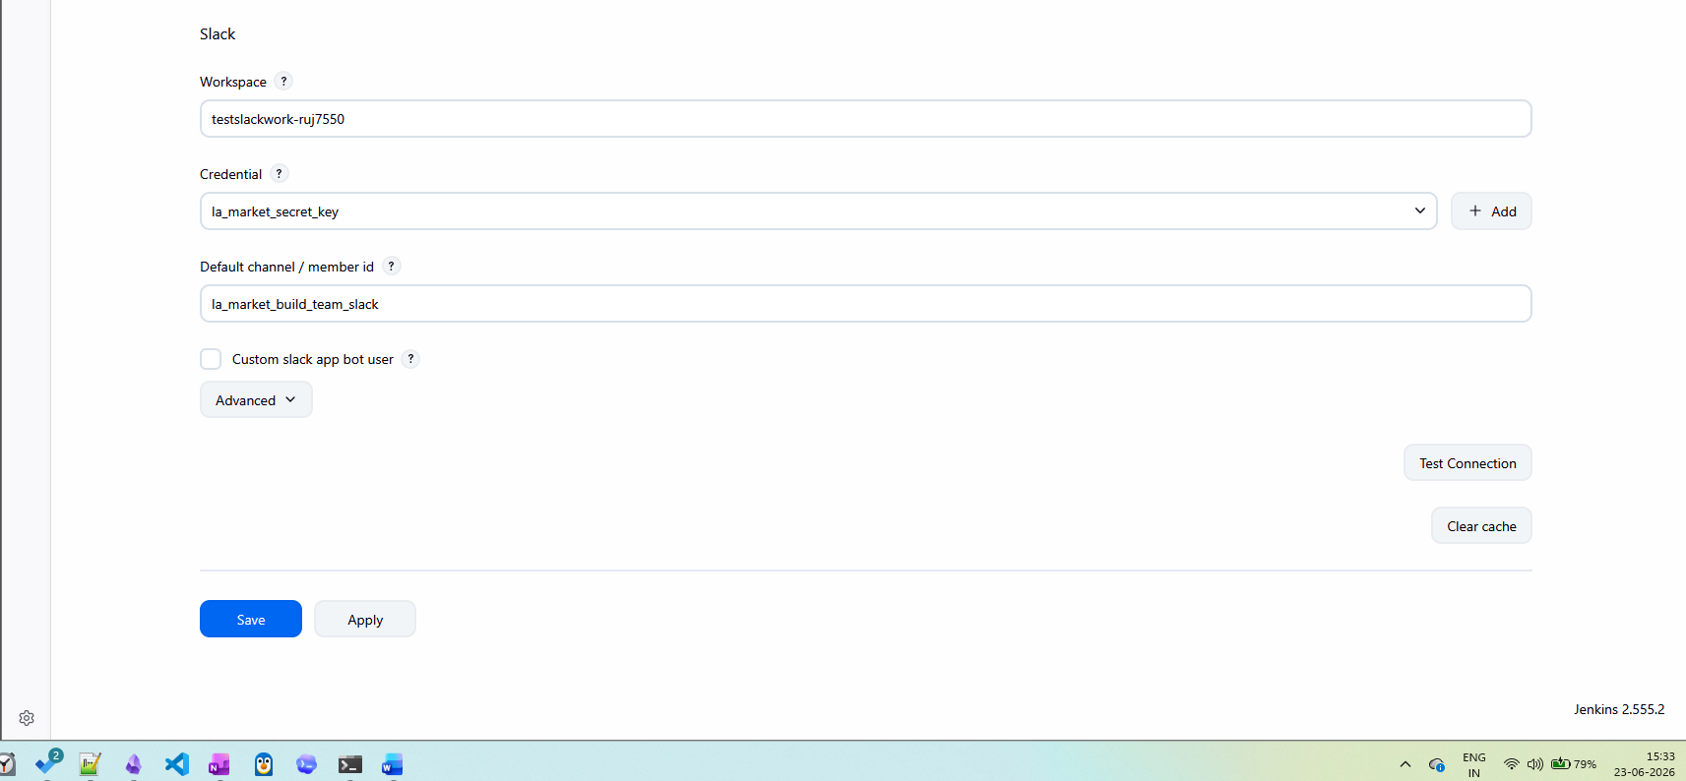

Step 4: Create Jenkins Freestyle Project
Project Name:
La_Market_Deployment_Pipeline
Purpose:
- Source Code Checkout
- Build Automation
- Deployment
- Notifications
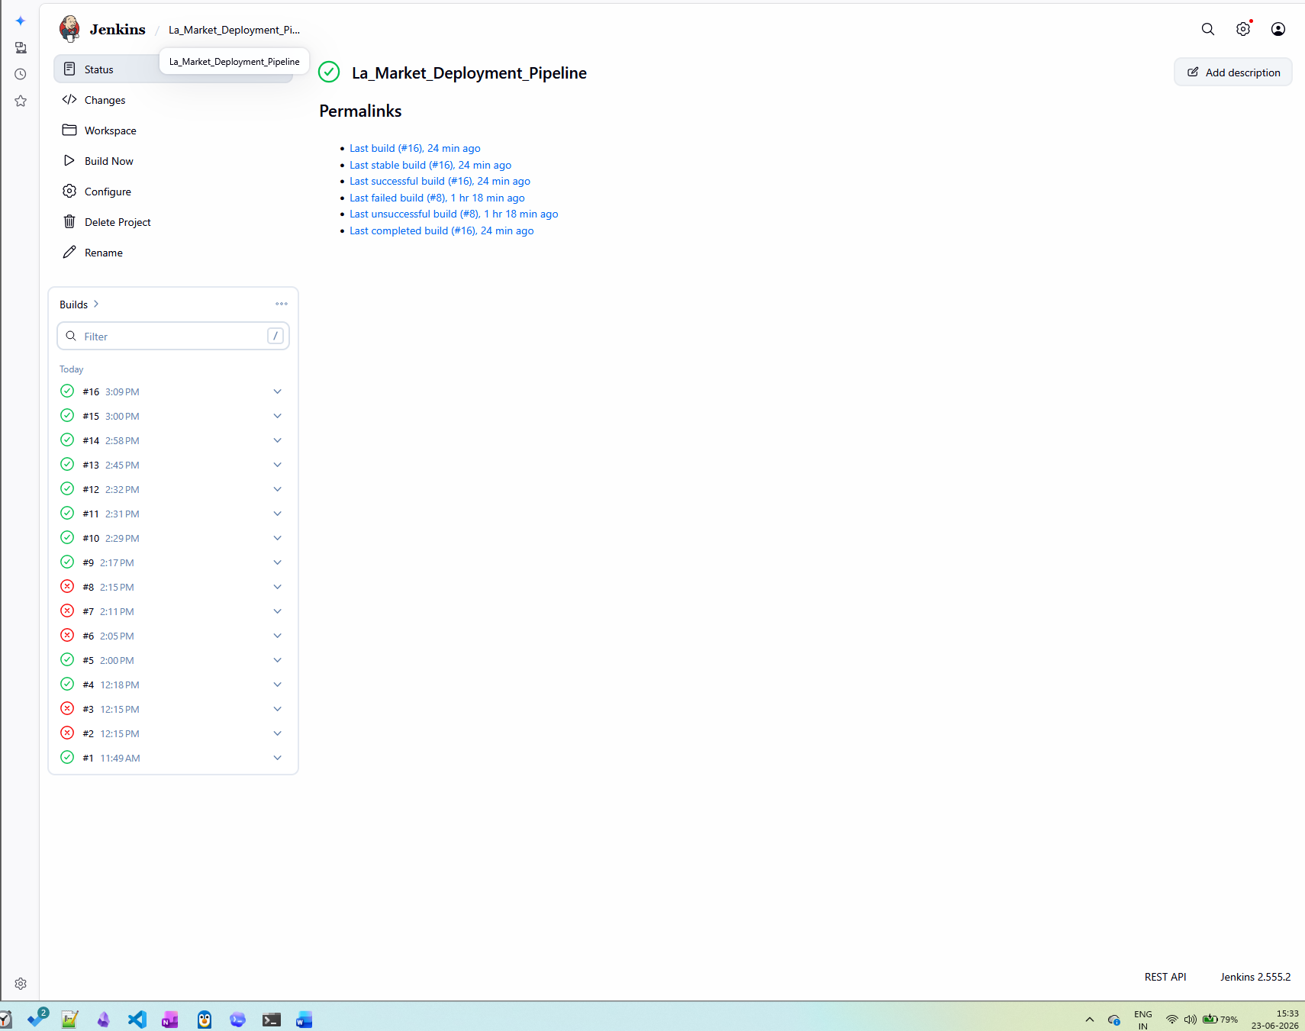

Step 5: Create GitHub Repository
Repository Name:
La_Market_Deployment_Pipeline
Repository Contents:
- pom.xml
- index.jsp
- Maven project structure

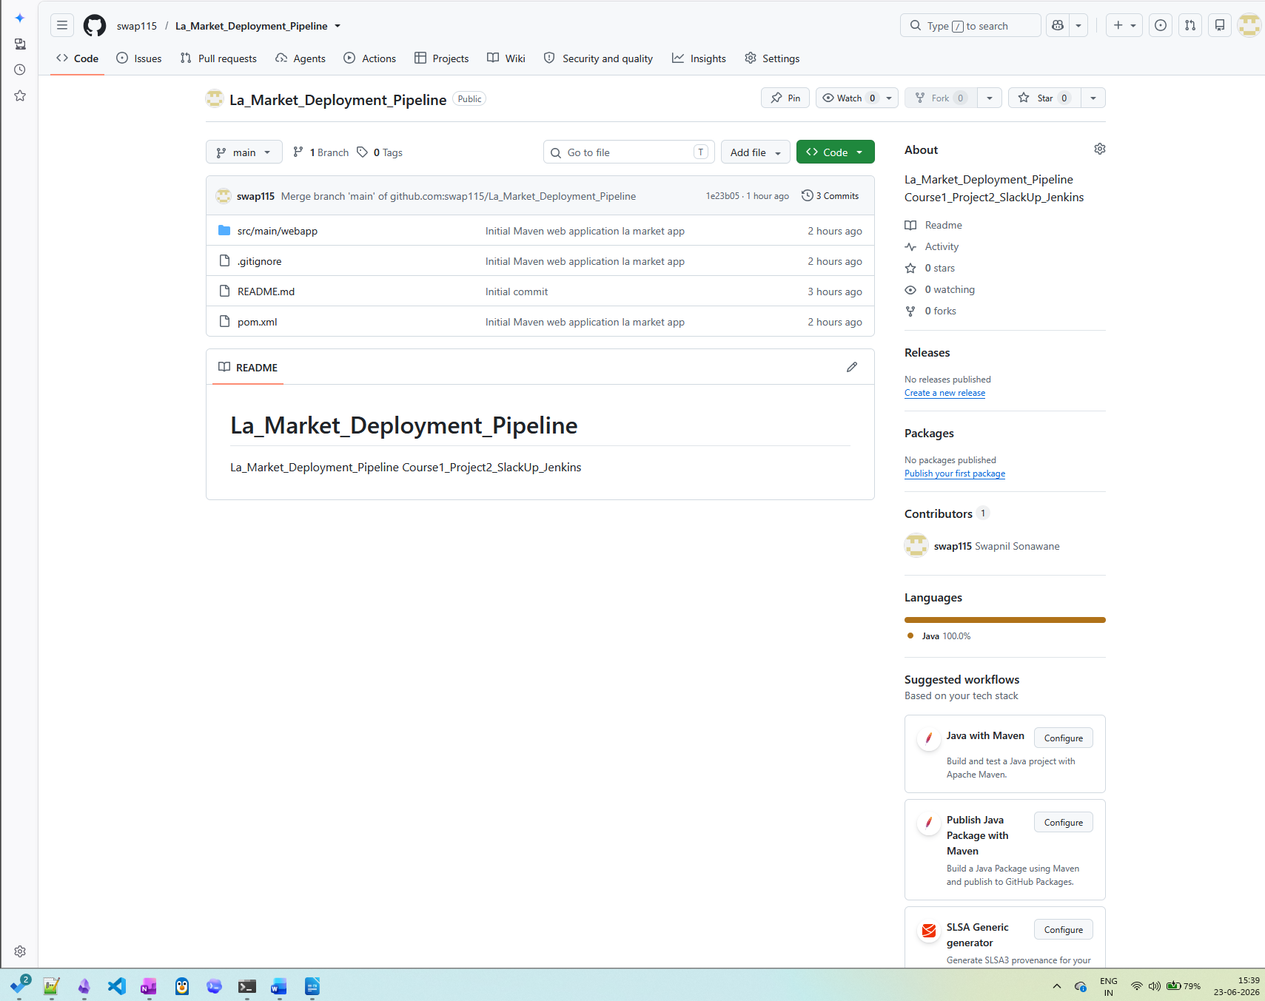

Step 6: Configure Source Code Management
Configured Git Repository in Jenkins.
Repository URL:
git@github.com:swap115/La_Market_Deployment_Pipeline.git
Branch:
main
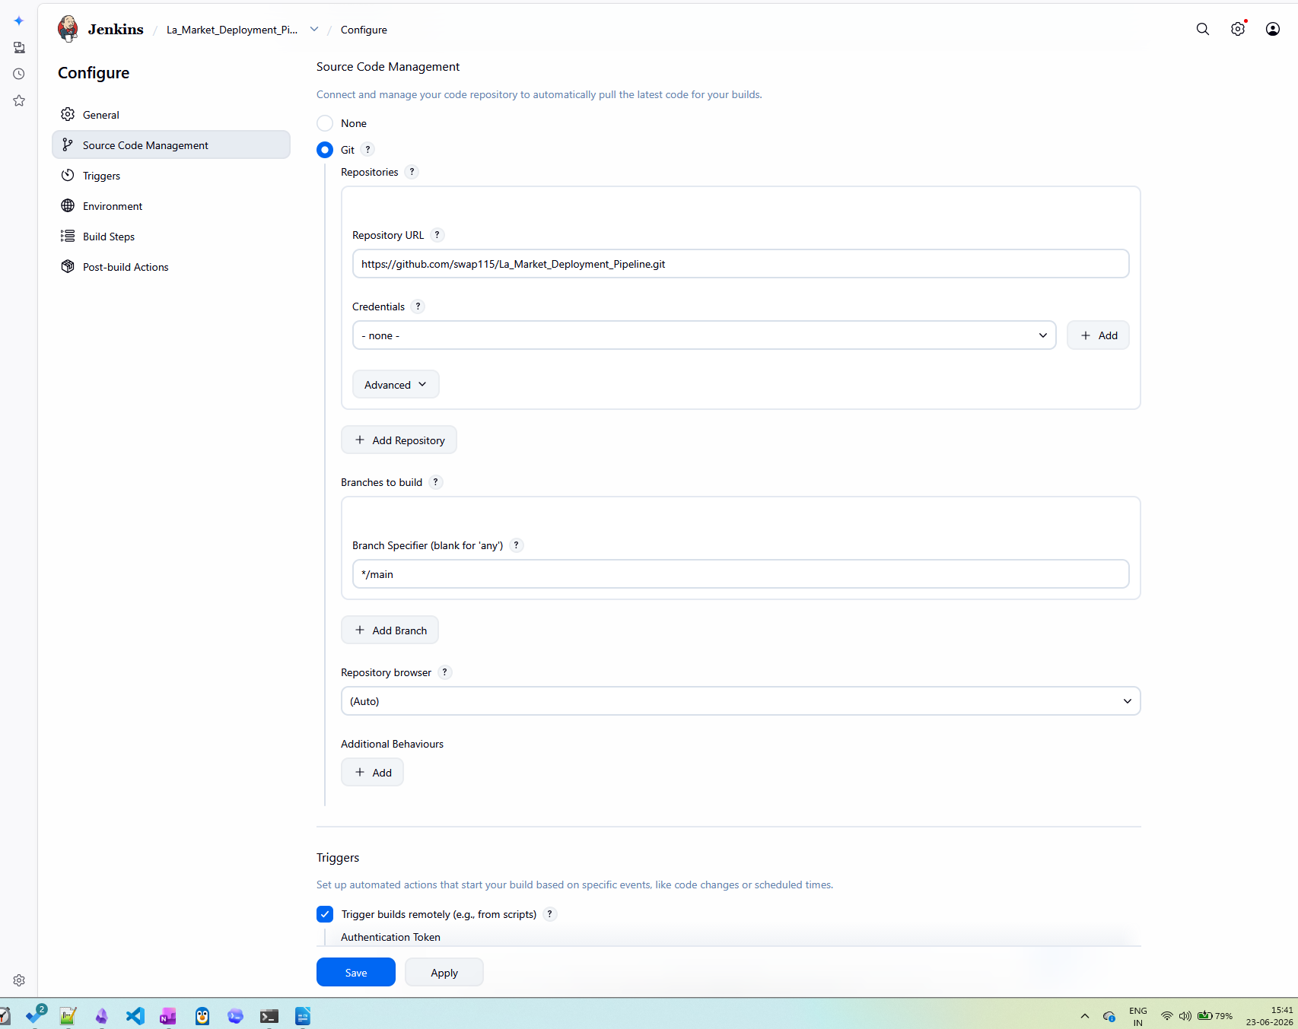

Step 7: Maven Build Configuration
Build Step Added:
Invoke Top Level Maven Targets
Goals:
clean package
Purpose:
- Compile Source Code
- Generate WAR File
- Package Application
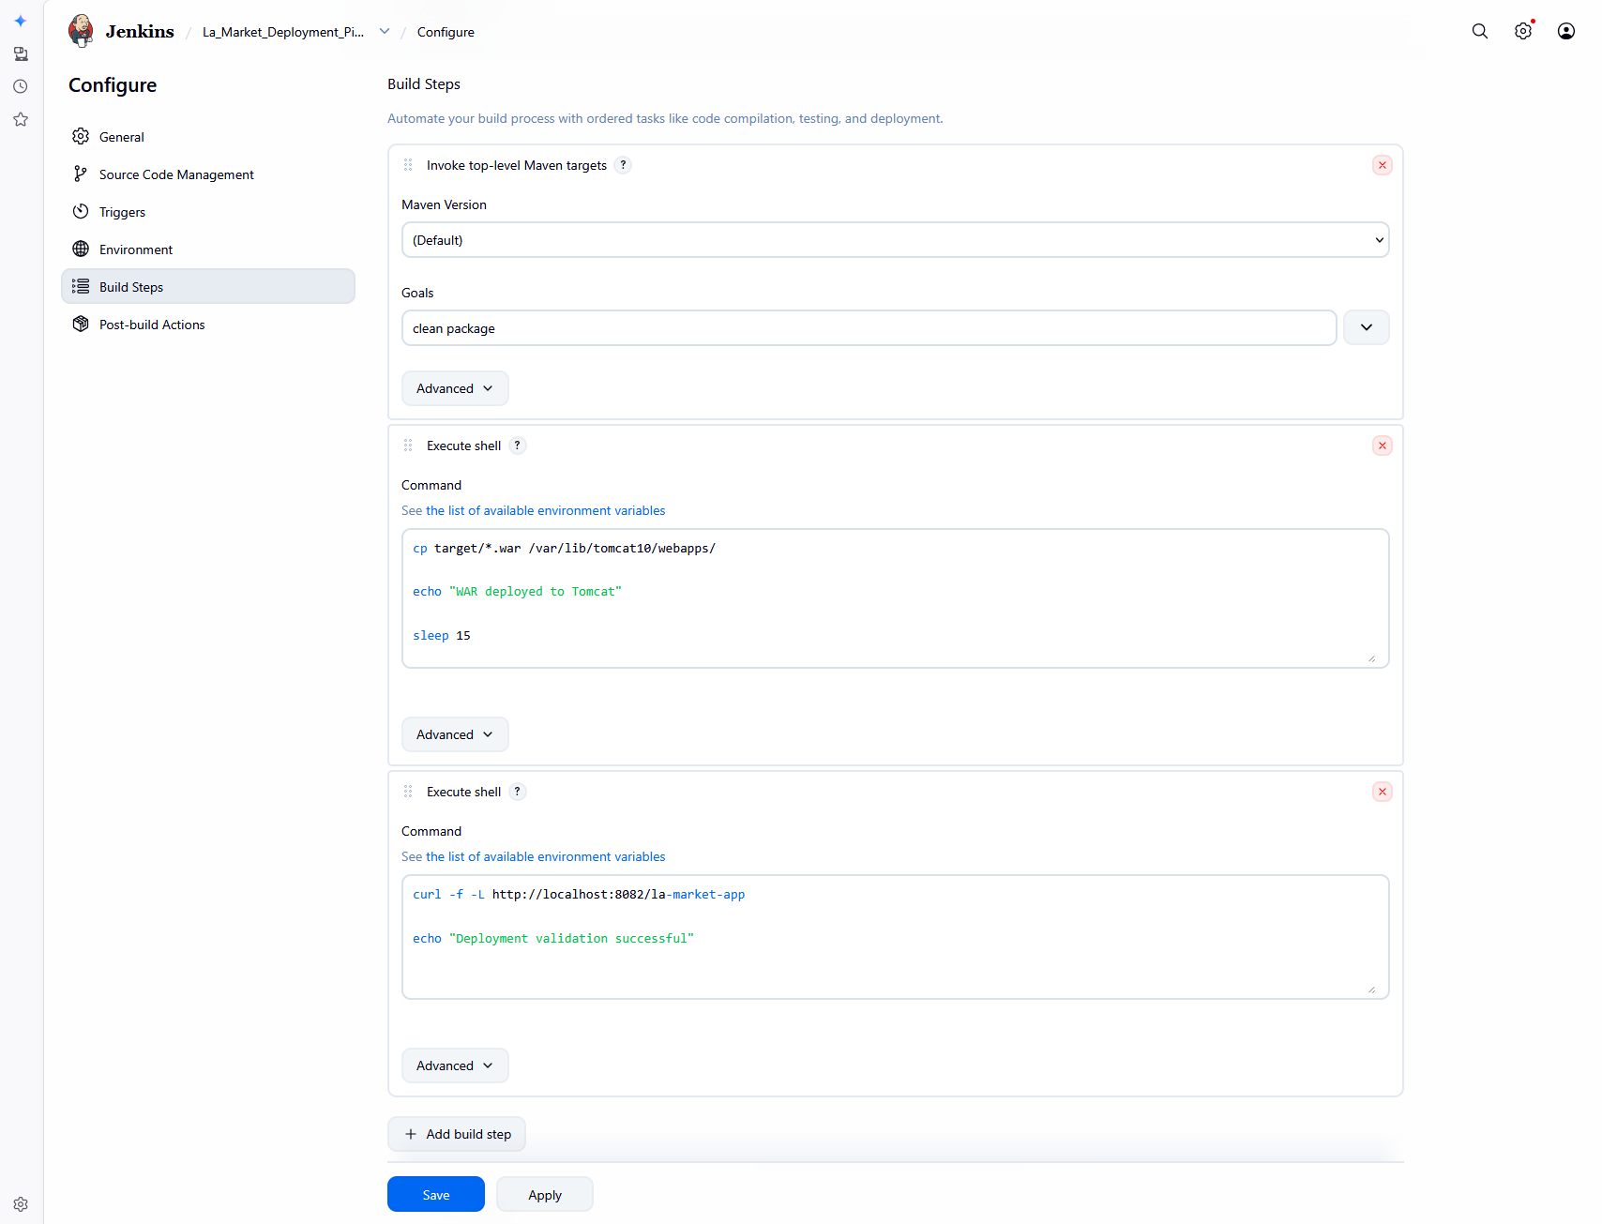

Step 8: Maven WAR Generation
Generated Artifact:
la-market-app.war
Location:
/var/lib/jenkins/workspace/La_Market_Deployment_Pipeline/target/

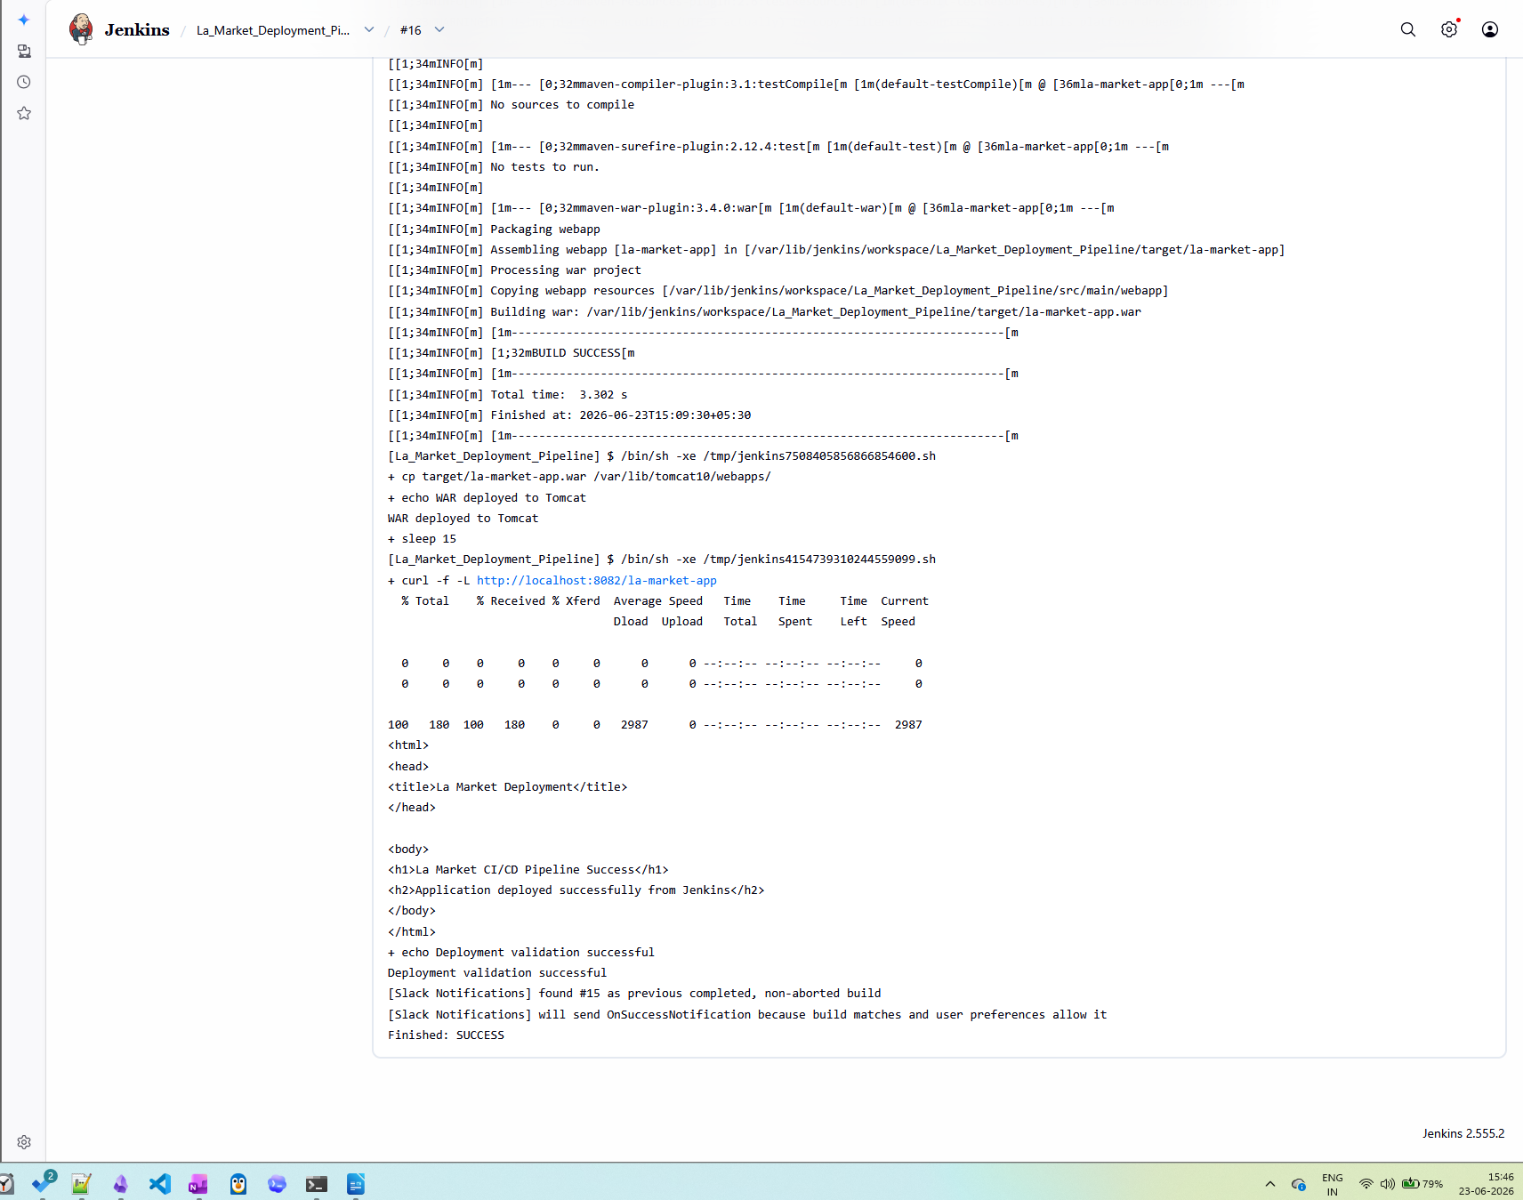

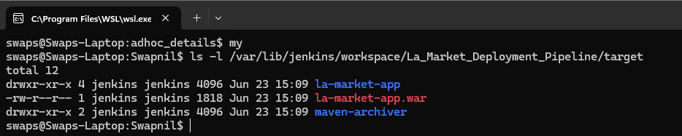
Step 9: Apache Tomcat Configuration
Tomcat Port:
8082
Application URL:
http://localhost:8082/la-market-app
Purpose:
Application Deployment and Hosting
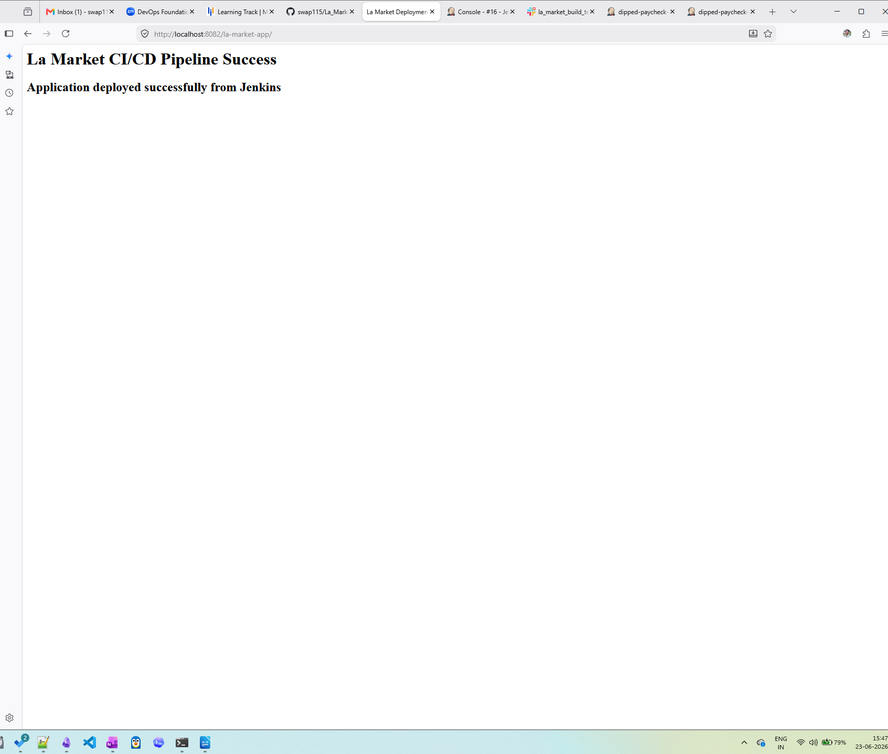

Step 10: Automated Deployment
Added Execute Shell Build Step:
cp target/*.war /var/lib/tomcat10/webapps/
Purpose:
Deploy WAR artifact to Tomcat automatically.



Step 11: Application Validation
Health Check Script:
curl -f -L http://localhost:8082/la-market-app
Purpose:
Validate successful deployment after WAR deployment.


Step 12: Slack Notifications
Configured Notifications:
- Build Start
- Build Success
- Build Failure
Purpose:
Provide real-time build updates to development teams.



13. Slack Slash Command Integration
Objective
Enable users to trigger Jenkins jobs directly from Slack.

Step 1: Install Build Authorization Token Root Plugin
Plugin Installed:
Build Authorization Token Root Plugin
Purpose:
Allow secure remote triggering of Jenkins jobs.
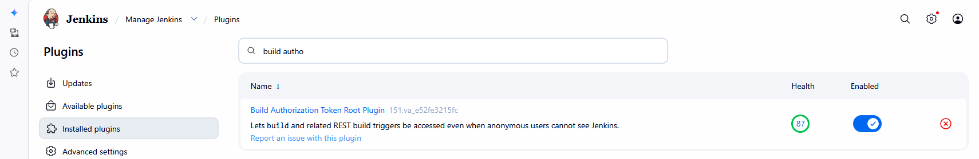

Step 2: Configure Remote Build Trigger
Job Configuration:
Build Triggers
→ Trigger builds remotely
Token:
lamarket123
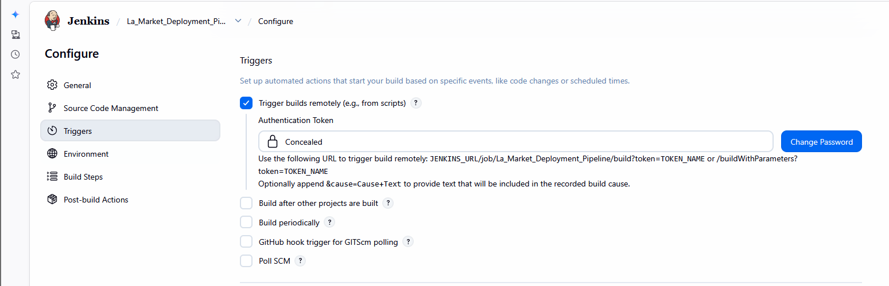
Step 3: Configure ngrok
Purpose:
Expose Jenkins running on localhost to the internet.
Command:
ngrok http 8080
Generated Public URL:
https://dipped-paycheck-retread.ngrok-free.dev

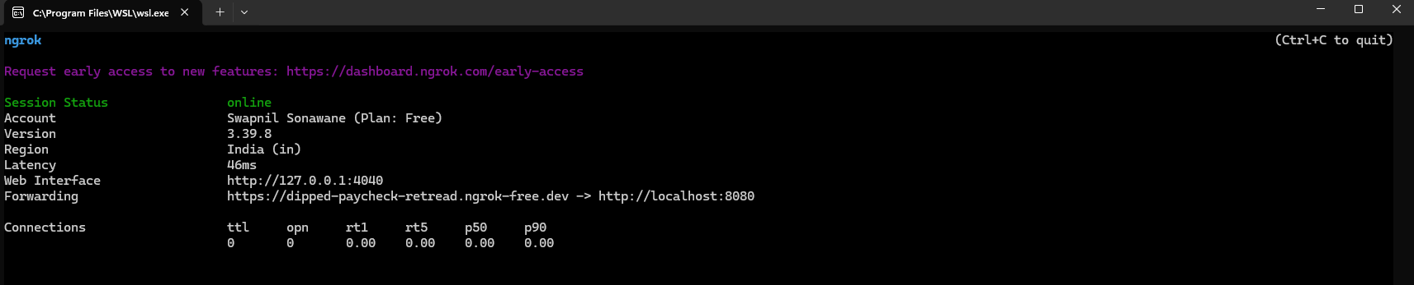

Step 4: Create Slack App
Created Slack Application:
LaMarketDeployApp
Purpose:
Support Slash Commands
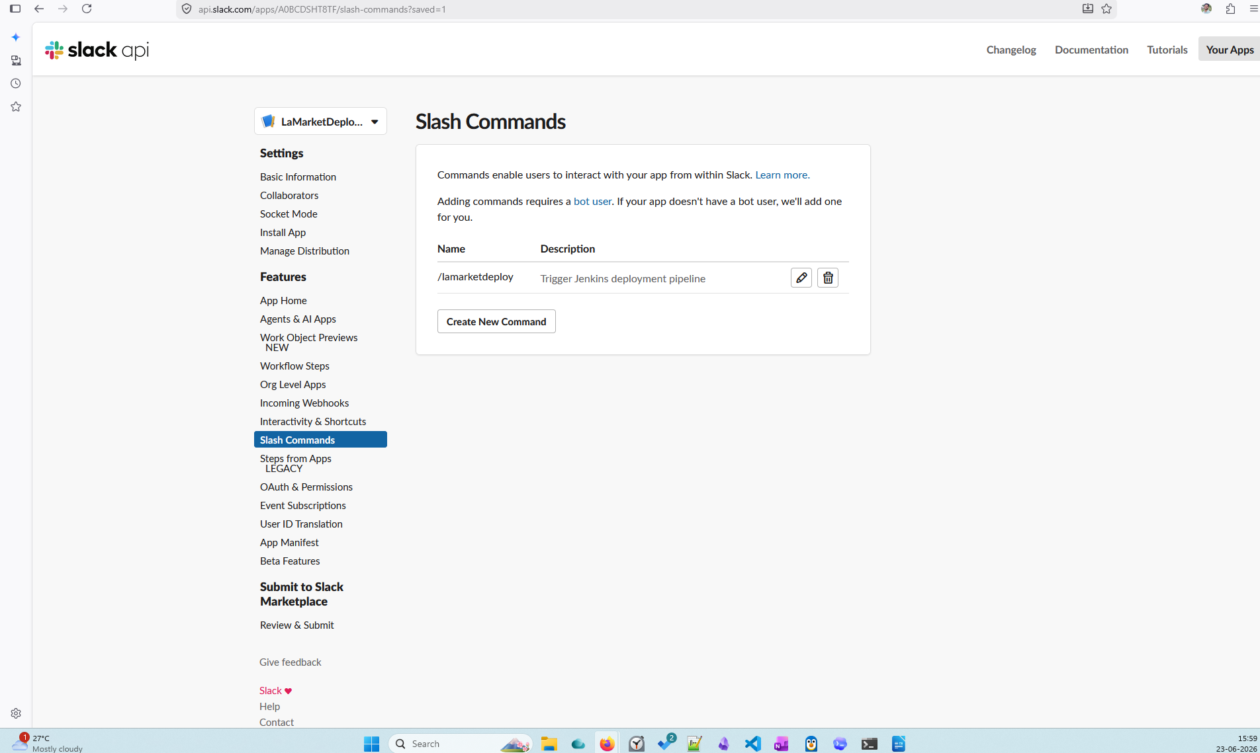

Step 5: Configure Slash Command
Command:
/lamarketdeploy
Request URL:
https://dipped-paycheck-retread.ngrok-free.dev/buildByToken/build?job=La_Market_Deployment_Pipeline&token=lamarket123
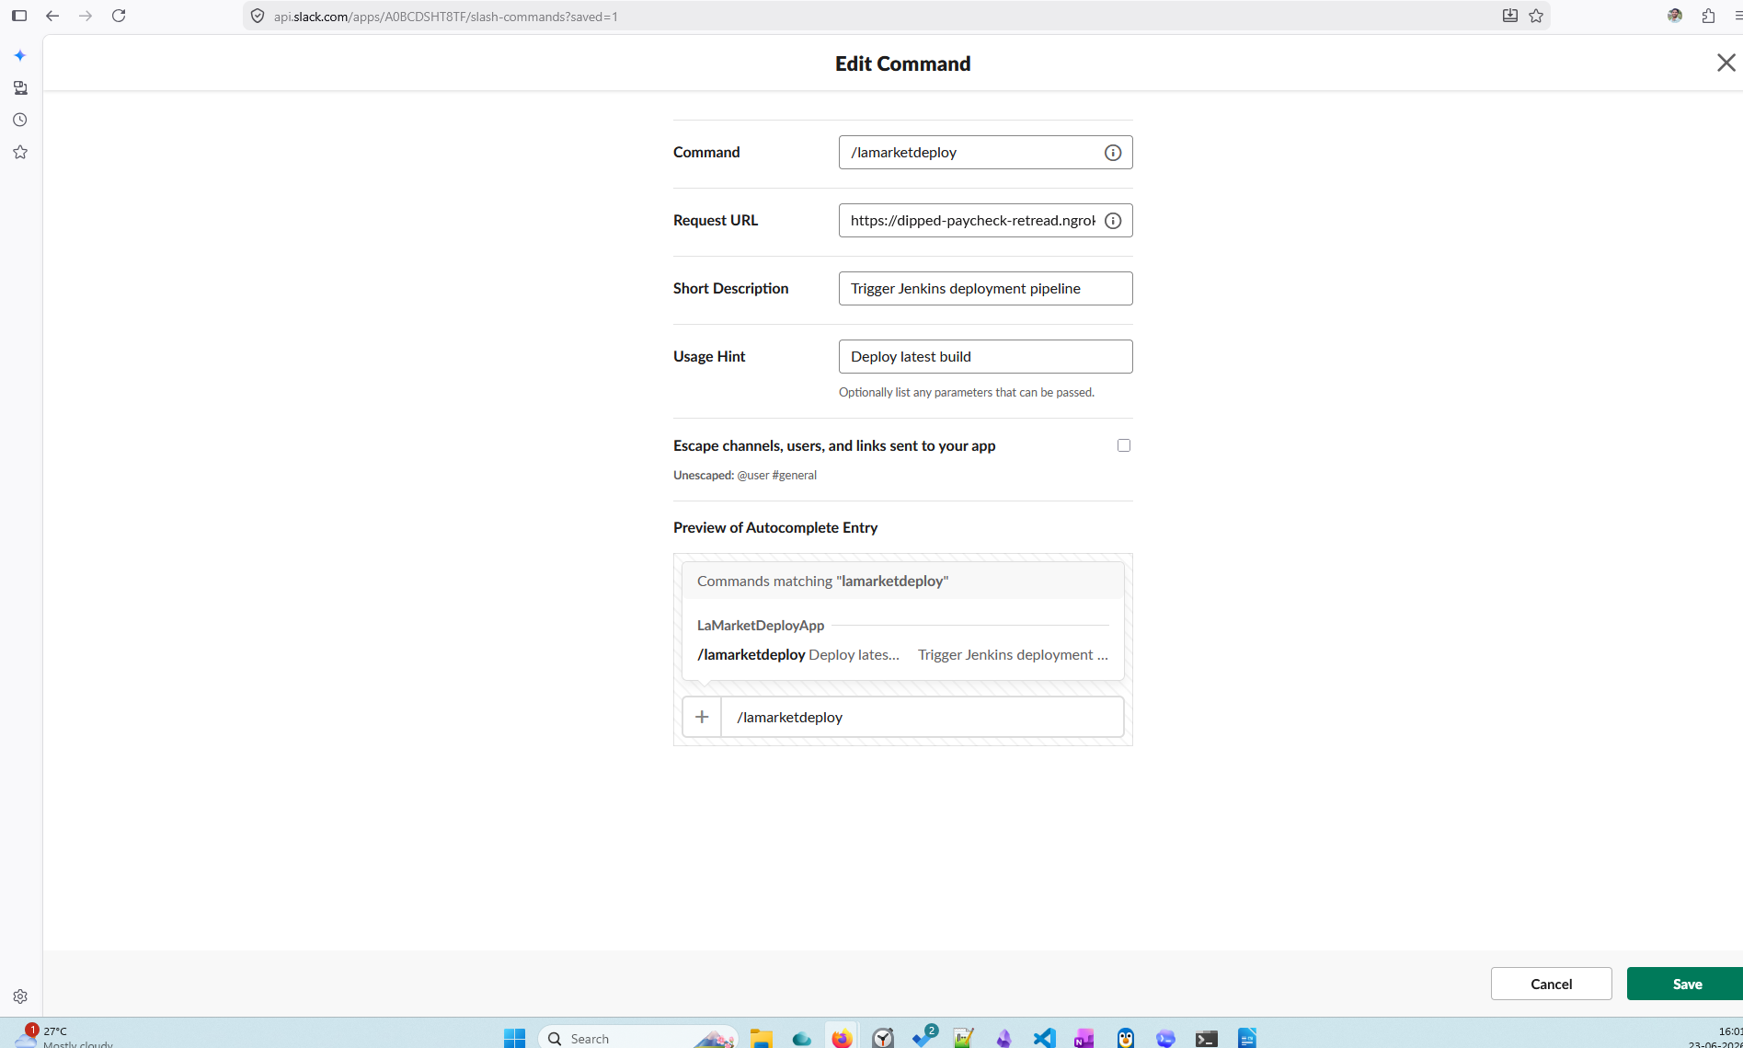
Step 6: Validate Remote Invocation
Execution Flow:
Slack Slash Command
↓
ngrok
↓
Jenkins Remote Trigger
↓
Build Execution
↓
Tomcat Deployment
↓
Slack Notification

https://dipped-paycheck-retread.ngrok-free.dev/buildByToken/build?job=La_Market_Deployment_Pipeline&token=lamarket123

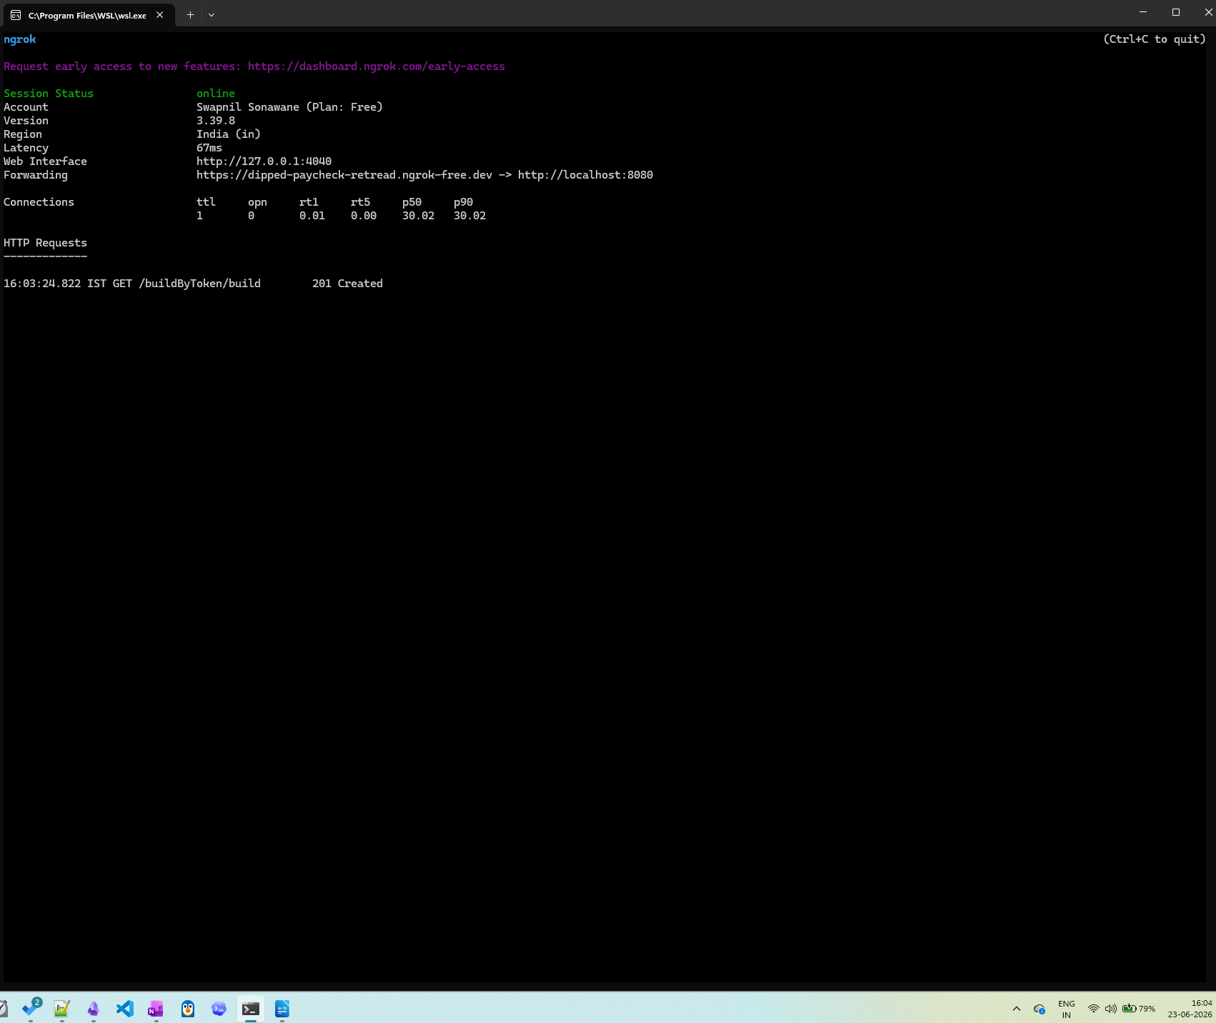

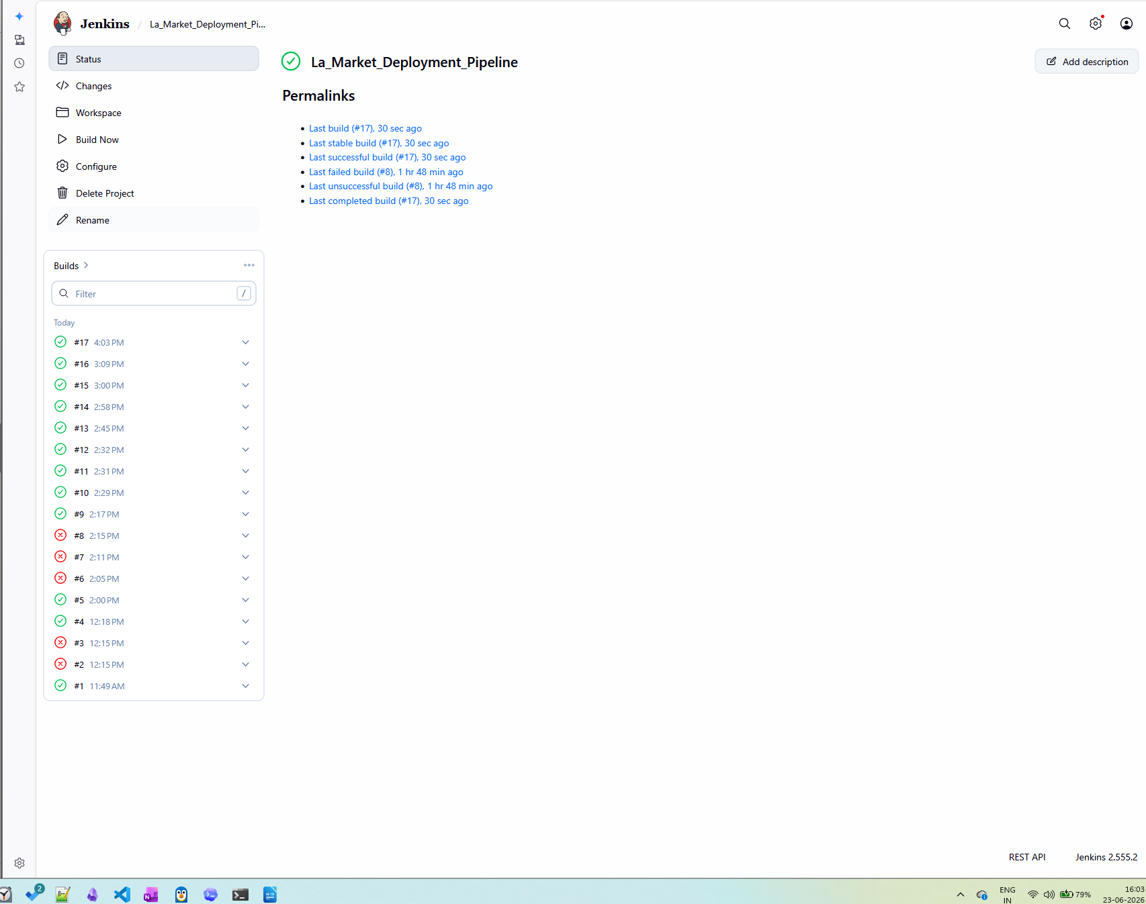

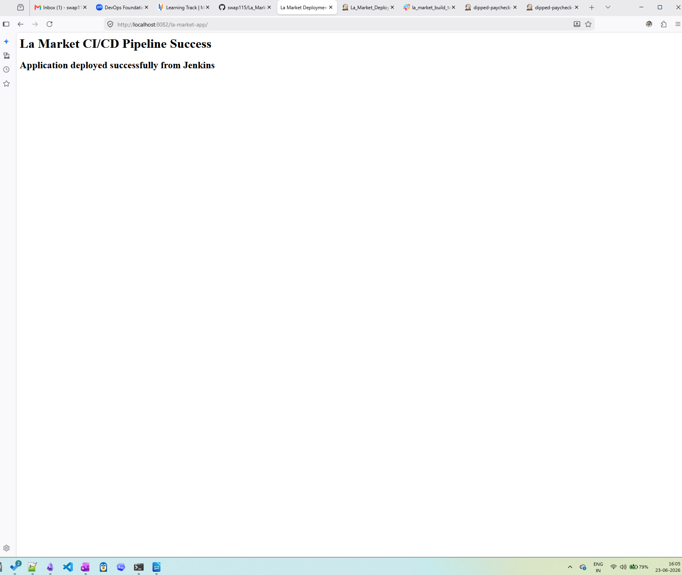

14. Challenges Encountered and Resolution
Issue | Resolution
Git Branch Not Found | Changed branch from master to main
Maven WAR Plugin Compatibility | Upgraded maven-war-plugin to 3.4.0
Jenkins Deployment Permission Error | Added Jenkins access to deployment directory
Tomcat Deployment Validation Returned 302 | Updated validation logic to follow redirects
Slack Command Returned 403 | Used Build Authorization Token Root Plugin endpoint
Slack Command Not Reaching Jenkins | Exposed Jenkins using ngrok

15. Results
Successfully implemented:
- Jenkins and Slack Integration
- GitHub Source Code Integration
- Maven Build Automation
- WAR Artifact Generation
- Tomcat Deployment
- Application Health Validation
- Slack Build Notifications
- Slack-based Remote Jenkins Job Triggering

16. Conclusion
The project successfully integrated Slack with Jenkins to automate build, deployment and notification processes.
The solution enables development teams to:
- Trigger Jenkins jobs from Slack
- Receive real-time build updates
- Automate application deployment
- Improve collaboration and deployment efficiency
The implemented workflow closely resembles a real-world CI/CD pipeline used in modern DevOps environments.

