Division case:

Inputs:

- Left Operand Knob = 0

- Operator Knob = "/"

- Right Operand Knob = 1

Outputs:

- Result LEDs should not display as the result, error LED should be ON

Division case:

Inputs:

- Left Operand Knob = 1

- Operator Knob = "/"

- Right Operand Knob = 0

Outputs:

- Result LEDs should not display as the result, error LED should be ON

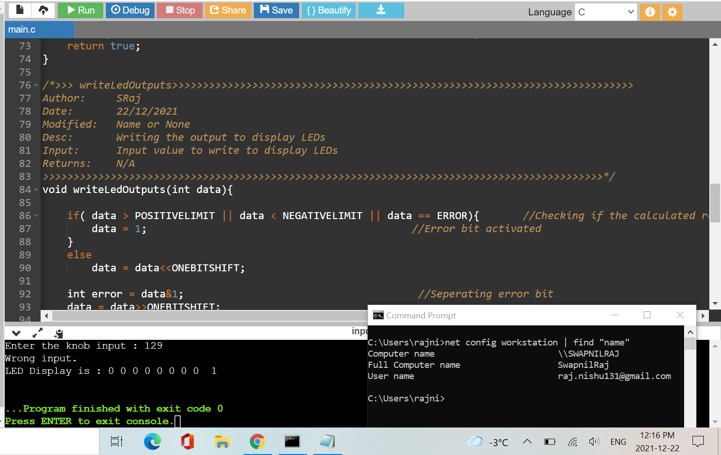

Multiplication case:

Inputs:

- Left Operand Knob = 0

- Operator Knob = "\*"

- Right Operand Knob = 1

Outputs:

- Result LEDs should not display as the result, error LED should be ON

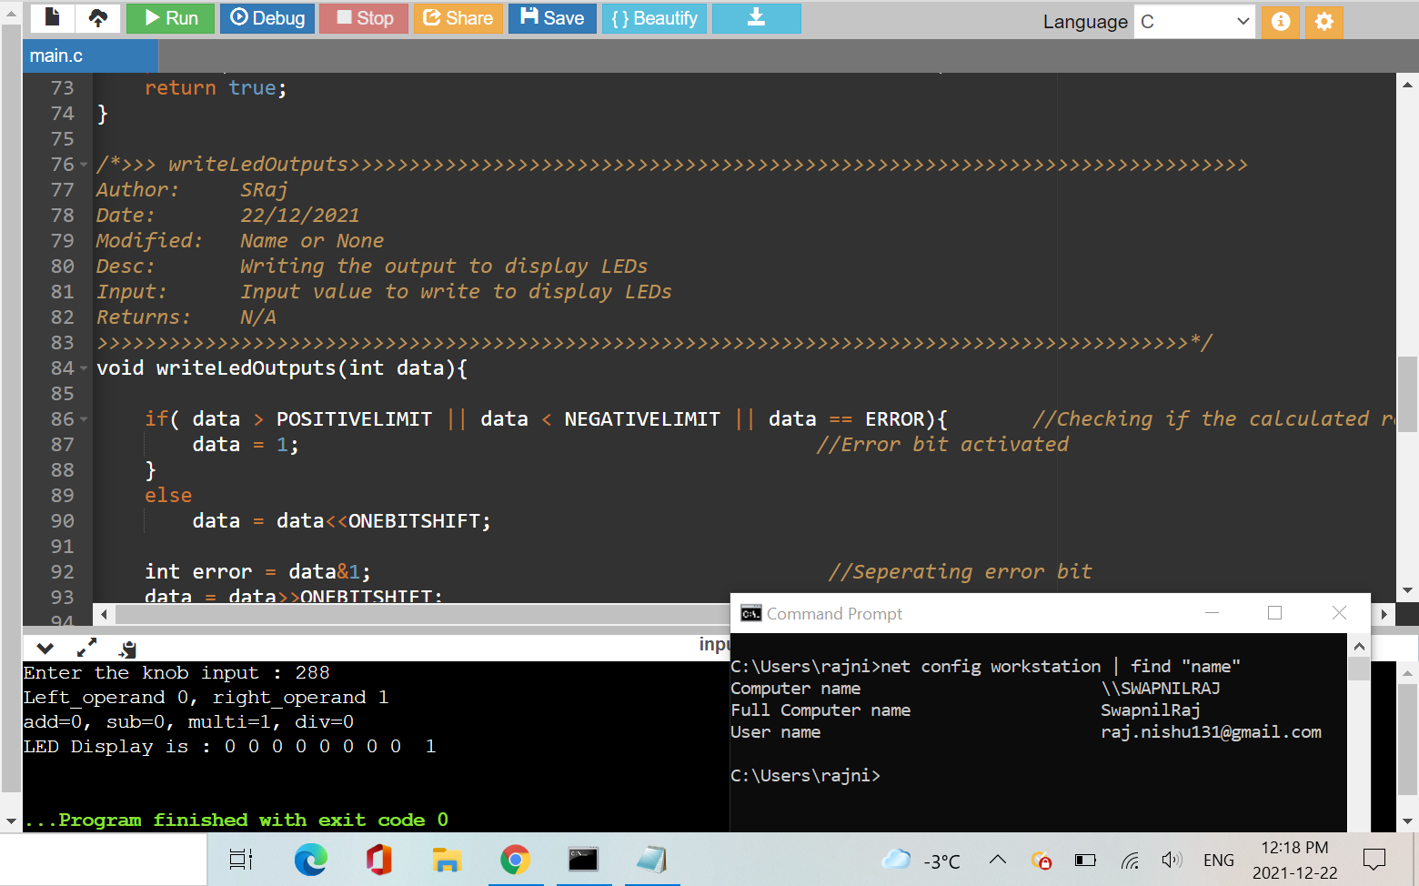

Addition case:

Inputs:

- Left Operand Knob = 1

- Operator Knob = "+"

- Right Operand Knob = 1

Outputs:

- Result LEDs should not display 2 as the result, error LED should be OFF

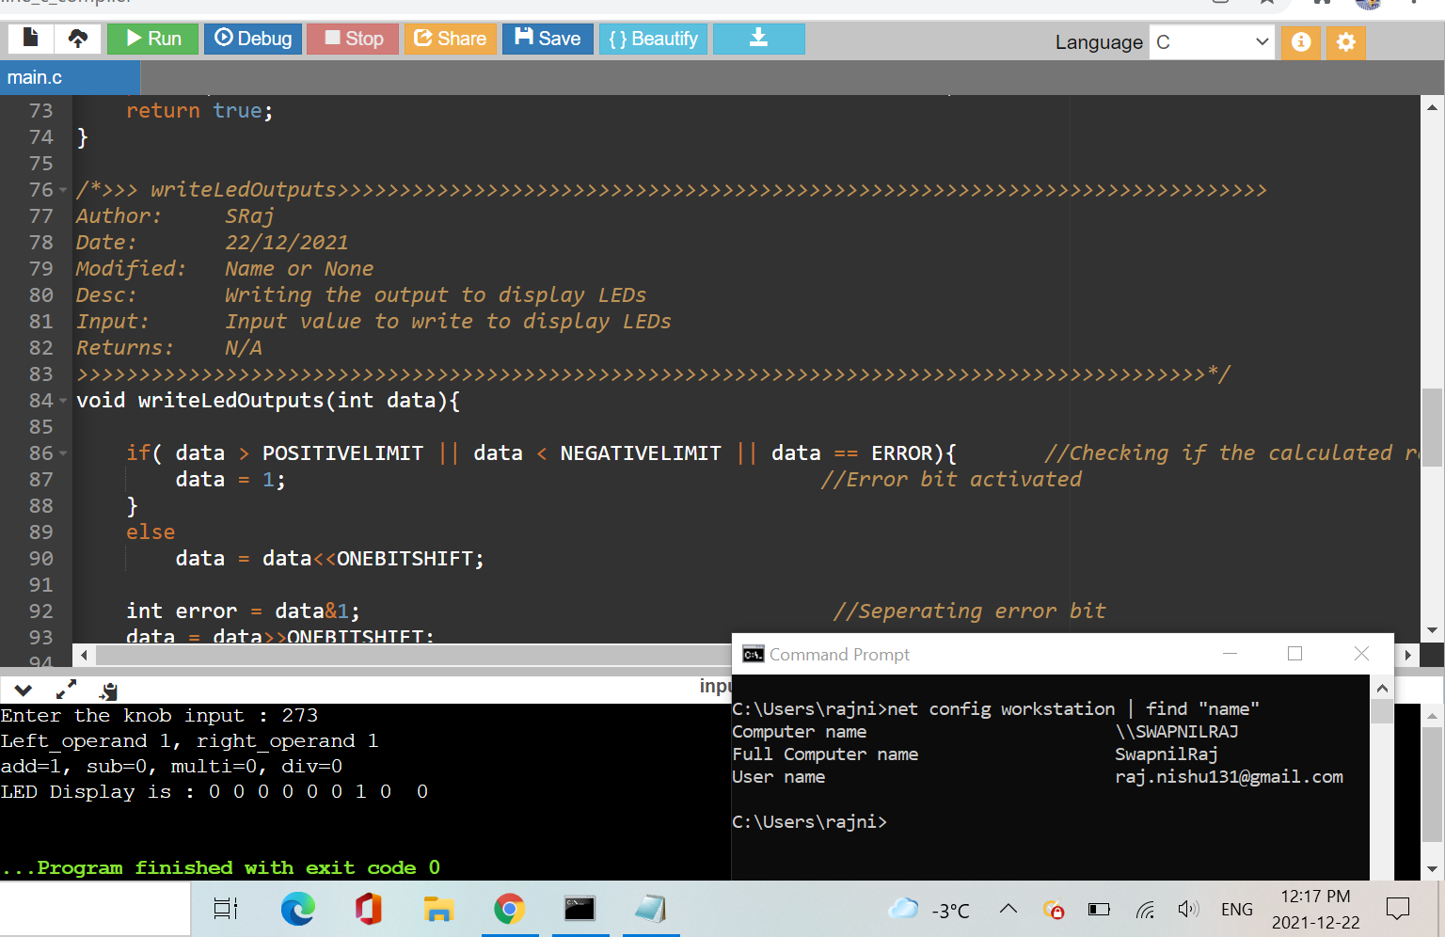

Multiplication case:

Inputs:

- Left Operand Knob = 15

- Operator Knob = "\*"

- Right Operand Knob = 15

Outputs:

- Result LEDs should not display as the result, error LED should be ON

