KUTUMBA

C1-U1 — Older Teacher Pack
  - Grades 4–5 run sheet and activities
C1-U1 • Kārtika / Dāmodara Family Utsava
V13 • Families Growing in Krishna Consciousness
Program Director: Swapnil Patil
Internal founding-cohort teaching material — human/temple review EXTERNAL_OPEN
KUTUMBA | Families Growing in Krishna Consciousness

Locked Saturday Schedule
Time | Block
1:50–2:00 | Arrival
2:00–2:10 | Opening mantras + welcome
2:10–2:30 | All-family launch/orientation
2:30–3:10 | Parallel tracks
3:10–3:30 | Reunification + bhakti laboratory
3:30–3:40 | Snack + water
3:40–3:55 | Saṅkalpa + project + home practice
3:55–4:00 | Close

TIME CUE | Utsava planning date 2026-10-31. Use 2:30 / 3:10 cues when parallel tracks run; local tithi remains EXTERNAL_OPEN.

Primary verse: ŚB 10.9.18
Source URL: https://vedabase.io/en/library/sb/10/9/18/

Older Teacher Run Sheet
Canonical source: 11-weekly-program-library/first-six-months/c1-u1-kartika-damodara-family-utsava/teacher/OLDER-TEACHER-GUIDE-V13.md • SHA-256: f5cb3b54a355c83da8aac112c0a5d9dde788257a347d16ab98f974578bec2d5a
Use with printable stations. Operator completeness pack.

Main Facilitator Guide — C1-U1
Kārtika / Dāmodara Family Utsava · Saturday 2026-10-31 (planning Saturday) Status: Internal founding-cohort — EXTERNAL_OPEN Entry: V13-UTSAVA-START-HERE.md

Two-minute summary
Dāmodara means Kṛṣṇa bound at the belly — and more deeply, bound by mother Yaśodā’s love. Primary: ŚB 10.9.18 (https://vedabase.io/en/library/sb/10/9/18/). Supporting chapter frame: ŚB 10.9 (https://vedabase.io/en/library/sb/10/9/).

Exact primary
- Reference: ŚB 10.9.18
- URL: https://vedabase.io/en/library/sb/10/9/18/
- Devanāgarī: स्वमातु: स्विन्नगात्राया विस्रस्तकबरस्रज: । दृष्ट्वा परिश्रमं कृष्ण: कृपयासीत् स्वबन्धने ॥ १८ ॥
- IAST: sva-mātuḥ svinna-gātrāyā visrasta-kabara-srajaḥ / dṛṣṭvā pariśramaṁ kṛṣṇaḥ kṛpayāsīt sva-bandhane
- KUTUMBA teaching meaning: Seeing mother Yaśodā tired from trying to bind Him, Kṛṣṇa became merciful and agreed to be bound.
- Supporting: ŚB 10.9.19 — https://vedabase.io/en/library/sb/10/9/19/ — the Lord who controls the universe shows the quality of coming under the control of His devotee.
- Rights: Sanskrit from VedaBase display; KUTUMBA meaning original; no full purport.

Teaching map
Time | Block
1:50–2:00 | Arrival; LED safety board
2:00–2:10 | Opening mantras
2:10–2:30 | Festival launch + verse
2:30–3:10 | Parallel stations
3:10–3:30 | Reunify + soft kīrtana
3:30–3:40 | Snack + water
3:40–3:55 | Saṅkalpa
3:55–4:00 | Close

10–20 minute speaking script
Speak naturally. Pause for a 20-second pair share. Do not replace with “see research.”
Welcome. Tonight is our Kārtika / Dāmodara Family Utsava planning Saturday — 2026-10-31.
Calendar honesty first: this is a family observance candidate during the Kārtika season window. We do not claim that October 31 is the exact local Diwali or Govardhana tithi. Local confirmation remains EXTERNAL_OPEN.
Essential question: How does mother Yaśodā’s love show that Kṛṣṇa is conquered by devotion?
Primary: ŚB 10.9.18 — https://vedabase.io/en/library/sb/10/9/18/
KUTUMBA teaching meaning: “Seeing mother Yaśodā tired from trying to bind Him, Kṛṣṇa became merciful and agreed to be bound.”
Story frame from ŚB 10.9 (paraphrase only; no invented dialogue): Mother Yaśodā’s household work and butter-churning lead to Kṛṣṇa’s butter mischief. She tries to bind Him. Rope after rope is short. When she is exhausted, Kṛṣṇa accepts her love and allows Himself

O01 — ŚB 10.9.18 Observation
Observe the verse layer. No purport dump.

VERSE CARD • ŚB 10.9.18

KUTUMBA teaching meaning: Seeing mother Yaśodā tired, Kṛṣṇa mercifully agreed to be bound.
Source: https://vedabase.io/en/library/sb/10/9/18/
Rights/status: Sanskrit/Bengali display + KUTUMBA teaching meaning; no full purport

Who is tired?
________________________________________________________________
________________________________________________________________
________________________________________________________________
What does Kṛṣṇa do?
________________________________________________________________
________________________________________________________________
________________________________________________________________
What does mercy look like?
________________________________________________________________
________________________________________________________________
________________________________________________________________

O02 — Dāmodara Narrative Map
Map SB 10.9 paraphrase stations. No invented dialogue.
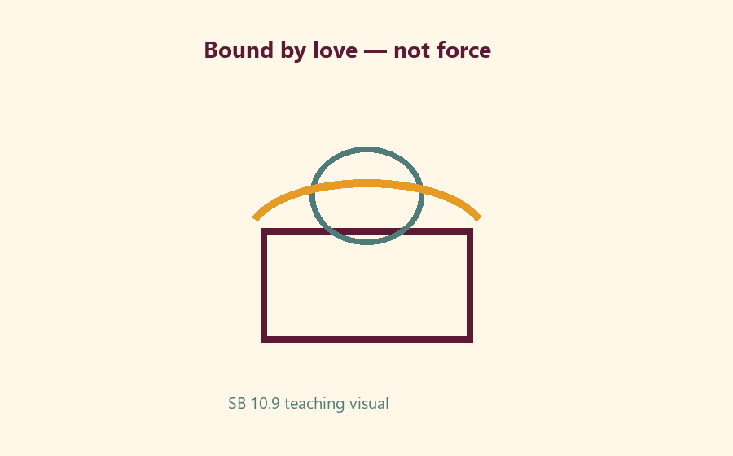
Station 1:
________________________________________________________________
________________________________________________________________
Station 2:
________________________________________________________________
________________________________________________________________
Station 3:
________________________________________________________________
________________________________________________________________
Mercy moment:
________________________________________________________________
________________________________________________________________

O03 — Love vs Force Sort
Sort into Bound-by-love / Bound-by-force / Not sure.
CARD 1  Patient motherly effort | CARD 2  Harsh control
CARD 3  Gratitude service | CARD 4  Public ranking of devotion
CARD 5  Private saṅkalpa | CARD 6  Child fasting pressure
Cut on the dashed borders. Keep each card intact.

O04 — Kārtika Scenarios
Choose the KUTUMBA-aligned response.
Scenario: child fasting pressure →
________________________________________________________________
________________________________________________________________
________________________________________________________________
Scenario: open flame request →
________________________________________________________________
________________________________________________________________
________________________________________________________________
Scenario: ranking lamps →
________________________________________________________________
________________________________________________________________
________________________________________________________________
TEACHER NOTE | Correct redirects: no child fasting; LED default; no ranking.

O05 — Gratitude / Service Diagram
Remembrance → Gratitude → One service act.
Remembrance cue:
________________________________________________________________
________________________________________________________________
Gratitude sentence:
________________________________________________________________
________________________________________________________________
Service act this week:
________________________________________________________________
________________________________________________________________

O06 — Exit Ticket
Three lines only.
Memory line:
________________________________________________________________
________________________________________________________________
One thing Yaśodā shows:
________________________________________________________________
________________________________________________________________
One safe home act:
________________________________________________________________
________________________________________________________________
RIGHTS NOTE | KUTUMBA-original framing; cited third-party material retains its own rights. Human/temple review remains EXTERNAL_OPEN.

