KUTUMBA

C1-U1 — Saturday Print Packet
  - Complete ordered participant and teacher packet
C1-U1 • Kārtika / Dāmodara Family Utsava
V13 • Families Growing in Krishna Consciousness
Program Director: Swapnil Patil
Internal founding-cohort teaching material — human/temple review EXTERNAL_OPEN
KUTUMBA | Families Growing in Krishna Consciousness

Quick Schedule
Time | Block
1:50–2:00 | Arrival
2:00–2:10 | Opening mantras + welcome
2:10–2:30 | All-family launch/orientation
2:30–3:10 | Parallel tracks
3:10–3:30 | Reunification + bhakti laboratory
3:30–3:40 | Snack + water
3:40–3:55 | Saṅkalpa + project + home practice
3:55–4:00 | Close

TIME CUE | Utsava planning date 2026-10-31. Use 2:30 / 3:10 cues when parallel tracks run; local tithi remains EXTERNAL_OPEN.

Primary verse: ŚB 10.9.18
Source URL: https://vedabase.io/en/library/sb/10/9/18/

Opening Mantras
Canonical source: launch/OPENING-MANTRAS-HANDOUT.md • SHA-256: e9487fa3eef1f08c79b8a191932fc70aae9766d2ad3b52a5c47815e3d50e6cb6
KUTUMBA · Families Growing in Krishna Consciousness Program Director: Swapnil Patil

1. Śrīla Prabhupāda Praṇāma
nama oṁ viṣṇu-pādāya kṛṣṇa-preṣṭhāya bhū-tale śrīmate bhaktivedānta-svāmin iti nāmine namas te sārasvate deve gaura-vāṇī-pracāriṇe nirviśeṣa-śūnyavādi-pāścātya-deśa-tāriṇe
Direct sources (verify chanting sheet locally):
- https://vedabase.io/en/library/transcripts/690110in-los-angeles/
- https://vedabase.io/en/library/transcripts/690413sb-new-york/
KUTUMBA plain meaning: We offer respects to Śrīla Prabhupāda, dear to Kṛṣṇa, who carries Lord Caitanya's message.

2. Pañca-tattva Mantra
(jaya) śrī-kṛṣṇa-caitanya prabhu-nityānanda śrī-advaita gadādhara śrīvāsādi-gaura-bhakta-vṛnda
Source: https://vedabase.io/en/library/cc/adi/7/4/ Also see transcript context: https://vedabase.io/en/library/transcripts/710328bg-bombay/

3. Hare Kṛṣṇa Mahā-mantra
Hare Kṛṣṇa Hare Kṛṣṇa Kṛṣṇa Kṛṣṇa Hare Hare Hare Rāma Hare Rāma Rāma Rāma Hare Hare
Direct sources (complete sixteen-word mahā-mantra stated / teaching context):
- Lecture on the Mahā-mantra: https://vedabase.io/en/library/transcripts/660909le-new-york/
- Śrī Caitanya-caritāmṛta Ādi 7.83 (nature of the mahā-mantra): https://vedabase.io/en/library/cc/adi/7/83/
Invitation only — never forced volume or punishment.
RIGHTS NOTE | do not invent extra prayers; temple sheet is exact-text control where required.

Parent Track Run Sheet
Canonical source: 11-weekly-program-library/first-six-months/c1-u1-kartika-damodara-family-utsava/teacher/PARENT-GUIDE-V13.md • SHA-256: a1ad0f11050bf853b283650bb0915dc2e437aefb85caa1179dc7295407984a61
Use with printable stations. Operator completeness pack.

Main Facilitator Guide — C1-U1
Kārtika / Dāmodara Family Utsava · Saturday 2026-10-31 (planning Saturday) Status: Internal founding-cohort — EXTERNAL_OPEN Entry: V13-UTSAVA-START-HERE.md

Two-minute summary
Dāmodara means Kṛṣṇa bound at the belly — and more deeply, bound by mother Yaśodā’s love. Primary: ŚB 10.9.18 (https://vedabase.io/en/library/sb/10/9/18/). Supporting chapter frame: ŚB 10.9 (https://vedabase.io/en/library/sb/10/9/).

Exact primary
- Reference: ŚB 10.9.18
- URL: https://vedabase.io/en/library/sb/10/9/18/
- Devanāgarī: स्वमातु: स्विन्नगात्राया विस्रस्तकबरस्रज: । दृष्ट्वा परिश्रमं कृष्ण: कृपयासीत् स्वबन्धने ॥ १८ ॥
- IAST: sva-mātuḥ svinna-gātrāyā visrasta-kabara-srajaḥ / dṛṣṭvā pariśramaṁ kṛṣṇaḥ kṛpayāsīt sva-bandhane
- KUTUMBA teaching meaning: Seeing mother Yaśodā tired from trying to bind Him, Kṛṣṇa became merciful and agreed to be bound.
- Supporting: ŚB 10.9.19 — https://vedabase.io/en/library/sb/10/9/19/ — the Lord who controls the universe shows the quality of coming under the control of His devotee.
- Rights: Sanskrit from VedaBase display; KUTUMBA meaning original; no full purport.

Teaching map
Time | Block
1:50–2:00 | Arrival; LED safety board
2:00–2:10 | Opening mantras
2:10–2:30 | Festival launch + verse
2:30–3:10 | Parallel stations
3:10–3:30 | Reunify + soft kīrtana
3:30–3:40 | Snack + water
3:40–3:55 | Saṅkalpa
3:55–4:00 | Close

10–20 minute speaking script
Speak naturally. Pause for a 20-second pair share. Do not replace with “see research.”
Welcome. Tonight is our Kārtika / Dāmodara Family Utsava planning Saturday — 2026-10-31.
Calendar honesty first: this is a family observance candidate during the Kārtika season window. We do not claim that October 31 is the exact local Diwali or Govardhana tithi. Local confirmation remains EXTERNAL_OPEN.
Essential question: How does mother Yaśodā’s love show that Kṛṣṇa is conquered by devotion?
Primary: ŚB 10.9.18 — https://vedabase.io/en/library/sb/10/9/18/
KUTUMBA teaching meaning: “Seeing mother Yaśodā tired from trying to bind Him, Kṛṣṇa became merciful and agreed to be bound.”
Story frame from ŚB 10.9 (paraphrase only; no invented dialogue): Mother Yaśodā’s household work and butter-churning lead to Kṛṣṇa’s butter mischief. She tries to bind Him. Rope after rope is short. When she is exhausted, Kṛṣṇa accepts her love and allows Himself

P01 — Private Reflection
Sharing optional.

Where do we force outcomes?
________________________________________________________________
________________________________________________________________
________________________________________________________________
Where could love/patience lead instead?
________________________________________________________________
________________________________________________________________
________________________________________________________________
SAFETY & PRIVACY | Write privately. Do not collect sheets into Git.

P02 — Source Observation
ŚB 10.9.18

VERSE CARD • ŚB 10.9.18

KUTUMBA teaching meaning: Kṛṣṇa agrees to be bound when He sees mother’s fatigue.
Source: https://vedabase.io/en/library/sb/10/9/18/
Rights/status: Sanskrit/Bengali display + KUTUMBA teaching meaning; no full purport

What stands out?
________________________________________________________________
________________________________________________________________
________________________________________________________________
What must we not claim about Oct 31?
________________________________________________________________
________________________________________________________________
________________________________________________________________

P03 — Substantial Family Case
Child-fasting pressure during Kārtika.
Mistaken conclusion:
________________________________________________________________
________________________________________________________________
________________________________________________________________
Principle:
________________________________________________________________
________________________________________________________________
________________________________________________________________
Family action:
________________________________________________________________
________________________________________________________________
________________________________________________________________
DO NOT SPECULATE | No child fasting instructions. Local tithi EXTERNAL_OPEN.

P04 — Household Operating Application
Kārtika remembrance without ranking.
Remembrance cue:
________________________________________________________________
________________________________________________________________
Service act:
________________________________________________________________
________________________________________________________________
LED/no-flame plan:
________________________________________________________________
________________________________________________________________
Minimum version:
________________________________________________________________
________________________________________________________________
FAMILY APPLICATION | Tiny and regular beats dramatic and ranked.

P05 — Private Next-Step Saṅkalpa
KEY IDEA | specific action + frequency + trigger + minimum version

Specific action:
________________________________________________________________
________________________________________________________________
Frequency:
________________________________________________________________
________________________________________________________________
Trigger:
________________________________________________________________
________________________________________________________________
Minimum version:
________________________________________________________________
________________________________________________________________

Younger Child Rules
Canonical source: launch/CHILD-HOUSE-RULES.md • SHA-256: 6a525f3dd1da740db86e246622696c7b08e28c1f1475227567d639a5bd54ce47
Parents remain onsite. Facilitators guide the session. Host property rules also apply.

Shared rules (all ages)
1. Keep your body safe — feet on the floor; hands gentle.
2. Use respectful speech — no teasing, yelling, or mean labels.
3. Follow the facilitator safety cue immediately (pause / freeze / come here).
4. No jumping on furniture.
5. No indoor throwing.
6. No writing on walls, books, or furniture that are not activity materials.
7. Ask before entering private rooms.
8. Respect belongings — ask before touching what is not yours.
9. Devices away unless the lesson specifically needs them.
10. Snack only in the allowed area; water anytime with permission.
11. Help clean up before leaving.

Correction ladder (no public shame)
1. Calm reminder
2. Redirect / offer a choice
3. Brief quiet reset in a visible space
4. Parent involvement
5. Sit out a specific activity
6. Private parent/program conversation for repeated patterns
Never: public shame, yelling, sarcasm, corporal punishment, forced chanting, or comparing children.

Younger (K–2) emphasis
- Soft voices indoors
- Stay with the group
- Hands to yourself
- Ask before leaving the room

Older (Grades 4–5) emphasis
- Model respectful speech for younger children
- Devices fully away unless assigned
- Help clean-up leadership
- Honest questions welcome; speculation wait for source check
Printable versions: W1 launch-pack CHILD-RULES-YOUNGER.md and CHILD-RULES-OLDER.md.

Y01 — Dāmodara Story Sequence
Order the cards. Tell the story kindly.
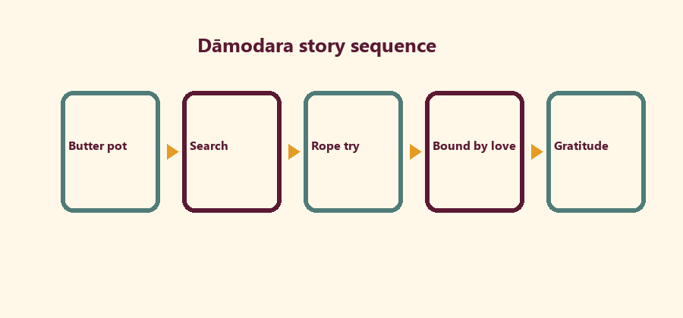
CARD 1  Butter pot | CARD 2  Search
CARD 3  Rope try | CARD 4  Bound by love
CARD 5
Gratitude

Memory phrase
Kṛṣṇa is bound by love.
Cut on the dashed borders. Keep each card intact.
CHILD ACTIVITY | Kind voices only. No mocking mother Yaśodā.

Y02 — Rope-of-Love Craft
Write love/service words on paper strips. Link them.
Love word 1:
________________________________________________________________
________________________________________________________________
Love word 2:
________________________________________________________________
________________________________________________________________
Service word:
________________________________________________________________
________________________________________________________________
SAFETY & PRIVACY | Paper craft only. No real rope play-bondage.

Y03 — LED Gratitude Lamp Card
Color the card. Write one thank-you.
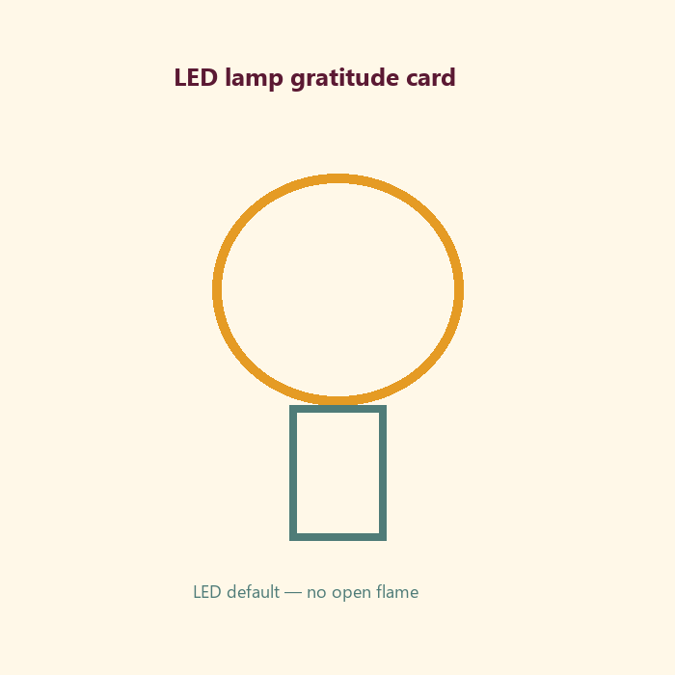
I thank Kṛṣṇa for:
________________________________________________________________
________________________________________________________________
I can help at home by:
________________________________________________________________
________________________________________________________________
SAFETY & PRIVACY | LED default. No child open flame. No child fasting.

Y04 — Kind Līlā Speech
Choose kind words about the butter story.
CARD 1  Kind: Mother loved Kṛṣṇa | CARD 2  Unkind: mocking laugh
CARD 3  Kind: Kṛṣṇa is merciful | CARD 4  Unkind: teasing fasting
Cut on the dashed borders. Keep each card intact.

Y05 — Memory Phrase Mat
Kṛṣṇa is bound by love.

Memory phrase
Kṛṣṇa is bound by love.
KEY IDEA | Kṛṣṇa is bound by love.

Older Child Rules
Canonical source: launch/CHILD-HOUSE-RULES.md • SHA-256: 6a525f3dd1da740db86e246622696c7b08e28c1f1475227567d639a5bd54ce47
Parents remain onsite. Facilitators guide the session. Host property rules also apply.

Shared rules (all ages)
1. Keep your body safe — feet on the floor; hands gentle.
2. Use respectful speech — no teasing, yelling, or mean labels.
3. Follow the facilitator safety cue immediately (pause / freeze / come here).
4. No jumping on furniture.
5. No indoor throwing.
6. No writing on walls, books, or furniture that are not activity materials.
7. Ask before entering private rooms.
8. Respect belongings — ask before touching what is not yours.
9. Devices away unless the lesson specifically needs them.
10. Snack only in the allowed area; water anytime with permission.
11. Help clean up before leaving.

Correction ladder (no public shame)
1. Calm reminder
2. Redirect / offer a choice
3. Brief quiet reset in a visible space
4. Parent involvement
5. Sit out a specific activity
6. Private parent/program conversation for repeated patterns
Never: public shame, yelling, sarcasm, corporal punishment, forced chanting, or comparing children.

Younger (K–2) emphasis
- Soft voices indoors
- Stay with the group
- Hands to yourself
- Ask before leaving the room

Older (Grades 4–5) emphasis
- Model respectful speech for younger children
- Devices fully away unless assigned
- Help clean-up leadership
- Honest questions welcome; speculation wait for source check
Printable versions: W1 launch-pack CHILD-RULES-YOUNGER.md and CHILD-RULES-OLDER.md.

O01 — ŚB 10.9.18 Observation
Observe the verse layer. No purport dump.

VERSE CARD • ŚB 10.9.18

KUTUMBA teaching meaning: Seeing mother Yaśodā tired, Kṛṣṇa mercifully agreed to be bound.
Source: https://vedabase.io/en/library/sb/10/9/18/
Rights/status: Sanskrit/Bengali display + KUTUMBA teaching meaning; no full purport

Who is tired?
________________________________________________________________
________________________________________________________________
________________________________________________________________
What does Kṛṣṇa do?
________________________________________________________________
________________________________________________________________
________________________________________________________________
What does mercy look like?
________________________________________________________________
________________________________________________________________
________________________________________________________________

O02 — Dāmodara Narrative Map
Map SB 10.9 paraphrase stations. No invented dialogue.
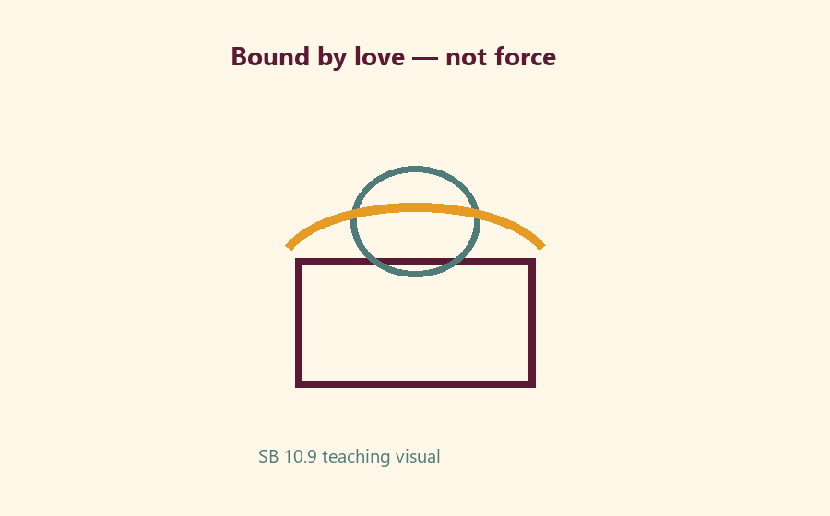
Station 1:
________________________________________________________________
________________________________________________________________
Station 2:
________________________________________________________________
________________________________________________________________
Station 3:
________________________________________________________________
________________________________________________________________
Mercy moment:
________________________________________________________________
________________________________________________________________

O03 — Love vs Force Sort
Sort into Bound-by-love / Bound-by-force / Not sure.
CARD 1  Patient motherly effort | CARD 2  Harsh control
CARD 3  Gratitude service | CARD 4  Public ranking of devotion
CARD 5  Private saṅkalpa | CARD 6  Child fasting pressure
Cut on the dashed borders. Keep each card intact.

O04 — Kārtika Scenarios
Choose the KUTUMBA-aligned response.
Scenario: child fasting pressure →
________________________________________________________________
________________________________________________________________
________________________________________________________________
Scenario: open flame request →
________________________________________________________________
________________________________________________________________
________________________________________________________________
Scenario: ranking lamps →
________________________________________________________________
________________________________________________________________
________________________________________________________________
TEACHER NOTE | Correct redirects: no child fasting; LED default; no ranking.

O05 — Gratitude / Service Diagram
Remembrance → Gratitude → One service act.
Remembrance cue:
________________________________________________________________
________________________________________________________________
Gratitude sentence:
________________________________________________________________
________________________________________________________________
Service act this week:
________________________________________________________________
________________________________________________________________

O06 — Exit Ticket
Three lines only.
Memory line:
________________________________________________________________
________________________________________________________________
One thing Yaśodā shows:
________________________________________________________________
________________________________________________________________
One safe home act:
________________________________________________________________
________________________________________________________________

Module Project
Canonical source: 11-weekly-program-library/first-six-months/c1-u1-kartika-damodara-family-utsava/project/V13-MODULE-PROJECT-BRIEF.md • SHA-256: ca2665f947d1b92ded3126f910fa8daa966576839dad0d75490c07a241d01c97
Artifact: Family “bound by love” gratitude card (LED theme) contributed to Cycle 1 closing memory later. Noncompetitive. Optional photo stays private to family — not committed to Git.

Week Home Practice
Memory: Kṛṣṇa is bound by love.
Minimum: Say memory line once + one gratitude or help-at-home act before next Saturday. Ideal (5–15 min): Memory line + one-sentence paraphrase of ŚB 10.9.18 + LED/no-flame remembrance once. No photo proof. No ranking. No child fasting.

TEACHER-ONLY
Remove teacher-only pages before distributing participant copies.

Younger Teacher Run Sheet
Canonical source: 11-weekly-program-library/first-six-months/c1-u1-kartika-damodara-family-utsava/teacher/YOUNGER-TEACHER-GUIDE-V13.md • SHA-256: 04d46aeb31fff61030a73a5462c835909e91c21ebfb0250f5766b1c27d4f6fad
Use with printable stations. Operator completeness pack.

Main Facilitator Guide — C1-U1
Kārtika / Dāmodara Family Utsava · Saturday 2026-10-31 (planning Saturday) Status: Internal founding-cohort — EXTERNAL_OPEN Entry: V13-UTSAVA-START-HERE.md

Two-minute summary
Dāmodara means Kṛṣṇa bound at the belly — and more deeply, bound by mother Yaśodā’s love. Primary: ŚB 10.9.18 (https://vedabase.io/en/library/sb/10/9/18/). Supporting chapter frame: ŚB 10.9 (https://vedabase.io/en/library/sb/10/9/).

Exact primary
- Reference: ŚB 10.9.18
- URL: https://vedabase.io/en/library/sb/10/9/18/
- Devanāgarī: स्वमातु: स्विन्नगात्राया विस्रस्तकबरस्रज: । दृष्ट्वा परिश्रमं कृष्ण: कृपयासीत् स्वबन्धने ॥ १८ ॥
- IAST: sva-mātuḥ svinna-gātrāyā visrasta-kabara-srajaḥ / dṛṣṭvā pariśramaṁ kṛṣṇaḥ kṛpayāsīt sva-bandhane
- KUTUMBA teaching meaning: Seeing mother Yaśodā tired from trying to bind Him, Kṛṣṇa became merciful and agreed to be bound.
- Supporting: ŚB 10.9.19 — https://vedabase.io/en/library/sb/10/9/19/ — the Lord who controls the universe shows the quality of coming under the control of His devotee.
- Rights: Sanskrit from VedaBase display; KUTUMBA meaning original; no full purport.

Teaching map
Time | Block
1:50–2:00 | Arrival; LED safety board
2:00–2:10 | Opening mantras
2:10–2:30 | Festival launch + verse
2:30–3:10 | Parallel stations
3:10–3:30 | Reunify + soft kīrtana
3:30–3:40 | Snack + water
3:40–3:55 | Saṅkalpa
3:55–4:00 | Close

10–20 minute speaking script
Speak naturally. Pause for a 20-second pair share. Do not replace with “see research.”
Welcome. Tonight is our Kārtika / Dāmodara Family Utsava planning Saturday — 2026-10-31.
Calendar honesty first: this is a family observance candidate during the Kārtika season window. We do not claim that October 31 is the exact local Diwali or Govardhana tithi. Local confirmation remains EXTERNAL_OPEN.
Essential question: How does mother Yaśodā’s love show that Kṛṣṇa is conquered by devotion?
Primary: ŚB 10.9.18 — https://vedabase.io/en/library/sb/10/9/18/
KUTUMBA teaching meaning: “Seeing mother Yaśodā tired from trying to bind Him, Kṛṣṇa became merciful and agreed to be bound.”
Story frame from ŚB 10.9 (paraphrase only; no invented dialogue): Mother Yaśodā’s household work and butter-churning lead to Kṛṣṇa’s butter mischief. She tries to bind Him. Rope after rope is short. When she is exhausted, Kṛṣṇa accepts her love and allows Himself

Older Teacher Run Sheet
Canonical source: 11-weekly-program-library/first-six-months/c1-u1-kartika-damodara-family-utsava/teacher/OLDER-TEACHER-GUIDE-V13.md • SHA-256: f5cb3b54a355c83da8aac112c0a5d9dde788257a347d16ab98f974578bec2d5a
Use with printable stations. Operator completeness pack.

Main Facilitator Guide — C1-U1
Kārtika / Dāmodara Family Utsava · Saturday 2026-10-31 (planning Saturday) Status: Internal founding-cohort — EXTERNAL_OPEN Entry: V13-UTSAVA-START-HERE.md

Two-minute summary
Dāmodara means Kṛṣṇa bound at the belly — and more deeply, bound by mother Yaśodā’s love. Primary: ŚB 10.9.18 (https://vedabase.io/en/library/sb/10/9/18/). Supporting chapter frame: ŚB 10.9 (https://vedabase.io/en/library/sb/10/9/).

Exact primary
- Reference: ŚB 10.9.18
- URL: https://vedabase.io/en/library/sb/10/9/18/
- Devanāgarī: स्वमातु: स्विन्नगात्राया विस्रस्तकबरस्रज: । दृष्ट्वा परिश्रमं कृष्ण: कृपयासीत् स्वबन्धने ॥ १८ ॥
- IAST: sva-mātuḥ svinna-gātrāyā visrasta-kabara-srajaḥ / dṛṣṭvā pariśramaṁ kṛṣṇaḥ kṛpayāsīt sva-bandhane
- KUTUMBA teaching meaning: Seeing mother Yaśodā tired from trying to bind Him, Kṛṣṇa became merciful and agreed to be bound.
- Supporting: ŚB 10.9.19 — https://vedabase.io/en/library/sb/10/9/19/ — the Lord who controls the universe shows the quality of coming under the control of His devotee.
- Rights: Sanskrit from VedaBase display; KUTUMBA meaning original; no full purport.

Teaching map
Time | Block
1:50–2:00 | Arrival; LED safety board
2:00–2:10 | Opening mantras
2:10–2:30 | Festival launch + verse
2:30–3:10 | Parallel stations
3:10–3:30 | Reunify + soft kīrtana
3:30–3:40 | Snack + water
3:40–3:55 | Saṅkalpa
3:55–4:00 | Close

10–20 minute speaking script
Speak naturally. Pause for a 20-second pair share. Do not replace with “see research.”
Welcome. Tonight is our Kārtika / Dāmodara Family Utsava planning Saturday — 2026-10-31.
Calendar honesty first: this is a family observance candidate during the Kārtika season window. We do not claim that October 31 is the exact local Diwali or Govardhana tithi. Local confirmation remains EXTERNAL_OPEN.
Essential question: How does mother Yaśodā’s love show that Kṛṣṇa is conquered by devotion?
Primary: ŚB 10.9.18 — https://vedabase.io/en/library/sb/10/9/18/
KUTUMBA teaching meaning: “Seeing mother Yaśodā tired from trying to bind Him, Kṛṣṇa became merciful and agreed to be bound.”
Story frame from ŚB 10.9 (paraphrase only; no invented dialogue): Mother Yaśodā’s household work and butter-churning lead to Kṛṣṇa’s butter mischief. She tries to bind Him. Rope after rope is short. When she is exhausted, Kṛṣṇa accepts her love and allows Himself

Main Facilitator Speaking Map
Canonical source: 11-weekly-program-library/first-six-months/c1-u1-kartika-damodara-family-utsava/teacher/MAIN-FACILITATOR-GUIDE-V13.md • SHA-256: 31284cce93a5b7a9c4a824d222af934c85855c4313c2808a6aa560ea5e59e4d8
Kārtika / Dāmodara Family Utsava · Saturday 2026-10-31 (planning Saturday) Status: Internal founding-cohort — EXTERNAL_OPEN Entry: V13-UTSAVA-START-HERE.md

Two-minute summary
Dāmodara means Kṛṣṇa bound at the belly — and more deeply, bound by mother Yaśodā’s love. Primary: ŚB 10.9.18 (https://vedabase.io/en/library/sb/10/9/18/). Supporting chapter frame: ŚB 10.9 (https://vedabase.io/en/library/sb/10/9/).

Exact primary
- Reference: ŚB 10.9.18
- URL: https://vedabase.io/en/library/sb/10/9/18/
- Devanāgarī: स्वमातु: स्विन्नगात्राया विस्रस्तकबरस्रज: । दृष्ट्वा परिश्रमं कृष्ण: कृपयासीत् स्वबन्धने ॥ १८ ॥
- IAST: sva-mātuḥ svinna-gātrāyā visrasta-kabara-srajaḥ / dṛṣṭvā pariśramaṁ kṛṣṇaḥ kṛpayāsīt sva-bandhane
- KUTUMBA teaching meaning: Seeing mother Yaśodā tired from trying to bind Him, Kṛṣṇa became merciful and agreed to be bound.
- Supporting: ŚB 10.9.19 — https://vedabase.io/en/library/sb/10/9/19/ — the Lord who controls the universe shows the quality of coming under the control of His devotee.
- Rights: Sanskrit from VedaBase display; KUTUMBA meaning original; no full purport.

Teaching map
Time | Block
1:50–2:00 | Arrival; LED safety board
2:00–2:10 | Opening mantras
2:10–2:30 | Festival launch + verse
2:30–3:10 | Parallel stations
3:10–3:30 | Reunify + soft kīrtana
3:30–3:40 | Snack + water
3:40–3:55 | Saṅkalpa
3:55–4:00 | Close

10–20 minute speaking script
Speak naturally. Pause for a 20-second pair share. Do not replace with “see research.”
Welcome. Tonight is our Kārtika / Dāmodara Family Utsava planning Saturday — 2026-10-31.
Calendar honesty first: this is a family observance candidate during the Kārtika season window. We do not claim that October 31 is the exact local Diwali or Govardhana tithi. Local confirmation remains EXTERNAL_OPEN.
Essential question: How does mother Yaśodā’s love show that Kṛṣṇa is conquered by devotion?
Primary: ŚB 10.9.18 — https://vedabase.io/en/library/sb/10/9/18/
KUTUMBA teaching meaning: “Seeing mother Yaśodā tired from trying to bind Him, Kṛṣṇa became merciful and agreed to be bound.”
Story frame from ŚB 10.9 (paraphrase only; no invented dialogue): Mother Yaśodā’s household work and butter-churning lead to Kṛṣṇa’s butter mischief. She tries to bind Him. Rope after rope is short. When she is exhausted, Kṛṣṇa accepts her love and allows Himself to be bound. Supporting ŚB 10.9.19 teaches that the Lord who rules the universe shows the wonder of being controlled by a devotee’s love.
Analogy one — rope vs love: material rope fails; love succeeds. Limit: do not teach children that physical ropes are magical toys for “catching God.”
Analogy two — tired mother, merciful child: effort meets grace. Limit: children’s obedience at home is not identical to Yaśodā’s pure parental devotion.
Analogy three — LED lamp remembrance: light as gratitude cue during Kārtika. Limit: LED is pedagogy/safety default; open flame is adult-only if ever permitted.
Household case: A family wants to “do Kārtika perfectly” and pressures a child to skip dinner. Mistaken conclusion: devotion requires child fasting. Principle: no child fasting instructions in KUTUMBA. Action: choose gratitude, kīrtana, and service instead.
We will not speculate about exact miracle physics beyond what śāstra states. Deferral line: if a question needs temple authority or local calendar precision, mark it EXTERNAL_OPEN and continue with love, service, and safe remembrance.
Memory line: Kṛṣṇa is bound by love.

Analogies with limits
1. Rope vs love — limit above.
2. Tired mother / merciful response — limit above.
3. LED remembrance lamp — limit above.

Three family cases
1. Pressure to fast a child — redirect to gratitude/service.
2. Sibling teases “you can’t catch Kṛṣṇa” during craft — redirect to respect for līlā.
3. Parent compares who’s “more into Kārtika” — block ranking; keep private saṅkalpa.

Q&A boundaries
- Exact Diwali/Govardhana date? → EXTERNAL_OPEN local calendar.
- Must we offer Dāmodarāṣṭaka? → Only from verified authoritative source if used; optional enrichment, not invented text tonight.
- Open flame lamps? → LED default; owner safety plan required otherwise.

Do not speculate
Do not invent dialogue for Yaśodā/Kṛṣṇa. Do not claim Oct 31 equals exact tithi. Do not teach child fasting.

Track transition (2:30)
Parents → gratitude/service plan. Younger → sequence + rope-of-love craft + LED card. Older → SB 10.9 narrative map + exit ticket.

Reunification (3:10)
One shared sentence: “Kṛṣṇa is bound by love.” Soft kīrtana invitation.

Room / Material / Snack / Cleanup Checklist
Done | Area | Check
☐ | Room | Parent circle, younger floor zone, older table zone, clear aisles
☐ | Materials | Labeled track folders, pencils, crayons, tape, timer
☐ | Privacy | Completed forms remain private and never enter Git
☐ | Snack | Snack and water staged for 3:30; allergy plan confirmed
☐ | Safety | Calm corner visible; private rooms closed; exits clear
☐ | Cleanup | Tables wiped and host home reset assigned

RIGHTS NOTE | KUTUMBA-original framing; cited third-party material retains its own rights. Human/temple review remains EXTERNAL_OPEN.

