KUTUMBA

C1-U1 — Younger Teacher Pack
  - K–2 run sheet and activities
C1-U1 • Kārtika / Dāmodara Family Utsava
V13 • Families Growing in Krishna Consciousness
Program Director: Swapnil Patil
Internal founding-cohort teaching material — human/temple review EXTERNAL_OPEN
KUTUMBA | Families Growing in Krishna Consciousness

Locked Saturday Schedule
Time | Block
1:50–2:00 | Arrival
2:00–2:10 | Opening mantras + welcome
2:10–2:30 | All-family launch/orientation
2:30–3:10 | Parallel tracks
3:10–3:30 | Reunification + bhakti laboratory
3:30–3:40 | Snack + water
3:40–3:55 | Saṅkalpa + project + home practice
3:55–4:00 | Close

TIME CUE | Utsava planning date 2026-10-31. Use 2:30 / 3:10 cues when parallel tracks run; local tithi remains EXTERNAL_OPEN.

Primary verse: ŚB 10.9.18
Source URL: https://vedabase.io/en/library/sb/10/9/18/

Younger Teacher Run Sheet
Canonical source: 11-weekly-program-library/first-six-months/c1-u1-kartika-damodara-family-utsava/teacher/YOUNGER-TEACHER-GUIDE-V13.md • SHA-256: 04d46aeb31fff61030a73a5462c835909e91c21ebfb0250f5766b1c27d4f6fad
Use with printable stations. Operator completeness pack.

Main Facilitator Guide — C1-U1
Kārtika / Dāmodara Family Utsava · Saturday 2026-10-31 (planning Saturday) Status: Internal founding-cohort — EXTERNAL_OPEN Entry: V13-UTSAVA-START-HERE.md

Two-minute summary
Dāmodara means Kṛṣṇa bound at the belly — and more deeply, bound by mother Yaśodā’s love. Primary: ŚB 10.9.18 (https://vedabase.io/en/library/sb/10/9/18/). Supporting chapter frame: ŚB 10.9 (https://vedabase.io/en/library/sb/10/9/).

Exact primary
- Reference: ŚB 10.9.18
- URL: https://vedabase.io/en/library/sb/10/9/18/
- Devanāgarī: स्वमातु: स्विन्नगात्राया विस्रस्तकबरस्रज: । दृष्ट्वा परिश्रमं कृष्ण: कृपयासीत् स्वबन्धने ॥ १८ ॥
- IAST: sva-mātuḥ svinna-gātrāyā visrasta-kabara-srajaḥ / dṛṣṭvā pariśramaṁ kṛṣṇaḥ kṛpayāsīt sva-bandhane
- KUTUMBA teaching meaning: Seeing mother Yaśodā tired from trying to bind Him, Kṛṣṇa became merciful and agreed to be bound.
- Supporting: ŚB 10.9.19 — https://vedabase.io/en/library/sb/10/9/19/ — the Lord who controls the universe shows the quality of coming under the control of His devotee.
- Rights: Sanskrit from VedaBase display; KUTUMBA meaning original; no full purport.

Teaching map
Time | Block
1:50–2:00 | Arrival; LED safety board
2:00–2:10 | Opening mantras
2:10–2:30 | Festival launch + verse
2:30–3:10 | Parallel stations
3:10–3:30 | Reunify + soft kīrtana
3:30–3:40 | Snack + water
3:40–3:55 | Saṅkalpa
3:55–4:00 | Close

10–20 minute speaking script
Speak naturally. Pause for a 20-second pair share. Do not replace with “see research.”
Welcome. Tonight is our Kārtika / Dāmodara Family Utsava planning Saturday — 2026-10-31.
Calendar honesty first: this is a family observance candidate during the Kārtika season window. We do not claim that October 31 is the exact local Diwali or Govardhana tithi. Local confirmation remains EXTERNAL_OPEN.
Essential question: How does mother Yaśodā’s love show that Kṛṣṇa is conquered by devotion?
Primary: ŚB 10.9.18 — https://vedabase.io/en/library/sb/10/9/18/
KUTUMBA teaching meaning: “Seeing mother Yaśodā tired from trying to bind Him, Kṛṣṇa became merciful and agreed to be bound.”
Story frame from ŚB 10.9 (paraphrase only; no invented dialogue): Mother Yaśodā’s household work and butter-churning lead to Kṛṣṇa’s butter mischief. She tries to bind Him. Rope after rope is short. When she is exhausted, Kṛṣṇa accepts her love and allows Himself

Child House Rules
Canonical source: launch/CHILD-HOUSE-RULES.md • SHA-256: 6a525f3dd1da740db86e246622696c7b08e28c1f1475227567d639a5bd54ce47
Parents remain onsite. Facilitators guide the session. Host property rules also apply.

Shared rules (all ages)
1. Keep your body safe — feet on the floor; hands gentle.
2. Use respectful speech — no teasing, yelling, or mean labels.
3. Follow the facilitator safety cue immediately (pause / freeze / come here).
4. No jumping on furniture.
5. No indoor throwing.
6. No writing on walls, books, or furniture that are not activity materials.
7. Ask before entering private rooms.
8. Respect belongings — ask before touching what is not yours.
9. Devices away unless the lesson specifically needs them.
10. Snack only in the allowed area; water anytime with permission.
11. Help clean up before leaving.

Correction ladder (no public shame)
1. Calm reminder
2. Redirect / offer a choice
3. Brief quiet reset in a visible space
4. Parent involvement
5. Sit out a specific activity
6. Private parent/program conversation for repeated patterns
Never: public shame, yelling, sarcasm, corporal punishment, forced chanting, or comparing children.

Younger (K–2) emphasis
- Soft voices indoors
- Stay with the group
- Hands to yourself
- Ask before leaving the room

Older (Grades 4–5) emphasis
- Model respectful speech for younger children
- Devices fully away unless assigned
- Help clean-up leadership
- Honest questions welcome; speculation wait for source check
Printable versions: W1 launch-pack CHILD-RULES-YOUNGER.md and CHILD-RULES-OLDER.md.

Y01 — Dāmodara Story Sequence
Order the cards. Tell the story kindly.
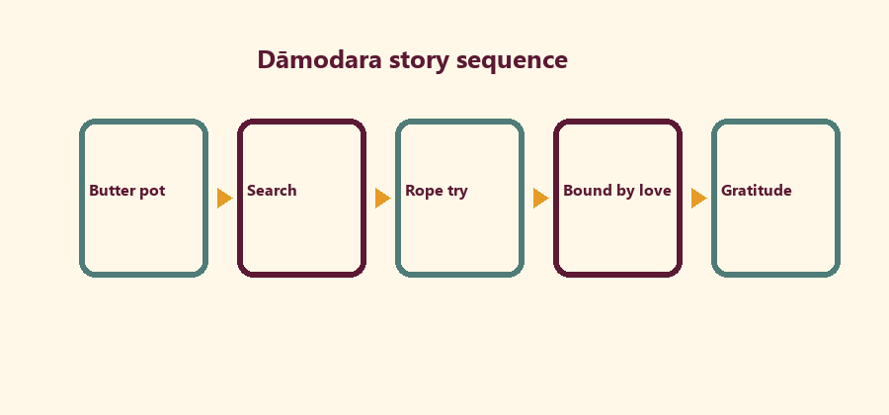
CARD 1  Butter pot | CARD 2  Search
CARD 3  Rope try | CARD 4  Bound by love
CARD 5
Gratitude

Memory phrase
Kṛṣṇa is bound by love.
Cut on the dashed borders. Keep each card intact.
CHILD ACTIVITY | Kind voices only. No mocking mother Yaśodā.

Y02 — Rope-of-Love Craft
Write love/service words on paper strips. Link them.
Love word 1:
________________________________________________________________
________________________________________________________________
Love word 2:
________________________________________________________________
________________________________________________________________
Service word:
________________________________________________________________
________________________________________________________________
SAFETY & PRIVACY | Paper craft only. No real rope play-bondage.

Y03 — LED Gratitude Lamp Card
Color the card. Write one thank-you.
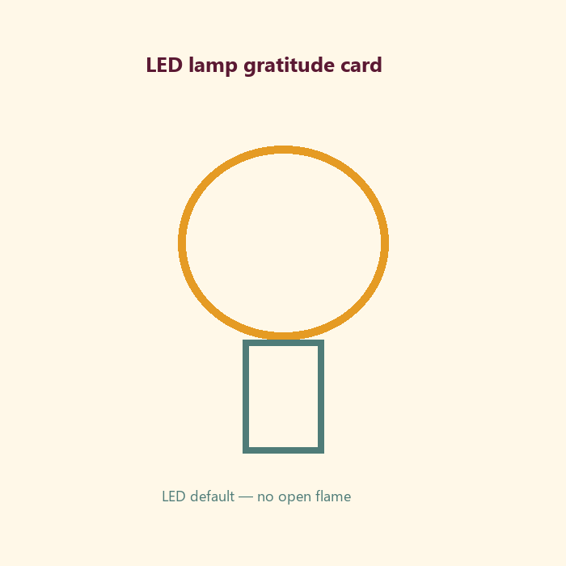
I thank Kṛṣṇa for:
________________________________________________________________
________________________________________________________________
I can help at home by:
________________________________________________________________
________________________________________________________________
SAFETY & PRIVACY | LED default. No child open flame. No child fasting.

Y04 — Kind Līlā Speech
Choose kind words about the butter story.
CARD 1  Kind: Mother loved Kṛṣṇa | CARD 2  Unkind: mocking laugh
CARD 3  Kind: Kṛṣṇa is merciful | CARD 4  Unkind: teasing fasting
Cut on the dashed borders. Keep each card intact.

Y05 — Memory Phrase Mat
Kṛṣṇa is bound by love.

Memory phrase
Kṛṣṇa is bound by love.
KEY IDEA | Kṛṣṇa is bound by love.

RIGHTS NOTE | KUTUMBA-original framing; cited third-party material retains its own rights. Human/temple review remains EXTERNAL_OPEN.

