KUTUMBA

C1-W2 — Saturday Print Packet
  - Complete ordered participant and teacher packet
C1-W2 • I Am Not This Body
V13 • Families Growing in Krishna Consciousness
Program Director: Swapnil Patil
Internal founding-cohort teaching material — human/temple review EXTERNAL_OPEN
KUTUMBA | Families Growing in Krishna Consciousness

Quick Schedule
Time | Block
1:50–2:00 | Arrival
2:00–2:10 | Opening mantras + welcome
2:10–2:30 | All-family launch/orientation
2:30–3:10 | Parallel tracks
3:10–3:30 | Reunification + bhakti laboratory
3:30–3:40 | Snack + water
3:40–3:55 | Saṅkalpa + project + home practice
3:55–4:00 | Close

TIME CUE | Track handoff is at 2:30; all groups reunite at 3:10.

Primary verse: BG 2.13
Source URL: https://vedabase.io/en/library/bg/2/13/

Opening Mantras
Canonical source: launch/OPENING-MANTRAS-HANDOUT.md • SHA-256: e9487fa3eef1f08c79b8a191932fc70aae9766d2ad3b52a5c47815e3d50e6cb6
KUTUMBA · Families Growing in Krishna Consciousness Program Director: Swapnil Patil

1. Śrīla Prabhupāda Praṇāma
nama oṁ viṣṇu-pādāya kṛṣṇa-preṣṭhāya bhū-tale śrīmate bhaktivedānta-svāmin iti nāmine namas te sārasvate deve gaura-vāṇī-pracāriṇe nirviśeṣa-śūnyavādi-pāścātya-deśa-tāriṇe
Direct sources (verify chanting sheet locally):
- https://vedabase.io/en/library/transcripts/690110in-los-angeles/
- https://vedabase.io/en/library/transcripts/690413sb-new-york/
KUTUMBA plain meaning: We offer respects to Śrīla Prabhupāda, dear to Kṛṣṇa, who carries Lord Caitanya's message.

2. Pañca-tattva Mantra
(jaya) śrī-kṛṣṇa-caitanya prabhu-nityānanda śrī-advaita gadādhara śrīvāsādi-gaura-bhakta-vṛnda
Source: https://vedabase.io/en/library/cc/adi/7/4/ Also see transcript context: https://vedabase.io/en/library/transcripts/710328bg-bombay/

3. Hare Kṛṣṇa Mahā-mantra
Hare Kṛṣṇa Hare Kṛṣṇa Kṛṣṇa Kṛṣṇa Hare Hare Hare Rāma Hare Rāma Rāma Rāma Hare Hare
Direct sources (complete sixteen-word mahā-mantra stated / teaching context):
- Lecture on the Mahā-mantra: https://vedabase.io/en/library/transcripts/660909le-new-york/
- Śrī Caitanya-caritāmṛta Ādi 7.83 (nature of the mahā-mantra): https://vedabase.io/en/library/cc/adi/7/83/
Invitation only — never forced volume or punishment.
RIGHTS NOTE | do not invent extra prayers; temple sheet is exact-text control where required.

Parent Track Run Sheet
Canonical source: 11-weekly-program-library/first-six-months/c1-w2-i-am-not-this-body/teacher/PARENT-GUIDE-V13.md • SHA-256: d1fc786c737512d0c88aed4f7e7679308fd9e6012c81f630c46abe7362664241
KUTUMBA · Families Growing in Krishna Consciousness Program Director: Swapnil Patil Week: I Am Not This Body · Date: 2026-09-19 Track window: Saturday 2:30–3:10 (parallel with K–2 and Grades 4–5) Reunite: 3:10 for bhakti laboratory Primary: BG 2.13 — https://vedabase.io/en/library/bg/2/13/ Status: Internal founding-cohort teaching material — human/temple review EXTERNAL_OPEN

Essential question
How should knowing I am not only this body change how we speak about bodies — at home?

Materials (print before Saturday)
From activities/v13-parent/:
- P01 Private reflection (labels / roles / body changes)
- P02 Respectful family language card sort
- P03 Substantial family case
- P04 Household operating application
- P05 Private next-step saṅkalpa
Also: pens; quiet writing space; verse card excerpt for BG 2.13.

Locked Saturday context (do not invent another clock)
- 1:50–2:00 Arrival / settle
- 2:00–2:10 Opening mantras + welcome (main room)
- 2:10–2:30 All-family launch (main facilitator)
- 2:30–3:10 This parent track
- 3:10–3:30 Reunification + bhakti laboratory
- 3:30–3:40 Snack + water only
- 3:40–3:55 Saṅkalpa + Cycle 1 project + home practice
- 3:55–4:00 Close
Parents remain onsite. This is not drop-off childcare. No public sādhana ranking. No forced disclosure.

0–5 — Private reflection (P01)
Printable: P01
Prompt (read aloud):
Which labels, roles, or body-change comments do we use at home that quietly treat the body as the whole self?
Instructions:
1. Private writing — about 4 minutes.
2. No forced sharing.
3. If finished early, underline one speech habit to watch this week.
Facilitator note: Warm presence; do not collect completed sheets into Git or a public folder.

5–12 — BG 2.13 observation (source)
Source: https://vedabase.io/en/library/bg/2/13/
Devanāgarī: देहिनोऽस्मिन् यथा देहे कौमारं यौवनं जरा । तथा देहान्तरप्राप्तिर्धीरस्तत्र न मुह्यति ॥ १३ ॥
IAST: dehino ’smin yathā dehe kaumāraṁ yauvanaṁ jarā / tathā dehāntara-prāptir dhīras tatra na muhyati
KUTUMBA teaching meaning (not a BBT translation): Just as the embodied self passes through childhood, youth, and old age in one body, the sober person is not bewildered when the self passes to another body.
Say in plain language:
- Body stages change; the conscious self continues.
- Care for the body remains a duty; identity is not reduced to appearance or metrics.
- Photos and psychology can help respectful teaching — they do not prove the soul.
- Deep jīva ontology waits for W3.
Adult memory line:
My body changes; I continue as the conscious self.

12–20 — Respectful language card sort (P02)
Printable: P02
Steps:
1. Lay out two mats: RESPECTFUL and MISTAKEN.
2. Adults sort language cards (appearance jokes, redirects, care statements, contempt statements).
3. Discuss one “almost right” card that needs a limit (e.g., health talk that becomes identity talk).
Keep tone practical, not competitive. No ranking of families’ past speech.
Facilitator key direction:
- Respectful = dignity + care + privacy + repair.
- Mistaken = mockery + public stats + body-as-trash + “just a joke” after hurt.

20–30 — Substantial family case (P03)
Printable: P03
Case (fictional): A middle-school child comes home upset after a relative joked about their height at a gathering. A sibling laughs and repeats the joke at dinner. One parent says “toughen up”; another parent freezes.
Ask:
1. What is the tempting mistaken conclusion?
2. What principle from BG 2.13 applies?
3. What is a compassionate response that protects dignity without public shaming?
4. What is one seven-day household action?
5. What should we not say?
Suggested facilitator answer direction:
- Mistaken: body jokes are harmless; silence is kindness enough.
- Principle: body changes; conscious person continues; speech must honor dignity (BG 2.13).
- Response: stop the repeat; affirm the child; privately coach the sibling; prepare a warm redirect for relatives.
- Action: family speech pledge — no appearance jokes this week; one nightly memory-line cue.
- Do not say: toughen up; spiritual people ignore feelings; announce the child’s stats.

30–35 — Household operating application (P04)
Printable: P04
Each household privately writes:
1. One body-care duty we keep (sleep / food / medicine / hygiene) as service readiness.
2. One speech rule we keep for seven days.
3. One redirect line when teasing starts.
4. Who starts the nightly cue if others are tired.
5. Minimum version on a hard day (memory line + one kind action).
No public reading required.

35–40 — Private next-step saṅkalpa (P05) + handoff
Printable: P05
Build: specific action + frequency + trigger + minimum version. Example: “After dinner, say the memory line once and name one kind body-speech we used today.”
Handoff to reunification:
Bring one sentence: “This week we will…” No scoreboard.

Facilitator notes / answers
Item | Direction
Science | May inform respectful speech pedagogy; never proves ātman.
Care | Health routines stay; refuse body-contempt spirituality.
Privacy | No compelled confession of home teasing.
Scope | Transmigration pointed to modestly; ontology deep-dive is W3.
Deferral | “I don't want to guess. I will verify that from Śrīla Prabhupāda's books / our source packet and come back to you.”

Boundaries
- Snack/water only on main schedule (3:30).
- No weekly meal language.
- No ranking.
- Do not invent BBT purport text.

P01 — Private Reflection (Labels / Roles / Body Changes)
SAFETY & PRIVACY | Write privately. Sharing is optional. Do not collect or place completed sheets in Git.

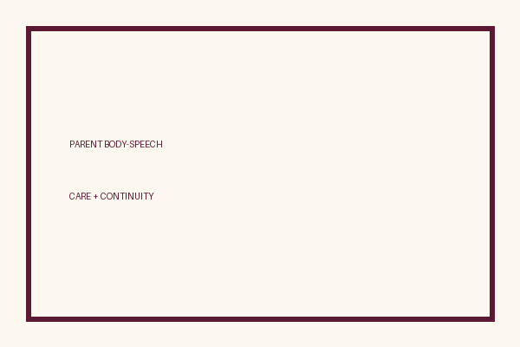
Which labels, roles, or body-change comments do we use at home that quietly treat the body as the whole self?
Private notes:
________________________________________________________________
________________________________________________________________
________________________________________________________________
________________________________________________________________
Habit to watch this week:
________________________________________________________________
________________________________________________________________
________________________________________________________________
________________________________________________________________

P02 — Respectful Family Language Card Sort
Sort onto RESPECTFUL vs MISTAKEN.
RESPECTFUL | MISTAKEN

L1  Bodies change. We stay kind. | L2  It’s just a joke — toughen up.
L3  I’m sorry — that joke about looks was not okay. | L4  Your whole worth is how you look.
L5  We care for health; we are not only metrics. | L6  Bodies are trash; real devotees ignore the body.
L7  Let’s change the subject — body stats stay private. | L8  Tell everyone their weight — honesty!
L9  You are a person who can love and serve — not a punchline. | L10  Photos prove we have a soul.
L11  Sleep and medicine are care, not a failure of spirituality. | L12  If you were spiritual, you wouldn’t need rest.
One ‘almost right’ sentence our home sometimes uses:
________________________________________________________________
________________________________________________________________
________________________________________________________________
Better rewrite with a limit:
________________________________________________________________
________________________________________________________________
________________________________________________________________

TEACHER-ONLY

P02 Facilitator Match Key
Item | Best match / guidance
RESPECTFUL | L1, L3, L5, L7, L9, L11
MISTAKEN | L2, L4, L6, L8, L10, L12

P03 — Substantial Family Case
SAFETY & PRIVACY | Fictional case. No compelled confession of real events.

A middle-school child comes home upset after a relative joked about their height. A sibling repeats the joke at dinner. One parent says “toughen up.” Another freezes.
Tempting mistaken conclusion:
________________________________________________________________
________________________________________________________________
________________________________________________________________
Principle from BG 2.13:
________________________________________________________________
________________________________________________________________
________________________________________________________________
Compassionate response:
________________________________________________________________
________________________________________________________________
________________________________________________________________
One seven-day household action:
________________________________________________________________
________________________________________________________________
________________________________________________________________
What we should not say:
________________________________________________________________
________________________________________________________________
________________________________________________________________

TEACHER-ONLY

P03 Facilitator Answer Direction
Item | Best match / guidance
Mistaken | Jokes harmless / silence enough / toughness fixes hurt
Principle | Body changes; person continues; speech honors dignity (BG 2.13)
Response | Stop repeat; affirm child; privately coach sibling; prepare relative redirect
Action | Speech pledge + nightly memory-line cue
Do not say | Toughen up; spiritual people ignore feelings; announce stats

P04 — Household Operating Application
SAFETY & PRIVACY | No ranking and no public reading required.

One body-care duty we keep as service readiness:
________________________________________________________________
________________________________________________________________
________________________________________________________________
One speech rule we keep for seven days:
________________________________________________________________
________________________________________________________________
________________________________________________________________
One redirect line when teasing starts:
________________________________________________________________
________________________________________________________________
________________________________________________________________
Who starts the nightly cue if others are tired:
________________________________________________________________
________________________________________________________________
________________________________________________________________
Minimum version on a hard day:
________________________________________________________________
________________________________________________________________
________________________________________________________________
Family initials (optional): ____________________ Date: ______________

Memory phrase
My body changes; I continue as the conscious self.

P05 — Private Next-Step Saṅkalpa
KEY IDEA | specific action + frequency + trigger + minimum version

Specific action:
________________________________________________________________
________________________________________________________________
Frequency:
________________________________________________________________
________________________________________________________________
Trigger (when and where):
________________________________________________________________
________________________________________________________________
Minimum version for a hard day:
________________________________________________________________
________________________________________________________________
Where we will place the reminder:
________________________________________________________________
________________________________________________________________

No photo proof. No ranking. The minimum version counts as success.

Younger Child Rules
Canonical source: launch/CHILD-HOUSE-RULES.md • SHA-256: 6a525f3dd1da740db86e246622696c7b08e28c1f1475227567d639a5bd54ce47
Parents remain onsite. Facilitators guide the session. Host property rules also apply.

Shared rules (all ages)
1. Keep your body safe — feet on the floor; hands gentle.
2. Use respectful speech — no teasing, yelling, or mean labels.
3. Follow the facilitator safety cue immediately (pause / freeze / come here).
4. No jumping on furniture.
5. No indoor throwing.
6. No writing on walls, books, or furniture that are not activity materials.
7. Ask before entering private rooms.
8. Respect belongings — ask before touching what is not yours.
9. Devices away unless the lesson specifically needs them.
10. Snack only in the allowed area; water anytime with permission.
11. Help clean up before leaving.

Correction ladder (no public shame)
1. Calm reminder
2. Redirect / offer a choice
3. Brief quiet reset in a visible space
4. Parent involvement
5. Sit out a specific activity
6. Private parent/program conversation for repeated patterns
Never: public shame, yelling, sarcasm, corporal punishment, forced chanting, or comparing children.

Younger (K–2) emphasis
- Soft voices indoors
- Stay with the group
- Hands to yourself
- Ask before leaving the room

Older (Grades 4–5) emphasis
- Model respectful speech for younger children
- Devices fully away unless assigned
- Help clean-up leadership
- Honest questions welcome; speculation wait for source check
Printable versions: W1 launch-pack CHILD-RULES-YOUNGER.md and CHILD-RULES-OLDER.md.

Y01 — Life-Stage Sequence Cards
Cut cards. Place in order: child → youth → elder. Bodies change; the person continues.
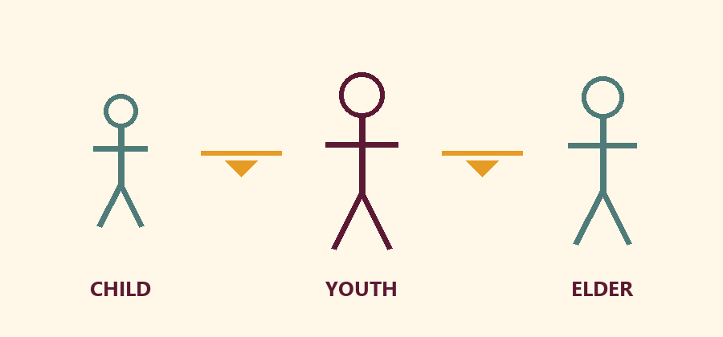

CHILD
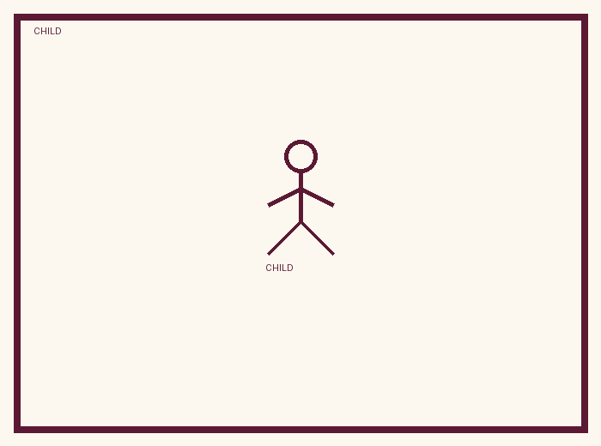
A smaller body. Growing.

YOUTH
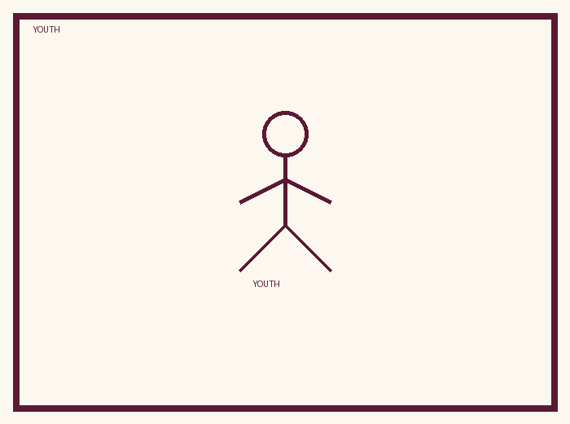
A growing body. Changing.

ELDER
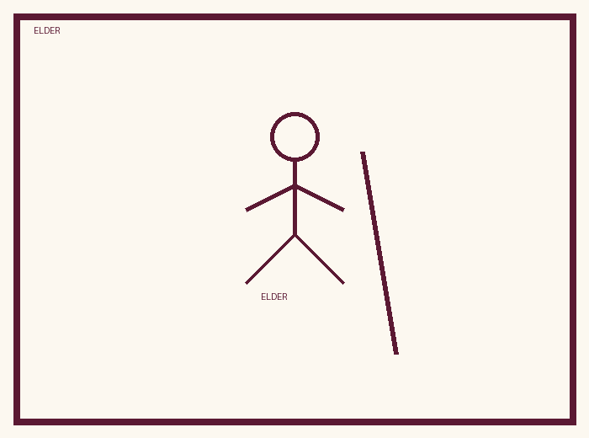
An older body. Still a person.

Memory phrase
My body changes; I continue as the conscious self.
Cut on the dashed borders. Keep each card intact.
TEACHER NOTE | Drawings are pedagogy — not proof of the soul. No death scare.

Y02 — Same-Person / Changing-Body Matching
Cut and match pairs. Body changed; person continues. Kind words only.
CARD 1  Baby shoes | CARD 2  Bigger shoes
CARD 3  Short sleeve last year | CARD 4  Longer arms this year
CARD 5  First tooth smile | CARD 6  Missing tooth smile
CARD 7  Small bicycle | CARD 8  Bigger bicycle seat
Cut on the dashed borders. Keep each card intact.

TEACHER-ONLY

Y02 Answer Key
Item | Best match / guidance
1–2 | Same child; feet grew
3–4 | Same child; body grew
5–6 | Same child; body changed
7–8 | Same rider; body grew

Y03 — Care / Self Cue Craft
Color Care (body) and Self (I). Practice Care → Self with the memory phrase.
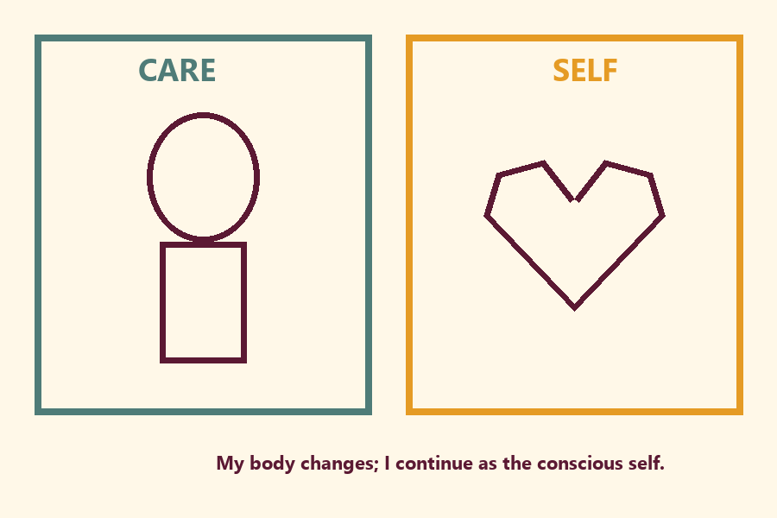
Draw one care act or kind speech bubble:
________________________________________________________________
________________________________________________________________

Memory phrase
My body changes; I continue as the conscious self.
TEACHER NOTE | Care remains good. Do not teach body neglect or ‘body is trash.’

Y04 — Kind Body-Speech Cards
Cut cards. After a redirect, children point to a KIND card.
CARD 1  You’re a friend. | CARD 2  Bodies change. We stay kind.
CARD 3  I care for my body with sleep and water. | CARD 4  I’m sorry. That was not kind.
CARD 5  Someone teases about hair. → Choose a kind repair. | CARD 6  Someone laughs about height. → Choose a kind repair.
Cut on the dashed borders. Keep each card intact.

TEACHER-ONLY

Y04 Teacher Demo (not ‘funny’ handouts)
Item | Best match / guidance
Mistaken demo | You’re weird looking. → Stop; choose kind card
Mistaken demo | It’s just a joke. → Stop; choose repair card
Guidance | Any KIND card OK; prefer repair after hurt

Y05 — Memory Phrase Mat
Place on floor/table. Tap each line while echoing during Grow-and-Freeze.
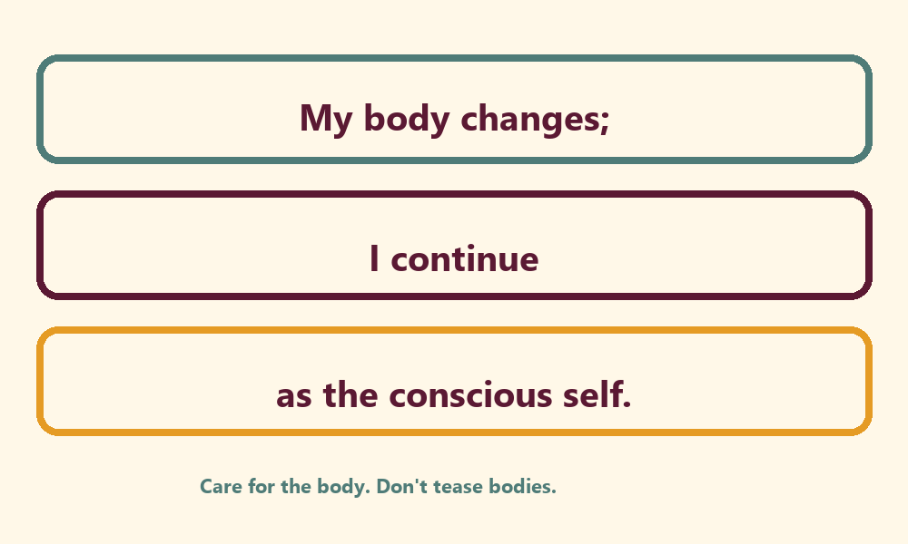

Memory phrase
My body changes; I continue as the conscious self.
Care for the body. Don’t tease bodies. · BG 2.13 family week

Older Child Rules
Canonical source: launch/CHILD-HOUSE-RULES.md • SHA-256: 6a525f3dd1da740db86e246622696c7b08e28c1f1475227567d639a5bd54ce47
Parents remain onsite. Facilitators guide the session. Host property rules also apply.

Shared rules (all ages)
1. Keep your body safe — feet on the floor; hands gentle.
2. Use respectful speech — no teasing, yelling, or mean labels.
3. Follow the facilitator safety cue immediately (pause / freeze / come here).
4. No jumping on furniture.
5. No indoor throwing.
6. No writing on walls, books, or furniture that are not activity materials.
7. Ask before entering private rooms.
8. Respect belongings — ask before touching what is not yours.
9. Devices away unless the lesson specifically needs them.
10. Snack only in the allowed area; water anytime with permission.
11. Help clean up before leaving.

Correction ladder (no public shame)
1. Calm reminder
2. Redirect / offer a choice
3. Brief quiet reset in a visible space
4. Parent involvement
5. Sit out a specific activity
6. Private parent/program conversation for repeated patterns
Never: public shame, yelling, sarcasm, corporal punishment, forced chanting, or comparing children.

Younger (K–2) emphasis
- Soft voices indoors
- Stay with the group
- Hands to yourself
- Ask before leaving the room

Older (Grades 4–5) emphasis
- Model respectful speech for younger children
- Devices fully away unless assigned
- Help clean-up leadership
- Honest questions welcome; speculation wait for source check
Printable versions: W1 launch-pack CHILD-RULES-YOUNGER.md and CHILD-RULES-OLDER.md.

O01 — BG 2.13 Observation Worksheet

VERSE CARD • BG 2.13
देहिनोऽस्मिन् यथा देहे कौमारं यौवनं जरा । तथा देहान्तरप्राप्तिर्धीरस्तत्र न मुह्यति ॥ १३ ॥
dehino ’smin yathā dehe kaumāraṁ yauvanaṁ jarā / tathā dehāntara-prāptir dhīras tatra na muhyati
KUTUMBA teaching meaning: Just as the embodied self passes through childhood, youth, and old age in one body, the sober person is not bewildered when the self passes to another body.
Source: https://vedabase.io/en/library/bg/2/13/
Rights/status: Scripture display/source: VedaBase; teaching meaning: KUTUMBA-original (not labeled as BBT translation).

Body stages named in the verse:
________________________________________________________________
Who is not bewildered? What does sober family speech look like?
________________________________________________________________
What does this verse NOT authorize? (mockery / body contempt as ‘spiritual’ / lab proof of ātman)
________________________________________________________________
One sentence paraphrase in my own words:
________________________________________________________________
Why don’t photos prove the soul?
________________________________________________________________
One question for the facilitator:
________________________________________________________________
Quick checks: Photos prove the soul? Yes / No · Ignore medicine if ‘spiritual’? Yes / No

O02 — Life-Stage Evidence Timeline
Timeline is pedagogy about change/continuity — not soul-proof.
Stage | One body change (no shame language) | What continues?
Childhood | ________________________ | ________________________
Youth | ________________________ | ________________________
Elder | ________________________ | ________________________

Why is this timeline helpful for teaching BG 2.13?
________________________________________________________________
________________________________________________________________
Why is this timeline not proof of the soul?
________________________________________________________________
________________________________________________________________

O03 — Identity Statement Sort
Sort onto SELF / CONTINUES · BODY / CHANGES · CARE DUTY. Discuss mistaken cards.
SELF / CONTINUES | BODY / CHANGES | CARE DUTY

CARD 1  I can choose kind words. | CARD 2  My height changes over years.
CARD 3  I sleep so I can serve with energy. | CARD 4  I can love and remember Kṛṣṇa.
CARD 5  My shoe size changes. | CARD 6  I drink water and eat to care for this body.
CARD 7  I am the same “I” across childhood and youth. | CARD 8  My hair length changes.
CARD 9  I take medicine when needed. | CARD 10  My whole worth is my appearance. (discuss)
CARD 11  Bodies are trash; skip care. (discuss) | CARD 12  Photos prove the soul. (discuss)
Cut on the dashed borders. Keep each card intact.

TEACHER-ONLY

O03 Answer Key
Item | Best match / guidance
SELF | kind words; love/remember Kṛṣṇa; same I across stages
BODY | height; shoe size; hair length
CARE DUTY | sleep; water/food; medicine
MISTAKEN discuss | appearance = worth; bodies trash; photos prove soul

O04 — Respectful Language Scenarios
For each scenario: mistaken conclusion · principle · response · action · what not to say.

Scenario 1
A: Sibling appearance tease at snack — “Just a joke.”
Mistaken conclusion:
________________________________________________________________
________________________________________________________________
Principle from BG 2.13:
________________________________________________________________
________________________________________________________________
Compassionate response:
________________________________________________________________
________________________________________________________________
Better family action:
________________________________________________________________
________________________________________________________________
What not to say:
________________________________________________________________
________________________________________________________________

Scenario 2
B: Teen identity = fitness metrics — “The body project is the self.”
Mistaken conclusion:
________________________________________________________________
________________________________________________________________
Principle from BG 2.13:
________________________________________________________________
________________________________________________________________
Compassionate response:
________________________________________________________________
________________________________________________________________
Better family action:
________________________________________________________________
________________________________________________________________
What not to say:
________________________________________________________________
________________________________________________________________

Scenario 3
C: Relative asks weight publicly — “Public body talk is fine.”
Mistaken conclusion:
________________________________________________________________
________________________________________________________________
Principle from BG 2.13:
________________________________________________________________
________________________________________________________________
Compassionate response:
________________________________________________________________
________________________________________________________________
Better family action:
________________________________________________________________
________________________________________________________________
What not to say:
________________________________________________________________
________________________________________________________________

TEACHER-ONLY

O04 Answer Key
Item | Best match / guidance
A | Stop/affirm/repair; speech pledge; not ‘toughen up’ / ‘just a joke’
B | Affirm health; separate care from identity; keep routine + memory/service; not ‘fitness is māyā’
C | Warm redirect; protect child; agree redirect line; not announce stats / angry lecture in front of child

O05 — Changing-Body / Enduring-Self Diagram
Stages → self continues → kind speech + responsible care.
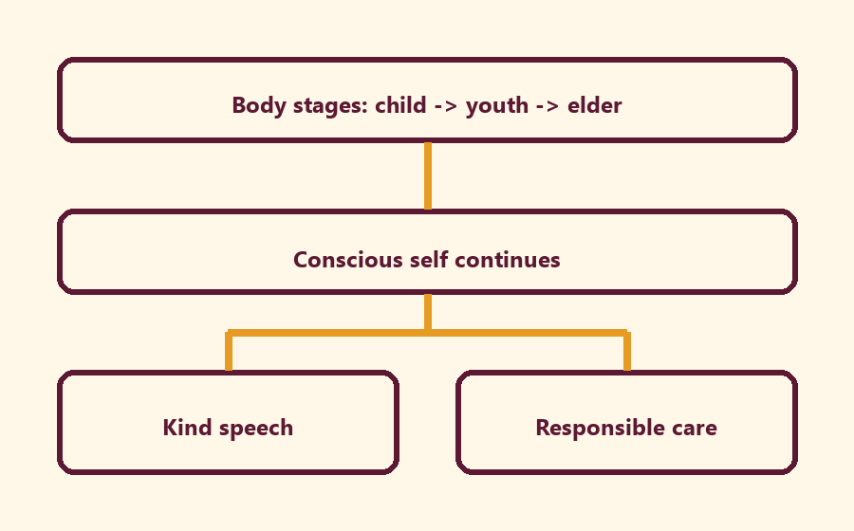
Write the short echo inside Kind speech:
________________________________________________________________
________________________________________________________________
One low-risk example of body change:
________________________________________________________________
________________________________________________________________
One care duty that remains good:
________________________________________________________________
________________________________________________________________
Why doesn’t this diagram prove the soul?
________________________________________________________________
________________________________________________________________
Short echo: Care for the body; don’t confuse it with the self.

O06 — Exit Ticket
Name: __________________________ Date: ______________
BG 2.13 in one sentence (my words):
________________________________________________________________
________________________________________________________________
One analogy and its limit:
________________________________________________________________
________________________________________________________________
One respectful body-speech rule for home:
________________________________________________________________
________________________________________________________________
True/False — Photos prove the soul:
________________________________________________________________
________________________________________________________________
True/False — Ignore medicine if ‘spiritual’:
________________________________________________________________
________________________________________________________________
One question I still have:
________________________________________________________________
________________________________________________________________
Project line — This week our family will speak about bodies by:
________________________________________________________________
________________________________________________________________

Module Project
Canonical source: 11-weekly-program-library/first-six-months/c1-w2-i-am-not-this-body/project/V13-MODULE-PROJECT-BRIEF.md • SHA-256: 1d47fc534b5f6e2ca81deda9cadef88b3a210aed936ffba0c2ef2bab36f66fa3
Cumulative project: Who Am I, and How Should Our Family Live? Week: C1-W2 — I Am Not This Body · Date: 2026-09-19 Primary: BG 2.13 — https://vedabase.io/en/library/bg/2/13/

Essential question (this layer)
How should knowing I am not only this body change how we speak about bodies?

This week’s contribution
Produce one week-specific artifact that a family can store for Week 6:
Audience | Artifact
Younger | Care / Self cue drawing or photo of craft (optional; no required sharing) + one kind-speech sentence
Older | Exit-ticket project line + diagram sentence
Parent | Operating application speech rule + saṅkalpa minimum version
Family reunification | One sentence: “This week we will…”

Steps (3–5 minutes in track / reunification)
1. Restate BG 2.13 conclusion in plain words.
2. Choose one speech or care practice.
3. Write/draw the artifact.
4. Store for Week 6 integration night.
5. Non-competitive sharing only if the family wants.

Success look-fors
- Artifact exists.
- Family can state: body changes; conscious self continues; care without confusion.
- Home cue named.
- No ranking. No forced disclosure.

Boundaries
Distinguish scripture paraphrase from analogy. Photos/psychology are not soul-proof. Do not invent BBT purport text. W6 will integrate; do not demand polished presentation tonight.

Week Home Practice
Week: I Am Not This Body · Primary: BG 2.13 URL: https://vedabase.io/en/library/bg/2/13/ Memory line: My body changes; I continue as the conscious self.

Minimum (counts)
Before next Saturday, as a family once:
1. Say the memory line together.
2. Name one kind body-speech OR one body-care act (sleep, water, brush, rest).
Five minutes counts. No ranking. No photo “proof” of the soul.

Ideal (still small)
1. Memory line.
2. One-sentence paraphrase of BG 2.13 in family words.
3. One gratitude or service act that cares for someone’s body without teasing.

Do not
- Force private disclosures.
- Use appearance jokes as “teaching.”
- Skip body care “because spiritual.”
- Claim science or photos prove the soul.

Next Saturday
C1-W3 — The Nature of the Soul (name only this week).

TEACHER-ONLY
Remove teacher-only pages before distributing participant copies.

Younger Teacher Run Sheet
Canonical source: 11-weekly-program-library/first-six-months/c1-w2-i-am-not-this-body/teacher/YOUNGER-TEACHER-GUIDE-V13.md • SHA-256: 04b4d717f3c16929b691aa36c96621c49ff7ccfccfabf52badfcc82bd9d09c91
Week: I Am Not This Body Primary: BG 2.13 — https://vedabase.io/en/library/bg/2/13/ Session length: 40 minutes (parallel track ~2:30–3:10) Parents: Remain onsite; reunite at 3:10 Status: Internal founding-cohort teaching material — human/temple review EXTERNAL_OPEN

Objective
Children experience that the body changes while the conscious “I” continues. They practice kind body-speech and take home a “care without confusing” cue card.

Exact memory phrase
My body changes; I continue as the conscious self.

Teacher background (2 minutes to review)
- KUTUMBA teaching meaning (adult wording): Just as the embodied self passes through childhood, youth, and old age in one body, the sober person is not bewildered when the self passes to another body.
- Child-facing paraphrase: Your body grows and changes, like clothes that get bigger. You are still you — the person who can love Kṛṣṇa. We care for our bodies; we do not tease bodies.
- Block misconceptions (child words):
- “Photos / science prove the soul.”
- “Bodies don’t matter — skip care.”
- “Appearance jokes are fine.”
- Do not: invent Kṛṣṇa–Arjuna dialogue; use death scare; dump full reincarnation ontology (preview only); force body-shame stories.

Materials
- Three life-stage picture cards (child / youth / elder — respectful drawings, not real family photos of students)
- Soft scarf or fabric square for “changing garments” demo
- Card stock for Care / Self cue cards
- Crayons / markers
- Printed visuals/v13/ if available
- Soft toss object for backup
- Calm-corner chair

Room setup
Circle on the floor; picture cards in order on a low stand; aisles clear for Grow-and-Freeze movement.

Minute-by-minute executable plan

0–5 min — Opening and recall
1. Welcome by name; feet on floor; hands in lap.
2. Show child → youth → elder cards quickly: “Bodies change.”
3. Echo memory phrase three times: My body changes; / I continue / as the conscious self.
4. Ask: “Did anyone’s shoes get too small this year?” Laugh gently; connect to change.

5–13 min — Story script (paraphrase only; ~8 minutes)
Say exactly this spine (do not invent deity dialogue):
Long ago, Arjuna felt heavy sadness about people he loved. His feelings were tangled with bodies and relationships. He asked Kṛṣṇa to teach him what was true. Kṛṣṇa taught that just as we pass through childhood, youth, and older age in one body, the sober person is not confused when the conscious self continues beyond one body’s stage. Clothes change; the person who wears them continues. Photos of a baby and a grown child show change — and still one “I.” We care for our bodies like a driver cares for a car. We do not call bodies trash. We do not tease how someone looks. My body changes; I continue as the conscious self.
Story boundaries: Paraphrase BG 2.13 and gentle BG 2.22 garment support only. No invented quotes. No gore. No “your body is garbage.” Full ontology waits for W3.

13–16 min — Three wonder questions
1. What changes as we grow? (Body / shoes / height)
2. Who continues — the person who can love and choose kind words? (I / conscious self)
3. What is one kind thing to say (or not say) about someone’s body?
Accept short answers. Affirm effort.

16–24 min — Movement game: Grow and Freeze (steps)
1. Spread children in a safe open space.
2. Teacher calls Grow! — children stretch tall slowly (body changing).
3. Teacher calls Freeze! — freeze; whisper memory phrase.
4. Teacher calls Kind hands! — hands on heart; smile at a neighbor (no touching without consent — wave is fine).
5. Play three rounds. On round three, show two cards: (A) tease about looks; (B) kind words. On Freeze, children point to B.
6. End seated; echo memory phrase once.

24–32 min — Craft: Care / Self cue card (steps)
1. Give each child a folded card stock.
2. Outside left: draw a small body outline; label Care.
3. Outside right: draw a simple heart or “I”; label Self.
4. Inside, teacher/helper writes: My body changes; I continue as the conscious self.
5. On the back, child draws one kind body action (sleep, water, brush teeth) OR one kind speech bubble (“You’re a friend”).
6. Practice once: touch Care → touch Self while saying the phrase.
Full printable steps also live in activities/v13-younger/.

32–35 min — Printable / coloring task
Color line-art if time; otherwise keep cue card as take-home.

35–38 min — Behavior redirects and quiet reset
- Feet on floor — “Feet visit the mat.”
- Kind words — “Use Care words.”
- Toy rests — “Toy naps on the shelf.”
- Quiet reset — calm corner with Care card; rejoin on Kind hands.

38–40 min — Cleanup and parent handoff
1. Materials away; each child holds cue card.
2. Parent line:
Memory: “My body changes; I continue as the conscious self.” Home cue: once daily — notice one body change or one kind body-speech; say the phrase.
1. No private teasing reports in the hallway.

Behavior redirects (quick reference)
Signal | Teacher line | Child action
Appearance tease | “Care words only.” | Repair sentence
Running | “Freeze bodies.” | Freeze, walk
Loud shout | “Soft self voice.” | Soft repeat
Shutdown | “Quiet reset okay.” | Calm corner 60 sec

Backup low-prep
1. Circle with soft toss object.
2. Catch → say “change” or “continue” or “kind.”
3. Three echoes of memory phrase.
4. Optional: wrap/unwrap scarf once as garment demo.

What success looks like
- Child can show Care vs Self on the card.
- Child can echo the memory phrase.
- Child can name one kind body-speech or care act.

Boundaries
- Snack/water only at main schedule (3:30).
- No weekly meal language.
- Psychology/photos are pedagogy — never “proof of the soul.”
- No forced confession of home teasing.

Older Teacher Run Sheet
Canonical source: 11-weekly-program-library/first-six-months/c1-w2-i-am-not-this-body/teacher/OLDER-TEACHER-GUIDE-V13.md • SHA-256: 941c66d11612b4fd3ed68705aa3a09760f5abdd45e8082fa59c591452991532b
Week: I Am Not This Body Primary: BG 2.13 — https://vedabase.io/en/library/bg/2/13/ Session length: ~40 minutes (parallel track ~2:30–3:10) Parents: Remain onsite; reunite at 3:10 Status: Internal founding-cohort teaching material — human/temple review EXTERNAL_OPEN

Objective
Students observe BG 2.13, explain that the body changes while the conscious self continues, map Care-without-confusion, practice respectful body speech, and contribute one project sentence answering: How should knowing I am not only this body change how we speak about bodies?

Exact memory phrase
My body changes; I continue as the conscious self.
Short echo: Care for the body; don’t confuse it with the self.

Teacher background
- KUTUMBA teaching meaning: Just as the embodied self passes through childhood, youth, and old age in one body, the sober person is not bewildered when the self passes to another body. (Label as KUTUMBA teaching meaning — not as BBT translation.)
- Supporting frames (one sentence each): BG 2.22 — garments analogy with limits (clothes chosen; bodies not costumes for mockery); BG 2.20 — preview only (deep teaching next week).
- Block: “Psychology or photos prove the soul” and “Body neglect is spiritual” and “Appearance jokes are harmless.”
- Scope: No full jīva ontology dump (W3); no rarity scare (W4).

Materials
- Printed verse strip: Devanāgarī + IAST + KUTUMBA teaching meaning
- Worksheet copies from activities/v13-older/
- Scenario cards (sibling appearance tease; fitness-as-self; public weight question — fictional)
- Care–Self / driver–vehicle diagram sheet
- Pencils; timer; answer key activities/v13-older/ (TEACHER-ONLY keys) for teacher only
- Project contribution half-sheets
- R / M fork cards (Respectful / Mistaken)

Minute-by-minute plan

0–5 min — Settle and hook
1. Welcome; feet on floor.
2. Hook: “Which is worse as a teaching error — treating the body as the whole self, or treating the body as trash?” Let two volunteers answer; hold both as incomplete extremes.
3. State essential question: How should knowing I am not only this body change how we speak about bodies?

5–14 min — Primary text observation (BG 2.13)
1. Display verse; read IAST aloud together once; teacher reads Devanāgarī slowly or plays authorized audio if available.
2. Students underline three idea-clusters in the teaching meaning: childhood–youth–old age, embodied self, not bewildered.
3. Observation prompts (write short answers):
- What changes inside one body according to the verse?
- Who is not bewildered when passage continues?
- What does this verse not authorize? (mockery; body contempt; lab proof of ātman)
1. Add one-sentence bridges:
- BG 2.22 — garments support continuity teaching; limits: bodies deserve care; not fashion props for jokes.
- BG 2.20 — preview only: soul not slain when body is — deep teaching next week.
1. Paraphrase only; no invented Kṛṣṇa–Arjuna dialogue; no gore.

14–22 min — Worksheet questions
Students complete Section A of the older activity pack:
1. Restate KUTUMBA teaching meaning in their own words (one sentence).
2. Name two body changes everyone recognizes.
3. Name one way to care for the body as service readiness (not identity).
4. Why don’t photos prove the soul?
5. Why is “bodies don’t matter” not this week’s teaching?
6. Rewrite “It’s just a joke” into a repair sentence after appearance teasing.
Teacher circulates; use OLDER-ANSWER-KEY.md for expected directions (not for grading ranks).

22–28 min — Scenario cards (small groups)
Each group gets one fictional card:
Card A — Sibling appearance tease at snack: Mistaken line: “Just a joke.” Card B — Teen identity = fitness metrics: Mistaken line: “The body project is the self.” Card C — Relative asks weight publicly: Mistaken line: “Public body talk is fine.”
For each card, group writes:
1. Mistaken conclusion
2. Principle from BG 2.13 (one sentence)
3. Compassionate response
4. Better family action
5. One sentence they should not say (shame, ranking, or public exposure)
Share one insight per group (60 seconds).

28–33 min — Puzzle / game: Respectful Fork
1. Teacher reads a short fork aloud (two endings about body speech or care).
2. Teams hold up R (respectful / aligned) or M (mistaken).
3. Three rounds, then students explain one “R” choice using the words care or self continues.
4. Keep energy respectful; no mocking wrong holds.
Sample forks (paraphrase freely):
- Tease vs repair after a height comment
- Skip sleep “because spiritual” vs rest as service readiness
- Announce someone’s stats vs change the subject warmly

33–37 min — Diagram task
On the Care–Self sheet, students fill:
Body stages (child→youth→elder) → Conscious self continues → Kind speech + responsible care
Circle the Kind speech box and write the short echo inside it. Use a low-risk example (shoes too small, lost pencil joke) — not forced trauma disclosure.

37–40 min — Project contribution + reflection + handoff
1. Complete project half-sheet: “This week our family will speak about bodies by _______________.”
2. Reflection (one sentence): How does BG 2.13 challenge both body-as-self and body-contempt?
3. Cleanup; bring sheets to reunification.
4. Parent handoff line: Home practice is once daily — notice one body change or repair one speech habit; say the memory phrase.

Extension (if group finishes early)
Compare garment analogy limits with driver–vehicle: maintain the vehicle for service; refuse harsh dualism. Still no W3 “I am God” deep dive beyond a one-line preview if asked.

Answer key pointer
Teacher-facing expected answers: activities/v13-older/ (TEACHER-ONLY keys). Do not distribute the key to students during the first attempt.

Behavior and privacy
- Redirect side talk: “Return to your Care–Self map — kind speech box.”
- No forced confession of real teasing incidents.
- No ranking scores aloud.
- Parents onsite; snack/water belongs to main schedule, not track rewards framed as a meal.

Main Facilitator Speaking Map
Canonical source: 11-weekly-program-library/first-six-months/c1-w2-i-am-not-this-body/teacher/MAIN-FACILITATOR-GUIDE-V13.md • SHA-256: 5d72ea5242bbb508b34fe983a557ef5f88ba00a8176f31f74fcf2b790c884cd7
KUTUMBA · Families Growing in Krishna Consciousness Program Director: Swapnil Patil Week: C1-W2 — I Am Not This Body · Date: 2026-09-19 Status: Internal founding-cohort teaching material — human/temple review EXTERNAL_OPEN Controlling guide: This V13 file is authoritative for Saturday delivery. Core teaching is inlined below. Entry point: V13-WEEK-START-HERE.md

Two-minute summary
Body changes; conscious self continues — care for the body without mistaking it for the self. Primary: BG 2.13 (https://vedabase.io/en/library/bg/2/13/). Essential question: How should knowing I am not only this body change how we speak about bodies?

Essential question
How should knowing I am not only this body change how we speak about bodies?

15-minute night-before prep
1. Open https://vedabase.io/en/library/bg/2/13/ and reread Devanāgarī, IAST, and KUTUMBA teaching meaning below.
2. Rehearse the speaking script section aloud once (aim for clear 10–15 minute delivery with pauses).
3. Pack younger + older + parent printables from activities/v13-*.
4. Review misconception to block: Psychology or photos prove the soul.
5. Confirm snack/water only (no weekly meal); parents onsite; privacy reminder card visible.
6. Confirm locked clock: arrival 1:50; tracks 2:30–3:10; reunify 3:10–3:30; close 4:00.

60-minute deep prep
1. Read the inlined analogies, examples, and three cases in this guide until you can teach them without notes.
2. Mark which discovery / understanding / application questions you will actually ask.
3. Choose one analogy and one case as your "must teach" pair; keep the others ready for Q&A.
4. Walk the room: parent circle, younger zone, older zone, reunification seats.
5. Pre-write the home-practice minimum version on a card (5 minutes counts).
6. Review deferral line: laboratory methods measure bodies/behavior; ātman/bhakti claims rest on śāstra — no false science proof.
7. Skim project/V13-MODULE-PROJECT-BRIEF.md for this week's artifact layer.
8. Optional enrichment only (not a substitute for this guide): research/V13-* files.

Exact primary and supporting readings

Primary (locked)
- Reference: BG 2.13
- URL: https://vedabase.io/en/library/bg/2/13/
- Devanāgarī: देहिनोऽस्मिन् यथा देहे कौमारं यौवनं जरा । तथा देहान्तरप्राप्तिर्धीरस्तत्र न मुह्यति ॥ १३ ॥
- IAST: dehino ’smin yathā dehe kaumāraṁ yauvanaṁ jarā / tathā dehāntara-prāptir dhīras tatra na muhyati
- KUTUMBA teaching meaning: Just as the embodied self passes through childhood, youth, and old age in one body, the sober person is not bewildered when the self passes to another body.
- Rights: Sanskrit verse text from VedaBase display; KUTUMBA teaching meaning original; no full purport.

Supporting readings
- BG 2.22 — https://vedabase.io/en/library/bg/2/22/ — As one puts on new garments, the soul accepts new bodies — analogy with limits; full ontology reserved for W3.
- BG 2.20 — https://vedabase.io/en/library/bg/2/20/ — Supporting: the soul is not slain when the body is slain — preview only; deep teaching next week.

Teaching map with exact Saturday 1:50–4:00 time cues
Time | Block | Facilitator focus
1:50–2:00 | Arrival | Welcome; privacy; parents onsite; materials check
2:00–2:10 | Opening mantras | Keep simple; invitation not volume contest
2:10–2:30 | Shared opening / Prem-kī-Kathā + verse | Deliver opening of speaking script; state memory line
2:30–3:10 | Parallel tracks | Parent circle / younger / older — see track transition
3:10–3:30 | Reunification / bhakti lab | Family synthesis sentence; no ranking
3:30–3:40 | Snack + water only | No weekly meal service
3:40–3:55 | Saṅkalpa / project / Q&A | Home cue + project artifact + likely questions
3:55–4:00 | Closing | Next-week title only; no early ontology

10–20 minute speaking script (deliverable prose)
Facilitation note: Speak naturally. Pause for the 20-second pair share where indicated. Do not replace this with "see research."
Welcome back. Tonight's title is simple and easy to misuse: I Am Not This Body.
Essential question: How should knowing I am not only this body change how we speak about bodies?
Primary reading: BG 2.13 — https://vedabase.io/en/library/bg/2/13/
KUTUMBA teaching meaning: "Just as the embodied self passes through childhood, youth, and old age in one body, the sober person is not bewildered when the self passes to another body."
Conclusion: Body changes; conscious self continues — care for the body without mistaking it for the self.
If you remember only one boundary, remember this: psychology insights and family photos can help us teach respectfully. They do not prove the soul. Our doctrine rests on śāstra.
Walk through the verse with me in plain language. In one body we all recognize childhood, youth, and later age. The sober person is not bewildered when the embodied self continues beyond one body's stage — including, the verse indicates, the passage to another body. We will not dump cosmology on K–2 tonight. We will teach dignity: the body changes; the conscious person continues; speech about bodies should be kind.
Analogy one — changing garments (supported by BG 2.22): clothes change, wearer continues. Limit: clothes are chosen; bodies are not costumes for mockery; bodies deserve care.
Analogy two — life-stage photos: same name across pictures. Limit: photos are pedagogy, not proof.
Analogy three — driver and vehicle: operator is not the metal. Limit: refuse harsh dualism. Maintain the vehicle for service.
Scriptural frame: Arjuna's opening grief is tangled with bodily relationships (https://vedabase.io/en/library/bg/1/). Kṛṣṇa's teaching begins by clarifying the embodied self. Paraphrase only.
Household case: sibling appearance teasing at snack. Mistaken conclusion: "just a joke." Principle: respectful speech. Action: repair language and make a seven-day pledge.
We are not teaching body neglect. Sleep, food, medicine, and hygiene remain acts of responsibility. We are teaching identity clarity.
Supporting readings:
- BG 2.22 — https://vedabase.io/en/library/bg/2/22/ — As one puts on new garments, the soul accepts new bodies — analogy with limits; full ontology reserved for W3.
- BG 2.20 — https://vedabase.io/en/library/bg/2/20/ — Supporting: the soul is not slain when the body is slain — preview only; deep teaching next week.
Tracks next. Memory line: My body changes; I continue as the conscious self.
I am going to teach the analogies slowly, with limits in the same breath, because an analogy without a limit becomes a new false doctrine.
First: Changing garments. Clothes change; the wearer continues. Helps children grasp body vs self. Limit: Clothes are chosen; bodies are not fashion accessories. Do not teach contempt for the body.
Second: Life-stage photos. Same person across childhood, youth, elder photos — continuity of the 'I'. Limit: Photos are not ontology proof; memory and personality also change in expression.
Third: Driver and vehicle. The operator uses the vehicle; the operator is not the metal. Limit: Avoid harsh dualism ('body is trash'). Care for the vehicle for service.
Hold those as teaching tools, not as replacements for BG 2.13.
Now two sourced examples, paraphrased only.
Example A — Arjuna's grief at Kurukṣetra opening (BG Ch. 1–2 narrative). Arjuna's distress is tied to bodily relationships. Kṛṣṇa's teaching begins by clarifying the embodied self — paraphrase only; no invented dialogue. Link: https://vedabase.io/en/library/bg/1/
Example B — Garment analogy support (BG 2.22). Scriptural analogy for changing bodies; keep limits explicit in class. Link: https://vedabase.io/en/library/bg/2/22/
Next I will walk all three household cases out loud so you can copy the pattern at home. Please listen for seven fields every time: situation, mistaken conclusion, principle, source, compassionate response, action, and what not to say.
Case 1. Situation: A sibling teases another about appearance during snack. Mistaken conclusion: Body comments are harmless jokes. Principle and source: BG 2.13 — respectful speech about changing bodies; dignity of every person. (https://vedabase.io/en/library/bg/2/13/) Compassionate response: Stop the tease gently. Affirm both children's dignity. Repair with a kind sentence. Family action: Family speech pledge: no appearance jokes at home this week. What not to say: Toughen up. It's just a joke. Spiritual people ignore feelings.
Case 2. Situation: A teen builds identity almost entirely around fitness metrics. Mistaken conclusion: The body project is the self. Principle and source: Care for body as vehicle; self continues beyond stages (BG 2.13). (https://vedabase.io/en/library/bg/2/13/) Compassionate response: Affirm health goals. Separate 'I care for this body' from 'I am only this body.' Family action: Keep healthy routine; add one non-body identity practice (memory line / service). What not to say: Fitness is māyā — stop exercising. Your body doesn't matter.
Case 3. Situation: A relative asks a child's weight publicly at a gathering. Mistaken conclusion: Public body talk is normal and fine. Principle and source: Privacy + respect; body is not public property. (Program privacy practice + BG 2.13 dignity) Compassionate response: Change the subject warmly; protect the child without shaming the relative in front of others if possible. Family action: Parents agree on a redirect line beforehand. What not to say: Announce the child's stats. Lecture the relative with anger in front of the child.
I will now ask the room three discovery questions. You may answer in a whisper to a partner:
- What changes about your body that you can notice without shame?
- Where have body jokes hurt someone at home or school?
- What would respectful body-speech sound like this week?
Understanding check — please be ready to say in one sentence: Body changes; conscious self continues — care for the body without mistaking it for the self. Name the primary: BG 2.13. Name what we are not teaching tonight: ranking, speculation, and the misconception “Psychology or photos prove the soul.”
Application — before you leave the shared opening, decide silently: time + place for home practice; who starts if others are tired; and the minimum version if the week is hard. Five minutes counts. Memory line plus one kind action counts.
Let me demonstrate a minimum home practice out loud so nobody leaves confused. Tonight after dinner, or at the same chair each evening, someone says the memory line once: “My body changes; I continue as the conscious self.” Then one family member paraphrases BG 2.13 in a single sentence. Then one gratitude or service act — thanking someone, offering water, putting shoes away as kindness, or a short prayer. If the house is chaotic, keep only the memory line and one kind action. That still honors tonight’s conclusion: Body changes; conscious self continues — care for the body without mistaking it for the self.
When we reunite at 3:10, I will not score families. I will ask for one sentence: “This week we will…” Drawings count. Whispered parent sentences count. Loud brilliance is not holier than quiet sincerity.
Likely questions you may hear from adults — rehearse these answers with me:
If someone asks, “Do photos prove the soul?” — answer: No. Photos help pedagogy about continuity. Ontology rests on śāstra (BG 2.13+), not albums.
If someone asks, “Should we ignore the body?” — answer: No. Care for health, rest, and hygiene. Refuse identity = body, not refuse care.
If someone asks, “Is this teaching reincarnation details?” — answer: This week introduces continuity of the self through stages and points to transmigration modestly. Deep soul ontology is W3.
If someone asks, “What about disability or illness?” — answer: Every body deserves dignity and care. Never imply someone is 'less' because of bodily condition.
If someone asks, “Can psychology replace this lesson?” — answer: Psychology may help speech and body-image habits. It does not prove ātman.
A short word on boundaries. We do not invent quotations. We do not dump full purports into Git or into the room. We do not diagnose families medically or spiritually in public. We do not guarantee initiation, advancement, or certification. We do not claim human, temple, CPO, or publication approval. Science may help habits; it does not prove ātman or replace śāstra.
Operational covenant aloud: Saturday 1:50–4:00 (teaching window 2:00–4:00); snack and water only; parents onsite; private struggles stay private; no false approval labels.
Recite with me before tracks:
- Essential question: How should knowing I am not only this body change how we speak about bodies?
- Conclusion: Body changes; conscious self continues — care for the body without mistaking it for the self.
- Memory line: My body changes; I continue as the conscious self.
- Misconception to block: Psychology or photos prove the soul.
- Primary: BG 2.13 — https://vedabase.io/en/library/bg/2/13/
Parents: your job in the parent circle is not to perform brilliance. It is to leave with a cue, a minimum version, and a kinder sentence than the one you might have used last week. Younger and older teachers will deepen practice in age bands. We reunite at 3:10 for one family sentence: “This week we will…”
That is the heart of tonight's teaching. Let us practice it, not merely admire it.

Analogies with limits (inline — teach from here)

1. Changing garments
- Teaches: Clothes change; the wearer continues. Helps children grasp body vs self.
- Limit (say out loud): Clothes are chosen; bodies are not fashion accessories. Do not teach contempt for the body.

2. Life-stage photos
- Teaches: Same person across childhood, youth, elder photos — continuity of the 'I'.
- Limit (say out loud): Photos are not ontology proof; memory and personality also change in expression.

3. Driver and vehicle
- Teaches: The operator uses the vehicle; the operator is not the metal.
- Limit (say out loud): Avoid harsh dualism ('body is trash'). Care for the vehicle for service.

Scriptural and devotional examples (inline paraphrase)

1. Arjuna's grief at Kurukṣetra opening
- Provenance: BG Ch. 1–2 narrative
- URL: https://vedabase.io/en/library/bg/1/
- Classroom paraphrase use: Arjuna's distress is tied to bodily relationships. Kṛṣṇa's teaching begins by clarifying the embodied self — paraphrase only; no invented dialogue.

2. Garment analogy support
- Provenance: BG 2.22
- URL: https://vedabase.io/en/library/bg/2/22/
- Classroom paraphrase use: Scriptural analogy for changing bodies; keep limits explicit in class.

Three constructed household cases (inline)

Constructed case 1
Field | Content
Situation | A sibling teases another about appearance during snack.
Mistaken conclusion | Body comments are harmless jokes.
Principle | BG 2.13 — respectful speech about changing bodies; dignity of every person.
Source | https://vedabase.io/en/library/bg/2/13/
Compassionate response | Stop the tease gently. Affirm both children's dignity. Repair with a kind sentence.
Family action | Family speech pledge: no appearance jokes at home this week.
What not to say | Toughen up. It's just a joke. Spiritual people ignore feelings.

Constructed case 2
Field | Content
Situation | A teen builds identity almost entirely around fitness metrics.
Mistaken conclusion | The body project *is* the self.
Principle | Care for body as vehicle; self continues beyond stages (BG 2.13).
Source | https://vedabase.io/en/library/bg/2/13/
Compassionate response | Affirm health goals. Separate 'I care for this body' from 'I am only this body.'
Family action | Keep healthy routine; add one non-body identity practice (memory line / service).
What not to say | Fitness is māyā — stop exercising. Your body doesn't matter.

Constructed case 3
Field | Content
Situation | A relative asks a child's weight publicly at a gathering.
Mistaken conclusion | Public body talk is normal and fine.
Principle | Privacy + respect; body is not public property.
Source | Program privacy practice + BG 2.13 dignity
Compassionate response | Change the subject warmly; protect the child without shaming the relative in front of others if possible.
Family action | Parents agree on a redirect line beforehand.
What not to say | Announce the child's stats. Lecture the relative with anger in front of the child.

Discovery questions
1. What changes about your body that you can notice without shame?
2. Where have body jokes hurt someone at home or school?
3. What would respectful body-speech sound like this week?

Understanding questions
1. State BG 2.13's teaching meaning in one sentence.
2. Name one analogy and its limit.
3. What does this week not claim about science or photos?

Application questions
1. What family speech rule will we keep for seven days?
2. How will we care for the body as service this week?
3. What is our minimum respectful redirect when teasing starts?

Five likely Q&A
Question | Source-based direction
Do photos prove the soul? | No. Photos help pedagogy about continuity. Ontology rests on śāstra (BG 2.13+), not albums.
Should we ignore the body? | No. Care for health, rest, and hygiene. Refuse identity = body, not refuse care.
Is this teaching reincarnation details? | This week introduces continuity of the self through stages and points to transmigration modestly. Deep soul ontology is W3.
What about disability or illness? | Every body deserves dignity and care. Never imply someone is 'less' because of bodily condition.
Can psychology replace this lesson? | Psychology may help speech and body-image habits. It does not prove ātman.

Misconceptions to block
- Psychology or photos prove the soul.
- Confusing analogy with scripture quotation
- Importing next week's full ontology early
- Ranking families or children
- Claiming science proves or disproves ātman / bhakti metaphysics
- False human, temple, CPO, or publication approval labels
- Body neglect framed as spirituality

What not to speculate about
- Invented quotations, purport dumps, or unverified lecture lines
- Private medical or spiritual diagnoses of families
- Guarantees of advancement, initiation, or certification
- Graphic retellings or fear-based death pressure on children
- Exact past-life claims for any child or adult in the room

Track transition (say at ~2:28)
Parents remain in the parent circle. Younger friends go with [younger teacher]. Older students go with [older teacher]. We reunite at 3:10. We do not rank groups.

Family reunification synthesis (3:10–3:30)
Invite one sentence per family tied to the essential question:
"This week we will…"
Accept drawings or whispered parent sentences for shy children. No scoreboard.

Project contribution
Advance the cumulative project Who Am I, and How Should Our Family Live? using project/V13-MODULE-PROJECT-BRIEF.md. This week layer must connect to BG 2.13 and tonight's conclusion. Store artifacts for Week 6. Non-competitive.

Home practice (5–15 minutes)
1. Say the memory line once: My body changes; I continue as the conscious self.
2. Paraphrase BG 2.13 in one family sentence.
3. Do one gratitude or service act.
4. Minimum version if exhausted: memory line + one kind action only.

Next-week preview
Name only: C1-W3 — The Nature of the Soul. Do not teach next week's ontology in depth tonight.

Do not claim
Human/temple/CPO approval; publication readiness; BBT ownership of KUTUMBA teaching meanings; science proving ātman; ranking results; guaranteed spiritual outcomes.

Misconceptions and no-speculation boundaries
- Do not invent dialogue for scriptural persons.
- Do not diagnose private karma or modes as insults in the room.
- Do not claim temple/BBT/human approval that has not been given.
- Defer off-scope questions with: “I don't want to guess. I will verify that from Śrīla Prabhupāda's books / our source packet and come back to you.”

Room / Material / Snack / Cleanup Checklist
Done | Area | Check
☐ | Room | Parent circle, younger floor zone, older table zone, clear aisles
☐ | Materials | Labeled track folders, pencils, crayons, tape, timer
☐ | Privacy | Completed forms remain private and never enter Git
☐ | Snack | Snack and water staged for 3:30; allergy plan confirmed
☐ | Safety | Calm corner visible; private rooms closed; exits clear
☐ | Cleanup | Tables wiped and host home reset assigned

RIGHTS NOTE | KUTUMBA-original framing; cited third-party material retains its own rights. Human/temple review remains EXTERNAL_OPEN.

