KUTUMBA

C1-W2 — Younger Teacher Pack
  - K–2 run sheet and activities
C1-W2 • I Am Not This Body
V13 • Families Growing in Krishna Consciousness
Program Director: Swapnil Patil
Internal founding-cohort teaching material — human/temple review EXTERNAL_OPEN
KUTUMBA | Families Growing in Krishna Consciousness

Locked Saturday Schedule
Time | Block
1:50–2:00 | Arrival
2:00–2:10 | Opening mantras + welcome
2:10–2:30 | All-family launch/orientation
2:30–3:10 | Parallel tracks
3:10–3:30 | Reunification + bhakti laboratory
3:30–3:40 | Snack + water
3:40–3:55 | Saṅkalpa + project + home practice
3:55–4:00 | Close

TIME CUE | Track handoff is at 2:30; all groups reunite at 3:10.

Primary verse: BG 2.13
Source URL: https://vedabase.io/en/library/bg/2/13/

Younger Teacher Run Sheet
Canonical source: 11-weekly-program-library/first-six-months/c1-w2-i-am-not-this-body/teacher/YOUNGER-TEACHER-GUIDE-V13.md • SHA-256: 04b4d717f3c16929b691aa36c96621c49ff7ccfccfabf52badfcc82bd9d09c91
Week: I Am Not This Body Primary: BG 2.13 — https://vedabase.io/en/library/bg/2/13/ Session length: 40 minutes (parallel track ~2:30–3:10) Parents: Remain onsite; reunite at 3:10 Status: Internal founding-cohort teaching material — human/temple review EXTERNAL_OPEN

Objective
Children experience that the body changes while the conscious “I” continues. They practice kind body-speech and take home a “care without confusing” cue card.

Exact memory phrase
My body changes; I continue as the conscious self.

Teacher background (2 minutes to review)
- KUTUMBA teaching meaning (adult wording): Just as the embodied self passes through childhood, youth, and old age in one body, the sober person is not bewildered when the self passes to another body.
- Child-facing paraphrase: Your body grows and changes, like clothes that get bigger. You are still you — the person who can love Kṛṣṇa. We care for our bodies; we do not tease bodies.
- Block misconceptions (child words):
- “Photos / science prove the soul.”
- “Bodies don’t matter — skip care.”
- “Appearance jokes are fine.”
- Do not: invent Kṛṣṇa–Arjuna dialogue; use death scare; dump full reincarnation ontology (preview only); force body-shame stories.

Materials
- Three life-stage picture cards (child / youth / elder — respectful drawings, not real family photos of students)
- Soft scarf or fabric square for “changing garments” demo
- Card stock for Care / Self cue cards
- Crayons / markers
- Printed visuals/v13/ if available
- Soft toss object for backup
- Calm-corner chair

Room setup
Circle on the floor; picture cards in order on a low stand; aisles clear for Grow-and-Freeze movement.

Minute-by-minute executable plan

0–5 min — Opening and recall
1. Welcome by name; feet on floor; hands in lap.
2. Show child → youth → elder cards quickly: “Bodies change.”
3. Echo memory phrase three times: My body changes; / I continue / as the conscious self.
4. Ask: “Did anyone’s shoes get too small this year?” Laugh gently; connect to change.

5–13 min — Story script (paraphrase only; ~8 minutes)
Say exactly this spine (do not invent deity dialogue):
Long ago, Arjuna felt heavy sadness about people he loved. His feelings were tangled with bodies and relationships. He asked Kṛṣṇa to teach him what was true. Kṛṣṇa taught that just as we pass through childhood, youth, and older age in one body, the sober person is not confused when the conscious self continues beyond one body’s stage. Clothes change; the person who wears them continues. Photos of a baby and a grown child show change — and still one “I.” We care for our bodies like a driver cares for a car. We do not call bodies trash. We do not tease how someone looks. My body changes; I continue as the conscious self.
Story boundaries: Paraphrase BG 2.13 and gentle BG 2.22 garment support only. No invented quotes. No gore. No “your body is garbage.” Full ontology waits for W3.

13–16 min — Three wonder questions
1. What changes as we grow? (Body / shoes / height)
2. Who continues — the person who can love and choose kind words? (I / conscious self)
3. What is one kind thing to say (or not say) about someone’s body?
Accept short answers. Affirm effort.

16–24 min — Movement game: Grow and Freeze (steps)
1. Spread children in a safe open space.
2. Teacher calls Grow! — children stretch tall slowly (body changing).
3. Teacher calls Freeze! — freeze; whisper memory phrase.
4. Teacher calls Kind hands! — hands on heart; smile at a neighbor (no touching without consent — wave is fine).
5. Play three rounds. On round three, show two cards: (A) tease about looks; (B) kind words. On Freeze, children point to B.
6. End seated; echo memory phrase once.

24–32 min — Craft: Care / Self cue card (steps)
1. Give each child a folded card stock.
2. Outside left: draw a small body outline; label Care.
3. Outside right: draw a simple heart or “I”; label Self.
4. Inside, teacher/helper writes: My body changes; I continue as the conscious self.
5. On the back, child draws one kind body action (sleep, water, brush teeth) OR one kind speech bubble (“You’re a friend”).
6. Practice once: touch Care → touch Self while saying the phrase.
Full printable steps also live in activities/v13-younger/.

32–35 min — Printable / coloring task
Color line-art if time; otherwise keep cue card as take-home.

35–38 min — Behavior redirects and quiet reset
- Feet on floor — “Feet visit the mat.”
- Kind words — “Use Care words.”
- Toy rests — “Toy naps on the shelf.”
- Quiet reset — calm corner with Care card; rejoin on Kind hands.

38–40 min — Cleanup and parent handoff
1. Materials away; each child holds cue card.
2. Parent line:
Memory: “My body changes; I continue as the conscious self.” Home cue: once daily — notice one body change or one kind body-speech; say the phrase.
1. No private teasing reports in the hallway.

Behavior redirects (quick reference)
Signal | Teacher line | Child action
Appearance tease | “Care words only.” | Repair sentence
Running | “Freeze bodies.” | Freeze, walk
Loud shout | “Soft self voice.” | Soft repeat
Shutdown | “Quiet reset okay.” | Calm corner 60 sec

Backup low-prep
1. Circle with soft toss object.
2. Catch → say “change” or “continue” or “kind.”
3. Three echoes of memory phrase.
4. Optional: wrap/unwrap scarf once as garment demo.

What success looks like
- Child can show Care vs Self on the card.
- Child can echo the memory phrase.
- Child can name one kind body-speech or care act.

Boundaries
- Snack/water only at main schedule (3:30).
- No weekly meal language.
- Psychology/photos are pedagogy — never “proof of the soul.”
- No forced confession of home teasing.

Child House Rules
Canonical source: launch/CHILD-HOUSE-RULES.md • SHA-256: 6a525f3dd1da740db86e246622696c7b08e28c1f1475227567d639a5bd54ce47
Parents remain onsite. Facilitators guide the session. Host property rules also apply.

Shared rules (all ages)
1. Keep your body safe — feet on the floor; hands gentle.
2. Use respectful speech — no teasing, yelling, or mean labels.
3. Follow the facilitator safety cue immediately (pause / freeze / come here).
4. No jumping on furniture.
5. No indoor throwing.
6. No writing on walls, books, or furniture that are not activity materials.
7. Ask before entering private rooms.
8. Respect belongings — ask before touching what is not yours.
9. Devices away unless the lesson specifically needs them.
10. Snack only in the allowed area; water anytime with permission.
11. Help clean up before leaving.

Correction ladder (no public shame)
1. Calm reminder
2. Redirect / offer a choice
3. Brief quiet reset in a visible space
4. Parent involvement
5. Sit out a specific activity
6. Private parent/program conversation for repeated patterns
Never: public shame, yelling, sarcasm, corporal punishment, forced chanting, or comparing children.

Younger (K–2) emphasis
- Soft voices indoors
- Stay with the group
- Hands to yourself
- Ask before leaving the room

Older (Grades 4–5) emphasis
- Model respectful speech for younger children
- Devices fully away unless assigned
- Help clean-up leadership
- Honest questions welcome; speculation wait for source check
Printable versions: W1 launch-pack CHILD-RULES-YOUNGER.md and CHILD-RULES-OLDER.md.

Y01 — Life-Stage Sequence Cards
Cut cards. Place in order: child → youth → elder. Bodies change; the person continues.
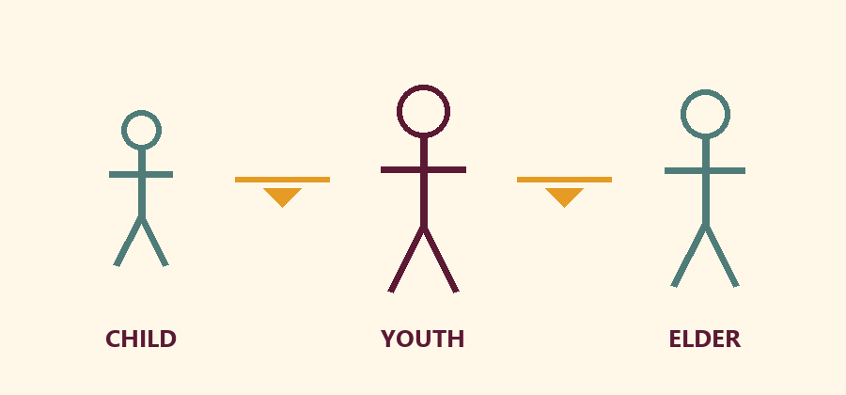

CHILD
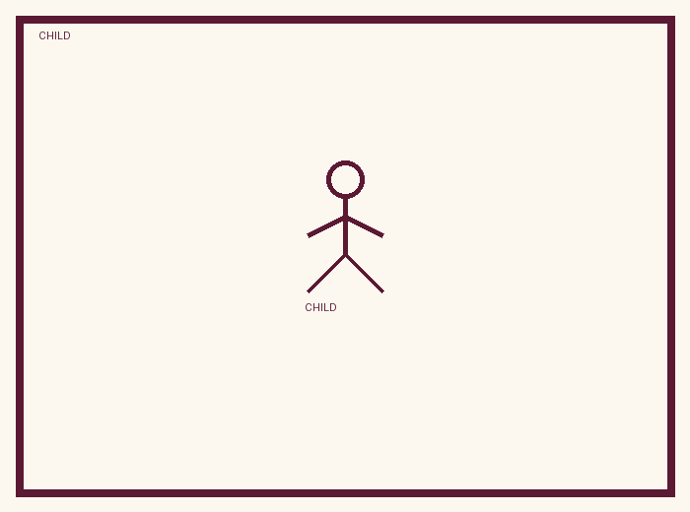
A smaller body. Growing.

YOUTH
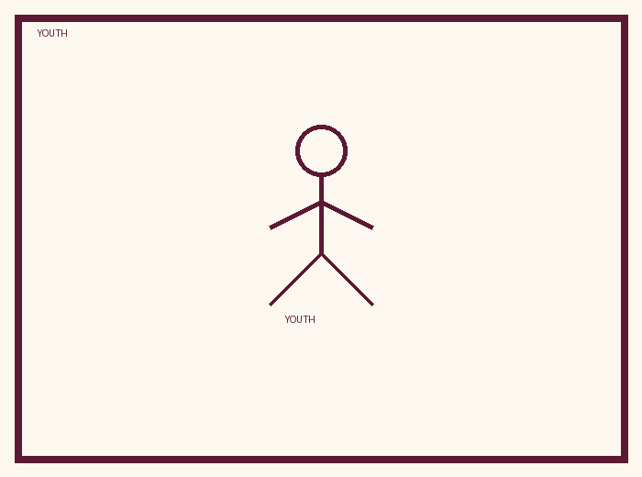
A growing body. Changing.

ELDER
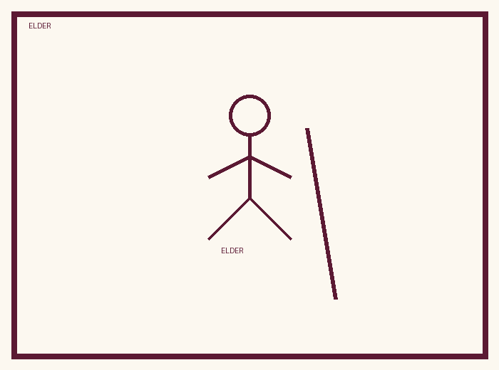
An older body. Still a person.

Memory phrase
My body changes; I continue as the conscious self.
Cut on the dashed borders. Keep each card intact.
TEACHER NOTE | Drawings are pedagogy — not proof of the soul. No death scare.

Y02 — Same-Person / Changing-Body Matching
Cut and match pairs. Body changed; person continues. Kind words only.
CARD 1  Baby shoes | CARD 2  Bigger shoes
CARD 3  Short sleeve last year | CARD 4  Longer arms this year
CARD 5  First tooth smile | CARD 6  Missing tooth smile
CARD 7  Small bicycle | CARD 8  Bigger bicycle seat
Cut on the dashed borders. Keep each card intact.

TEACHER-ONLY

Y02 Answer Key
Item | Best match / guidance
1–2 | Same child; feet grew
3–4 | Same child; body grew
5–6 | Same child; body changed
7–8 | Same rider; body grew

Y03 — Care / Self Cue Craft
Color Care (body) and Self (I). Practice Care → Self with the memory phrase.
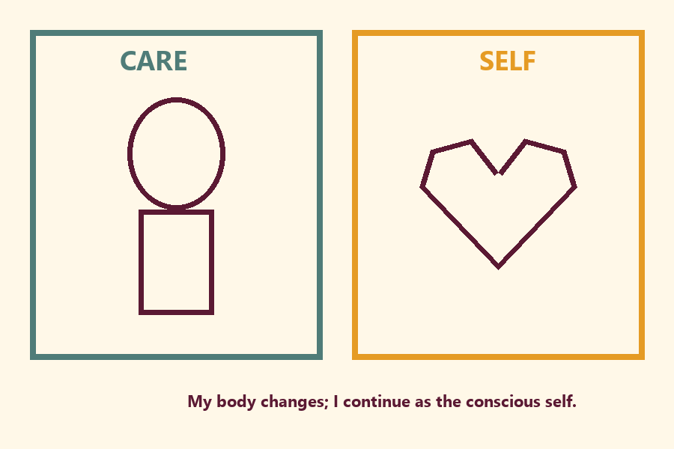
Draw one care act or kind speech bubble:
________________________________________________________________
________________________________________________________________

Memory phrase
My body changes; I continue as the conscious self.
TEACHER NOTE | Care remains good. Do not teach body neglect or ‘body is trash.’

Y04 — Kind Body-Speech Cards
Cut cards. After a redirect, children point to a KIND card.

CARD 1  You’re a friend. | CARD 2  Bodies change. We stay kind.
CARD 3  I care for my body with sleep and water. | CARD 4  I’m sorry. That was not kind.
CARD 5  Someone teases about hair. → Choose a kind repair. | CARD 6  Someone laughs about height. → Choose a kind repair.
Cut on the dashed borders. Keep each card intact.

TEACHER-ONLY

Y04 Teacher Demo (not ‘funny’ handouts)
Item | Best match / guidance
Mistaken demo | You’re weird looking. → Stop; choose kind card
Mistaken demo | It’s just a joke. → Stop; choose repair card
Guidance | Any KIND card OK; prefer repair after hurt

Y05 — Memory Phrase Mat
Place on floor/table. Tap each line while echoing during Grow-and-Freeze.
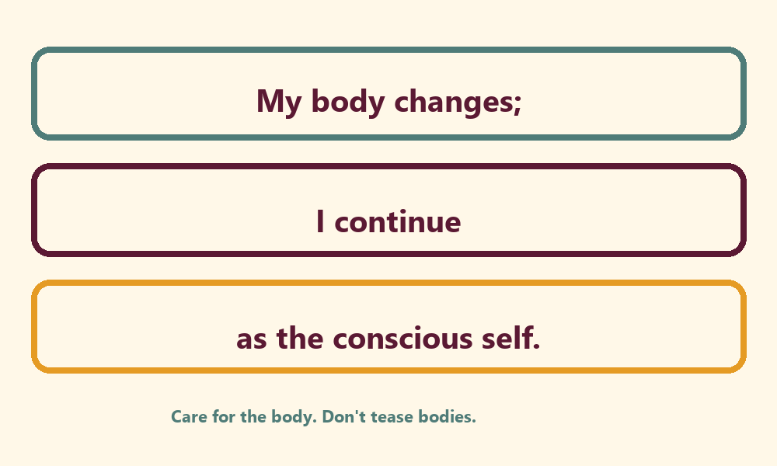

Memory phrase
My body changes; I continue as the conscious self.
Care for the body. Don’t tease bodies. · BG 2.13 family week
RIGHTS NOTE | KUTUMBA-original framing; cited third-party material retains its own rights. Human/temple review remains EXTERNAL_OPEN.

