KUTUMBA

C1-W3 — Older Teacher Pack
  - Grades 4–5 run sheet and activities
C1-W3 • The Nature of the Soul
V13 • Families Growing in Krishna Consciousness
Program Director: Swapnil Patil
Internal founding-cohort teaching material — human/temple review EXTERNAL_OPEN
KUTUMBA | Families Growing in Krishna Consciousness

Locked Saturday Schedule
Time | Block
1:50–2:00 | Arrival
2:00–2:10 | Opening mantras + welcome
2:10–2:30 | All-family launch/orientation
2:30–3:10 | Parallel tracks
3:10–3:30 | Reunification + bhakti laboratory
3:30–3:40 | Snack + water
3:40–3:55 | Saṅkalpa + project + home practice
3:55–4:00 | Close

TIME CUE | Track handoff is at 2:30; all groups reunite at 3:10.

Primary verse: BG 2.20
Source URL: https://vedabase.io/en/library/bg/2/20/

Older Teacher Run Sheet
Canonical source: 11-weekly-program-library/first-six-months/c1-w3-the-nature-of-the-soul/teacher/OLDER-TEACHER-GUIDE-V13.md • SHA-256: 8d2513d07f06015f699a90c231925ddf68b5635cc00755c24fc550458820a5d3
Week ID: C1-W3 · Date: 2026-09-26 · Entry: V13-WEEK-START-HERE.md\n\nWeek: The Nature of the Soul Primary: BG 2.20 — https://vedabase.io/en/library/bg/2/20/ Session length: ~40 minutes (parallel track ~2:30–3:10) Parents: Remain onsite; reunite at 3:10 Status: Internal founding-cohort teaching material — human/temple review EXTERNAL_OPEN

Objective
Students observe BG 2.20, map jīva is/is-not (eternal, conscious, individual, minute, related in service — not God Himself), complete a sun-ray diagram, practice a science deferral line, and answer: If I am a soul, how should I live?

Exact memory phrase
I am an eternal soul — conscious, individual, and meant for Kṛṣṇa's service.
Short echo: Spark who serves — not the sun.

Teacher background
- KUTUMBA teaching meaning: The soul is never born and never dies; unborn, eternal, and everlasting — not destroyed when the body is destroyed. (KUTUMBA teaching meaning — not BBT translation.)
- Supporting frames: BG 15.7 — eternal fragmental parts (qualitative likeness, quantitative difference); BG 2.17 — that which pervades the body is indestructible; ŚB 5.10 Jaḍa Bharata context — bodily labels do not define the soul (gentle paraphrase only).
- Block: “All souls are God / we are the Supreme”; “science disproved the soul”; “body contempt is spiritual.”
- Science stance: N/A — no empirical claim is needed for this week's doctrinal conclusion about ātman. Labs measure bodies/behavior; doctrine rests on śāstra.

Materials
- Printed verse strip: Devanāgarī + IAST + KUTUMBA teaching meaning
- Worksheet copies from activities/v13-older/
- Scenario cards (‘I am God’ boast; anti-science dismissal; hygiene neglect — fictional)
- Is/Is-not + sun-ray diagram sheet
- Pencils; timer; activities/v13-older/ (keys in teacher-only pages) (teacher only)
- Project contribution half-sheets
- T / F cards for Soul Map game

Minute-by-minute plan

0–5 min — Settle and hook
1. Welcome; feet on floor.
2. Hook: “If a child proudly says ‘I am God,’ what gentle correction fits — and what would shame look like?” Collect two answers; hold for verse.
3. Essential question: If I am a soul, how should I live?

5–14 min — Primary text observation (BG 2.20)
1. Display verse; read IAST together once; Devanāgarī slowly or authorized audio.
2. Students underline: never born / never dies / not destroyed when the body is destroyed.
3. Observation prompts (write short answers):
- What continues when the body is destroyed?
- What is not claimed (that jīva = the Supreme)?
- What domain does laboratory science measure?
1. Add bridges:
- BG 15.7 — fragmental part; spark ≠ sun.
- Science deferral line aloud once as a class.
1. Paraphrase only; no invented dialogue; Jaḍa Bharata only if gentle and nonviolent.

14–22 min — Worksheet questions
Students complete Section A:
1. Restate teaching meaning in one sentence.
2. Fill: eternal _______________ parts (fragmental).
3. Mark IS / IS NOT for body, Supreme, conscious individual, service.
4. Write a gentle correction for “I am God.”
5. Write science deferral in own words.
6. Name one body-care act as service readiness.
Circulate with answer key for directions, not ranks.

22–28 min — Scenario cards (small groups)
Card A — Child: ‘I am God.’ Mistaken: Soul equals the Supreme. Card B — Adult: ‘Science disproved the soul.’ Mistaken: Empiricism settled ātman. Card C — Family neglects hygiene ‘because we are soul.’ Mistaken: Body contempt is spiritual.
Each group writes mistaken conclusion / principle / compassionate response / better action / what not to say. Share 60 seconds.

28–33 min — Puzzle / game: Soul Map True/False
1. Teacher reads statements (examples below).
2. Teams hold T or F, then one sentence why.
3. Four to five rounds; respectful energy; no mocking.
Sample statements:
- The soul is never born. (T)
- The jīva is God Himself. (F)
- Labs prove the soul exists. (F)
- Caring for the body can support service. (T)
- Bodily job labels fully define the person. (F)

33–37 min — Diagram task
Complete is/is-not table and sun ← ray sketch. Circle service relationship. Write short echo inside. Low-risk examples only.

37–40 min — Project contribution + reflection + handoff
1. Project: “Because I am a soul, this week I will live by _______________.”
2. Reflection: How do BG 2.20 and BG 15.7 together block both nihilism and “I am God”?
3. Cleanup; reunification sheets ready.
4. Parent handoff: daily phrase + one care act as service readiness; keep science deferral ready.

Extension (if group finishes early)
One gentle Jaḍa Bharata status-label point (ŚB 5.10) — nonviolent, no invented dialogue — connecting bodily labels ≠ soul identity.

Answer key pointer
Teacher-facing expected answers: activities/v13-older/ (keys in teacher-only pages). Do not distribute during first attempt.

Behavior and privacy
- Redirect “I am God” boasts without public shame: “Dear spark who serves.”
- No ranking; no forced metaphysical debates with visitors.
- Snack/water on main schedule only — not track bribes.

V13 printable wiring
Code | Activity | Printable folder
O01–O06 | Verse observation + attributes grid (+ scenarios/exit) | `activities/v13-older/`

Use Word builders in scripts/v13/printables/C1-W3.py (OLDER_BUILDERS). Teacher-only keys stay behind TEACHER-ONLY divider pages. Memory phrase: I am an eternal soul — conscious, individual, and meant for Kṛṣṇa's service.

O01 — BG 2.20 Observation
Underline never born / never dies / not destroyed with the body.
ŚĀSTRA | BG 2.20 — https://vedabase.io/en/library/bg/2/20/

What does the verse say happens to the soul when the body is destroyed?
________________________________________________________________
List two attributes of the soul from tonight's teaching.
________________________________________________________________
What must we NOT claim about science tonight?
________________________________________________________________
Paraphrase the KUTUMBA teaching meaning in one sentence.
________________________________________________________________

O02 — Soul Attributes Grid
Fill IS attributes and IS NOT column.
Attribute | Means in kid/teen words | Is NOT
Eternal |  | Created at birth
Conscious |  | A rock
Individual |  | Merged into Godhood
Minute / fragmental |  | The Supreme
Related in service |  | Independent God

DO NOT SPECULATE | Science is N/A as proof of the soul this week.

O03 — Identity Statement Sort
ALIGNED / MISTAKEN / MIXED.
CARD 1  I am God. | CARD 2  I am an eternal soul meant to serve Kṛṣṇa.
CARD 3  My grades are the whole me. | CARD 4  I care for my body so I can serve.
CARD 5  Labs proved there is no soul. | CARD 6  When I fail a test I am worthless.
Cut on the dashed borders. Keep each card intact.

TEACHER-ONLY

O03 Key
Item | Best match / guidance
1 | MISTAKEN Godhood
2 | ALIGNED
3 | MISTAKEN outcome=self
4 | ALIGNED
5 | MISTAKEN science proof
6 | MISTAKEN

O04 — Success/Failure Scenarios
Seven fields: situation through what not to say.
CARD 1  A: Win trophy — I am God now | CARD 2  B: Fail test — I am nothing
CARD 3
C: Neglect hygiene because soul
Card A notes
________________________________________________________________
________________________________________________________________
Card B notes
________________________________________________________________
________________________________________________________________
Card C notes
________________________________________________________________
________________________________________________________________

TEACHER-ONLY
Correct Godhood gently; restore care; refuse lab-proof fights.

O05 — Jīva Is / Is-Not Diagram
Label IS and IS NOT zones.
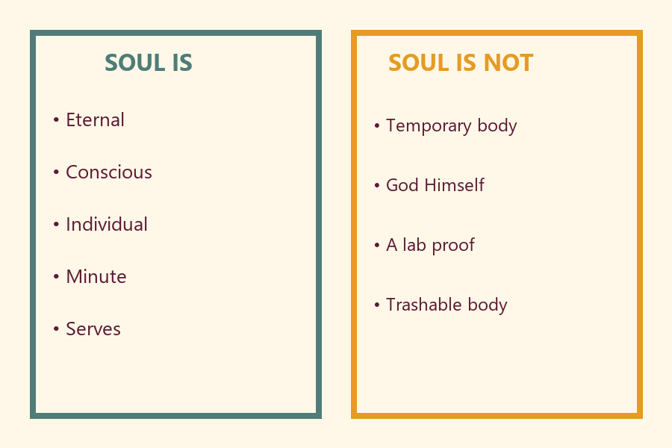
One service arrow means:
________________________________________________________________
One care arrow means:
________________________________________________________________

O06 — Exit Ticket
Before reunification.
Memory phrase:
________________________________________________________________
One service act I will try:
________________________________________________________________
One care act I will keep:
________________________________________________________________
Project sentence — If I am a soul, how should I live?
________________________________________________________________
RIGHTS NOTE | KUTUMBA-original framing; cited third-party material retains its own rights. Human/temple review remains EXTERNAL_OPEN.

