KUTUMBA

C1-W3 — Younger Teacher Pack
  - K–2 run sheet and activities
C1-W3 • The Nature of the Soul
V13 • Families Growing in Krishna Consciousness
Program Director: Swapnil Patil
Internal founding-cohort teaching material — human/temple review EXTERNAL_OPEN
KUTUMBA | Families Growing in Krishna Consciousness

Locked Saturday Schedule
Time | Block
1:50–2:00 | Arrival
2:00–2:10 | Opening mantras + welcome
2:10–2:30 | All-family launch/orientation
2:30–3:10 | Parallel tracks
3:10–3:30 | Reunification + bhakti laboratory
3:30–3:40 | Snack + water
3:40–3:55 | Saṅkalpa + project + home practice
3:55–4:00 | Close

TIME CUE | Track handoff is at 2:30; all groups reunite at 3:10.

Primary verse: BG 2.20
Source URL: https://vedabase.io/en/library/bg/2/20/

Younger Teacher Run Sheet
Canonical source: 11-weekly-program-library/first-six-months/c1-w3-the-nature-of-the-soul/teacher/YOUNGER-TEACHER-GUIDE-V13.md • SHA-256: 6699c9afa9613c06265d0e6f330ce49ffefb8cfebf728ea96f0d1ff789906d28
Week ID: C1-W3 · Date: 2026-09-26 · Entry: V13-WEEK-START-HERE.md\n\nWeek: The Nature of the Soul Primary: BG 2.20 — https://vedabase.io/en/library/bg/2/20/ Session length: 40 minutes (parallel track ~2:30–3:10) Parents: Remain onsite; reunite at 3:10 Status: Internal founding-cohort teaching material — human/temple review EXTERNAL_OPEN

Objective
Children experience that they are an eternal soul — conscious, individual, and meant for Kṛṣṇa’s service — not God Himself. They take home a “spark serves the sun” cue card and one care-as-service act.

Exact memory phrase
I am an eternal soul — conscious, individual, and meant for Kṛṣṇa's service.

Teacher background (2 minutes to review)
- KUTUMBA teaching meaning (adult wording): The soul is never born and never dies; unborn, eternal, and everlasting — not destroyed when the body is destroyed.
- Child-facing paraphrase: You are a tiny bright spark meant to love and serve Kṛṣṇa. Sparks are not the whole sun. We still brush teeth and sleep — caring for the body helps us serve.
- Block misconceptions (child words):
- “I am God.”
- “Science proved there is no soul.”
- “Bodies don’t need care because we are soul.”
- Do not: invent dialogue; use violence in Jaḍa Bharata retelling; shame a child who says “I am God”; claim lab proof of ātman.

Materials
- Yellow “sun” circle and smaller “spark/ray” cutouts (one spark per child)
- Soft house picture or toy house + small figure (resident demo)
- Card stock for spark-service cards
- Crayons; printed line-art if available
- Soft toss object; calm-corner chair

Room setup
Circle; sun poster at center; spark cutouts ready; aisles clear for Spark-and-Serve movement.

Minute-by-minute executable plan

0–5 min — Opening and recall
1. Welcome; feet on floor.
2. Show sun + one spark: “Same light-nature — spark is not the sun.”
3. Echo memory phrase twice (break into beats): I am an eternal soul — / conscious, individual — / meant for Kṛṣṇa's service.
4. Briefly recall W2: body changes; self continues — today we learn what kind of self.

5–13 min — Story script (paraphrase only; ~8 minutes)
Say exactly this spine (do not invent deity dialogue):
Last week we learned: bodies change; the conscious self continues. Today we ask: what kind of self am I? Kṛṣṇa teaches that the soul is never born and never dies. When the body is finished, the soul is not destroyed. The living being is like a ray of the sun — sharing light-nature, but not the whole sun. We are tiny parts meant to serve Kṛṣṇa, not to become the Supreme. Long ago, a wise person named Jaḍa Bharata helped a king see that labels about bodies — strong, weak, important jobs — do not define the soul. We tell that gently, without scary details. If someone says “I am God,” we smile and say: “You are a dear spark meant to serve, not the whole sun.” And we still care for our house — our body — so we can serve with energy.
Story boundaries: BG 2.20 + BG 15.7 fragmental part; Jaḍa Bharata / ŚB 5.10 gentle nonviolent paraphrase only. No invented quotes. No “science proves soul.”

13–16 min — Three wonder questions
1. Is the spark the whole sun? (No)
2. What is the soul meant for? (Kṛṣṇa’s service)
3. Name one way to care for the body so we can serve. (sleep / water / brush)

16–24 min — Movement game: Spark and Serve (steps)
1. Children stand in open space holding imaginary sparks (open palms).
2. Teacher calls Spark! — children wiggle fingers (alive, conscious).
3. Teacher calls Not the sun! — point to sun poster; shake head gently; whisper “I serve.”
4. Teacher calls Serve! — take three gentle steps toward a “service mat” (help pile: toy tidy, or kindness mat) and sit.
5. Three rounds. Round three: show cards (A) “I am God” (B) “I am a spark who serves.” Point to B on Serve.
6. End seated; echo memory phrase once.

24–32 min — Craft: Spark-service cue card (steps)
1. Fold card stock; stick or draw a yellow spark on the front.
2. Inside, write: I am an eternal soul — conscious, individual, and meant for Kṛṣṇa's service. (or short: Dear spark — I serve Kṛṣṇa.)
3. On the back: draw one service act (help set plate, soft voice, tidy toys) AND one body-care act.
4. Practice: touch spark → say “not the sun” → say “I serve.”
5. Take-home placement: near toothbrush or dinner plate.
Full steps also in activities/v13-younger/.

32–35 min — Printable / coloring task
Color line-art if time; else keep spark card.

35–38 min — Behavior redirects and quiet reset
- Feet on floor — “Spark feet on the mat.”
- Kind words — “Serve voice.”
- I am God boast — “Smile — dear spark who serves.”
- Quiet reset — calm corner with sun picture; rejoin on Serve.

38–40 min — Cleanup and parent handoff
Memory: “I am an eternal soul — conscious, individual, and meant for Kṛṣṇa's service.” Home cue: once daily — say the phrase and do one care act as service readiness. Labs measure bodies; soul teaching comes from śāstra.

Behavior redirects (quick reference)
Signal | Teacher line | Child action
“I am God” | “Dear spark who serves.” | Repeat gently
Body neglect talk | “Care helps us serve.” | Name one care act
Running | “Spark walk.” | Walk
Shutdown | “Quiet reset okay.” | Calm corner 60 sec

Backup low-prep
Soft toss: catch → say “spark,” “serve,” or “care.” Three phrase echoes. Optional: place spark cutouts on sun, then take one home.

What success looks like
- Child can say spark ≠ sun.
- Child can echo (or finish) memory phrase.
- Child can name one service + one care act.

Boundaries
- Snack/water at 3:30 only; no weekly meal.
- N/A — no empirical claim is needed for this week's doctrinal conclusion about ātman — do not claim science proves or disproves the soul.
- No ranking; no public shame for “I am God” moments.

V13 printable wiring
Code | Activity | Printable folder
Y01–Y05 | Soul is / is-not classification cards (+ supporting crafts/sorts) | `activities/v13-younger/`

Use Word builders in scripts/v13/printables/C1-W3.py (YOUNGER_BUILDERS). Visuals: visuals/v13/. Memory phrase: I am an eternal soul — conscious, individual, and meant for Kṛṣṇa's service.

Child House Rules
Canonical source: launch/CHILD-HOUSE-RULES.md • SHA-256: 6a525f3dd1da740db86e246622696c7b08e28c1f1475227567d639a5bd54ce47
Parents remain onsite. Facilitators guide the session. Host property rules also apply.

Shared rules (all ages)
1. Keep your body safe — feet on the floor; hands gentle.
2. Use respectful speech — no teasing, yelling, or mean labels.
3. Follow the facilitator safety cue immediately (pause / freeze / come here).
4. No jumping on furniture.
5. No indoor throwing.
6. No writing on walls, books, or furniture that are not activity materials.
7. Ask before entering private rooms.
8. Respect belongings — ask before touching what is not yours.
9. Devices away unless the lesson specifically needs them.
10. Snack only in the allowed area; water anytime with permission.
11. Help clean up before leaving.

Correction ladder (no public shame)
1. Calm reminder
2. Redirect / offer a choice
3. Brief quiet reset in a visible space
4. Parent involvement
5. Sit out a specific activity
6. Private parent/program conversation for repeated patterns
Never: public shame, yelling, sarcasm, corporal punishment, forced chanting, or comparing children.

Younger (K–2) emphasis
- Soft voices indoors
- Stay with the group
- Hands to yourself
- Ask before leaving the room

Older (Grades 4–5) emphasis
- Model respectful speech for younger children
- Devices fully away unless assigned
- Help clean-up leadership
- Honest questions welcome; speculation wait for source check
Printable versions: W1 launch-pack CHILD-RULES-YOUNGER.md and CHILD-RULES-OLDER.md.

Y01 — Soul Is / Is-Not Cards
Sort into SOUL IS vs SOUL IS NOT.
CARD 1  IS: Eternal | CARD 2  IS: Conscious
CARD 3  IS: Meant to serve Kṛṣṇa | CARD 4  IS NOT: The temporary body
CARD 5  IS NOT: God Himself | CARD 6  IS NOT: A spark equal to the whole sun

Memory phrase
I am an eternal soul — conscious, individual, and meant for Kṛṣṇa's service.
Cut on the dashed borders. Keep each card intact.

Y02 — Spark and Sun Match
Same light-nature — not the whole sun.
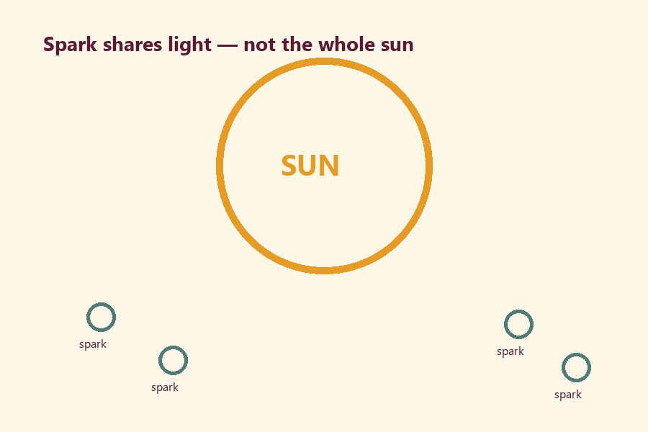
TEACHER NOTE | If a child says I am God, smile and correct: dear spark who serves.

Cut on the dashed borders. Keep each card intact.

Y03 — Spark-Service Cue Craft
Care act + service act on the card.
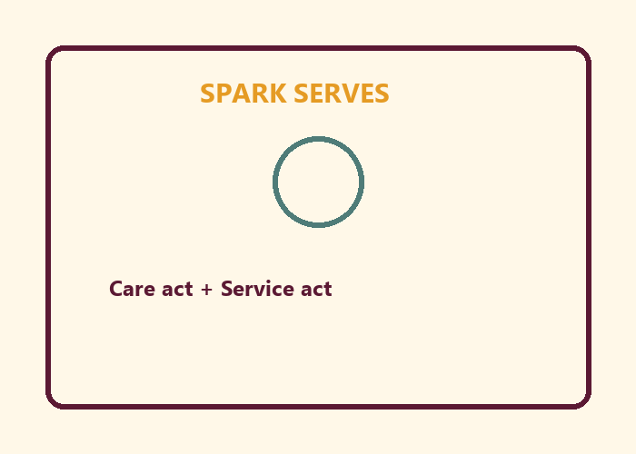
My care act:
________________________________________________________________
My service act:
________________________________________________________________

Memory phrase
I am an eternal soul — conscious, individual, and meant for Kṛṣṇa's service.

Y04 — Care-as-Service Cards
Sort CARE HELPS SERVICE vs BODY NEGLECT.
CARD 1  CARE: Sleep so I can serve | CARD 2  CARE: Drink water
CARD 3  CARE: Brush teeth | CARD 4  NEGLECT: Ignore rest because soul
CARD 5  NEGLECT: Body is trash | CARD 6  NEGLECT: Skip hygiene to look spiritual
Cut on the dashed borders. Keep each card intact.

Y05 — Memory Phrase Mat
Landing mat for Spark-and-Serve.


Memory phrase
I am an eternal soul — conscious, individual, and meant for Kṛṣṇa's service.
RIGHTS NOTE | KUTUMBA-original framing; cited third-party material retains its own rights. Human/temple review remains EXTERNAL_OPEN.

