KUTUMBA

C1-W4 — Older Teacher Pack
  - Grades 4–5 run sheet and activities
C1-W4 • Why Human Life Is Rare and Valuable
V13 • Families Growing in Krishna Consciousness
Program Director: Swapnil Patil
Internal founding-cohort teaching material — human/temple review EXTERNAL_OPEN
KUTUMBA | Families Growing in Krishna Consciousness

Locked Saturday Schedule
Time | Block
1:50–2:00 | Arrival
2:00–2:10 | Opening mantras + welcome
2:10–2:30 | All-family launch/orientation
2:30–3:10 | Parallel tracks
3:10–3:30 | Reunification + bhakti laboratory
3:30–3:40 | Snack + water
3:40–3:55 | Saṅkalpa + project + home practice
3:55–4:00 | Close

TIME CUE | Track handoff is at 2:30; all groups reunite at 3:10.

Primary verse: ŚB 11.9.29
Source URL: https://vedabase.io/en/library/sb/11/9/29/

Older Teacher Run Sheet
Canonical source: 11-weekly-program-library/first-six-months/c1-w4-why-human-life-is-rare-and-valuable/teacher/OLDER-TEACHER-GUIDE-V13.md • SHA-256: 300f6c037caf1a626dd036e44cc6b36ddcac3fd88c28519027ede07e1f3753ca
Week ID: C1-W4 · Date: 2026-10-03 · Entry: V13-WEEK-START-HERE.md\n\nWeek: Why Human Life Is Rare and Valuable Primary: ŚB 11.9.29 — https://vedabase.io/en/library/sb/11/9/29/ Session length: ~40 minutes (parallel track ~2:30–3:10) Parents: Remain onsite; reunite at 3:10 Status: Internal founding-cohort teaching material — human/temple review EXTERNAL_OPEN

Objective
Students observe ŚB 11.9.29, protect inquiry and practice time without fear tactics, correctly source Nārada–Mṛgāri to CC Madhya 24.229–282, complete a Must/Should/Optional time-jar, and answer: What deserves protected family time?

Exact memory phrase
Human life is a rare chance to ask who I am and serve Kṛṣṇa.
Short echo: Rare chance — protect practice time.

Teacher background
- KUTUMBA teaching meaning: After many births one obtains the rare human form — temporary yet able to give the highest purpose. A sober person should quickly endeavor for the ultimate good while this body lasts. (KUTUMBA teaching meaning — not BBT translation.)
- Supporting frames: BG 2.40 — little progress not lost (helps five-minute families); CC Madhya 24.229–282 — mercy and authorized instruction transform harmful conduct.
- Hard source lock: Mṛgāri is not SB 6.x and not SB 4.8. Useful Madhya anchors if needed: intro 24.229, name 24.242, bow 24.255–256, careful steps 24.270–272, conclusion 24.278–282 — paraphrase only; no gore.
- Block: Fear/death-pressure motivation; entertainment-first as default; busy = successful human life; species contempt.

Materials
- Printed verse strip: Devanāgarī + IAST + KUTUMBA teaching meaning
- Worksheet copies from activities/v13-older/
- Scenario cards (screens eat quiet block; death-scare parent; full calendar — fictional)
- Must / Should / Optional time-jar diagram sheet
- Pencils; timer; activities/v13-older/ (keys in teacher-only pages) (teacher only)
- Project contribution half-sheets
- Source-check cards: M24 vs WRONG; priority-sort slips

Minute-by-minute plan

0–5 min — Settle and hook
1. Welcome; feet on floor.
2. Hook: “Does urgency have to mean fear?” Collect yes/no with one reason each; hold both for the verse.
3. Essential question: What deserves protected family time?

5–14 min — Primary text observation (ŚB 11.9.29)
1. Display verse; read IAST aloud together once; Devanāgarī slowly or authorized audio.
2. Students underline: rare / temporary / highest purpose / endeavor.
3. Observation prompts (write short answers):
- What is rare, and what can it give?
- What should a sober person do while the body lasts?
- What classroom language do we refuse (terror / death pressure)?
1. Bridges:
- BG 2.40 — a little sincere endeavor is not lost.
- Source drill: write CC Madhya 24.229–282 as the only Mṛgāri source; mark SB 6.x / SB 4.8 as wrong.
1. Paraphrase Madhya mercy arc in one gentle sentence if used — no invented dialogue, no gore.

14–22 min — Worksheet questions
Students complete Section A:
1. Restate teaching meaning in opportunity language (one sentence).
2. Rewrite a fear-based ask into an invitation ask.
3. Circle rare / purpose / endeavor; cross out terror ranking.
4. Select correct Mṛgāri source.
5. Explain how BG 2.40 helps a five-minute family.
6. Name one Must slot to protect this week.
Circulate with answer key for directions, not ranks.

22–28 min — Scenario cards (small groups)
Card A — Screens eat the only quiet evening block. Mistaken: Entertainment first is always fine. Card B — Parent uses death scare to force chanting. Mistaken: Fear creates lasting urgency. Card C — Calendar full; no inquiry time. Mistaken: Busy equals successful human life.
Each group writes mistaken conclusion / principle / compassionate response / better action / what not to say. Share 60 seconds.

28–33 min — Puzzle / game: Source Check + Priority Sort
1. Round 1 — Source Check: Teacher reads citations for Mṛgāri. Teams hold M24 or WRONG.
2. Round 2 — Priority Sort: Quietly sort activity slips into Must / Should / Optional.
3. One student explains one Must using “rare chance” language (not scare language).
4. Keep energy respectful; no mocking wrong holds.

33–37 min — Diagram task
Fill Must / Should / Optional jars. Move one Optional below a Must spiritual cue. Write the short echo inside Must. Low-risk schedule examples only — no forced disclosure of home screen battles.

37–40 min — Project contribution + reflection + handoff
1. Project: “This week we protect _______________ before Optional screens.”
2. Reflection: How does ŚB 11.9.29 invite urgency without panic?
3. Cleanup; reunification sheets ready.
4. Parent handoff: Must slot first; invitation language; Mṛgāri = Madhya 24 if discussed.

Extension (if group finishes early)
Map Madhya 24 mercy arc in three words only: meet → teach → careful life. Still no gore; still no SB mis-citation.

Answer key pointer
Teacher-facing expected answers: activities/v13-older/ (keys in teacher-only pages). Do not distribute during first attempt.

Behavior and privacy
- Redirect scare language: “Chance words only.”
- No public shame about screens or busy calendars.
- No ranking families by how “urgent” they sound.
- Snack/water on main schedule only.

V13 printable wiring
Code | Activity | Printable folder
O01–O06 | Priority / time-budget challenge (+ scenarios/exit) | `activities/v13-older/`

Use Word builders in scripts/v13/printables/C1-W4.py (OLDER_BUILDERS). Teacher-only keys stay behind TEACHER-ONLY divider pages. Memory phrase: Human life is a rare chance to ask who I am and serve Kṛṣṇa.

O01 — ŚB 11.9.29 Observation
Rare · temporary · endeavor · ultimate good.
ŚĀSTRA | ŚB 11.9.29 — https://vedabase.io/en/library/sb/11/9/29/

DO NOT SPECULATE | If Mṛgāri is used: CC Madhya 24.229–282 — NOT ŚB.

What is rare according to the teaching meaning?
________________________________________________________________
How do we teach urgency without fear?
________________________________________________________________
Where is Mṛgāri sourced if used?
________________________________________________________________
Paraphrase ŚB 11.9.29 in one sentence.
________________________________________________________________

O02 — Priority / Time-Budget Challenge
Protect one inquiry slot.
Block | Minutes | Must / Should / Optional | Why
Dinner | 30
Screens | 45
Inquiry / practice | 15
Homework | 40
Free play | 20

Which Must will we protect first this week?
________________________________________________________________
________________________________________________________________

O03 — Opportunity Statement Sort
ALIGNED / FEAR / MIXED.
CARD 1  Human life is a chance to ask who I am. | CARD 2  Scare children with death to force sādhana.
CARD 3  Five sincere minutes are not lost (BG 2.40 support). | CARD 4  Species contempt makes us spiritual.
CARD 5  Protect a Must jar slot before Optional screens. | CARD 6  If you miss one night you are doomed.
Cut on the dashed borders. Keep each card intact.

TEACHER-ONLY

O03 Key
Item | Best match / guidance
1 | ALIGNED
2 | FEAR
3 | ALIGNED
4 | MISTAKEN
5 | ALIGNED
6 | FEAR

O04 — Busy Family Scenarios
Seven fields.
CARD 1  A: Screens eat the only quiet block | CARD 2  B: Parent uses death scare
CARD 3
C: Service opportunity vs sports overtime
Card A notes
________________________________________________________________
________________________________________________________________
Card B notes
________________________________________________________________
________________________________________________________________
Card C notes
________________________________________________________________
________________________________________________________________

TEACHER-ONLY
Invitation not panic; Mṛgāri = Madhya 24 if used.

O05 — Time-Budget Diagram
Must before Optional.
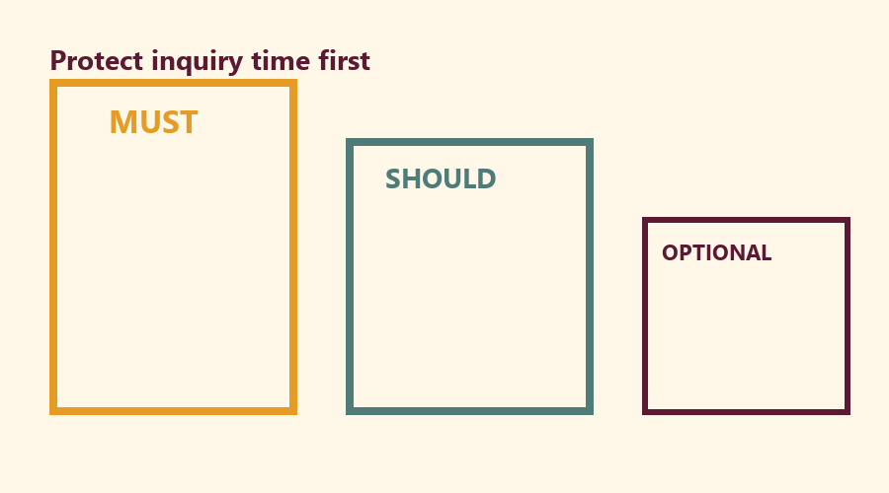
Our family Must slot:
________________________________________________________________
Mercy note (not panic):
________________________________________________________________

O06 — Exit Ticket
Before reunification.
Memory phrase:
________________________________________________________________
One protected-time act:
________________________________________________________________
Project sentence — What deserves protected family time?
________________________________________________________________
RIGHTS NOTE | KUTUMBA-original framing; cited third-party material retains its own rights. Human/temple review remains EXTERNAL_OPEN.

