KUTUMBA

C1-W4 — Younger Teacher Pack
  - K–2 run sheet and activities
C1-W4 • Why Human Life Is Rare and Valuable
V13 • Families Growing in Krishna Consciousness
Program Director: Swapnil Patil
Internal founding-cohort teaching material — human/temple review EXTERNAL_OPEN
KUTUMBA | Families Growing in Krishna Consciousness

Locked Saturday Schedule
Time | Block
1:50–2:00 | Arrival
2:00–2:10 | Opening mantras + welcome
2:10–2:30 | All-family launch/orientation
2:30–3:10 | Parallel tracks
3:10–3:30 | Reunification + bhakti laboratory
3:30–3:40 | Snack + water
3:40–3:55 | Saṅkalpa + project + home practice
3:55–4:00 | Close

TIME CUE | Track handoff is at 2:30; all groups reunite at 3:10.

Primary verse: ŚB 11.9.29
Source URL: https://vedabase.io/en/library/sb/11/9/29/

Younger Teacher Run Sheet
Canonical source: 11-weekly-program-library/first-six-months/c1-w4-why-human-life-is-rare-and-valuable/teacher/YOUNGER-TEACHER-GUIDE-V13.md • SHA-256: e6ff5b635e02cfb0374849f2f8bbe1fd4f9d8308737ea06b6afd4c0ba9ddc8cd
Week ID: C1-W4 · Date: 2026-10-03 · Entry: V13-WEEK-START-HERE.md\n\nWeek: Why Human Life Is Rare and Valuable Primary: ŚB 11.9.29 — https://vedabase.io/en/library/sb/11/9/29/ Session length: 40 minutes (parallel track ~2:30–3:10) Parents: Remain onsite; reunite at 3:10 Status: Internal founding-cohort teaching material — human/temple review EXTERNAL_OPEN

Objective
Children experience human life as a rare chance to ask who we are and serve Kṛṣṇa — with opportunity language, not fear. They make a Must / Optional ticket card and protect one tiny practice slot.

Exact memory phrase
Human life is a rare chance to ask who I am and serve Kṛṣṇa.

Teacher background (2 minutes to review)
- KUTUMBA teaching meaning (adult wording): After many births one obtains the rare human form — temporary yet able to give the highest purpose. A sober person should quickly endeavor for the ultimate good while this body lasts.
- Child-facing paraphrase: Getting a human life is like a special ticket — meant to be used for asking “Who am I?” and serving Kṛṣṇa. We speak of chance and kindness, never scary death pressure.
- Block misconceptions (child words):
- “Scare kids so they chant.”
- “Screens always come first.”
- “Busy means successful.”
- Do not: invent Nārada–Mṛgāri dialogue; show gore; cite Mṛgāri from SB 6.x or SB 4.8 (source is CC Madhya 24.229–282 only); mock other life forms.

Materials
- Paper “rare ticket” props (one demo + one per child later)
- Must jar / Optional jar labels (two small boxes or jars)
- Card stock for Must-ticket cards
- Soft toss object; crayons; line-art if available
- Picture cards: screen-first vs practice-first (gentle, not shaming)

Room setup
Circle; jars visible; open space for Ticket Walk game.

Minute-by-minute executable plan

0–5 min — Opening and recall
1. Welcome; feet on floor.
2. Hold up rare ticket: “Hard to get — meant to be used, not forgotten in a drawer.”
3. Echo memory phrase three times.
4. Ask: “What is one special thing humans can do with words?” (ask questions / say Kṛṣṇa’s names — accept short answers)

5–13 min — Story script (paraphrase only; ~8 minutes)
Say exactly this spine (do not invent deity dialogue):
Śrīmad-Bhāgavatam teaches that after many births, the human form is rare. It does not last forever, but it can help us reach the highest purpose. A sober person uses this chance carefully for the ultimate good. Think of a rare ticket to something wonderful. You would not throw it away. You would use it wisely — without panic, without shouting at friends. In Caitanya-caritāmṛta Madhya chapter 24, Nārada meets a hunter named Mṛgāri. With mercy and teaching, the hunter’s life turns toward care and devotion — even careful steps so tiny creatures are not harmed. We tell this gently, without scary details. The source is Madhya 24 — not other books. At home we protect a little time to ask who we are and serve Kṛṣṇa. Screens can wait for Optional. We never scare children with death talk to make them practice.
Story boundaries: ŚB 11.9.29 + CC Madhya 24.229–282 paraphrase only. No gore. Opportunity language only. BG 2.40 may be whispered as “a little sincere practice is not lost” if a child fears missing out.

13–16 min — Three wonder questions
1. Is human life a rare chance or a scare story? (Chance)
2. What belongs in the Must jar first — practice or endless screens? (Practice / asking who I am)
3. How did mercy help Mṛgāri’s life change — fear or kind teaching? (Kind teaching / mercy)

16–24 min — Movement game: Ticket Walk (steps)
1. Children walk in a circle holding imaginary tickets.
2. Teacher calls Must! — freeze; whisper memory phrase; take one step toward Must jar.
3. Teacher calls Optional! — soft sit; count to three; then stand (Optional waits).
4. Teacher calls Kind chance! — hand on heart; smile (no fear faces).
5. Three rounds. Round three: point to practice-first card, not screen-first.
6. End seated; echo phrase once.

24–32 min — Craft: Must-ticket card (steps)
1. Give ticket-shaped card stock.
2. Front: decorate “RARE TICKET” / draw a small path or lamp.
3. Inside: write memory phrase (helper may write) or short: Rare chance — ask & serve.
4. Back: two boxes — Must (draw hearing / memory phrase) and Optional (draw a toy/screen).
5. Child places a sticker or star in Must.
6. Practice: “Must first, then Optional.”
Full steps in activities/v13-younger/.

32–35 min — Printable / coloring task
Line-art if time; else keep ticket.

35–38 min — Behavior redirects and quiet reset
- Fear talk from peer — “We use chance words, not scare words.”
- Running — “Ticket walk.”
- Snatching — “Kind hands.”
- Quiet reset — calm corner with ticket; rejoin on Must.

38–40 min — Cleanup and parent handoff
Memory: “Human life is a rare chance to ask who I am and serve Kṛṣṇa.” Home cue: one Must slot before Optional screens. No death scare. Mṛgāri source if asked: CC Madhya 24.

Behavior redirects (quick reference)
Signal | Teacher line | Child action
Scare language | “Chance words only.” | Soft rewrite
Screen demand | “Must first.” | Point to Must
Running | “Ticket walk.” | Walk
Shutdown | “Quiet reset okay.” | Calm corner 60 sec

Backup low-prep
Soft toss: catch → say “chance,” “ask,” “serve,” or “Must.” Three phrase echoes. Optional: sort picture cards into Must vs Optional jars.

What success looks like
- Child can say rare chance (not scare).
- Child can echo memory phrase.
- Child can point Must before Optional.

Boundaries
- Snack/water at 3:30; no weekly meal.
- Mṛgāri = CC Madhya 24 only.
- No species contempt; no panic harvest language.

V13 printable wiring
Code | Activity | Printable folder
Y01–Y05 | Time-gift jar craft (+ supporting crafts/sorts) | `activities/v13-younger/`

Use Word builders in scripts/v13/printables/C1-W4.py (YOUNGER_BUILDERS). Visuals: visuals/v13/. Memory phrase: Human life is a rare chance to ask who I am and serve Kṛṣṇa.

Child House Rules
Canonical source: launch/CHILD-HOUSE-RULES.md • SHA-256: 6a525f3dd1da740db86e246622696c7b08e28c1f1475227567d639a5bd54ce47
Parents remain onsite. Facilitators guide the session. Host property rules also apply.

Shared rules (all ages)
1. Keep your body safe — feet on the floor; hands gentle.
2. Use respectful speech — no teasing, yelling, or mean labels.
3. Follow the facilitator safety cue immediately (pause / freeze / come here).
4. No jumping on furniture.
5. No indoor throwing.
6. No writing on walls, books, or furniture that are not activity materials.
7. Ask before entering private rooms.
8. Respect belongings — ask before touching what is not yours.
9. Devices away unless the lesson specifically needs them.
10. Snack only in the allowed area; water anytime with permission.
11. Help clean up before leaving.

Correction ladder (no public shame)
1. Calm reminder
2. Redirect / offer a choice
3. Brief quiet reset in a visible space
4. Parent involvement
5. Sit out a specific activity
6. Private parent/program conversation for repeated patterns
Never: public shame, yelling, sarcasm, corporal punishment, forced chanting, or comparing children.

Younger (K–2) emphasis
- Soft voices indoors
- Stay with the group
- Hands to yourself
- Ask before leaving the room

Older (Grades 4–5) emphasis
- Model respectful speech for younger children
- Devices fully away unless assigned
- Help clean-up leadership
- Honest questions welcome; speculation wait for source check
Printable versions: W1 launch-pack CHILD-RULES-YOUNGER.md and CHILD-RULES-OLDER.md.

Y01 — Time-Gift Jar
Place MUST tokens before OPTIONAL.
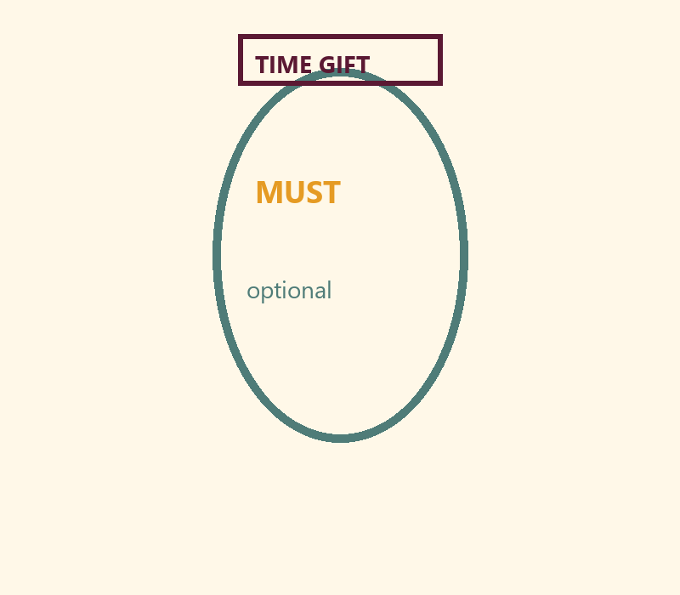
CARD 1  MUST: Story / prayer | CARD 2  MUST: Help tidy
CARD 3  MUST: Kind words | CARD 4  OPTIONAL: Extra screens
CARD 5  OPTIONAL: More toys later | CARD 6  OPTIONAL: Extra snacks

Memory phrase
Human life is a rare chance to ask who I am and serve Kṛṣṇa.
Cut on the dashed borders. Keep each card intact.

Y02 — Must / Optional Sort
Protect inquiry and kindness time.
CARD 1  Picture: family prayer | CARD 2  Picture: endless scrolling
CARD 3  Picture: helping sibling | CARD 4  Picture: delayed chore forever
CARD 5  Picture: short outdoor play | CARD 6  Picture: all-night screens
TEACHER NOTE | No death scare. Invitation language only.

Cut on the dashed borders. Keep each card intact.

Y03 — Rare Ticket Craft
Ask who I am + serve.
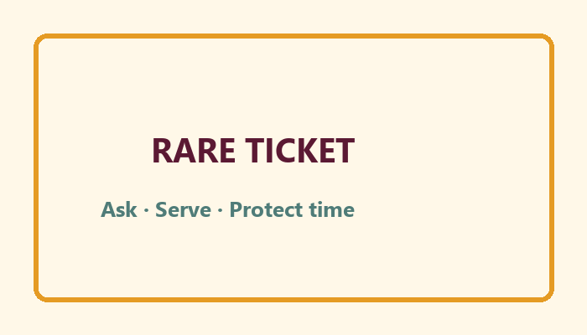
I will protect this time gift:
________________________________________________________________
________________________________________________________________

Memory phrase
Human life is a rare chance to ask who I am and serve Kṛṣṇa.

Y04 — Kind Time-Speech Cards
INVITATION vs FEAR.
CARD 1  INVITE: Let's protect our story time. | CARD 2  INVITE: Five minutes of holy name counts.
CARD 3  INVITE: Human life is a chance to ask and serve. | CARD 4  FEAR: Do this or something terrible.
CARD 5  FEAR: Death is coming — panic! | CARD 6  FEAR: You're wasting life forever.
Cut on the dashed borders. Keep each card intact.

Y05 — Memory Phrase Mat
Must-first landing.


Memory phrase
Human life is a rare chance to ask who I am and serve Kṛṣṇa.
RIGHTS NOTE | KUTUMBA-original framing; cited third-party material retains its own rights. Human/temple review remains EXTERNAL_OPEN.

