KUTUMBA

C1-W5 — Older Teacher Pack
  - Grades 4–5 run sheet and activities
C1-W5 • The Temporary World and the Search for Permanent Happiness
V13 • Families Growing in Krishna Consciousness
Program Director: Swapnil Patil
Internal founding-cohort teaching material — human/temple review EXTERNAL_OPEN
KUTUMBA | Families Growing in Krishna Consciousness

Locked Saturday Schedule
Time | Block
1:50–2:00 | Arrival
2:00–2:10 | Opening mantras + welcome
2:10–2:30 | All-family launch/orientation
2:30–3:10 | Parallel tracks
3:10–3:30 | Reunification + bhakti laboratory
3:30–3:40 | Snack + water
3:40–3:55 | Saṅkalpa + project + home practice
3:55–4:00 | Close

TIME CUE | Track handoff is at 2:30; all groups reunite at 3:10.

Primary verse: BG 8.15
Source URL: https://vedabase.io/en/library/bg/8/15/

Older Teacher Run Sheet
Canonical source: 11-weekly-program-library/first-six-months/c1-w5-the-temporary-world-and-the-search-for-permanent-happiness/teacher/OLDER-TEACHER-GUIDE-V13.md • SHA-256: e2536473a28ffbd2f25779d3a23ccef15fea944ff124315acc957826132207e1
Week ID: C1-W5 · Date: 2026-10-10 · Entry: V13-WEEK-START-HERE.md\n\nWeek: The Temporary World and the Search for Permanent Happiness Primary: BG 8.15 — https://vedabase.io/en/library/bg/8/15/ Session length: ~40 minutes (parallel track ~2:30–3:10) Parents: Remain onsite; reunite at 3:10 Status: Internal founding-cohort teaching material — human/temple review EXTERNAL_OPEN

Objective
Students observe BG 8.15, distinguish temporary contact pleasure from lasting shelter in the Lord, refuse “affection is worthless,” complete a Temporary→Gratitude→Lasting diagram, and answer: How can enjoyment become gratitude and service?

Exact memory phrase
Temporary joys can be used with gratitude; lasting fulfillment is in Kṛṣṇa.
Short echo: Enjoy with thanks; shelter in Kṛṣṇa.

Teacher background
- KUTUMBA teaching meaning: Having attained the Lord, great souls do not return again to this temporary world of misery; they have reached the highest perfection. (KUTUMBA teaching meaning — not BBT translation.)
- Supporting frames: BG 5.22 — sense-contact pleasures are temporary (support only); BG 9.27 — ordinary acts can turn toward offering (support only). Neither replaces BG 8.15 as locked primary.
- Block: “Material things and family affection are worthless”; “the next purchase will finally satisfy”; “science proves detachment / proves Kṛṣṇa.”
- Tone lock: “Temporary world of misery” does not authorize shaming birthdays, toys, or hugs.

Materials
- Printed verse strip: Devanāgarī + IAST + KUTUMBA teaching meaning
- Worksheet copies from activities/v13-older/
- Scenario cards (purchase chase; shaming toy joy; work defeats prayer — fictional)
- Temporary → Gratitude/offering → Lasting shelter diagram sheet
- Pencils; timer; activities/v13-older/ (keys in teacher-only pages) (teacher only)
- Project contribution half-sheets
- G / S fork cards (Gratitude-path / Seize-or-Shame)

Minute-by-minute plan

0–5 min — Settle and hook
1. Welcome; feet on floor.
2. Hook: “Can something be enjoyable and still not be final shelter?” Collect two answers.
3. Essential question: How can enjoyment become gratitude and service?

5–14 min — Primary text observation (BG 8.15)
1. Display verse; read IAST aloud together once; Devanāgarī slowly or authorized audio.
2. Students underline: attained the Lord / temporary world of misery / highest perfection.
3. Observation prompts (write short answers):
- What is lasting according to the teaching meaning?
- What must we not conclude about hugs, toys, or lawful fun?
- Confirm locked primary: BG 8.15 (not BG 5.22 / 9.27).
1. Bridges:
- BG 5.22 — temporary nature of sense-contact pleasure (support).
- BG 9.27 — offering mood for ordinary acts (support).
1. Paraphrase only; Dhruva mention only with “no identical-result promise.”

14–22 min — Worksheet questions
Students complete Section A:
1. Restate teaching meaning in one sentence.
2. Mark locked primary as BG 8.15.
3. List two temporary joys receivable with gratitude.
4. Why “affection is worthless” is not this week’s teaching.
5. Write a gratitude pause before a non-essential purchase.
6. What gratitude research can support — and cannot prove.
Circulate with answer key for directions, not ranks.

22–28 min — Scenario cards (small groups)
Card A — Weekend purchase chase for a happiness spike. Mistaken: The next thing will finally satisfy. Card B — Parent shames a child’s joy in a toy. Mistaken: Material joy is sinful; affection worthless. Card C — Work always defeats prayer time. Mistaken: Career alone is permanent security.
Each group writes mistaken conclusion / principle / compassionate response / better action / what not to say. Share 60 seconds.

28–33 min — Puzzle / game: Gratitude Fork
1. Teacher reads short forks (two endings).
2. Teams hold G (gratitude/service path) or S (seize forever / shame joy).
3. Three rounds; explain one G using BG 8.15 or offering language from BG 9.27.
4. Keep energy respectful; no mocking wrong holds.
Sample forks:
- Grab next buy angrily vs pause and thank
- Force throw-away to “prove detachment” vs enjoy + thanks
- Cancel all livelihood vs protect one cue without quitting-job theater

33–37 min — Diagram task
Fill:
Temporary joy → Gratitude / offering → Lasting shelter in Kṛṣṇa (BG 8.15)
Circle lasting shelter; write short echo inside. Low-risk examples only (favorite snack, birthday candle) — not forced spending disclosures.

37–40 min — Project contribution + reflection + handoff
1. Project: “Before _______________ we will say Thank You, Kṛṣṇa / practice offering mood.”
2. Reflection: How does BG 8.15 challenge both endless acquisition and contempt for affection?
3. Cleanup; reunification sheets ready.
4. Parent handoff: gratitude pause; do not shame toys; gratitude studies ≠ ontology proof.

Extension (if group finishes early)
One sentence on Dhruva (ŚB 4.8–4.9): mixed motive can turn toward the Lord — do not promise identical results to children.

Answer key pointer
Teacher-facing expected answers: activities/v13-older/ (keys in teacher-only pages). Do not distribute during first attempt.

Behavior and privacy
- Redirect shame-as-renunciation: “Joy with thanks is allowed.”
- No ranking families by purchases or “detachment.”
- Snack/water on main schedule only.

V13 printable wiring
Code | Activity | Printable folder
O01–O06 | Happiness-duration lab (+ scenarios/exit) | `activities/v13-older/`

Use Word builders in scripts/v13/printables/C1-W5.py (OLDER_BUILDERS). Teacher-only keys stay behind TEACHER-ONLY divider pages. Memory phrase: Temporary joys can be used with gratitude; lasting fulfillment is in Kṛṣṇa.

O01 — BG 8.15 Observation
Temporary world vs lasting shelter.
ŚĀSTRA | BG 8.15 — https://vedabase.io/en/library/bg/8/15/

DO NOT SPECULATE | No depression/mental-health claims. No shame of ordinary enjoyment.

What is temporary according to tonight's teaching?
________________________________________________________________
What do we refuse to shame?
________________________________________________________________
How can enjoyment become gratitude and service?
________________________________________________________________
Paraphrase BG 8.15 teaching meaning in one sentence.
________________________________________________________________

O02 — Happiness-Duration Lab
Brief / medium / lasting-direction.
Experience | Duration feel | Gratitude possible? | Can it be final shelter?
New gadget unboxing
Family meal together
Holy name / prayer
Winning an argument
Quiet service help

One sentence: temporary tools vs lasting shelter:
________________________________________________________________
________________________________________________________________

O03 — Statement Sort
ALIGNED / SHAMING / MIXED.
CARD 1  Temporary joys can be used with gratitude. | CARD 2  Family affection is worthless.
CARD 3  Ask temporary things to give permanent fulfillment. | CARD 4  Offer ordinary acts to Kṛṣṇa (BG 9.27 support).
CARD 5  Sense-contact pleasures are temporary (BG 5.22 support). | CARD 6  If you enjoy a birthday you failed spiritually.
Cut on the dashed borders. Keep each card intact.

TEACHER-ONLY

O03 Key
Item | Best match / guidance
1 | ALIGNED
2 | SHAMING
3 | MISTAKEN shelter
4 | ALIGNED
5 | ALIGNED support
6 | SHAMING

O04 — Comfort vs Meaning Scenarios
Seven fields.
CARD 1  A: Purchase chase never ends | CARD 2  B: Parent shames child's toy
CARD 3
C: Work forever defeats prayer cue
Card A notes
________________________________________________________________
________________________________________________________________
Card B notes
________________________________________________________________
________________________________________________________________
Card C notes
________________________________________________________________
________________________________________________________________

TEACHER-ONLY
Gratitude pause; no depression claims; protect one cue.

O05 — Temporary vs Lasting Diagram
Label both sides; keep enjoyment without contempt.
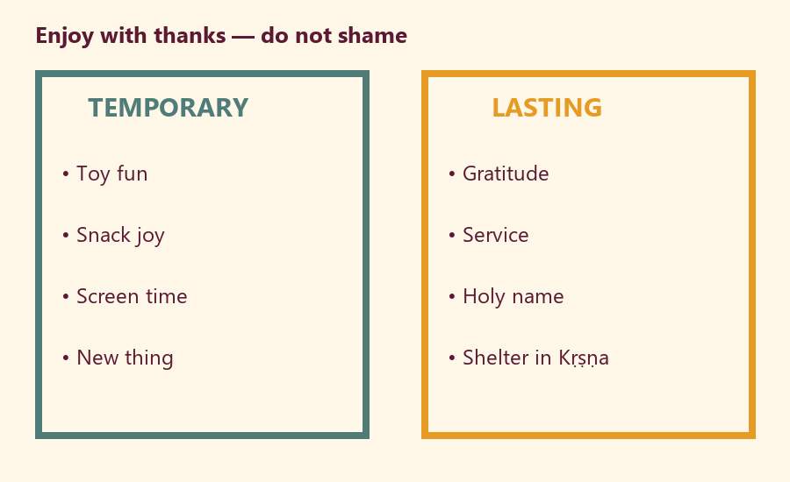
Offering line I will try:
________________________________________________________________
Joy I will thank without shaming:
________________________________________________________________

O06 — Exit Ticket
Before reunification.
Memory phrase:
________________________________________________________________
One gratitude act:
________________________________________________________________
Project sentence — How can enjoyment become gratitude and service?
________________________________________________________________
RIGHTS NOTE | KUTUMBA-original framing; cited third-party material retains its own rights. Human/temple review remains EXTERNAL_OPEN.

