KUTUMBA

C1-W5 — Younger Teacher Pack
  - K–2 run sheet and activities
C1-W5 • The Temporary World and the Search for Permanent Happiness
V13 • Families Growing in Krishna Consciousness
Program Director: Swapnil Patil
Internal founding-cohort teaching material — human/temple review EXTERNAL_OPEN
KUTUMBA | Families Growing in Krishna Consciousness

Locked Saturday Schedule
Time | Block
1:50–2:00 | Arrival
2:00–2:10 | Opening mantras + welcome
2:10–2:30 | All-family launch/orientation
2:30–3:10 | Parallel tracks
3:10–3:30 | Reunification + bhakti laboratory
3:30–3:40 | Snack + water
3:40–3:55 | Saṅkalpa + project + home practice
3:55–4:00 | Close

TIME CUE | Track handoff is at 2:30; all groups reunite at 3:10.

Primary verse: BG 8.15
Source URL: https://vedabase.io/en/library/bg/8/15/

Younger Teacher Run Sheet
Canonical source: 11-weekly-program-library/first-six-months/c1-w5-the-temporary-world-and-the-search-for-permanent-happiness/teacher/YOUNGER-TEACHER-GUIDE-V13.md • SHA-256: 8f653d8ce37666b724253ef696315151f5a640628fb4889caa25a545a251347b
Week ID: C1-W5 · Date: 2026-10-10 · Entry: V13-WEEK-START-HERE.md\n\nWeek: The Temporary World and the Search for Permanent Happiness Primary: BG 8.15 — https://vedabase.io/en/library/bg/8/15/ Session length: 40 minutes (parallel track ~2:30–3:10) Parents: Remain onsite; reunite at 3:10 Status: Internal founding-cohort teaching material — human/temple review EXTERNAL_OPEN

Objective
Children experience that temporary joys can be received with gratitude, while lasting fulfillment is in Kṛṣṇa. They make a sparkler/lamp thank-you card — without shaming toys or hugs.

Exact memory phrase
Temporary joys can be used with gratitude; lasting fulfillment is in Kṛṣṇa.

Teacher background (2 minutes to review)
- KUTUMBA teaching meaning (adult wording): Having attained the Lord, great souls do not return again to this temporary world of misery; they have reached the highest perfection.
- Child-facing paraphrase: Toys and parties are like sparklers — bright and short. Kṛṣṇa is like a steady lamp. We say thank you for sparklers; we look for lasting light in Kṛṣṇa. Hugs and fun are not “bad.”
- Block misconceptions (child words):
- “Toys and family love are worthless.”
- “The next buy will finally make me happy forever.”
- “Science proves detachment / proves Kṛṣṇa.”
- Do not: invent deity dialogue; shame a child’s joy; promise identical Dhruva results; treat BG 5.22 as the locked primary (support only).

Materials
- Sparkler picture + lamp picture (safe drawings — no real sparklers indoors)
- Small offering-plate prop or paper plate
- Card stock for Thank-You / Lamp cards
- Crayons; soft toss object; line-art if available
- Calm-corner chair

Room setup
Circle; sparkler vs lamp cards visible; space for Sparkle-and-Still movement.

Minute-by-minute executable plan

0–5 min — Opening and recall
1. Welcome; feet on floor.
2. Show sparkler card then lamp card: “Brief flash / lasting light.”
3. Echo memory phrase twice (two halves): Temporary joys with gratitude; / lasting fulfillment in Kṛṣṇa.
4. Ask: “What is one fun thing you enjoyed this week?” Affirm; add “Thank You, Kṛṣṇa” together once.

5–13 min — Story script (paraphrase only; ~8 minutes)
Say exactly this spine (do not invent deity dialogue):
Kṛṣṇa teaches that great souls who attain the Lord do not return again to this temporary world of misery — they reach the highest perfection. “Temporary world of misery” does not mean birthdays are bad or parents’ hugs are worthless. It means temporary things cannot be our final forever home. A sparkler is fun — then it fades. A lamp keeps shining. We can enjoy a sparkler and still remember the lamp. Sometimes people think the next toy will finally finish wanting. Wanting can keep growing — like drinking salty water in a story picture (not a doctor claim). Better: enjoy, say thank you, and remember Kṛṣṇa. Dhruva’s story shows mixed wishes can turn toward the Lord — we do not promise the same results to every child. Tonight we practice: gratitude for temporary joys; lasting fulfillment in Kṛṣṇa.
Story boundaries: BG 8.15 primary; BG 5.22 / 9.27 support only; Dhruva paraphrase without result guarantees. No shame. No invented quotes.

13–16 min — Three wonder questions
1. Are hugs and toys worthless? (No — receive with thanks)
2. Can a sparkler be our forever home? (No)
3. Whom do we remember for lasting fulfillment? (Kṛṣṇa)

16–24 min — Movement game: Sparkle and Still (steps)
1. Children stand in open space.
2. Teacher calls Sparkle! — gentle finger wiggles for three seconds (temporary joy).
3. Teacher calls Thank You! — hands together; whisper “Thank You, Kṛṣṇa.”
4. Teacher calls Still lamp! — freeze tall; whisper second half of memory phrase.
5. Three rounds. Round three: show two endings — (A) grab next toy with angry want; (B) enjoy + thanks. Point to B on Still lamp.
6. End seated; full phrase once.

24–32 min — Craft: Thank-You / Lamp card (steps)
1. Fold card stock.
2. Outside left: draw a sparkler or favorite toy; label Thanks.
3. Outside right: draw a simple lamp; label Kṛṣṇa.
4. Inside: write memory phrase (helper may write) or short: Thanks for sparklers; lamp is Kṛṣṇa.
5. Back: child draws one temporary joy + one offering/thanks moment (plate, prayer hands).
6. Practice: touch Thanks → Lamp while saying the phrase.
Full steps in activities/v13-younger/.

32–35 min — Printable / coloring task
Line-art if time; else keep card.

35–38 min — Behavior redirects and quiet reset
- Toy shame from peer — “Joy with thanks is okay.”
- Grabby want — “Sparkle, then Thank You.”
- Running — “Still lamp bodies.”
- Quiet reset — calm corner with lamp card.

38–40 min — Cleanup and parent handoff
Memory: “Temporary joys can be used with gratitude; lasting fulfillment is in Kṛṣṇa.” Home cue: before one fun thing, say “Thank You, Kṛṣṇa.” Do not shame toys. Gratitude research ≠ proof of Kṛṣṇa.

Behavior redirects (quick reference)
Signal | Teacher line | Child action
Shaming joy | “Thanks is allowed.” | Soft rewrite
Grabby spiral | “Sparkle → Thank You.” | Pause + thanks
Running | “Still lamp.” | Freeze
Shutdown | “Quiet reset okay.” | Calm corner 60 sec

Backup low-prep
Soft toss: catch → say “thanks,” “lamp,” or “Kṛṣṇa.” Three phrase echoes. Optional: pass paper plate; each child “offers” a word of thanks.

What success looks like
- Child can show Thanks vs Lamp.
- Child can echo memory phrase (or halves).
- Child does not treat affection as sinful.

Boundaries
- Snack/water at 3:30; no weekly meal.
- Primary locked: BG 8.15 (not BG 5.22).
- No ranking; no forced confession of purchase habits.

V13 printable wiring
Code | Activity | Printable folder
Y01–Y05 | Temporary / lasting sort (+ supporting crafts/sorts) | `activities/v13-younger/`

Use Word builders in scripts/v13/printables/C1-W5.py (YOUNGER_BUILDERS). Visuals: visuals/v13/. Memory phrase: Temporary joys can be used with gratitude; lasting fulfillment is in Kṛṣṇa.

Child House Rules
Canonical source: launch/CHILD-HOUSE-RULES.md • SHA-256: 6a525f3dd1da740db86e246622696c7b08e28c1f1475227567d639a5bd54ce47
Parents remain onsite. Facilitators guide the session. Host property rules also apply.

Shared rules (all ages)
1. Keep your body safe — feet on the floor; hands gentle.
2. Use respectful speech — no teasing, yelling, or mean labels.
3. Follow the facilitator safety cue immediately (pause / freeze / come here).
4. No jumping on furniture.
5. No indoor throwing.
6. No writing on walls, books, or furniture that are not activity materials.
7. Ask before entering private rooms.
8. Respect belongings — ask before touching what is not yours.
9. Devices away unless the lesson specifically needs them.
10. Snack only in the allowed area; water anytime with permission.
11. Help clean up before leaving.

Correction ladder (no public shame)
1. Calm reminder
2. Redirect / offer a choice
3. Brief quiet reset in a visible space
4. Parent involvement
5. Sit out a specific activity
6. Private parent/program conversation for repeated patterns
Never: public shame, yelling, sarcasm, corporal punishment, forced chanting, or comparing children.

Younger (K–2) emphasis
- Soft voices indoors
- Stay with the group
- Hands to yourself
- Ask before leaving the room

Older (Grades 4–5) emphasis
- Model respectful speech for younger children
- Devices fully away unless assigned
- Help clean-up leadership
- Honest questions welcome; speculation wait for source check
Printable versions: W1 launch-pack CHILD-RULES-YOUNGER.md and CHILD-RULES-OLDER.md.

Y01 — Temporary / Lasting Sort
Enjoy with thanks — do not shame.
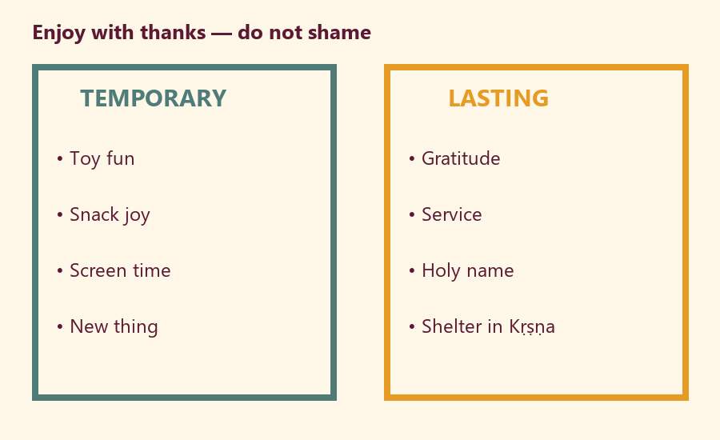
CARD 1  TEMP: New toy fun | CARD 2  TEMP: Snack joy
CARD 3  TEMP: Screen episode | CARD 4  LASTING: Thank You Kṛṣṇa
CARD 5  LASTING: Help someone | CARD 6  LASTING: Holy name / prayer

Memory phrase
Temporary joys can be used with gratitude; lasting fulfillment is in Kṛṣṇa.
Cut on the dashed borders. Keep each card intact.

Y02 — Sparkler and Lamp Match
Enjoy sparkler; remember lamp.
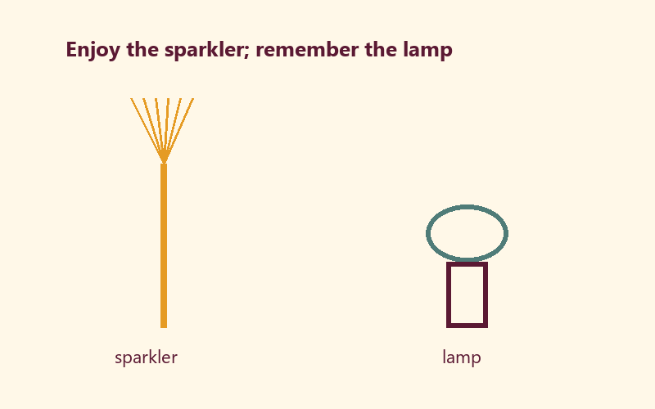
TEACHER NOTE | Toys are not worthless. Temporary joys need gratitude.

Cut on the dashed borders. Keep each card intact.

Y03 — Gratitude Offering Craft
Draw a joy + Thank You, Kṛṣṇa.
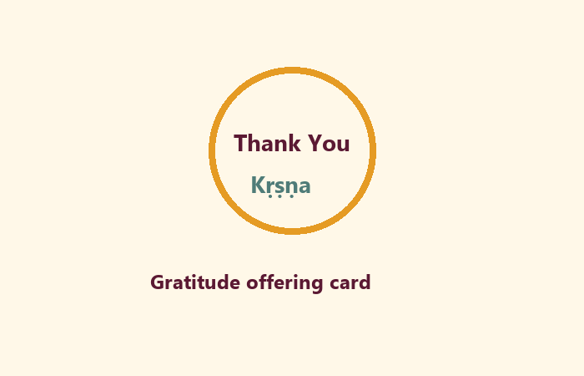
Temporary joy I enjoyed:
________________________________________________________________
Thank You line:
________________________________________________________________

Memory phrase
Temporary joys can be used with gratitude; lasting fulfillment is in Kṛṣṇa.

Y04 — Kind Enjoyment Speech
GRATITUDE vs SHAME.
CARD 1  GRATITUDE: Thank you for this fun. | CARD 2  GRATITUDE: Let's offer a short prayer after play.
CARD 3  GRATITUDE: Toys can be enjoyed with care. | CARD 4  SHAME: Your toy is māyā — you are bad.
CARD 5  SHAME: Real devotees never enjoy anything. | CARD 6  SHAME: Family hugs are worthless.
Cut on the dashed borders. Keep each card intact.

Y05 — Memory Phrase Mat
Landing mat.


Memory phrase
Temporary joys can be used with gratitude; lasting fulfillment is in Kṛṣṇa.
RIGHTS NOTE | KUTUMBA-original framing; cited third-party material retains its own rights. Human/temple review remains EXTERNAL_OPEN.

