KUTUMBA

C1-W6 — Older Teacher Pack
  - Grades 4–5 run sheet and activities
C1-W6 • Integration Night: Who Am I, and How Should Our Family Live?
V13 • Families Growing in Krishna Consciousness
Program Director: Swapnil Patil
Internal founding-cohort teaching material — human/temple review EXTERNAL_OPEN
KUTUMBA | Families Growing in Krishna Consciousness

Locked Saturday Schedule
Time | Block
1:50–2:00 | Arrival
2:00–2:10 | Opening mantras + welcome
2:10–2:30 | All-family launch/orientation
2:30–3:10 | Parallel tracks
3:10–3:30 | Reunification + bhakti laboratory
3:30–3:40 | Snack + water
3:40–3:55 | Saṅkalpa + project + home practice
3:55–4:00 | Close

TIME CUE | Integration planning date 2026-10-17. Use 2:30 / 3:10 cues when parallel tracks run; local tithi remains EXTERNAL_OPEN.

Primary verse: Cycle 1 review (W5 as BG 8.15)
Source URL: https://vedabase.io/en/library/bg/8/15/

Older Teacher Run Sheet
Canonical source: 11-weekly-program-library/first-six-months/c1-w6-integration-night-who-am-i-and-how-should-our-family-live/teacher/OLDER-TEACHER-GUIDE-V13.md • SHA-256: bb63062ac485cdd72c31a234b140d185da4f403efc6c5f4e6a6d349c2809bfb8
Week ID: C1-W6 · Date: 2026-10-17 · Entry: V13-WEEK-START-HERE.md\n\nWeek: Integration Night — Who Am I and How Should Our Family Live? Primary: Cycle 1 review chain — ŚB 1.2.18 · BG 2.13 · BG 2.20 · ŚB 11.9.29 · BG 8.15 Session length: ~40 minutes (parallel track ~2:30–3:10) Parents: Remain onsite; reunite at 3:10 Status: Internal founding-cohort teaching material — human/temple review EXTERNAL_OPEN

Objective
Students retrieve the Cycle 1 chain without ranking, match each week to its locked primary (W5 = BG 8.15), build a coherent identity–purpose–practice map, choose an invitational share format, and answer: Can our family explain and apply what we learned?

Exact memory phrase
We remember who we are and how our family chooses to live.
Short echo: One chain — hear, identity, soul, chance, shelter.

Teacher background
- KUTUMBA teaching meaning: Identity, purpose, and practice must form one coherent family life — reviewing the Cycle 1 chain with W5 as BG 8.15.
- Locked review set:
1. ŚB 1.2.18 — hearing and service steady devotion
2. BG 2.13 — body changes; self continues
3. BG 2.20 — eternal soul (not God Himself)
4. ŚB 11.9.29 — rare human opportunity
5. BG 8.15 — lasting shelter (locked W5 primary)
- Block: Competition/ranking; loudest = wisest; speed to Cycle 2 while confused; wrong Mṛgāri sources (must be CC Madhya 24 if mentioned).
- Rubric lenses (never placement): understanding, application, teamwork, source accuracy.

Materials
- Five review verse strips (references + short teaching cues)
- Worksheet copies from activities/v13-older/
- Scenario cards (contest fear; one child dominates; rush to C2 — fictional)
- Necklace / station-map diagram sheet
- Pencils; timer; activities/v13-older/ (keys in teacher-only pages) (teacher only)
- Project contribution half-sheets
- Match cards: week theme ↔ verse (plus distractors); M24 / WRONG cards

Minute-by-minute plan

0–5 min — Settle and hook
1. Welcome; feet on floor. Say aloud: “Retrieval is mercy, not a quiz show.”
2. Hook: “Is drawing-only or one sentence enough for success tonight?” Affirm yes.
3. Essential question: Can our family explain and apply what we learned?

5–14 min — Primary text observation (review chain)
1. Display five references in order; students copy the chain.
2. Confirm W5 locked primary is BG 8.15 (cross out BG 5.22 / 9.27 if offered as “the” W5 primary).
3. Observation prompts (write short answers):
- Which verse steadies hearing + home practice?
- Which separates body change from continuing self?
- Which blocks “I am God”?
- Which teaches rare opportunity without fear?
- Which names lasting shelter in the Lord?
1. One-sentence synthesis: identity + purpose + practice = coherent family life.
2. Paraphrase only; no new Cycle 2 ontology.

14–22 min — Worksheet questions
Students complete Section A:
1. Fill each week’s locked primary.
2. Confirm W5 = BG 8.15.
3. Name one blocked misconception per week.
4. Write one integrated family living sentence.
Circulate with answer key for directions, not ranks. Missed weeks = refill kindly, not public “behind.”

22–28 min — Scenario cards (small groups)
Card A — Family fears presenting (thinks contest). Mistaken: Presentation equals ranking. Card B — One child dominates every share. Mistaken: Loudest equals wisest. Card C — Parents want Cycle 2 despite W2–W3 confusion. Mistaken: Speed equals progress.
Each group writes mistaken conclusion / principle / compassionate response / better action / what not to say. Share 60 seconds.

28–33 min — Puzzle / game: Chain Match Relay
1. Teams quietly match five themes to five locked primaries.
2. Include two distractor verses to reject.
3. Bonus: if Mṛgāri appears on a card, mark M24 or WRONG.
4. One student explains the necklace in ~20 seconds — no scores announced aloud.

33–37 min — Diagram task
Fill:
Hearing → Body/Self clarity → Soul nature → Rare opportunity → Lasting shelter → Family living practice
Circle Family living practice; write short echo inside. Private family details stay private.

37–40 min — Project contribution + reflection + handoff
1. Project: “Our family can explain Cycle 1 by _______________ and will apply _______________ this week.”
2. Choose share format: one sentence / drawing-only / short team roles.
3. Reflection: Where might ranking or speed pretend to be progress?
4. Parent handoff: invitational share; extend C1 privately if unclear; no public “behind.”

Extension (if group finishes early)
Build a four-lens checklist (understanding / application / teamwork / source accuracy) for their own share — still no placement scores or hallway comparisons.

Answer key pointer
Teacher-facing expected answers: activities/v13-older/ (keys in teacher-only pages). Do not distribute during first attempt.

Behavior and privacy
- Rotate speakers; quieter voices first when needed.
- Drawing-only is full success.
- No ranking; no “behind” labels.
- Snack/water on main schedule only.

V13 printable wiring
Code | Activity | Printable folder
O01–O06 | Misconception clinic (+ scenarios/exit) | `activities/v13-older/`

Use Word builders in scripts/v13/printables/C1-W6.py (OLDER_BUILDERS). Teacher-only keys stay behind TEACHER-ONLY divider pages. Memory phrase: Who am I, and how should our family live?

O01 — Cycle 1 Chain Retrieval
Retrieve W1–W5 — open-notes mercy OK.
Week | Primary | One-sentence meaning
W1 | ŚB 1.2.18
W2 | BG 2.13
W3 | BG 2.20
W4 | ŚB 11.9.29
W5 | BG 8.15

KEY IDEA | No major new doctrine tonight.

O02 — Misconception Clinic
Repair Cycle 1 errors with sources.
CARD 1  Photos prove the soul | CARD 2  I am God
CARD 3  Scare kids with death for sādhana | CARD 4  Family affection is worthless
CARD 5  Rank families by presentation polish | CARD 6  Mṛgāri is in ŚB 6.x
Repair lines (with source pointers):
________________________________________________________________
________________________________________________________________
________________________________________________________________
________________________________________________________________

TEACHER-ONLY

O02 Key
Item | Best match / guidance
1 | Pedagogy ≠ proof — BG 2.13
2 | Fragmental part — BG 15.7 / BG 2.20
3 | Invitation — ŚB 11.9.29
4 | Use with gratitude — BG 8.15
5 | Noncompetitive integration
6 | CC Madhya 24.229–282

O03 — Family Presentation Outline
≤10 minutes · noncompetitive.
Who we are (identity):
________________________________________________________________
________________________________________________________________
How we live (practice):
________________________________________________________________
________________________________________________________________
One source we remember:
________________________________________________________________
________________________________________________________________
One home act:
________________________________________________________________
________________________________________________________________
TIME CUE | Four families × up to 10 minutes.

O04 — Team Coaching Scenarios
Mercy without ranking.
CARD 1  A: Shy family — drawing only | CARD 2  B: Share runs long past 10 min
CARD 3
C: Family missed two weeks
Card A notes
________________________________________________________________
________________________________________________________________
Card B notes
________________________________________________________________
________________________________________________________________
Card C notes
________________________________________________________________
________________________________________________________________

TEACHER-ONLY
Retrieval is mercy; incomplete is welcome; no scoreboard.

O05 — Integration Necklace Map
Five beads + living sentence.
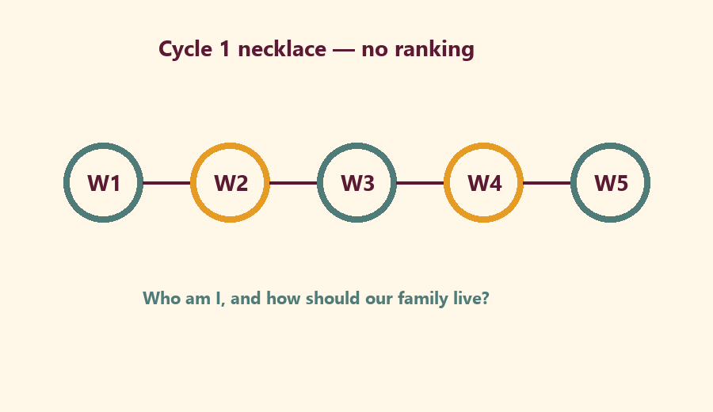
Center living sentence:
________________________________________________________________
________________________________________________________________

O06 — Exit Ticket
Before close.
Memory phrase:
________________________________________________________________
One home living act:
________________________________________________________________
One thanks to another family (no ranking):
________________________________________________________________
RIGHTS NOTE | KUTUMBA-original framing; cited third-party material retains its own rights. Human/temple review remains EXTERNAL_OPEN.

