KUTUMBA

C1-W6 — Younger Teacher Pack
  - K–2 run sheet and activities
C1-W6 • Integration Night: Who Am I, and How Should Our Family Live?
V13 • Families Growing in Krishna Consciousness
Program Director: Swapnil Patil
Internal founding-cohort teaching material — human/temple review EXTERNAL_OPEN
KUTUMBA | Families Growing in Krishna Consciousness

Locked Saturday Schedule
Time | Block
1:50–2:00 | Arrival
2:00–2:10 | Opening mantras + welcome
2:10–2:30 | All-family launch/orientation
2:30–3:10 | Parallel tracks
3:10–3:30 | Reunification + bhakti laboratory
3:30–3:40 | Snack + water
3:40–3:55 | Saṅkalpa + project + home practice
3:55–4:00 | Close

TIME CUE | Integration planning date 2026-10-17. Use 2:30 / 3:10 cues when parallel tracks run; local tithi remains EXTERNAL_OPEN.

Primary verse: Cycle 1 review (W5 as BG 8.15)
Source URL: https://vedabase.io/en/library/bg/8/15/

Younger Teacher Run Sheet
Canonical source: 11-weekly-program-library/first-six-months/c1-w6-integration-night-who-am-i-and-how-should-our-family-live/teacher/YOUNGER-TEACHER-GUIDE-V13.md • SHA-256: 45d633b239fe24e26f7667e452a9ea80280b86de26eb5ced45a1db9c4a5ef4a5
Week ID: C1-W6 · Date: 2026-10-17 · Entry: V13-WEEK-START-HERE.md\n\nWeek: Integration Night — Who Am I and How Should Our Family Live? Primary: Cycle 1 review chain — ŚB 1.2.18 · BG 2.13 · BG 2.20 · ŚB 11.9.29 · BG 8.15 Session length: 40 minutes (parallel track ~2:30–3:10) Parents: Remain onsite; reunite at 3:10 Status: Internal founding-cohort teaching material — human/temple review EXTERNAL_OPEN

Objective
Children retrieve Cycle 1 as one necklace of beads — hearing, body/self, soul who serves, rare chance, lasting lamp — and take home a five-bead family card. Drawing-only shares count as success; no ranking.

Exact memory phrase
We remember who we are and how our family chooses to live.

Teacher background (2 minutes to review)
- KUTUMBA teaching meaning (adult wording): Identity, purpose, and practice must form one coherent family life — reviewing the Cycle 1 chain with W5 locked as BG 8.15.
- Child-facing paraphrase: Five beads on one string: Hear+Practice · Body changes/I continue · Spark who serves · Rare chance · Thanks + Kṛṣṇa’s lamp. Missing a week is okay — we refill kindly, not like a contest.
- Block misconceptions (child words):
- “Tonight is a contest / ranking.”
- “Only loud kids win.”
- “We must rush to Cycle 2 even if confused.”
- Do not: invent new ontology; score families; force verbal shares; cite Mṛgāri from wrong books if W4 bead appears (CC Madhya 24 only).

Materials
- Five large paper beads or circles labeled: Hear · Body/Self · Soul · Chance · Lamp
- Yarn or string for necklace demo
- Card stock for five-bead take-home cards
- Crayons; soft toss object; line-art if available
- “Drawing share” option cards (success without speaking)

Room setup
Five bead stations in a gentle path; circle for opening; aisles clear for Bead Walk.

Minute-by-minute executable plan

0–5 min — Opening and recall
1. Welcome; feet on floor. “Tonight we remember — not a contest.”
2. Show empty string, then add beads one by one as you name weeks lightly.
3. Echo memory phrase three times: We remember who we are / and how our family / chooses to live.
4. Ask: “Is drawing your bead okay?” Yes — celebrate nods.

5–13 min — Story script (paraphrase only; ~8 minutes)
Say exactly this spine (do not invent deity dialogue):
For five weeks our families learned pieces that belong on one string. First bead: Regular hearing and a tiny home practice steady our devotion. Second bead: My body changes; I continue as the conscious self — kind words about bodies. Third bead: I am an eternal soul — a spark who serves Kṛṣṇa, not the whole sun — and I still care for my body. Fourth bead: Human life is a rare chance to ask who I am and serve — chance words, not scare words. Fifth bead: Temporary joys with gratitude; lasting fulfillment in Kṛṣṇa — the lamp. Tonight we put the beads together. If your family missed a bead, we smile and refill. Loud is not wiser. Drawing is success. We remember who we are and how our family chooses to live.
Story boundaries: Review only locked primaries above. No new metaphysics. No ranking. W5 bead = BG 8.15. Mṛgāri only if needed = Madhya 24.

13–16 min — Three wonder questions
1. Are we having a contest tonight? (No)
2. Name one bead you remember. (any week)
3. What is one way our family can live this week? (hear / kind words / serve / Must / thanks)

16–24 min — Movement game: Bead Walk (steps)
1. Place five bead stations in a path.
2. Children walk slowly station to station.
3. At each station, teacher gives a one-word cue; children echo the matching short line:
- Hear → “Hear + Practice”
- Body → “I continue”
- Soul → “Spark who serves”
- Chance → “Rare chance”
- Lamp → “Thanks + lamp”
1. After station five, freeze and say full memory phrase.
2. Two full walks max. Optional: children carry a paper bead and drop it in a “family bowl” (no scores).
3. End seated.

24–32 min — Craft: Five-bead family card (steps)
1. Give horizontal card stock with five circles pre-drawn (or children draw five).
2. Color each bead a different color; helper labels 1–5 with week icons if literacy is limited.
3. Inside or below, write memory phrase (helper may write).
4. Child draws one family living choice in a sixth “live” box (dinner phrase, kind words, thanks).
5. Practice pointing beads 1→5 while whispering cues.
6. Offer drawing-only reunification option: show card instead of speaking.
Full steps in activities/v13-younger/.

32–35 min — Printable / coloring task
Line-art if time; else keep bead card. Drawing-only is complete success.

35–38 min — Behavior redirects and quiet reset
- Contest talk — “No ranking — beads for every family.”
- Dominating share — “Friend’s turn; drawing is success.”
- Running — “Bead walk feet.”
- Quiet reset — calm corner with one bead; rejoin on phrase.

38–40 min — Cleanup and parent handoff
Memory: “We remember who we are and how our family chooses to live.” Home cue: point to one bead nightly and do one living choice. Drawing-only share is success. Do not rush confused families publicly.

Behavior redirects (quick reference)
Signal | Teacher line | Child action
Ranking talk | “No contest.” | Soft rewrite
Dominating | “Friend’s turn.” | Pass turn
Running | “Bead walk.” | Walk
Shutdown | “Drawing is success.” | Show card

Backup low-prep
Soft toss: catch → name one bead word (hear / continue / spark / chance / lamp). Three phrase echoes. Skip stations if energy crashes; use five cards on floor instead.

What success looks like
- Child can point to at least three beads with a cue word.
- Child can echo memory phrase.
- Child feels safe with drawing-only share.

Boundaries
- Snack/water at 3:30; no weekly meal.
- No family ranking; no “behind” labels.
- Review only — no new Cycle 2 ontology.

V13 printable wiring
Code | Activity | Printable folder
Y01–Y05 | Family artifact share (+ supporting crafts/sorts) | `activities/v13-younger/`

Use Word builders in scripts/v13/printables/C1-W6.py (YOUNGER_BUILDERS). Visuals: visuals/v13/. Memory phrase: Who am I, and how should our family live?

Child House Rules
Canonical source: launch/CHILD-HOUSE-RULES.md • SHA-256: 6a525f3dd1da740db86e246622696c7b08e28c1f1475227567d639a5bd54ce47
Parents remain onsite. Facilitators guide the session. Host property rules also apply.

Shared rules (all ages)
1. Keep your body safe — feet on the floor; hands gentle.
2. Use respectful speech — no teasing, yelling, or mean labels.
3. Follow the facilitator safety cue immediately (pause / freeze / come here).
4. No jumping on furniture.
5. No indoor throwing.
6. No writing on walls, books, or furniture that are not activity materials.
7. Ask before entering private rooms.
8. Respect belongings — ask before touching what is not yours.
9. Devices away unless the lesson specifically needs them.
10. Snack only in the allowed area; water anytime with permission.
11. Help clean up before leaving.

Correction ladder (no public shame)
1. Calm reminder
2. Redirect / offer a choice
3. Brief quiet reset in a visible space
4. Parent involvement
5. Sit out a specific activity
6. Private parent/program conversation for repeated patterns
Never: public shame, yelling, sarcasm, corporal punishment, forced chanting, or comparing children.

Younger (K–2) emphasis
- Soft voices indoors
- Stay with the group
- Hands to yourself
- Ask before leaving the room

Older (Grades 4–5) emphasis
- Model respectful speech for younger children
- Devices fully away unless assigned
- Help clean-up leadership
- Honest questions welcome; speculation wait for source check
Printable versions: W1 launch-pack CHILD-RULES-YOUNGER.md and CHILD-RULES-OLDER.md.

Y01 — Cycle Bead Recall
Touch W1–W5 beads — mercy, not quiz.
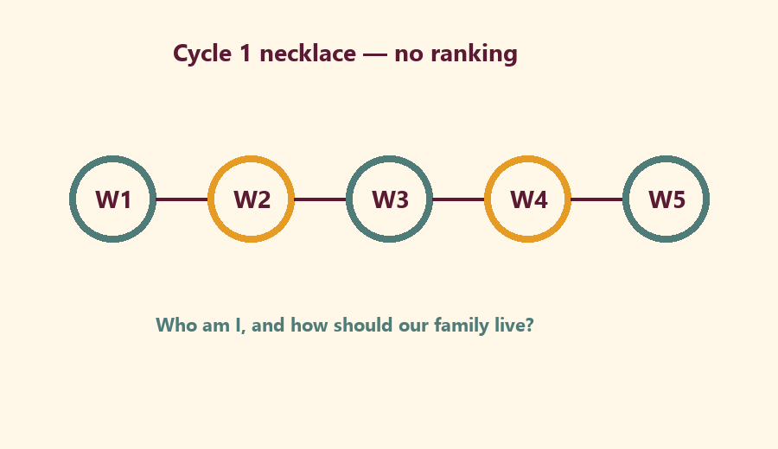
CARD 1  W1 Hear/serve | CARD 2  W2 Body≠only-self
CARD 3  W3 Eternal soul | CARD 4  W4 Rare chance
CARD 5  W5 Lasting shelter | CARD 6  Helper: drawings count

Memory phrase
Who am I, and how should our family live?
Cut on the dashed borders. Keep each card intact.

Y02 — Artifact Share Practice
Show a drawing up to 1 minute.
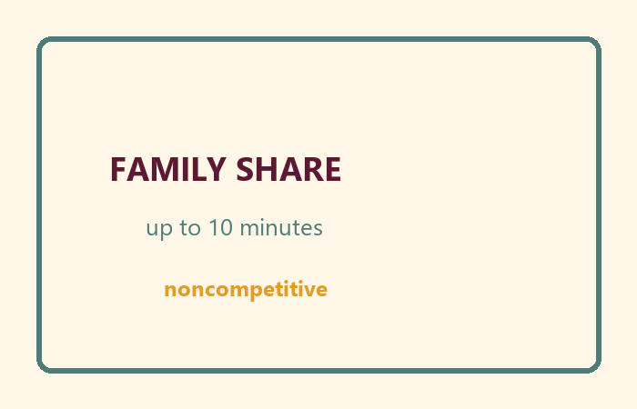
My helper sentence:
________________________________________________________________
________________________________________________________________
TEACHER NOTE | Noncompetitive. Whispered shares count.

Y03 — Family Sentence Craft
Who am I, and how should our family live?
Draw or write our family sentence:
________________________________________________________________
________________________________________________________________
________________________________________________________________
________________________________________________________________

Memory phrase
Who am I, and how should our family live?

Y04 — Kind Listener Cards
KIND LISTEN vs RANKING.
CARD 1  KIND: Eyes on the speaker | CARD 2  KIND: Clap for effort
CARD 3  KIND: Help a shy friend | CARD 4  RANK: Who was best?
CARD 5  RANK: You forgot — fail | CARD 6  RANK: Louder is holier
Cut on the dashed borders. Keep each card intact.

Y05 — Memory Phrase Mat
Integration landing.


Memory phrase
Who am I, and how should our family live?
RIGHTS NOTE | KUTUMBA-original framing; cited third-party material retains its own rights. Human/temple review remains EXTERNAL_OPEN.

