KUTUMBA

C2-U2 — Older Teacher Pack
  - Grades 4–5 run sheet and activities
C2-U2 • Gītā Jayantī Family Utsava
V13 • Families Growing in Krishna Consciousness
Program Director: Swapnil Patil
Internal founding-cohort teaching material — human/temple review EXTERNAL_OPEN
KUTUMBA | Families Growing in Krishna Consciousness

Locked Saturday Schedule
Time | Block
1:50–2:00 | Arrival
2:00–2:10 | Opening mantras + welcome
2:10–2:30 | All-family launch/orientation
2:30–3:10 | Parallel tracks
3:10–3:30 | Reunification + bhakti laboratory
3:30–3:40 | Snack + water
3:40–3:55 | Saṅkalpa + project + home practice
3:55–4:00 | Close

TIME CUE | Utsava planning date 2026-12-19. Use 2:30 / 3:10 cues when parallel tracks run; local tithi remains EXTERNAL_OPEN.

Primary verse: BG 18.65
Source URL: https://vedabase.io/en/library/bg/18/65/

Older Teacher Run Sheet
Canonical source: 11-weekly-program-library/first-six-months/c2-u2-gita-jayanti-family-utsava/teacher/OLDER-TEACHER-GUIDE-V13.md • SHA-256: c81e66f55b37a58a28cf6ecbc13cce6a9e753bd3ac8f9ca1df901b9f5b78eb46
Use with printable stations. Operator completeness pack.

Main Facilitator Guide — C2-U2
Gītā Jayantī Family Utsava · Saturday 2026-12-19 (planning); published example Gītā Jayantī 2026-12-20 Status: INTERNAL · EXTERNAL_OPEN local tithi/human/temple gates Entry: V13-UTSAVA-START-HERE.md

Exact primary
- Reference: BG 18.65
- URL: https://vedabase.io/en/library/bg/18/65/
- Devanāgarī: मन्मना भव मद्भक्तो मद्याजी मां नमस्कुरु । मामेवैष्यसि सत्यं ते प्रतिजाने प्रियोऽसि मे ॥ ६५ ॥
- IAST: man-manā bhava mad-bhakto mad-yājī māṁ namaskuru / mām evaiṣyasi satyaṁ te pratijāne priyo ’si me
- KUTUMBA teaching meaning: Always think of Me, become My devotee, worship Me, and offer homage unto Me; thus you will come to Me. I promise this because you are dear to Me.
- Whole-Gītā frame: https://vedabase.io/en/library/bg/
- Rights: Sanskrit display + KUTUMBA meaning; no full purport.

10–20 minute speaking script
Welcome to our Gītā Jayantī Family Utsava planning Saturday — 2026-12-19.
Calendar honesty: published planning example lists Gītā Jayantī on 2026-12-20. Tonight is a family observance candidate, not a claim that our local exact tithi is settled. Local confirmation remains EXTERNAL_OPEN.
Essential question: How should our family receive Kṛṣṇa’s Gītā instruction without pressure or ranking?
Primary: BG 18.65 — https://vedabase.io/en/library/bg/18/65/
KUTUMBA teaching meaning: “Always think of Me, become My devotee, worship Me, and offer homage unto Me; thus you will come to Me. I promise this because you are dear to Me.”
The Gītā is Kṛṣṇa’s instruction to Arjuna in a moment of confusion about duty. We will not invent battlefield dialogue. We will teach the invitation: remember Kṛṣṇa, live as His devotee, and honor Him in ordinary family life.
Analogy one — map of 18 chapters: a map helps travel; it is not the destination. Limit: children need not memorize all chapter titles tonight.
Analogy two — decision flashlight: the Gītā lights the next faithful step. Limit: not every modern choice has a one-verse slogan; some questions defer to parents/temple.
Analogy three — reading plan like watering a plant: tiny and regular. Limit: no competitive chapter-count contests.
Household case: A parent sets a child “book distribution quota” for Jayantī. Mistaken conclusion: love equals numbers. Principle: no pressure-based distribution goals for children. Action: gratitude for the book + one kind share if natural.
Memory line: **Think of Kṛṣṇa; become Hi

O01 — BG 18.65 Observation

VERSE CARD • BG 18.65

KUTUMBA teaching meaning: Think of Me; become My devotee; worship Me; offer homage.
Source: https://vedabase.io/en/library/bg/18/65/
Rights/status: Sanskrit/Bengali display + KUTUMBA teaching meaning; no full purport

Four invitations I see:
________________________________________________________________
________________________________________________________________
________________________________________________________________
One promise I notice:
________________________________________________________________
________________________________________________________________
________________________________________________________________
One family application:
________________________________________________________________
________________________________________________________________
________________________________________________________________

O02 — 18-Chapter Map Worksheet
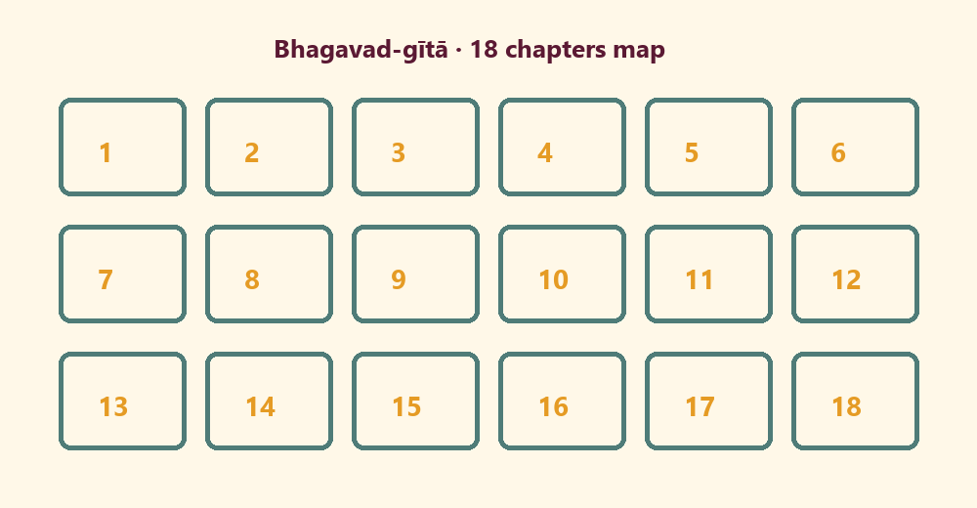
A chapter number I notice:
________________________________________________________________
________________________________________________________________
Why a map helps:
________________________________________________________________
________________________________________________________________
Map limit:
________________________________________________________________
________________________________________________________________

O03 — Theme Sort
CARD 1  man-manā | CARD 2  mad-bhakta
CARD 3  mad-yājī | CARD 4  namaskuru
CARD 5  ranking contest | CARD 6  quota pressure

O04 — Arjuna Decision Case
Paraphrase only — no invented dialogue.
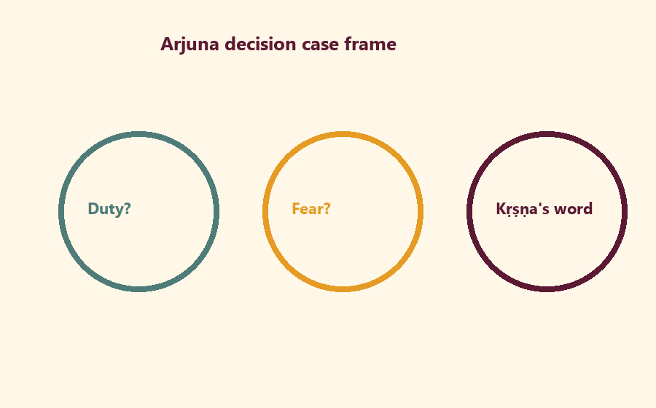
Duty tension:
________________________________________________________________
________________________________________________________________
________________________________________________________________
Fear tension:
________________________________________________________________
________________________________________________________________
________________________________________________________________
Kṛṣṇa’s instruction direction:
________________________________________________________________
________________________________________________________________
________________________________________________________________

O05 — Family Reading Plan
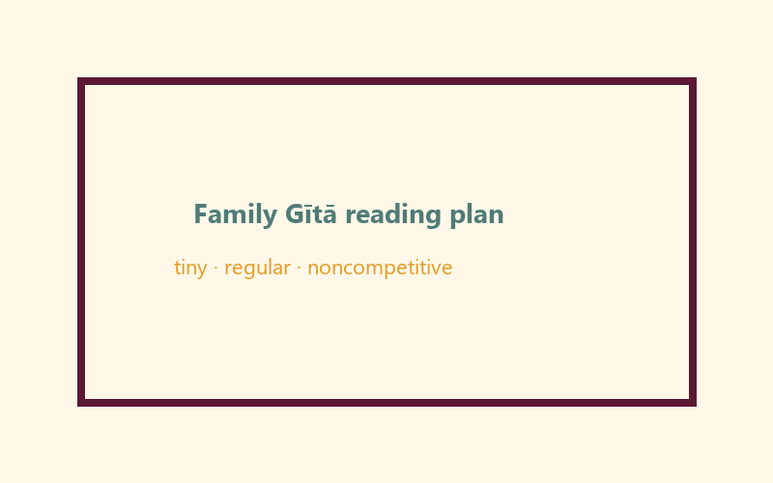
When:
________________________________________________________________
________________________________________________________________
How long (minutes):
________________________________________________________________
________________________________________________________________
Minimum version:
________________________________________________________________
________________________________________________________________

O06 — Exit Ticket
Memory line:
________________________________________________________________
________________________________________________________________
One BG 18.65 word:
________________________________________________________________
________________________________________________________________
Home reading cue:
________________________________________________________________
________________________________________________________________
RIGHTS NOTE | KUTUMBA-original framing; cited third-party material retains its own rights. Human/temple review remains EXTERNAL_OPEN.

