KUTUMBA

C2-U2 — Saturday Print Packet
  - Complete ordered participant and teacher packet
C2-U2 • Gītā Jayantī Family Utsava
V13 • Families Growing in Krishna Consciousness
Program Director: Swapnil Patil
Internal founding-cohort teaching material — human/temple review EXTERNAL_OPEN
KUTUMBA | Families Growing in Krishna Consciousness

Quick Schedule
Time | Block
1:50–2:00 | Arrival
2:00–2:10 | Opening mantras + welcome
2:10–2:30 | All-family launch/orientation
2:30–3:10 | Parallel tracks
3:10–3:30 | Reunification + bhakti laboratory
3:30–3:40 | Snack + water
3:40–3:55 | Saṅkalpa + project + home practice
3:55–4:00 | Close

TIME CUE | Utsava planning date 2026-12-19. Use 2:30 / 3:10 cues when parallel tracks run; local tithi remains EXTERNAL_OPEN.

Primary verse: BG 18.65
Source URL: https://vedabase.io/en/library/bg/18/65/

Opening Mantras
Canonical source: launch/OPENING-MANTRAS-HANDOUT.md • SHA-256: e9487fa3eef1f08c79b8a191932fc70aae9766d2ad3b52a5c47815e3d50e6cb6
KUTUMBA · Families Growing in Krishna Consciousness Program Director: Swapnil Patil

1. Śrīla Prabhupāda Praṇāma
nama oṁ viṣṇu-pādāya kṛṣṇa-preṣṭhāya bhū-tale śrīmate bhaktivedānta-svāmin iti nāmine namas te sārasvate deve gaura-vāṇī-pracāriṇe nirviśeṣa-śūnyavādi-pāścātya-deśa-tāriṇe
Direct sources (verify chanting sheet locally):
- https://vedabase.io/en/library/transcripts/690110in-los-angeles/
- https://vedabase.io/en/library/transcripts/690413sb-new-york/
KUTUMBA plain meaning: We offer respects to Śrīla Prabhupāda, dear to Kṛṣṇa, who carries Lord Caitanya's message.

2. Pañca-tattva Mantra
(jaya) śrī-kṛṣṇa-caitanya prabhu-nityānanda śrī-advaita gadādhara śrīvāsādi-gaura-bhakta-vṛnda
Source: https://vedabase.io/en/library/cc/adi/7/4/ Also see transcript context: https://vedabase.io/en/library/transcripts/710328bg-bombay/

3. Hare Kṛṣṇa Mahā-mantra
Hare Kṛṣṇa Hare Kṛṣṇa Kṛṣṇa Kṛṣṇa Hare Hare Hare Rāma Hare Rāma Rāma Rāma Hare Hare
Direct sources (complete sixteen-word mahā-mantra stated / teaching context):
- Lecture on the Mahā-mantra: https://vedabase.io/en/library/transcripts/660909le-new-york/
- Śrī Caitanya-caritāmṛta Ādi 7.83 (nature of the mahā-mantra): https://vedabase.io/en/library/cc/adi/7/83/
Invitation only — never forced volume or punishment.
RIGHTS NOTE | do not invent extra prayers; temple sheet is exact-text control where required.

Parent Track Run Sheet
Canonical source: 11-weekly-program-library/first-six-months/c2-u2-gita-jayanti-family-utsava/teacher/PARENT-GUIDE-V13.md • SHA-256: 5efd54af45bec5f8364db0f4e6eb2e910721882f52e20772853c8dc4604d67e4
Use with printable stations. Operator completeness pack.

Main Facilitator Guide — C2-U2
Gītā Jayantī Family Utsava · Saturday 2026-12-19 (planning); published example Gītā Jayantī 2026-12-20 Status: INTERNAL · EXTERNAL_OPEN local tithi/human/temple gates Entry: V13-UTSAVA-START-HERE.md

Exact primary
- Reference: BG 18.65
- URL: https://vedabase.io/en/library/bg/18/65/
- Devanāgarī: मन्मना भव मद्भक्तो मद्याजी मां नमस्कुरु । मामेवैष्यसि सत्यं ते प्रतिजाने प्रियोऽसि मे ॥ ६५ ॥
- IAST: man-manā bhava mad-bhakto mad-yājī māṁ namaskuru / mām evaiṣyasi satyaṁ te pratijāne priyo ’si me
- KUTUMBA teaching meaning: Always think of Me, become My devotee, worship Me, and offer homage unto Me; thus you will come to Me. I promise this because you are dear to Me.
- Whole-Gītā frame: https://vedabase.io/en/library/bg/
- Rights: Sanskrit display + KUTUMBA meaning; no full purport.

10–20 minute speaking script
Welcome to our Gītā Jayantī Family Utsava planning Saturday — 2026-12-19.
Calendar honesty: published planning example lists Gītā Jayantī on 2026-12-20. Tonight is a family observance candidate, not a claim that our local exact tithi is settled. Local confirmation remains EXTERNAL_OPEN.
Essential question: How should our family receive Kṛṣṇa’s Gītā instruction without pressure or ranking?
Primary: BG 18.65 — https://vedabase.io/en/library/bg/18/65/
KUTUMBA teaching meaning: “Always think of Me, become My devotee, worship Me, and offer homage unto Me; thus you will come to Me. I promise this because you are dear to Me.”
The Gītā is Kṛṣṇa’s instruction to Arjuna in a moment of confusion about duty. We will not invent battlefield dialogue. We will teach the invitation: remember Kṛṣṇa, live as His devotee, and honor Him in ordinary family life.
Analogy one — map of 18 chapters: a map helps travel; it is not the destination. Limit: children need not memorize all chapter titles tonight.
Analogy two — decision flashlight: the Gītā lights the next faithful step. Limit: not every modern choice has a one-verse slogan; some questions defer to parents/temple.
Analogy three — reading plan like watering a plant: tiny and regular. Limit: no competitive chapter-count contests.
Household case: A parent sets a child “book distribution quota” for Jayantī. Mistaken conclusion: love equals numbers. Principle: no pressure-based distribution goals for children. Action: gratitude for the book + one kind share if natural.
Memory line: **Think of Kṛṣṇa; become Hi

P01 — Private Reflection

Where Gītā already touches our home:
________________________________________________________________
________________________________________________________________
________________________________________________________________
Where pressure sneaks in:
________________________________________________________________
________________________________________________________________
________________________________________________________________
SAFETY & PRIVACY | Private writing. Optional share.

P02 — Source Observation
BG 18.65

VERSE CARD • BG 18.65

KUTUMBA teaching meaning: Always think of Me; become My devotee.
Source: https://vedabase.io/en/library/bg/18/65/
Rights/status: Sanskrit/Bengali display + KUTUMBA teaching meaning; no full purport

What stands out?
________________________________________________________________
________________________________________________________________
________________________________________________________________
Calendar honesty note:
________________________________________________________________
________________________________________________________________
________________________________________________________________

P03 — Family Case
Child distribution quota pressure
Mistaken conclusion:
________________________________________________________________
________________________________________________________________
________________________________________________________________
Principle:
________________________________________________________________
________________________________________________________________
________________________________________________________________
Action:
________________________________________________________________
________________________________________________________________
________________________________________________________________
DO NOT SPECULATE | No child quotas. Local tithi EXTERNAL_OPEN.

P04 — Household Reading Plan
Cue:
________________________________________________________________
________________________________________________________________
Duration:
________________________________________________________________
________________________________________________________________
Who starts:
________________________________________________________________
________________________________________________________________
Minimum version:
________________________________________________________________
________________________________________________________________
FAMILY APPLICATION | Tiny and regular.

P05 — Private Saṅkalpa
KEY IDEA | specific action + frequency + trigger + minimum version

Specific action:
________________________________________________________________
________________________________________________________________
Frequency:
________________________________________________________________
________________________________________________________________
Trigger:
________________________________________________________________
________________________________________________________________
Minimum version:
________________________________________________________________
________________________________________________________________

Younger Child Rules
Canonical source: launch/CHILD-HOUSE-RULES.md • SHA-256: 6a525f3dd1da740db86e246622696c7b08e28c1f1475227567d639a5bd54ce47
Parents remain onsite. Facilitators guide the session. Host property rules also apply.

Shared rules (all ages)
1. Keep your body safe — feet on the floor; hands gentle.
2. Use respectful speech — no teasing, yelling, or mean labels.
3. Follow the facilitator safety cue immediately (pause / freeze / come here).
4. No jumping on furniture.
5. No indoor throwing.
6. No writing on walls, books, or furniture that are not activity materials.
7. Ask before entering private rooms.
8. Respect belongings — ask before touching what is not yours.
9. Devices away unless the lesson specifically needs them.
10. Snack only in the allowed area; water anytime with permission.
11. Help clean up before leaving.

Correction ladder (no public shame)
1. Calm reminder
2. Redirect / offer a choice
3. Brief quiet reset in a visible space
4. Parent involvement
5. Sit out a specific activity
6. Private parent/program conversation for repeated patterns
Never: public shame, yelling, sarcasm, corporal punishment, forced chanting, or comparing children.

Younger (K–2) emphasis
- Soft voices indoors
- Stay with the group
- Hands to yourself
- Ask before leaving the room

Older (Grades 4–5) emphasis
- Model respectful speech for younger children
- Devices fully away unless assigned
- Help clean-up leadership
- Honest questions welcome; speculation wait for source check
Printable versions: W1 launch-pack CHILD-RULES-YOUNGER.md and CHILD-RULES-OLDER.md.

Y01 — 18-Chapter Map
Point and wonder. No forced memorization.
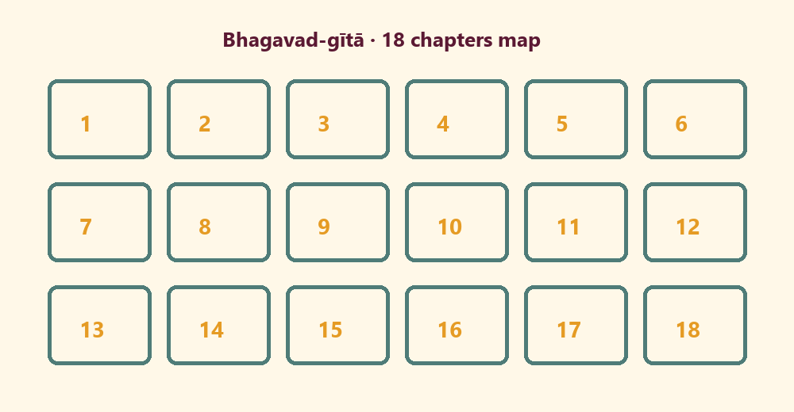

Memory phrase
Think of Kṛṣṇa; become His devotee.

Y02 — Find the Gītā Theme
Match theme cards.
CARD 1  Remember Kṛṣṇa | CARD 2  Be a devotee
CARD 3  Worship | CARD 4  Offer homage
CARD 5  Kind share | CARD 6  Not a contest
Cut on the dashed borders. Keep each card intact.

Y03 — Devotee Craft
I can think of Kṛṣṇa when…
When I wake:
________________________________________________________________
________________________________________________________________
When I help:
________________________________________________________________
________________________________________________________________
When I sing:
________________________________________________________________
________________________________________________________________

Y04 — Book Gratitude Card
Thank you for the Gītā.
I am grateful for:
________________________________________________________________
________________________________________________________________
One kind thing I can do:
________________________________________________________________
________________________________________________________________
TEACHER NOTE | No child book-distribution quotas.

Y05 — Memory Phrase Mat
Think of Kṛṣṇa; become His devotee.

Memory phrase
Think of Kṛṣṇa; become His devotee.

Older Child Rules
Canonical source: launch/CHILD-HOUSE-RULES.md • SHA-256: 6a525f3dd1da740db86e246622696c7b08e28c1f1475227567d639a5bd54ce47
Parents remain onsite. Facilitators guide the session. Host property rules also apply.

Shared rules (all ages)
1. Keep your body safe — feet on the floor; hands gentle.
2. Use respectful speech — no teasing, yelling, or mean labels.
3. Follow the facilitator safety cue immediately (pause / freeze / come here).
4. No jumping on furniture.
5. No indoor throwing.
6. No writing on walls, books, or furniture that are not activity materials.
7. Ask before entering private rooms.
8. Respect belongings — ask before touching what is not yours.
9. Devices away unless the lesson specifically needs them.
10. Snack only in the allowed area; water anytime with permission.
11. Help clean up before leaving.

Correction ladder (no public shame)
1. Calm reminder
2. Redirect / offer a choice
3. Brief quiet reset in a visible space
4. Parent involvement
5. Sit out a specific activity
6. Private parent/program conversation for repeated patterns
Never: public shame, yelling, sarcasm, corporal punishment, forced chanting, or comparing children.

Younger (K–2) emphasis
- Soft voices indoors
- Stay with the group
- Hands to yourself
- Ask before leaving the room

Older (Grades 4–5) emphasis
- Model respectful speech for younger children
- Devices fully away unless assigned
- Help clean-up leadership
- Honest questions welcome; speculation wait for source check
Printable versions: W1 launch-pack CHILD-RULES-YOUNGER.md and CHILD-RULES-OLDER.md.

O01 — BG 18.65 Observation

VERSE CARD • BG 18.65

KUTUMBA teaching meaning: Think of Me; become My devotee; worship Me; offer homage.
Source: https://vedabase.io/en/library/bg/18/65/
Rights/status: Sanskrit/Bengali display + KUTUMBA teaching meaning; no full purport

Four invitations I see:
________________________________________________________________
________________________________________________________________
________________________________________________________________
One promise I notice:
________________________________________________________________
________________________________________________________________
________________________________________________________________
One family application:
________________________________________________________________
________________________________________________________________
________________________________________________________________

O02 — 18-Chapter Map Worksheet
A chapter number I notice:
________________________________________________________________
________________________________________________________________
Why a map helps:
________________________________________________________________
________________________________________________________________
Map limit:
________________________________________________________________
________________________________________________________________

O03 — Theme Sort
CARD 1  man-manā | CARD 2  mad-bhakta
CARD 3  mad-yājī | CARD 4  namaskuru
CARD 5  ranking contest | CARD 6  quota pressure

O04 — Arjuna Decision Case
Paraphrase only — no invented dialogue.
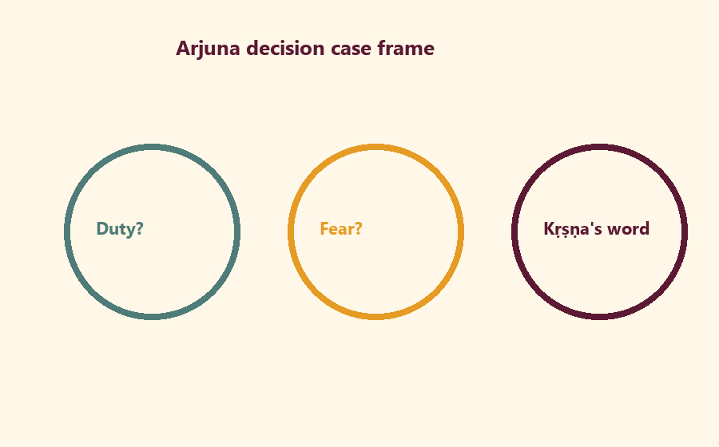
Duty tension:
________________________________________________________________
________________________________________________________________
________________________________________________________________
Fear tension:
________________________________________________________________
________________________________________________________________
________________________________________________________________
Kṛṣṇa’s instruction direction:
________________________________________________________________
________________________________________________________________
________________________________________________________________

O05 — Family Reading Plan
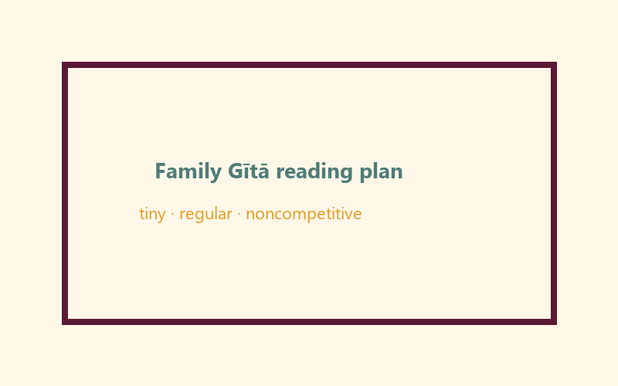
When:
________________________________________________________________
________________________________________________________________
How long (minutes):
________________________________________________________________
________________________________________________________________
Minimum version:
________________________________________________________________
________________________________________________________________

O06 — Exit Ticket
Memory line:
________________________________________________________________
________________________________________________________________
One BG 18.65 word:
________________________________________________________________
________________________________________________________________
Home reading cue:
________________________________________________________________
________________________________________________________________

Module Project
Canonical source: 11-weekly-program-library/first-six-months/c2-u2-gita-jayanti-family-utsava/project/V13-MODULE-PROJECT-BRIEF.md • SHA-256: e7c544a81da34f65d1615a201f18b2fa3d1ccc7361bfa13fea53517785b466e8
Chapter-poster contribution (one chapter number + one kind theme word). Noncompetitive exhibit later at Mela if desired.

Week Home Practice
Memory: Think of Kṛṣṇa; become His devotee. Minimum: memory line + one short family Gītā opening before next meeting window. No ranking. No child quotas.

TEACHER-ONLY
Remove teacher-only pages before distributing participant copies.

Younger Teacher Run Sheet
Canonical source: 11-weekly-program-library/first-six-months/c2-u2-gita-jayanti-family-utsava/teacher/YOUNGER-TEACHER-GUIDE-V13.md • SHA-256: c3f7423b2d5e9f8a4ba3e247b51870e9c2db9df9ca66383947f90e3b5fdb26ac
Use with printable stations. Operator completeness pack.

Main Facilitator Guide — C2-U2
Gītā Jayantī Family Utsava · Saturday 2026-12-19 (planning); published example Gītā Jayantī 2026-12-20 Status: INTERNAL · EXTERNAL_OPEN local tithi/human/temple gates Entry: V13-UTSAVA-START-HERE.md

Exact primary
- Reference: BG 18.65
- URL: https://vedabase.io/en/library/bg/18/65/
- Devanāgarī: मन्मना भव मद्भक्तो मद्याजी मां नमस्कुरु । मामेवैष्यसि सत्यं ते प्रतिजाने प्रियोऽसि मे ॥ ६५ ॥
- IAST: man-manā bhava mad-bhakto mad-yājī māṁ namaskuru / mām evaiṣyasi satyaṁ te pratijāne priyo ’si me
- KUTUMBA teaching meaning: Always think of Me, become My devotee, worship Me, and offer homage unto Me; thus you will come to Me. I promise this because you are dear to Me.
- Whole-Gītā frame: https://vedabase.io/en/library/bg/
- Rights: Sanskrit display + KUTUMBA meaning; no full purport.

10–20 minute speaking script
Welcome to our Gītā Jayantī Family Utsava planning Saturday — 2026-12-19.
Calendar honesty: published planning example lists Gītā Jayantī on 2026-12-20. Tonight is a family observance candidate, not a claim that our local exact tithi is settled. Local confirmation remains EXTERNAL_OPEN.
Essential question: How should our family receive Kṛṣṇa’s Gītā instruction without pressure or ranking?
Primary: BG 18.65 — https://vedabase.io/en/library/bg/18/65/
KUTUMBA teaching meaning: “Always think of Me, become My devotee, worship Me, and offer homage unto Me; thus you will come to Me. I promise this because you are dear to Me.”
The Gītā is Kṛṣṇa’s instruction to Arjuna in a moment of confusion about duty. We will not invent battlefield dialogue. We will teach the invitation: remember Kṛṣṇa, live as His devotee, and honor Him in ordinary family life.
Analogy one — map of 18 chapters: a map helps travel; it is not the destination. Limit: children need not memorize all chapter titles tonight.
Analogy two — decision flashlight: the Gītā lights the next faithful step. Limit: not every modern choice has a one-verse slogan; some questions defer to parents/temple.
Analogy three — reading plan like watering a plant: tiny and regular. Limit: no competitive chapter-count contests.
Household case: A parent sets a child “book distribution quota” for Jayantī. Mistaken conclusion: love equals numbers. Principle: no pressure-based distribution goals for children. Action: gratitude for the book + one kind share if natural.
Memory line: **Think of Kṛṣṇa; become Hi

Older Teacher Run Sheet
Canonical source: 11-weekly-program-library/first-six-months/c2-u2-gita-jayanti-family-utsava/teacher/OLDER-TEACHER-GUIDE-V13.md • SHA-256: c81e66f55b37a58a28cf6ecbc13cce6a9e753bd3ac8f9ca1df901b9f5b78eb46
Use with printable stations. Operator completeness pack.

Main Facilitator Guide — C2-U2
Gītā Jayantī Family Utsava · Saturday 2026-12-19 (planning); published example Gītā Jayantī 2026-12-20 Status: INTERNAL · EXTERNAL_OPEN local tithi/human/temple gates Entry: V13-UTSAVA-START-HERE.md

Exact primary
- Reference: BG 18.65
- URL: https://vedabase.io/en/library/bg/18/65/
- Devanāgarī: मन्मना भव मद्भक्तो मद्याजी मां नमस्कुरु । मामेवैष्यसि सत्यं ते प्रतिजाने प्रियोऽसि मे ॥ ६५ ॥
- IAST: man-manā bhava mad-bhakto mad-yājī māṁ namaskuru / mām evaiṣyasi satyaṁ te pratijāne priyo ’si me
- KUTUMBA teaching meaning: Always think of Me, become My devotee, worship Me, and offer homage unto Me; thus you will come to Me. I promise this because you are dear to Me.
- Whole-Gītā frame: https://vedabase.io/en/library/bg/
- Rights: Sanskrit display + KUTUMBA meaning; no full purport.

10–20 minute speaking script
Welcome to our Gītā Jayantī Family Utsava planning Saturday — 2026-12-19.
Calendar honesty: published planning example lists Gītā Jayantī on 2026-12-20. Tonight is a family observance candidate, not a claim that our local exact tithi is settled. Local confirmation remains EXTERNAL_OPEN.
Essential question: How should our family receive Kṛṣṇa’s Gītā instruction without pressure or ranking?
Primary: BG 18.65 — https://vedabase.io/en/library/bg/18/65/
KUTUMBA teaching meaning: “Always think of Me, become My devotee, worship Me, and offer homage unto Me; thus you will come to Me. I promise this because you are dear to Me.”
The Gītā is Kṛṣṇa’s instruction to Arjuna in a moment of confusion about duty. We will not invent battlefield dialogue. We will teach the invitation: remember Kṛṣṇa, live as His devotee, and honor Him in ordinary family life.
Analogy one — map of 18 chapters: a map helps travel; it is not the destination. Limit: children need not memorize all chapter titles tonight.
Analogy two — decision flashlight: the Gītā lights the next faithful step. Limit: not every modern choice has a one-verse slogan; some questions defer to parents/temple.
Analogy three — reading plan like watering a plant: tiny and regular. Limit: no competitive chapter-count contests.
Household case: A parent sets a child “book distribution quota” for Jayantī. Mistaken conclusion: love equals numbers. Principle: no pressure-based distribution goals for children. Action: gratitude for the book + one kind share if natural.
Memory line: **Think of Kṛṣṇa; become Hi

Main Facilitator Speaking Map
Canonical source: 11-weekly-program-library/first-six-months/c2-u2-gita-jayanti-family-utsava/teacher/MAIN-FACILITATOR-GUIDE-V13.md • SHA-256: adc2b7fd6839f58f6bfa376dadac5375b2cc157424a4e5ef1192ce60e4cd42b0
Gītā Jayantī Family Utsava · Saturday 2026-12-19 (planning); published example Gītā Jayantī 2026-12-20 Status: INTERNAL · EXTERNAL_OPEN local tithi/human/temple gates Entry: V13-UTSAVA-START-HERE.md

Exact primary
- Reference: BG 18.65
- URL: https://vedabase.io/en/library/bg/18/65/
- Devanāgarī: मन्मना भव मद्भक्तो मद्याजी मां नमस्कुरु । मामेवैष्यसि सत्यं ते प्रतिजाने प्रियोऽसि मे ॥ ६५ ॥
- IAST: man-manā bhava mad-bhakto mad-yājī māṁ namaskuru / mām evaiṣyasi satyaṁ te pratijāne priyo ’si me
- KUTUMBA teaching meaning: Always think of Me, become My devotee, worship Me, and offer homage unto Me; thus you will come to Me. I promise this because you are dear to Me.
- Whole-Gītā frame: https://vedabase.io/en/library/bg/
- Rights: Sanskrit display + KUTUMBA meaning; no full purport.

10–20 minute speaking script
Welcome to our Gītā Jayantī Family Utsava planning Saturday — 2026-12-19.
Calendar honesty: published planning example lists Gītā Jayantī on 2026-12-20. Tonight is a family observance candidate, not a claim that our local exact tithi is settled. Local confirmation remains EXTERNAL_OPEN.
Essential question: How should our family receive Kṛṣṇa’s Gītā instruction without pressure or ranking?
Primary: BG 18.65 — https://vedabase.io/en/library/bg/18/65/
KUTUMBA teaching meaning: “Always think of Me, become My devotee, worship Me, and offer homage unto Me; thus you will come to Me. I promise this because you are dear to Me.”
The Gītā is Kṛṣṇa’s instruction to Arjuna in a moment of confusion about duty. We will not invent battlefield dialogue. We will teach the invitation: remember Kṛṣṇa, live as His devotee, and honor Him in ordinary family life.
Analogy one — map of 18 chapters: a map helps travel; it is not the destination. Limit: children need not memorize all chapter titles tonight.
Analogy two — decision flashlight: the Gītā lights the next faithful step. Limit: not every modern choice has a one-verse slogan; some questions defer to parents/temple.
Analogy three — reading plan like watering a plant: tiny and regular. Limit: no competitive chapter-count contests.
Household case: A parent sets a child “book distribution quota” for Jayantī. Mistaken conclusion: love equals numbers. Principle: no pressure-based distribution goals for children. Action: gratitude for the book + one kind share if natural.
Memory line: Think of Kṛṣṇa; become His devotee.

Q&A boundaries
- Exact local date? → EXTERNAL_OPEN; published example 2026-12-20.
- Must children distribute books? → No quotas; gratitude and optional natural sharing only.

Room / Material / Snack / Cleanup Checklist
Done | Area | Check
☐ | Room | Parent circle, younger floor zone, older table zone, clear aisles
☐ | Materials | Labeled track folders, pencils, crayons, tape, timer
☐ | Privacy | Completed forms remain private and never enter Git
☐ | Snack | Snack and water staged for 3:30; allergy plan confirmed
☐ | Safety | Calm corner visible; private rooms closed; exits clear
☐ | Cleanup | Tables wiped and host home reset assigned

RIGHTS NOTE | KUTUMBA-original framing; cited third-party material retains its own rights. Human/temple review remains EXTERNAL_OPEN.

