KUTUMBA

C2-U2 — Younger Teacher Pack
  - K–2 run sheet and activities
C2-U2 • Gītā Jayantī Family Utsava
V13 • Families Growing in Krishna Consciousness
Program Director: Swapnil Patil
Internal founding-cohort teaching material — human/temple review EXTERNAL_OPEN
KUTUMBA | Families Growing in Krishna Consciousness

Locked Saturday Schedule
Time | Block
1:50–2:00 | Arrival
2:00–2:10 | Opening mantras + welcome
2:10–2:30 | All-family launch/orientation
2:30–3:10 | Parallel tracks
3:10–3:30 | Reunification + bhakti laboratory
3:30–3:40 | Snack + water
3:40–3:55 | Saṅkalpa + project + home practice
3:55–4:00 | Close

TIME CUE | Utsava planning date 2026-12-19. Use 2:30 / 3:10 cues when parallel tracks run; local tithi remains EXTERNAL_OPEN.

Primary verse: BG 18.65
Source URL: https://vedabase.io/en/library/bg/18/65/

Younger Teacher Run Sheet
Canonical source: 11-weekly-program-library/first-six-months/c2-u2-gita-jayanti-family-utsava/teacher/YOUNGER-TEACHER-GUIDE-V13.md • SHA-256: c3f7423b2d5e9f8a4ba3e247b51870e9c2db9df9ca66383947f90e3b5fdb26ac
Use with printable stations. Operator completeness pack.

Main Facilitator Guide — C2-U2
Gītā Jayantī Family Utsava · Saturday 2026-12-19 (planning); published example Gītā Jayantī 2026-12-20 Status: INTERNAL · EXTERNAL_OPEN local tithi/human/temple gates Entry: V13-UTSAVA-START-HERE.md

Exact primary
- Reference: BG 18.65
- URL: https://vedabase.io/en/library/bg/18/65/
- Devanāgarī: मन्मना भव मद्भक्तो मद्याजी मां नमस्कुरु । मामेवैष्यसि सत्यं ते प्रतिजाने प्रियोऽसि मे ॥ ६५ ॥
- IAST: man-manā bhava mad-bhakto mad-yājī māṁ namaskuru / mām evaiṣyasi satyaṁ te pratijāne priyo ’si me
- KUTUMBA teaching meaning: Always think of Me, become My devotee, worship Me, and offer homage unto Me; thus you will come to Me. I promise this because you are dear to Me.
- Whole-Gītā frame: https://vedabase.io/en/library/bg/
- Rights: Sanskrit display + KUTUMBA meaning; no full purport.

10–20 minute speaking script
Welcome to our Gītā Jayantī Family Utsava planning Saturday — 2026-12-19.
Calendar honesty: published planning example lists Gītā Jayantī on 2026-12-20. Tonight is a family observance candidate, not a claim that our local exact tithi is settled. Local confirmation remains EXTERNAL_OPEN.
Essential question: How should our family receive Kṛṣṇa’s Gītā instruction without pressure or ranking?
Primary: BG 18.65 — https://vedabase.io/en/library/bg/18/65/
KUTUMBA teaching meaning: “Always think of Me, become My devotee, worship Me, and offer homage unto Me; thus you will come to Me. I promise this because you are dear to Me.”
The Gītā is Kṛṣṇa’s instruction to Arjuna in a moment of confusion about duty. We will not invent battlefield dialogue. We will teach the invitation: remember Kṛṣṇa, live as His devotee, and honor Him in ordinary family life.
Analogy one — map of 18 chapters: a map helps travel; it is not the destination. Limit: children need not memorize all chapter titles tonight.
Analogy two — decision flashlight: the Gītā lights the next faithful step. Limit: not every modern choice has a one-verse slogan; some questions defer to parents/temple.
Analogy three — reading plan like watering a plant: tiny and regular. Limit: no competitive chapter-count contests.
Household case: A parent sets a child “book distribution quota” for Jayantī. Mistaken conclusion: love equals numbers. Principle: no pressure-based distribution goals for children. Action: gratitude for the book + one kind share if natural.
Memory line: **Think of Kṛṣṇa; become Hi

Child House Rules
Canonical source: launch/CHILD-HOUSE-RULES.md • SHA-256: 6a525f3dd1da740db86e246622696c7b08e28c1f1475227567d639a5bd54ce47
Parents remain onsite. Facilitators guide the session. Host property rules also apply.

Shared rules (all ages)
1. Keep your body safe — feet on the floor; hands gentle.
2. Use respectful speech — no teasing, yelling, or mean labels.
3. Follow the facilitator safety cue immediately (pause / freeze / come here).
4. No jumping on furniture.
5. No indoor throwing.
6. No writing on walls, books, or furniture that are not activity materials.
7. Ask before entering private rooms.
8. Respect belongings — ask before touching what is not yours.
9. Devices away unless the lesson specifically needs them.
10. Snack only in the allowed area; water anytime with permission.
11. Help clean up before leaving.

Correction ladder (no public shame)
1. Calm reminder
2. Redirect / offer a choice
3. Brief quiet reset in a visible space
4. Parent involvement
5. Sit out a specific activity
6. Private parent/program conversation for repeated patterns
Never: public shame, yelling, sarcasm, corporal punishment, forced chanting, or comparing children.

Younger (K–2) emphasis
- Soft voices indoors
- Stay with the group
- Hands to yourself
- Ask before leaving the room

Older (Grades 4–5) emphasis
- Model respectful speech for younger children
- Devices fully away unless assigned
- Help clean-up leadership
- Honest questions welcome; speculation wait for source check
Printable versions: W1 launch-pack CHILD-RULES-YOUNGER.md and CHILD-RULES-OLDER.md.

Y01 — 18-Chapter Map
Point and wonder. No forced memorization.
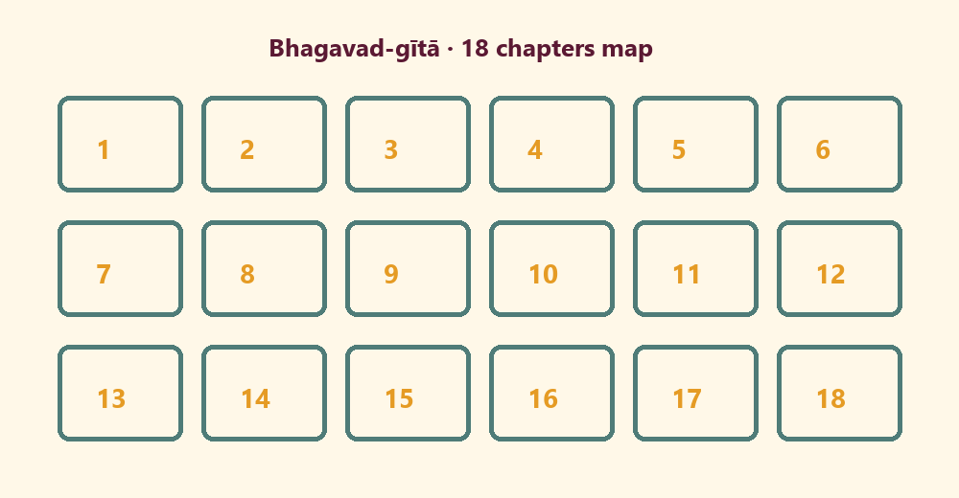

Memory phrase
Think of Kṛṣṇa; become His devotee.

Y02 — Find the Gītā Theme
Match theme cards.
CARD 1  Remember Kṛṣṇa | CARD 2  Be a devotee
CARD 3  Worship | CARD 4  Offer homage
CARD 5  Kind share | CARD 6  Not a contest
Cut on the dashed borders. Keep each card intact.

Y03 — Devotee Craft
I can think of Kṛṣṇa when…
When I wake:
________________________________________________________________
________________________________________________________________
When I help:
________________________________________________________________
________________________________________________________________
When I sing:
________________________________________________________________
________________________________________________________________

Y04 — Book Gratitude Card
Thank you for the Gītā.
I am grateful for:
________________________________________________________________
________________________________________________________________
One kind thing I can do:
________________________________________________________________
________________________________________________________________
TEACHER NOTE | No child book-distribution quotas.

Y05 — Memory Phrase Mat
Think of Kṛṣṇa; become His devotee.

Memory phrase
Think of Kṛṣṇa; become His devotee.
RIGHTS NOTE | KUTUMBA-original framing; cited third-party material retains its own rights. Human/temple review remains EXTERNAL_OPEN.

