KUTUMBA

C2-W1 — Older Teacher Pack
  - Grades 4–5 run sheet and activities
C2-W1 • Action and Reaction: How Karma Binds
V13 • Families Growing in Krishna Consciousness
Program Director: Swapnil Patil
Internal founding-cohort teaching material — human/temple review EXTERNAL_OPEN
KUTUMBA | Families Growing in Krishna Consciousness

Locked Saturday Schedule
Time | Block
1:50–2:00 | Arrival
2:00–2:10 | Opening mantras + welcome
2:10–2:30 | All-family launch/orientation
2:30–3:10 | Parallel tracks
3:10–3:30 | Reunification + bhakti laboratory
3:30–3:40 | Snack + water
3:40–3:55 | Saṅkalpa + project + home practice
3:55–4:00 | Close

TIME CUE | Track handoff is at 2:30; all groups reunite at 3:10.

Primary verse: BG 3.9
Source URL: https://vedabase.io/en/library/bg/3/9/

Older Teacher Run Sheet
Canonical source: 11-weekly-program-library/first-six-months/c2-w1-action-and-reaction-how-karma-binds/teacher/OLDER-TEACHER-GUIDE-V13.md • SHA-256: aa74253e334177fc1262223267197506608054621215e7f663a740c6736addaf
KUTUMBA · Families Growing in Krishna Consciousness Program Director: Swapnil Patil Week: Action and Reaction: How Karma Binds · Date: 2026-11-07 Track window: Saturday 2:30–3:10 (Grades 4–5) Reunite: 3:10 for bhakti laboratory Primary: BG 3.9 — https://vedabase.io/en/library/bg/3/9/ Primary mechanic: Cause-effect map Status: Internal founding-cohort teaching material — human/temple review EXTERNAL_OPEN

Essential question
How do our actions bind or free us?

Materials (print before Saturday)
From activities/v13-older/: O01–O06 Also pens/crayons; verse card; privacy reminder.

Locked Saturday context
- 1:50–2:00 Arrival · 2:00–2:10 Mantras · 2:10–2:30 All-family launch
- 2:30–3:10 This track · 3:10–3:30 Reunify · 3:30–3:40 Snack/water · 3:40–3:55 Saṅkalpa · 3:55–4:00 Close
Parents remain onsite. No public ranking. No forced disclosure.

Source layer (use mid-track)
Primary: BG 3.9 — https://vedabase.io/en/library/bg/3/9/
Devanāgarī: यज्ञार्थात्कर्मणोऽन्यत्र लोकोऽयं कर्मबन्धनः । तदर्थं कर्म कौन्तेय मुक्तसङ्गः समाचर ॥ ९ ॥
IAST: yajñārthāt karmaṇo ’nyatra loko ’yaṁ karma-bandhanaḥ / tad-arthaṁ karma kaunteya mukta-saṅgaḥ samācara
KUTUMBA teaching meaning (not a BBT translation): Work done for the satisfaction of the Lord frees us from bondage; otherwise action binds. Therefore act with detachment for His purpose.

Memory line
Choices are seeds. I want to plant service seeds.

V13 printable wiring (Cause-effect map)

V13 printable block 0–6 — BG 3.9 observation
Printable: activities/v13-older/O01-BG-3-9-OBSERVATION.md (O01-BG-3-9-OBSERVATION)
Observe verse layers; paraphrase; name what the verse does not authorize.
Keep primary mechanic (Cause-effect map). Block: Fatalism removes responsibility; do not diagnose others’ hardship as specific past karma.

V13 printable block 6–14 — Action → intention → consequence map
Printable: activities/v13-older/O02-ACTION-INTENTION-CONSEQUENCE-MAP.md (O02-ACTION-INTENTION-CONSEQUENCE-MAP)
Fill three boxes for a school/home scenario.
Keep primary mechanic (Cause-effect map). Block: Fatalism removes responsibility; do not diagnose others’ hardship as specific past karma.

V13 printable block 14–22 — Service vs selfish-attachment sort
Printable: activities/v13-older/O03-SERVICE-VS-SELFISH-SORT.md (O03-SERVICE-VS-SELFISH-SORT)
Sort cards; discuss almost-right traps.
Keep primary mechanic (Cause-effect map). Block: Fatalism removes responsibility; do not diagnose others’ hardship as specific past karma.

V13 printable block 22–30 — Choice–consequence scenarios
Printable: activities/v13-older/O04-CHOICE-CONSEQUENCE-SCENARIOS.md (O04-CHOICE-CONSEQUENCE-SCENARIOS)
Work three cases with principle + better action.
Keep primary mechanic (Cause-effect map). Block: Fatalism removes responsibility; do not diagnose others’ hardship as specific past karma.

V13 printable block 30–36 — Before–During–After diagram
Printable: activities/v13-older/O05-BEFORE-DURING-AFTER-DIAGRAM.md (O05-BEFORE-DURING-AFTER-DIAGRAM)
Map one duty with offered intention.
Keep primary mechanic (Cause-effect map). Block: Fatalism removes responsibility; do not diagnose others’ hardship as specific past karma.

V13 printable block 36–40 — Exit ticket
Printable: activities/v13-older/O06-EXIT-TICKET.md (O06-EXIT-TICKET)
One-sentence paraphrase + one home action.
Keep primary mechanic (Cause-effect map). Block: Fatalism removes responsibility; do not diagnose others’ hardship as specific past karma.

Close of track (handoff)
Bring one sentence or artifact to reunification. Do not start next week’s topic. Care boundary: No victim-blaming. No graphic hell imagery with children.

Inherited classroom depth (from V12 OLDER-TEACHER-GUIDE.md)
Keep story scripts, movement steps, and wonder questions below. Wire printables to the V13 codes above; do not replace this depth with “see research.”
KUTUMBA • Families Growing in Krishna Consciousness Program Director: Swapnil Patil Status: INTERNAL founding-cohort — human/temple review EXTERNAL_OPEN

Objective
Students will observe BG 3.9, explain that work aimed only at separate material interest binds while work for Viṣṇu should be done without selfish attachment, and analyze one action using intention–method–consequence.

Primary text observation — BG 3.9
Open and keep visible: https://vedabase.io/en/library/bg/3/9/
- Devanāgarī: यज्ञार्थात्कर्मणोऽन्यत्र लोकोऽयं कर्मबन्धनः । तदर्थं कर्म कौन्तेय मुक्तसङ्गः समाचर ॥ ९ ॥
- IAST: yajñārthāt karmaṇo ’nyatra loko ’yaṁ karma-bandhanaḥ / tad-arthaṁ karma kaunteya mukta-saṅgaḥ samācara
- KUTUMBA teaching meaning: Work done for the satisfaction of the Lord frees us from bondage; otherwise action binds. Therefore act with detachment for His purpose.
Students write on observation sheet (5 minutes):
1. Setting / speaker-listener (as known from class: Kṛṣṇa to Arjuna)
2. Key Sanskrit phrase they notice (example: karma-bandhanaḥ)
3. Teaching-meaning paraphrase in their own words (not a long dump)
4. One thing this verse does not say (example: “it does not say we should stop all duties” / “it does not say we may blame victims”)

Misconception to block
Fatalism removes responsibility. Also block: diagnosing another person’s suffering as specific past karma.

40-minute sequence
Minutes | Block
0–5 | Essential question + memory line
5–12 | Primary text observation (above)
12–18 | Worksheet questions
18–25 | Scenario cards (triads)
25–32 | Puzzle/game: Action-Chain / Seed-Fruit Match
32–36 | Diagram task: Intention–Method–Consequence
36–38 | Project contribution line
38–40 | Reflection + reunification sentence

Worksheet questions (write answers; check with activities/OLDER-ANSWER-KEY.md)
1. According to BG 3.9’s teaching meaning, what kind of work causes bondage?
2. What kind of work should we perform, and how (attachment posture)?
3. Using BG 4.16–18 support (URLs on worksheet), why is “just stop working” too simple?
4. Give one household example of offered work vs selfish work that look similar from outside.
5. Why must we refuse the sentence: “That family’s hardship proves their past karma”?
Supporting URLs on student sheet:
- https://vedabase.io/en/library/bg/4/16/
- https://vedabase.io/en/library/bg/4/17/
- https://vedabase.io/en/library/bg/4/18/

Scenario cards (real prompts — print from activity pack)
Students draw one card and answer: intention / method / likely consequence / one repair.
1. Angry text: You send a sharp message in a group chat after a schedule mix-up.
2. Gift for praise: You give a donation mainly hoping for public thanks.
3. Quiet repair: You fix a sibling’s project and notice yourself waiting for praise.
Teacher circulates; stop victim-blame language immediately.

Puzzle / game — Action-Chain / Seed-Fruit Match (WITH STEPS)
Materials: 8 seed cards + 8 fruit/result cards (see activities/OLDER-ACTIVITY-PACK.md)
1. Shuffle seed cards and fruit cards into two piles.
2. Students work in pairs.
3. Match each seed (action) to a plausible fruit (result). Include at least two delayed results (practice → skill; harsh words → later distrust).
4. For each match, pairs place an arrow card labeled direct, indirect, or delayed.
5. Teacher checks two matches aloud using answer key guidance.
6. Extension: build one action chain of three links from a single online post seed (post → screenshot → widened conflict) without shaming any real classmate.

Diagram task — Intention–Method–Consequence
Students complete a three-box diagram for one scenario:
- Intention: Why am I acting?
- Method: How am I acting (careful / hasty / honest / showy)?
- Consequence: What may grow for me and for others?
Then add a fourth mini-box: Offered version — how would before–during–after change this?
Diagram may align with visuals/V12/concept-diagram.svg if projected.

Project contribution
From project/CYCLE-CONTRIBUTION.md: write one sentence artifact line:
“Our family action that binds or frees: ______ / offered version: ______.”
Keep under two minutes. No ranking.

Reflection (1–2 minutes)
“One sentence: What is the difference between an analogy (seed-fruit) and the verse (BG 3.9)?”
Target: analogy teaches; verse authorizes the doctrine.

Extension (if early)
Read BG 3.13 URL https://vedabase.io/en/library/bg/3/13/ and write two columns: cooking for offering vs cooking only for myself — with one limit note (“no shaming newcomers”).

Reunification sentence
“This week I will offer ______ by before ______, during ______, after ______.”

Answer key pointer
Use activities/OLDER-ANSWER-KEY.md for secure targets. Do not leave the key on student desks.

Materials
Observation sheets, pencils, scenario cards, seed/fruit match cards, arrow cards, diagram sheets, verse URL list.

Do not claim
INTERNAL only; EXTERNAL_OPEN review; teaching meaning ≠ BBT translation; no fabricated human approval.

O01 — BG 3.9 observation
Observe verse layers; paraphrase; name what the verse does not authorize.

VERSE CARD • BG 3.9
यज्ञार्थात्कर्मणोऽन्यत्र लोकोऽयं कर्मबन्धनः । तदर्थं कर्म कौन्तेय मुक्तसङ्गः समाचर ॥ ९ ॥
yajñārthāt karmaṇo ’nyatra loko ’yaṁ karma-bandhanaḥ / tad-arthaṁ karma kaunteya mukta-saṅgaḥ samācara
KUTUMBA teaching meaning: Work done for the satisfaction of the Lord frees us from bondage; otherwise action binds. Therefore act with detachment for His purpose.
Source: https://vedabase.io/en/library/bg/3/9/
Rights/status: Scripture display/source: VedaBase; teaching meaning: KUTUMBA-original (not labeled as BBT translation).

What does the verse teach in my words?
________________________________________________________________
________________________________________________________________
What misconception does this week block?
________________________________________________________________
________________________________________________________________
One question for the facilitator:
________________________________________________________________
________________________________________________________________

O02 — Action → intention → consequence map
Fill three boxes for a school/home scenario.
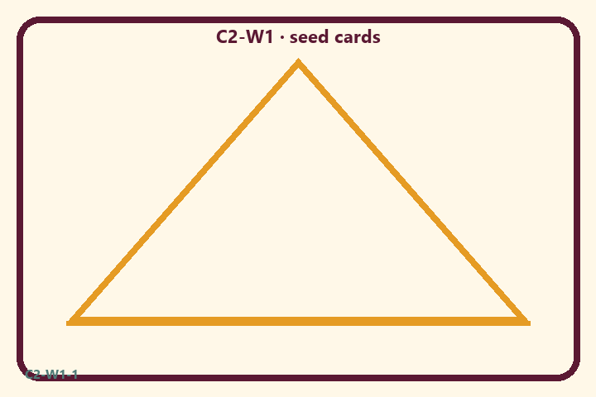
Prompt | My notes
Action → intention → consequence map | ________________
Limit / care | ________________

Application:
________________________________________________________________
________________________________________________________________
What not to say:
________________________________________________________________
________________________________________________________________
KEY IDEA | Action with selfish attachment binds; action for the Lord’s purpose can be purified.

O03 — Service vs selfish-attachment sort
Sort cards; discuss almost-right traps.
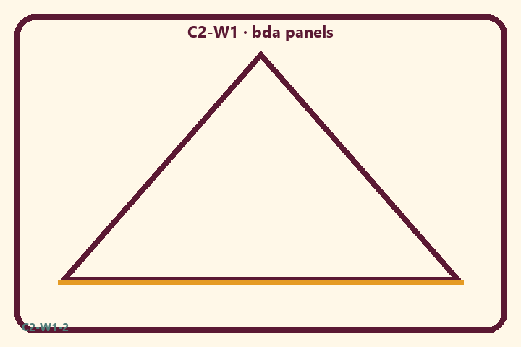
Prompt | My notes
Service vs selfish-attachment sort | ________________
Limit / care | ________________

Application:
________________________________________________________________
________________________________________________________________
What not to say:
________________________________________________________________
________________________________________________________________
KEY IDEA | Action with selfish attachment binds; action for the Lord’s purpose can be purified.

O04 — Choice–consequence scenarios
Work three cases with principle + better action.
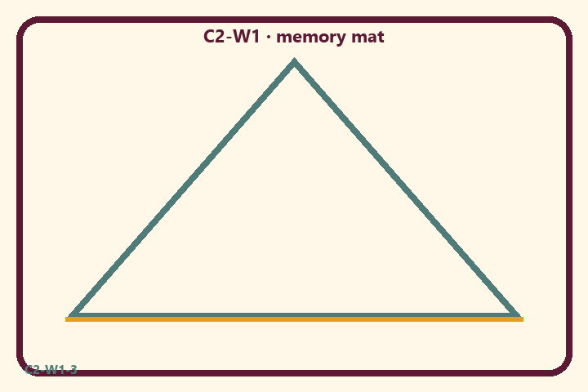
Prompt | My notes
Choice–consequence scenarios | ________________
Limit / care | ________________

Application:
________________________________________________________________
________________________________________________________________
What not to say:
________________________________________________________________
________________________________________________________________
KEY IDEA | Action with selfish attachment binds; action for the Lord’s purpose can be purified.

O05 — Before–During–After diagram
Map one duty with offered intention.
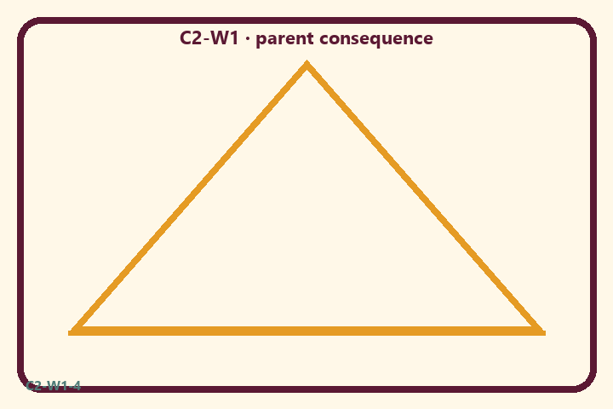
Prompt | My notes
Before–During–After diagram | ________________
Limit / care | ________________

Application:
________________________________________________________________
________________________________________________________________
What not to say:
________________________________________________________________
________________________________________________________________
KEY IDEA | Action with selfish attachment binds; action for the Lord’s purpose can be purified.

O06 — Exit ticket
One-sentence paraphrase + one home action.
Primary in one sentence:
________________________________________________________________
________________________________________________________________
One analogy or mechanic and its limit:
________________________________________________________________
________________________________________________________________
One home action:
________________________________________________________________
________________________________________________________________
One question I still have:
________________________________________________________________
________________________________________________________________
RIGHTS NOTE | KUTUMBA-original framing; cited third-party material retains its own rights. Human/temple review remains EXTERNAL_OPEN.

