KUTUMBA

C2-W1 — Parent Track
  - Facilitator guide and parent printables
C2-W1 • Action and Reaction: How Karma Binds
V13 • Families Growing in Krishna Consciousness
Program Director: Swapnil Patil
Internal founding-cohort teaching material — human/temple review EXTERNAL_OPEN
KUTUMBA | Families Growing in Krishna Consciousness

Locked Saturday Schedule
Time | Block
1:50–2:00 | Arrival
2:00–2:10 | Opening mantras + welcome
2:10–2:30 | All-family launch/orientation
2:30–3:10 | Parallel tracks
3:10–3:30 | Reunification + bhakti laboratory
3:30–3:40 | Snack + water
3:40–3:55 | Saṅkalpa + project + home practice
3:55–4:00 | Close

TIME CUE | Track handoff is at 2:30; all groups reunite at 3:10.

Primary verse: BG 3.9
Source URL: https://vedabase.io/en/library/bg/3/9/

Parent Facilitator Run Sheet
Canonical source: 11-weekly-program-library/first-six-months/c2-w1-action-and-reaction-how-karma-binds/teacher/PARENT-GUIDE-V13.md • SHA-256: 92be86f91e7fcc44223310f0bad6eefc5154454fc0b63d66771f1f4e9d005402
KUTUMBA · Families Growing in Krishna Consciousness Program Director: Swapnil Patil Week: Action and Reaction: How Karma Binds · Date: 2026-11-07 Track window: Saturday 2:30–3:10 (parents) Reunite: 3:10 for bhakti laboratory Primary: BG 3.9 — https://vedabase.io/en/library/bg/3/9/ Primary mechanic: Cause-effect map Status: Internal founding-cohort teaching material — human/temple review EXTERNAL_OPEN

Essential question
How do our actions bind or free us?

Materials (print before Saturday)
From activities/v13-parent/: P01–P05 Also pens/crayons; verse card; privacy reminder.

Locked Saturday context
- 1:50–2:00 Arrival · 2:00–2:10 Mantras · 2:10–2:30 All-family launch
- 2:30–3:10 This track · 3:10–3:30 Reunify · 3:30–3:40 Snack/water · 3:40–3:55 Saṅkalpa · 3:55–4:00 Close
Parents remain onsite. No public ranking. No forced disclosure.

Source layer (use mid-track)
Primary: BG 3.9 — https://vedabase.io/en/library/bg/3/9/
Devanāgarī: यज्ञार्थात्कर्मणोऽन्यत्र लोकोऽयं कर्मबन्धनः । तदर्थं कर्म कौन्तेय मुक्तसङ्गः समाचर ॥ ९ ॥
IAST: yajñārthāt karmaṇo ’nyatra loko ’yaṁ karma-bandhanaḥ / tad-arthaṁ karma kaunteya mukta-saṅgaḥ samācara
KUTUMBA teaching meaning (not a BBT translation): Work done for the satisfaction of the Lord frees us from bondage; otherwise action binds. Therefore act with detachment for His purpose.

Memory line
Choices are seeds. I want to plant service seeds.

V13 printable wiring (Cause-effect map)

V13 printable block 0–5 — Private reflection — binding speech/habits
Printable: activities/v13-parent/P01-PRIVATE-REFLECTION.md (P01-PRIVATE-REFLECTION)
Where does our home act for face/control rather than service?
Keep primary mechanic (Cause-effect map). Block: Fatalism removes responsibility; do not diagnose others’ hardship as specific past karma.

V13 printable block 5–12 — Consequence case card sort
Printable: activities/v13-parent/P02-CONSEQUENCE-CASE-CARD-SORT.md (P02-CONSEQUENCE-CASE-CARD-SORT)
Sort RESPONSIBLE REPAIR vs MISTAKEN DIAGNOSIS.
Keep primary mechanic (Cause-effect map). Block: Fatalism removes responsibility; do not diagnose others’ hardship as specific past karma.

V13 printable block 12–22 — Substantial family case
Printable: activities/v13-parent/P03-SUBSTANTIAL-FAMILY-CASE.md (P03-SUBSTANTIAL-FAMILY-CASE)
Public blame text after a missed pickup.
Keep primary mechanic (Cause-effect map). Block: Fatalism removes responsibility; do not diagnose others’ hardship as specific past karma.

V13 printable block 22–32 — Household operating application
Printable: activities/v13-parent/P04-HOUSEHOLD-OPERATING-APPLICATION.md (P04-HOUSEHOLD-OPERATING-APPLICATION)
One Before–During–After duty for seven days.
Keep primary mechanic (Cause-effect map). Block: Fatalism removes responsibility; do not diagnose others’ hardship as specific past karma.

V13 printable block 32–38 — Private next-step saṅkalpa
Printable: activities/v13-parent/P05-PRIVATE-NEXT-STEP-SANKALPA.md (P05-PRIVATE-NEXT-STEP-SANKALPA)
Specific action + frequency + trigger + minimum version.
Keep primary mechanic (Cause-effect map). Block: Fatalism removes responsibility; do not diagnose others’ hardship as specific past karma.

Close of track (handoff)
Bring one sentence or artifact to reunification. Do not start next week’s topic. Care boundary: No victim-blaming. No graphic hell imagery with children.

Inherited classroom depth (from V12 parent-lesson / constructed V13 flow)
Keep story scripts, movement steps, and wonder questions below. Wire printables to the V13 codes above; do not replace this depth with “see research.”

Essential question
How do our actions bind or free us?

Source
BG 3.9 — teaching meaning: Work done for the satisfaction of the Lord frees us from bondage; otherwise action binds. Therefore act with detachment for His purpose.

Discussion
One realistic household tension; no compelled confession.

Application
5–15 minute cue; minimum version counts.

Privacy
No public scoring of sādhana.

P01 — Private reflection — binding speech/habits
Where does our home act for face/control rather than service?

SAFETY & PRIVACY | Write privately. Sharing is optional. Do not collect or place completed sheets in Git.

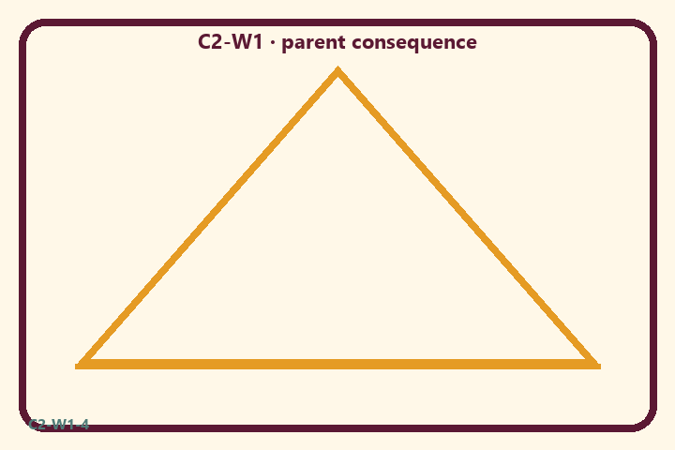
Where does our home act for face/control rather than service?
Private notes:
________________________________________________________________
________________________________________________________________
________________________________________________________________
________________________________________________________________
Habit to watch this week:
________________________________________________________________
________________________________________________________________
________________________________________________________________
________________________________________________________________

P02 — Consequence case card sort
Sort RESPONSIBLE REPAIR vs MISTAKEN DIAGNOSIS.
HELPFUL | MISTAKEN

L1  Quiet kitchen help | L2  Gift for applause
L3  Repair private apology | L4  Diagnose cousin’s illness as karma
L5  Offer food first | L6  Win the argument at all costs
TEACHER NOTE | Fatalism removes responsibility; do not diagnose others’ hardship as specific past karma.

P03 — Substantial family case
Public blame text after a missed pickup.
SAFETY & PRIVACY | Fictional case. No compelled confession of real events.

After a missed pickup, a parent sends a sharp group-chat blame message copying relatives. The logistics need was real; the public heat was extra.
Tempting mistaken conclusion:
________________________________________________________________
________________________________________________________________
________________________________________________________________
Principle from primary:
________________________________________________________________
________________________________________________________________
________________________________________________________________
Compassionate response:
________________________________________________________________
________________________________________________________________
________________________________________________________________
One seven-day household action:
________________________________________________________________
________________________________________________________________
________________________________________________________________
What we should not say:
________________________________________________________________
________________________________________________________________
________________________________________________________________
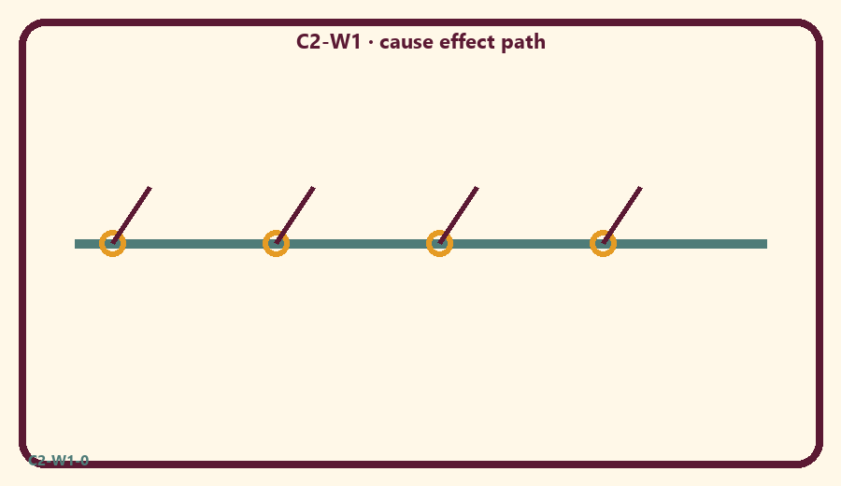

P04 — Household operating application
One Before–During–After duty for seven days.
SAFETY & PRIVACY | No ranking and no public reading required.

One household action for seven days:
________________________________________________________________
________________________________________________________________
________________________________________________________________
Trigger (when/where):
________________________________________________________________
________________________________________________________________
________________________________________________________________
Who starts if others are tired:
________________________________________________________________
________________________________________________________________
________________________________________________________________
Minimum version on a hard day:
________________________________________________________________
________________________________________________________________
________________________________________________________________

Memory phrase
Choices are seeds. I want to plant service seeds.

P05 — Private next-step saṅkalpa
Specific action + frequency + trigger + minimum version.
KEY IDEA | specific action + frequency + trigger + minimum version

Specific action:
________________________________________________________________
________________________________________________________________
Frequency:
________________________________________________________________
________________________________________________________________
Trigger (when and where):
________________________________________________________________
________________________________________________________________
Minimum version for a hard day:
________________________________________________________________
________________________________________________________________
Where we will place the reminder:
________________________________________________________________
________________________________________________________________
No ranking. The minimum version counts as success.
RIGHTS NOTE | KUTUMBA-original framing; cited third-party material retains its own rights. Human/temple review remains EXTERNAL_OPEN.

