KUTUMBA

C2-W1 — Younger Teacher Pack
  - K–2 run sheet and activities
C2-W1 • Action and Reaction: How Karma Binds
V13 • Families Growing in Krishna Consciousness
Program Director: Swapnil Patil
Internal founding-cohort teaching material — human/temple review EXTERNAL_OPEN
KUTUMBA | Families Growing in Krishna Consciousness

Locked Saturday Schedule
Time | Block
1:50–2:00 | Arrival
2:00–2:10 | Opening mantras + welcome
2:10–2:30 | All-family launch/orientation
2:30–3:10 | Parallel tracks
3:10–3:30 | Reunification + bhakti laboratory
3:30–3:40 | Snack + water
3:40–3:55 | Saṅkalpa + project + home practice
3:55–4:00 | Close

TIME CUE | Track handoff is at 2:30; all groups reunite at 3:10.

Primary verse: BG 3.9
Source URL: https://vedabase.io/en/library/bg/3/9/

Younger Teacher Run Sheet
Canonical source: 11-weekly-program-library/first-six-months/c2-w1-action-and-reaction-how-karma-binds/teacher/YOUNGER-TEACHER-GUIDE-V13.md • SHA-256: 3ba69fdc2a1c024dc9b97fa9e84d7a3154bbed5261bde08ba613aa4d77d654d9
KUTUMBA · Families Growing in Krishna Consciousness Program Director: Swapnil Patil Week: Action and Reaction: How Karma Binds · Date: 2026-11-07 Track window: Saturday 2:30–3:10 (K–2) Reunite: 3:10 for bhakti laboratory Primary: BG 3.9 — https://vedabase.io/en/library/bg/3/9/ Primary mechanic: Cause-effect map Status: Internal founding-cohort teaching material — human/temple review EXTERNAL_OPEN

Essential question
How do our actions bind or free us?

Materials (print before Saturday)
From activities/v13-younger/: Y01–Y05 Also pens/crayons; verse card; privacy reminder.

Locked Saturday context
- 1:50–2:00 Arrival · 2:00–2:10 Mantras · 2:10–2:30 All-family launch
- 2:30–3:10 This track · 3:10–3:30 Reunify · 3:30–3:40 Snack/water · 3:40–3:55 Saṅkalpa · 3:55–4:00 Close
Parents remain onsite. No public ranking. No forced disclosure.

Source layer (use mid-track)
Primary: BG 3.9 — https://vedabase.io/en/library/bg/3/9/
Devanāgarī: यज्ञार्थात्कर्मणोऽन्यत्र लोकोऽयं कर्मबन्धनः । तदर्थं कर्म कौन्तेय मुक्तसङ्गः समाचर ॥ ९ ॥
IAST: yajñārthāt karmaṇo ’nyatra loko ’yaṁ karma-bandhanaḥ / tad-arthaṁ karma kaunteya mukta-saṅgaḥ samācara
KUTUMBA teaching meaning (not a BBT translation): Work done for the satisfaction of the Lord frees us from bondage; otherwise action binds. Therefore act with detachment for His purpose.

Memory line
Choices are seeds. I want to plant service seeds.

V13 printable wiring (Cause-effect map)

V13 printable block 0–6 — Domino / cause-effect path (limits)
Printable: activities/v13-younger/Y01-DOMINO-PATH-CARDS.md (Y01-DOMINO-PATH-CARDS)
Place domino cards: action → next → result. Say the limit aloud.
Keep primary mechanic (Cause-effect map). Block: Fatalism removes responsibility; do not diagnose others’ hardship as specific past karma.

V13 printable block 6–14 — Seed choice matching
Printable: activities/v13-younger/Y02-SEED-CHOICE-MATCHING.md (Y02-SEED-CHOICE-MATCHING)
Match planting pictures to kind/service vs sharp/selfish seeds.
Keep primary mechanic (Cause-effect map). Block: Fatalism removes responsibility; do not diagnose others’ hardship as specific past karma.

V13 printable block 14–24 — Before–During–After craft
Printable: activities/v13-younger/Y03-BEFORE-DURING-AFTER-CRAFT.md (Y03-BEFORE-DURING-AFTER-CRAFT)
Fold a three-panel card for one small help at home.
Keep primary mechanic (Cause-effect map). Block: Fatalism removes responsibility; do not diagnose others’ hardship as specific past karma.

V13 printable block 24–32 — Soft-words redirect cards
Printable: activities/v13-younger/Y04-SOFT-WORDS-CARDS.md (Y04-SOFT-WORDS-CARDS)
After hot words, point to a soft repair card.
Keep primary mechanic (Cause-effect map). Block: Fatalism removes responsibility; do not diagnose others’ hardship as specific past karma.

V13 printable block 32–38 — Memory phrase mat
Printable: activities/v13-younger/Y05-MEMORY-PHRASE-MAT.md (Y05-MEMORY-PHRASE-MAT)
Tap each line while echoing the memory phrase.
Keep primary mechanic (Cause-effect map). Block: Fatalism removes responsibility; do not diagnose others’ hardship as specific past karma.

Close of track (handoff)
Bring one sentence or artifact to reunification. Do not start next week’s topic. Care boundary: No victim-blaming. No graphic hell imagery with children.

Inherited classroom depth (from V12 YOUNGER-TEACHER-GUIDE.md)
Keep story scripts, movement steps, and wonder questions below. Wire printables to the V13 codes above; do not replace this depth with “see research.”
KUTUMBA • Families Growing in Krishna Consciousness Program Director: Swapnil Patil Status: INTERNAL founding-cohort — human/temple review EXTERNAL_OPEN

Objective
Children will explain in child language that choices plant seeds, and they will practice planting “service seeds” (kind, careful helping) rather than “hurry-hurt seeds.”

Exact memory phrase
Choices are seeds. I want to plant service seeds.

Teacher background
- Primary verse for the week: BG 3.9 — https://vedabase.io/en/library/bg/3/9/
- Adult teaching meaning (for teacher clarity, not for children to memorize): Work done for the satisfaction of the Lord frees us from bondage; otherwise action binds. Therefore act with detachment for His purpose.
- Child-level bridge: Our choices are like seeds. Service seeds help. Selfish hurry-hurt seeds make trouble grow.
- Block: Fatalism removes responsibility. Also block victim-blaming (“you are sick because of bad karma”).
- Story source: seed/choices paraphrase plus a gentle King Nṛga care lesson from https://vedabase.io/en/library/sb/10/64/ — paraphrase only, no invented dialogue, no lizard/hell fright.

Materials (pack before 2:30)
- 8–12 picture seed cards (kind help / careful return / soft words / sharing) and 4 “hurry-hurt” cards (yank toy / shout / shove / hide mess)
- Soft toss object (scarf or foam ball)
- Crayons, US Letter print of visuals/V12/line-art-younger.svg
- Take-home phrase cards with memory phrase
- Tape or sticky tack; small basket labeled “Service Seeds”
- Optional allergy-safe paper “soil” tray (no real soil needed if allergies unknown)

40-minute run of show
Minutes | Block
0–5 | Welcome, calm bodies, echo memory phrase twice
5–13 | Story script (below)
13–16 | Three wonder questions
16–24 | Movement game: Seed Steps (full steps below)
24–33 | Craft: Service Seed Card (full steps below)
33–37 | Printable coloring + phrase paste
37–40 | Cleanup and parent handoff

Story script (5–8 minutes) — read/speak as prose
“Friends, sit soft like little seeds in safe soil. Today we learn: choices are seeds.
When I plant a mango seed, I do not get a mango in one second. I wait. Later, something grows. Our choices are like that. If I help put shoes in a neat line, that is a service seed. If I grab and shout ‘mine!’, that is a hurry-hurt seed. Different seeds grow different gardens.
Long ago there was a king who loved to give gifts. One day a gift got mixed up because he did not check carefully enough. The mix-up caused trouble. We do not make up extra talking for the king. We learn one thing: careful checking is a service seed. Careless hurry can grow a hard problem.
Kṛṣṇa teaches grown-ups in Bhagavad-gītā that work done for the Lord can free us, and other work can bind. For us today, we say it this way: Choices are seeds. I want to plant service seeds.
We will move like seeds. We will make a service-seed card. We will color. And when we see our parents, we will say our phrase together.”

Three wonder questions
1. What is one service seed you can plant at home tonight?
2. What happens inside a friendship when we plant hurry-hurt seeds?
3. Whom can we help carefully this week without asking for a clap?

Movement game — Seed Steps (WITH STEPS)
Name: Seed Steps Time: 7–8 minutes Space: Clear floor circle
1. Teacher places two zones with tape: Service Garden (green card) and Hard Patch (gray card).
2. Children stand in the middle as “sleeping seeds” (crouch).
3. Teacher holds up one picture card and names it aloud (example: “soft words” or “yank toy”).
4. If it is a service seed, children take three gentle heel-toe steps toward Service Garden, then freeze with hands on heart.
5. If it is a hurry-hurt seed, children take three tiny steps toward Hard Patch, then freeze and show “reset hands” (palms open, quiet).
6. Teacher says: “We can plant a new seed!” Children walk back to center and reset.
7. Play 6–8 cards. End with all children in Service Garden echoing: “Choices are seeds. I want to plant service seeds.”
8. If energy spikes: switch to seated hand-motions only (grow tall / curl small).

Craft — Service Seed Card (WITH STEPS)
Time: 8–9 minutes
1. Give each child a half-sheet card with a large empty seed outline.
2. Child colors the seed warm colors (yellow/orange/green).
3. Inside or under the seed, child draws one service action (helping set cups, returning a toy, gentle words).
4. Teacher or helper writes the child’s words in one short sentence if the child dictates (“I help with shoes”).
5. Glue or tape the memory phrase strip on the back: “Choices are seeds. I want to plant service seeds.”
6. Place finished cards in the Service Seeds basket until parent handoff.
7. Early finishers color the line-art printable (next section).

Printable task
1. Print visuals/V12/line-art-younger.svg on US Letter.
2. Children color the scene calmly.
3. At the bottom, child traces or stickers the memory phrase.
4. Write child’s first name only on the back (no private family stories).

Behavior redirects
- Feet on floor · hands kind · voices soft · toys rest on the shelf.
- If a child boasts or ranks (“I planted more seeds!”): “In KUTUMBA we cheer for everyone’s service seed.”
- If a child says someone “has bad karma”: “We don’t say that here. We plant our next service seed.”
- Quiet reset: sit, three breaths, soft palm tap on knees, rejoin.

Backup (if craft fails or time collapses)
1. Sit in a circle.
2. Pass the soft object.
3. Each child names one kind action or points to a service-seed card.
4. Whole group echoes the memory phrase three times.
5. Color only if minutes remain.

Cleanup / parent handoff (3:05–3:10 toward reunification)
1. Crayons in box; scraps in bin; cards in basket.
2. Children stand with their Service Seed Card.
3. Parent handoff line (say to parent, not as confession pressure):
“Memory phrase: Choices are seeds. I want to plant service seeds. Home cue: do one helpful action carefully before snack or bedtime.”
1. Do not report private behavior incidents in the hallway; use teacher private note only if safeguarding requires.

Do not claim
Not human-approved for public distribution; not a substitute for local temple authority; teaching meaning ≠ BBT translation.

Child House Rules
Canonical source: launch/CHILD-HOUSE-RULES.md • SHA-256: 6a525f3dd1da740db86e246622696c7b08e28c1f1475227567d639a5bd54ce47
Parents remain onsite. Facilitators guide the session. Host property rules also apply.

Shared rules (all ages)
1. Keep your body safe — feet on the floor; hands gentle.
2. Use respectful speech — no teasing, yelling, or mean labels.
3. Follow the facilitator safety cue immediately (pause / freeze / come here).
4. No jumping on furniture.
5. No indoor throwing.
6. No writing on walls, books, or furniture that are not activity materials.
7. Ask before entering private rooms.
8. Respect belongings — ask before touching what is not yours.
9. Devices away unless the lesson specifically needs them.
10. Snack only in the allowed area; water anytime with permission.
11. Help clean up before leaving.

Correction ladder (no public shame)
1. Calm reminder
2. Redirect / offer a choice
3. Brief quiet reset in a visible space
4. Parent involvement
5. Sit out a specific activity
6. Private parent/program conversation for repeated patterns
Never: public shame, yelling, sarcasm, corporal punishment, forced chanting, or comparing children.

Younger (K–2) emphasis
- Soft voices indoors
- Stay with the group
- Hands to yourself
- Ask before leaving the room

Older (Grades 4–5) emphasis
- Model respectful speech for younger children
- Devices fully away unless assigned
- Help clean-up leadership
- Honest questions welcome; speculation wait for source check
Printable versions: W1 launch-pack CHILD-RULES-YOUNGER.md and CHILD-RULES-OLDER.md.

Y01 — Domino / cause-effect path (limits)
Place domino cards: action → next → result. Say the limit aloud.
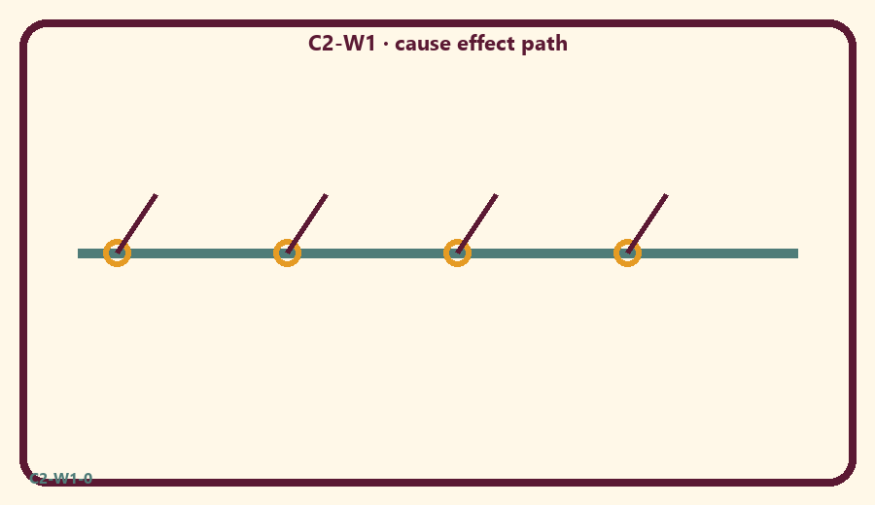
CARD 1  Plant a help seed | CARD 2  Send a sharp text seed
CARD 3  Share a toy seed | CARD 4  Hide a mess seed
CARD 5  Say sorry seed | CARD 6  Blame loudly seed

Memory phrase
Choices are seeds. I want to plant service seeds.
Cut on the dashed borders. Keep each card intact.
TEACHER NOTE | No victim-blaming. No graphic hell imagery with children.

Y02 — Seed choice matching
Match planting pictures to kind/service vs sharp/selfish seeds.
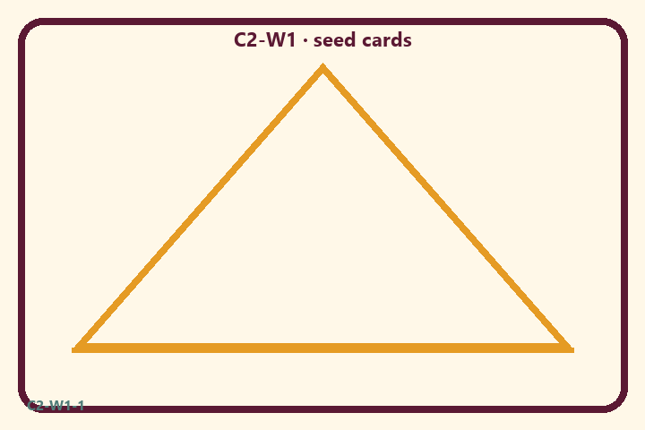
CARD 1  Plant a help seed | CARD 2  Send a sharp text seed
CARD 3  Share a toy seed | CARD 4  Hide a mess seed
CARD 5  Say sorry seed | CARD 6  Blame loudly seed

Memory phrase
Choices are seeds. I want to plant service seeds.
Cut on the dashed borders. Keep each card intact.
TEACHER NOTE | No victim-blaming. No graphic hell imagery with children.

Y03 — Before–During–After craft
Fold a three-panel card for one small help at home.
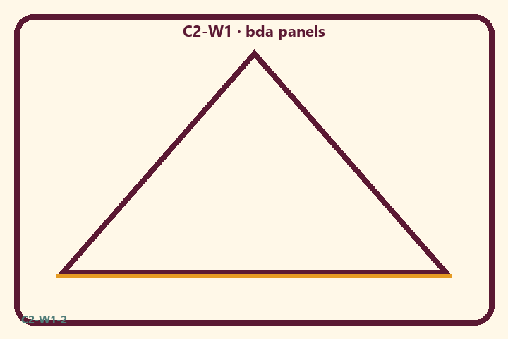
CARD 1  Plant a help seed | CARD 2  Send a sharp text seed
CARD 3  Share a toy seed | CARD 4  Hide a mess seed
CARD 5  Say sorry seed | CARD 6  Blame loudly seed

Memory phrase
Choices are seeds. I want to plant service seeds.
Cut on the dashed borders. Keep each card intact.
TEACHER NOTE | No victim-blaming. No graphic hell imagery with children.

Y04 — Soft-words redirect cards
After hot words, point to a soft repair card.
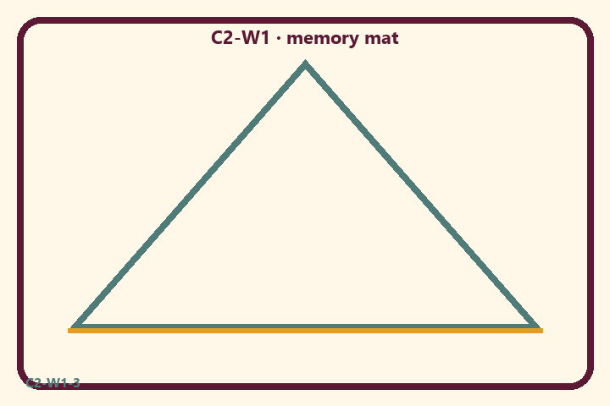
CARD 1  Plant a help seed | CARD 2  Send a sharp text seed
CARD 3  Share a toy seed | CARD 4  Hide a mess seed
CARD 5  Say sorry seed | CARD 6  Blame loudly seed

Memory phrase
Choices are seeds. I want to plant service seeds.
Cut on the dashed borders. Keep each card intact.
TEACHER NOTE | No victim-blaming. No graphic hell imagery with children.

Y05 — Memory phrase mat
Tap each line while echoing the memory phrase.

Memory phrase
Choices are seeds. I want to plant service seeds.
BG 3.9 · family week
RIGHTS NOTE | KUTUMBA-original framing; cited third-party material retains its own rights. Human/temple review remains EXTERNAL_OPEN.

